Diffusion Tract of Interest (TOI), (e.g. Superior Longitudinal Fasciculus (SLF)) Pipeline

This pipeline is done after doing the FBA pipeline. It will look at the chosen tracts of interest (TOI) from the user. We will first generate a track density image map in order to see the tracts, and then will apply manual allocations to the track of interest (TOI), which for me, is the superior longitudinal fasciculus (SLF). I will also show an example with the corpus callosum and the SLF as a TOI.

In terms of conducting the fixel analysis, it will be similar to what was done in the FBA pipeline, but this time with the tract of interest. Unlike the other pipelines, this pipeline will require more manual user input, depending on which tract you select. Additionally, there are many options to this, such as generating tracts from seedpoints and/or creating masks to help constrain the streamlines (note – I find that the generating tracts from seedpoints method is better). And so, you most likely need to be more manual with this ‘pipeline’, and it is best to only take this pipeline as a guide.

It is also very useful to have easy access between your generated files and a viewing gui (mrview). For example, I use a Linux environment (without a graphics card) for my main data processing, and transfer files via a mounted drive and/or with .ssh commands, while using a Windows system to view the MRtrix images (via a windows sub-system Linux (WSL)) on my local computer, in which you can read more about here:

<https://mrtrix.readthedocs.io/en/3.0_rc3/troubleshooting/display_issues.html#remote-display>

<https://www.mrtrix.org/download/windows-msys2/>

<https://community.mrtrix.org/t/mrtrix-fsl-ants-on-the-windows-subsystem-for-linux/377>

The pipeline can be downloaded from here: <https://github.com/Ltah72/DPRC-analysis>

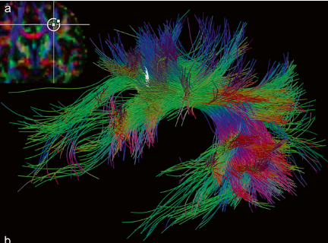

Selection of the SLF with white matter tract. Inclusion and exclusion applied. Image taken from *Diffusion Tensor Imaging: a practical handbook*.

Unlike other scripted pipelines, there is no 'formal manual' for this from mrtrix, and many of the steps are referenced by the mrtrix community forum and logic of steps/analysis.

Steps:

1. Compute track density image (TDI)
2. Option: Select a seedpoint via generating tracks
   1. E.g. superior longitudinal fasciculus (SLF)
3. Option: Create mask for the track of interest (TOI)
   1. E.g. corpus callosum
   2. E.g. superior longitudinal fasciculus (SLF)
   3. Edit your tracks with TOI mask as an input
4. Manually include/exclude fibres on your TOI if needed
5. Create a fixel mask with your TOI
6. Threshold the TOI mask
7. Compute fixel-based metrics (FD, FC, FDC) with the TOI fixel mask per each participant
8. **Compute track density image (TDI)**

Generate track density images (TDI) on the generated tracks *(tracks_2_million_sift.tck*

) file in order to visualise the tracts better. This will perform the mapping of streamlines to voxels.

Command: tckmap

Elapsed time: 1 sec

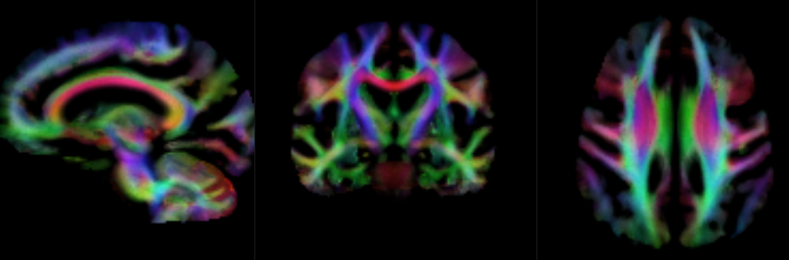

*Calamante, F., Tournier, J. D., Jackson, G. D., & Connelly, A. (2010). Track-density imaging (TDI): Super-resolution white matter imaging using whole-brain track-density mapping*

1. **Option: Select a seedpoint via generating tracks**

I first created a tract of the SLF on the left and right side separately, and then merged them together as one tract. It may also be good to conduct analysis (i.e. statistical analysis for group comparisons) on the left and right tract separately, in addition to both tracks combined.

It is best to view and edit the tracts on mrview (MRtrix’s viewing gui). To choose a seedpoint, it is best to find and choose the point of the main area of the TOI. You can also add in more seed points, if you do not think that it covers enough of the fibres. From there, you can then add in more parameters and exclude extraneous fibres to make a cleaner TOI. I also selected 10,000 tracts (10k) for the TOI (somewhere I had read that 10k was a good amount for a TOI, but I forget where :p).

Command: mrview (do this within the viewing gui of mrtrix)

tckgen

tckedit

Here is an example of my full TOI command for tckgen:

%for the left SLF tract

tckgen wmfod_template.mif -select 10k -maxlen 250 -minlen 10 -angle 45 -power 1.0 -cutoff 0.15 -seed_sphere 32.62,30.05,26.56,3 -seed_sphere 38.13,-30.24,24.24,2 -exclude 16.59,17.93,27.23,2 -exclude 46.95,-21.89,-18.17,5 -exclude 36.59,-31.79,-2.25,1 -exclude 39.12,-26.26,-4.86,2 -exclude 46.03,7.805,-7.66,2 -exclude 49.34,-35.52,-14.41,2 -exclude 50.96,-34.06,-13.5,2 -exclude 42.1,-37,-13.57,2 -exclude 38.3,-39.5,-3.83,2 -exclude 39.75,-41.43,-15.13,1 -exclude 36.41,-45.01,-1.24,1 -exclude 43.92,-34.85,-9.75,1 -exclude 17.36,15.72,28.83,1 -exclude 14.9,18.27,24.22,1 -exclude 29.44,-12.79,17.54,1 -exclude 25.8,10.52,12.03,1 -exclude 41.77,-38.25,-11.79,1 -exclude 39.1,-39.28,-1.16,1 -exclude 41.09,-41.09,-10.73,1 SLF_track_L.tck

Here are my results of the left and right SLF in 2D and 3D format:

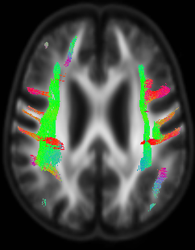

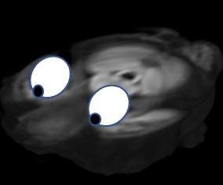 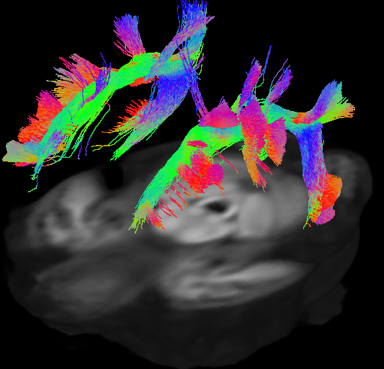

1. **Option: Create mask for the track of interest (TOI)**

Create a mask on the interested tract. You will need to do this manually through mrview, using the ROI editor. Once done, save the mask as a .mif file.

* 1. **Corpus callosum**

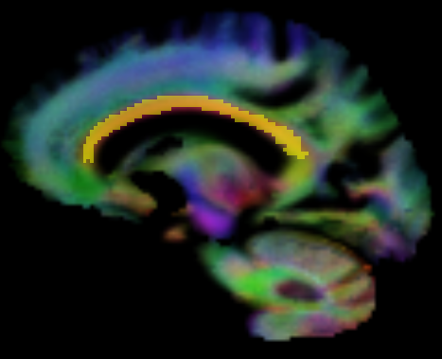

Example of the mask of the corpus callosum as a TOI.

Command: mrview (do this within the viewing gui of mrtrix)

* 1. **SLF tract**

Here is my SLF TOI:

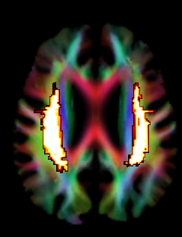

I also created a few exclusion masks, such as the corpus callosum and a mask excluding most regions besides the SLF, and added these to the analysis.

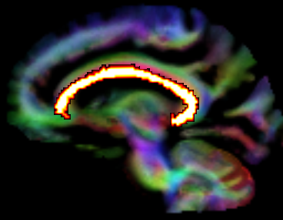 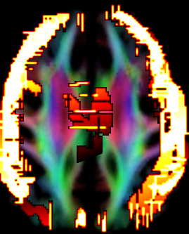

For anatomical regions of interests guides, I have found that this textbook has many useful diagrams for choosing the tracts of interest. You can download this for free via University of Auckland (UOA) library website (given if you are a part of the University).

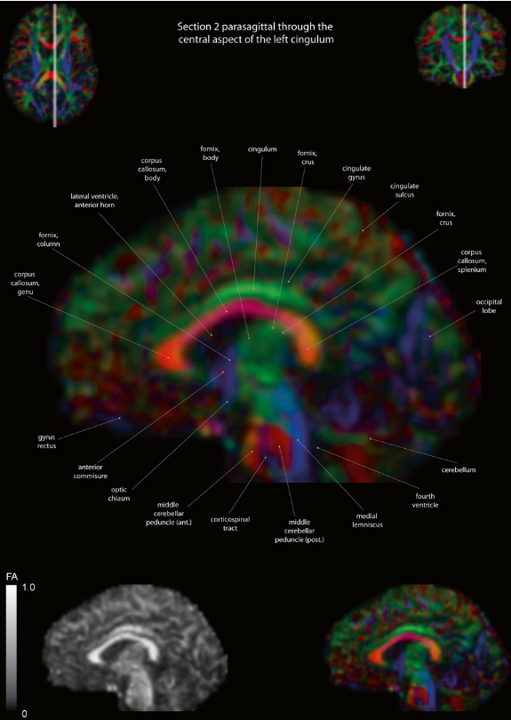

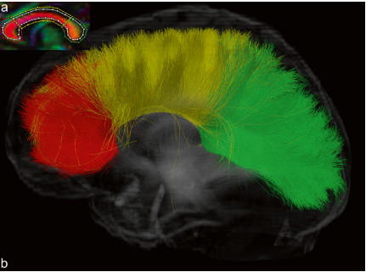

Corpus Callosum tract and all connecting fibres.

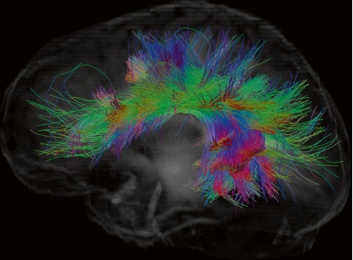

Superior longitudinal fasciculus tract and all connecting fibres.

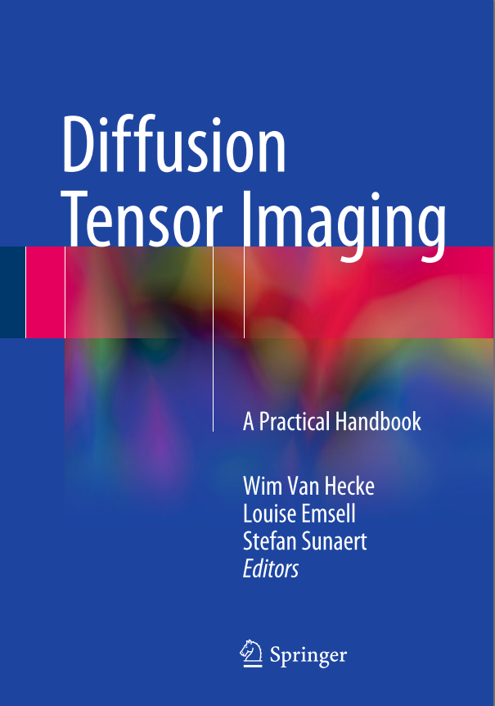

*Van Hecke, W., Emsell, L., & Sunaert, S. (2016). Diffusion Tensor Imaging: a practical handbook*

The *fsleyes* brain templates and brain atlases may also provide some good guidance for TOIs/ROIs. It may also be good to consult with your supervisor or someone who has good anatomical knowledge to check over your TOI masks.

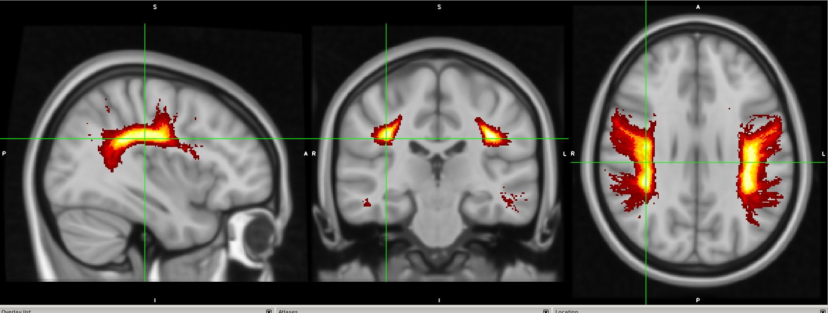

E.g. This is the MNU152_T1_1mm template with the left and right superior longitudinal fasiculi selected as region of interests.

**c. Edit your tracks with your TOI mask as your input**

By inputting the mask of your TOI, you will effectively include (most of) only those tracts of interest for your analysis. Use the 2 million tracts which were generated from the SIFT whole-brain FBA tracts as input for this.

Command: tckedit

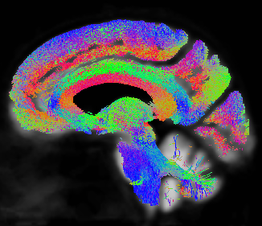

Example of the corpus callosum tracts which has been edited by the corpus callosum ROI mask (as featured in the previous steps) manually created by me. Once you have created your mask, make sure to move the file into the TOI directory where you are doing the analysis.

Elapsed time: 24 sec

1. **Manually include/exclude fibres on your TOI if needed**

Again, you will need to go back into mrview and view your file and decide whether you need to apply any manual edits. Again, it would be good to consult the anatomical guides for this.

Command: mrview

tckedit -include / -exclude

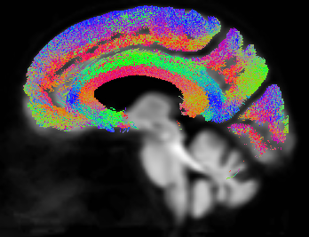

Corpus callosum tracts in which ‘non corpus callosum regions’ have been edited out with -exclude option in tckedit.

**\*Note that you will need to go into my script (TOI.m) and edit the lines for this.**

Elapsed time: < 1 sec

1. **Create a fixel mask with your TOI**

Create a fixel mask with your TOI. This will create an output of a TOI fixel mask within a new TOI fixel directory.

Command: tck2fixel

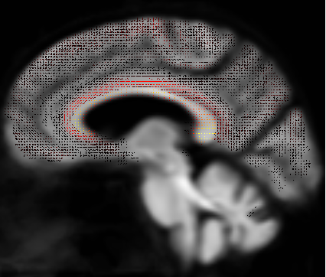

Corpus callosum fixel mask

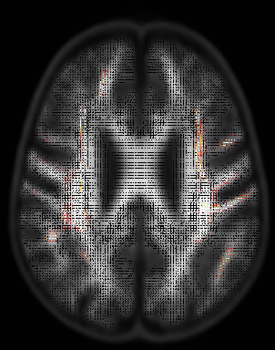 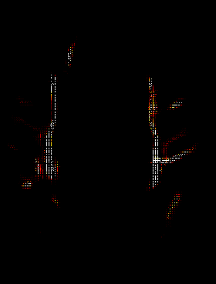

SLF fixel mask

Elapsed time: 13 sec

References from the mrtrix community forum to look at:

Assignment fixels to the tract of interest by taking the mean:

<https://community.mrtrix.org/t/calculating-average-fba-metrics-of-specific-tracts/1805/13>

<https://community.mrtrix.org/t/fixel-based-analysis-assign-significant-fixels-to-tracks/660/6>

Visualising the tracts of interest:

<https://community.mrtrix.org/t/how-to-generate-cropped-coloured-tractograms-a-la-raffelt-et-al-2016-figure-4a/614>

1. **Threshold the TOI mask**

Threshold your newly created TOI fixel mask. Choose the optimal absolute threshold value (with the -abs option) by viewing the mask image on mrview.

Command: mrview

mrthreshold

Elapsed time: < 1 sec

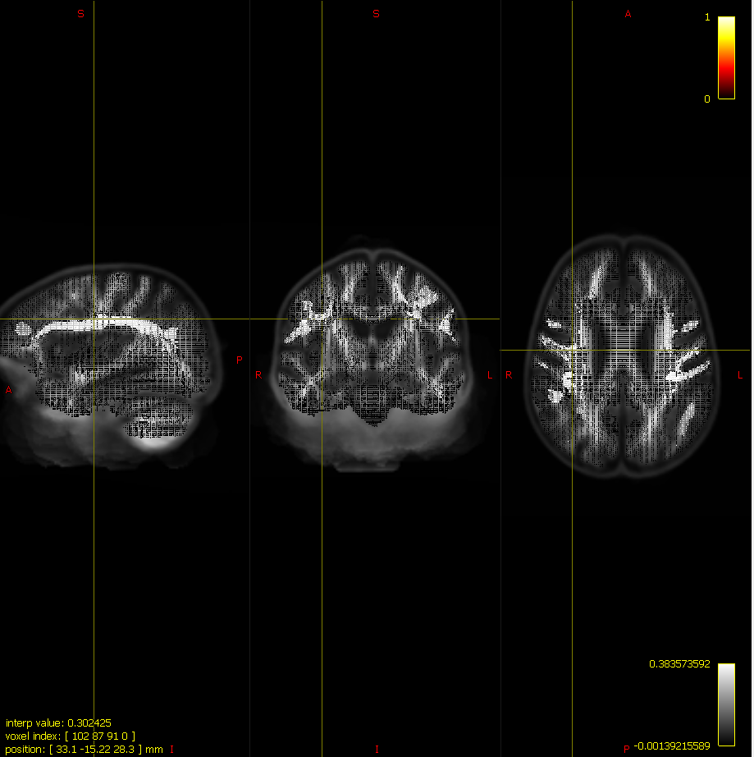

Thresholded mask (-abs 0.5) for the SLF tract.

Probably good to set your -abs threshold around 0.5 or so, in order to get rid of zero values. If you increase this threshold number, then it will constrain the fixels in the mask more.

<https://community.mrtrix.org/t/remove-fixels-with-value-0-from-fixelmask/1850>

1. **Compute fixel-based metrics (FD, FC, FDC) with the TOI fixel mask per each participant**

We will calculate the TOI fixel-based metrics (FD, FC, and FDC) using the threshold TOI fixel mask, in the **CreateTOIFBAMetricFiles.m** function that I created. This function will call upon mrstats and will calculate the mean, median, standard deviation (SD), standard error (std_rv), min, max, and count of fixels, of all of the FBA metrics for the TOI. This will be outputted into 3 text files for each of the metrics.

Command: mrstats -mask option

%Sample output: FD_[TOI]_TOI.txt

FC_log_[TOI]_TOI.txt

FDC_[TOI]_TOI.txt

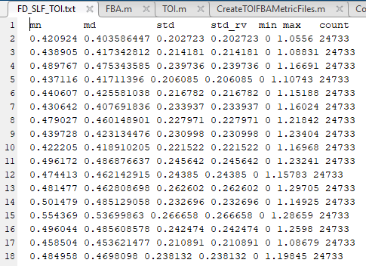

Like the whole-brain FBA metrics, here, you will take the output of each participant and put into a statistical software (e.g. R, SPSS) in order to compute a single metric value and conduct the statistical analysis to compare between your interested groups.

Do note that significant differences between your groups mean that that whole tract that you created and constrained is then the ‘visual output’ of the differences between your groups.

Elapsed time: 9 sec

References

Calamante, F., Tournier, J. D., Jackson, G. D., & Connelly, A. (2010). Track-density imaging (TDI): Super-resolution white matter imaging using whole-brain track-density mapping. *NeuroImage*, *53*(4), 1233–1243. https://doi.org/10.1016/j.neuroimage.2010.07.024

Van Hecke, W., Emsell, L., & Sunaert, S. (2016). Diffusion Tensor Imaging: a practical handbook. In *New York Springer* (Vol. 711). https://doi.org/10.1007/978-1-4939-3118-7