DPRC Diffusion CSD Pipeline

This pipeline takes the data from the preprocessing pipeline. Now, we will do some further analyses, which includes generating *fibre orientation distribution (FOD),* using *constrained spherical deconvolution (CSD)*. Script and files needed can be downloaded from here: <https://github.com/Ltah72/DPRC-diffusion-analysis>.

Like the preprocessing steps, most of these postprocessing steps will run through MRtrix3, with some fsl functions. Many of these steps can be found in detail on the mrtrix documentation page. This script will be run on all participants that you wish to include in your analysis. You will need to create a population template (in step 5) to represent all groups of your population cohort in order to compare them to one another.

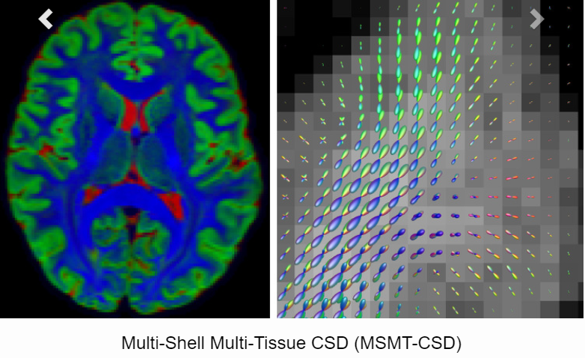

MRtrix3 manual (on multi-tisssue CSD: preprocessing, CSD, and FBA): <https://mrtrix.readthedocs.io/en/latest/fixel_based_analysis/mt_fibre_density_cross-section.html>

Andrew Jahn’s brain book: <https://andysbrainbook.readthedocs.io/en/latest/MRtrix/MRtrix_Introduction.html>

Steps:

1. Generate response function estimates with multi-tissue CSD
2. Compute a group average response function of each tissue
3. Create FOD images (wm, gm, csf)
   1. Upsample dwi image
   2. Upsample brain mask images
   3. FOD estimation (multi-tissue SD)
4. Joint bias field correction and intensity normalistion
5. Generate FOD population template
6. Register all subjects to FOD template
   1. Register to FOD template
   2. Warp mask to template
   3. Compute intersection of masks in template space

On the dementia vm (8 CPU cores with 8 GB RAM), steps 1-6 take approximately ~34 hours with 36 participants. All timings are elapsed from 1 participant, unless otherwise stated.

1. **Generate response function estimation with multi-tissue constrained spherical deconvolution (CSD) (per participant)**

We want to estimate the response function per each tissue type per each participant. It is necessary to obtain a unique set of three response functions for the 3 tissues (grey matter, white matter, and CSF) for the fixel-based analysis (FBA). We will use the *dhollander* algorithm to do this (which can be used with both single-shell and multi-shell data), as this has been the most superior of the currently available options:

<https://community.mrtrix.org/t/which-one-is-better-between-response-msmt-5tt-and-dhollander-for-hcp-data/857>

<https://www.researchgate.net/publication/324770874_Accuracy_of_response_function_estimation_algorithms_for_3-tissue_spherical_deconvolution_of_diverse_quality_diffusion_MRI_data>

<https://www.researchgate.net/publication/307863133_Unsupervised_3-tissue_response_function_estimation_from_single-shell_or_multi-shell_diffusion_MR_data_without_a_co-registered_T1_image>

In addition to using mtnormalise (later in this script), the dhollander algorithm is appropriate for handling white matter lesions:

<https://community.mrtrix.org/t/global-intensity-normalisation-and-white-matter-hyperintensities/3976>

Command: dwi2response dhollander

Elapsed time: 11 sec

You can check in mrview where the voxels from the image were used to construct the basis functions for each tissue type by looking at the voxels [PAR_NAME] .mif file.

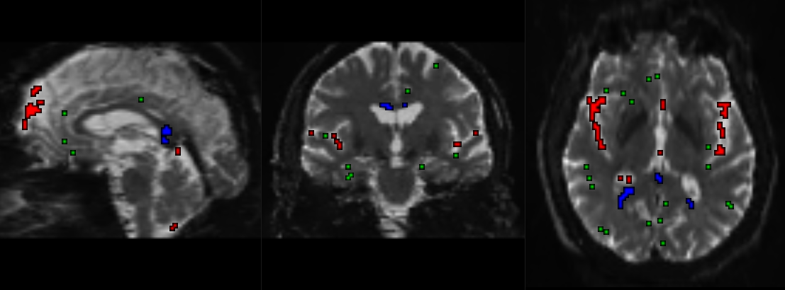

A sample of where the the response functions were taken from in one participant. Red is csf, blue is white matter, and green is grey matter.

1. **Compute a group average response function of each tissue**

Take the group average response function per each of the 3 tissues (wm, gm, csf). The ‘default option’ of choosing only 1 single subject per each group for the estimate response should be OK, as long as there are 3 unique response function estimates per each tissue. This is because the shape of the estimated white matter response function varies little across subjects. But we can also take the **group average response function (which is what my script does)**, after taking the response function for every participant. So, perform all of these steps on every participant per each group, then take the average response per group.

https://community.mrtrix.org/t/response-function-for-group-analysis/1077

%Sample input: responseFunctionCSF

responseFunctionGM 🡪 folders holding all participant response files

responseFunctionWM

Command: responsemean

%Sample output: group_average_responseCSF.txt

group_average_responseGM.txt

group_average_responseWM.txt

For a sanity check: you can inspect the basis functions for each tissue (wm, gm, csf) generated at each shell.

Command: shview

WM (more anisotropic):

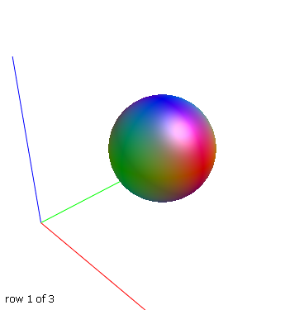 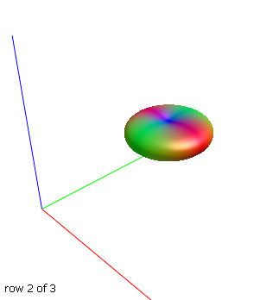 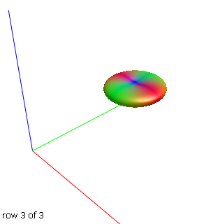

B0 B1000 B2000

GM (more isoptropic):

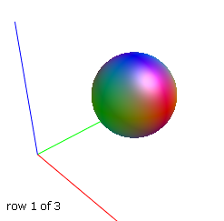 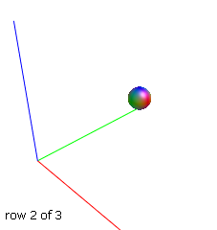 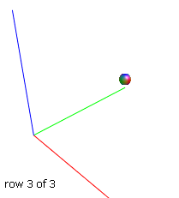

B0 B1000 B2000

CSF (even more isotropic):

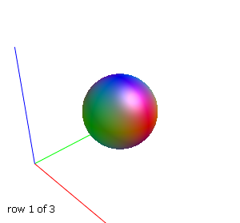 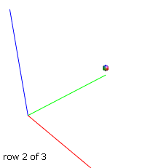 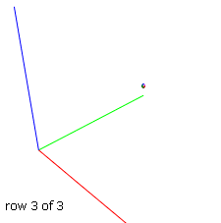

B0 B1000 B2000

Elapsed time: 1.5 sec

1. **Create FOD images (wm, gm, csf)**

Using the response estimate functions, we will create the FOD images of each tissue.

1. **Upsample DW images**

Upsampling DWI data *before* computing FODs increases anatomical contrast and improves downstream template building, registration, tractography and statistics.

With this step, you have the option to modify the grid of an image without interpolation (cropping or padding) or by regridding (this is what my script does) to an image grid with modified orientation, location and or resolution. The image content remains in place in real world coordinates.

Command: mrgrid -regrid

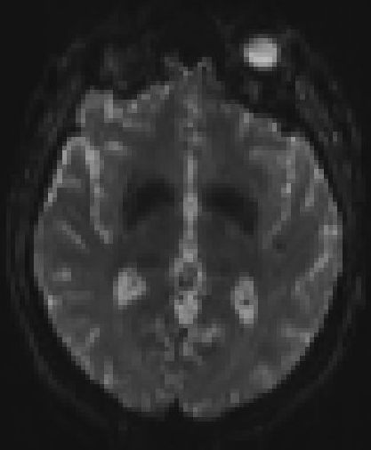 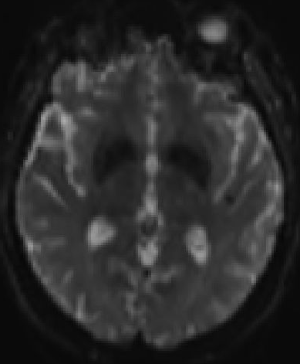

Pre-upsample dwi data Gaussian smoothing (-regrid)

The -regrid option performs changes of the voxel grid that require interpolation of the image such as changing the resolution or location and orientation of the voxel grid. If the image is down-sampled, the appropriate smoothing is automatically applied using Gaussian smoothing unless nearest neighbour interpolation is selected or oversample is changed explicitly. The resolution can only be changed for spatial dimensions. It is recommended to upsample to an isotropic voxel size of 1.25 mm for human brains (if your original resolution is already higher, you can skip this step).

Elapsed time: 1 min 10 sec

1. **Upsample brain mask images**

Compute a whole brain mask from the upsampled DW images. We will use BET again for this. Since topup has already been applied in the previous preprocessing script, we will just use the first b0 (ref_b0) as an input to create the new upsampled brain mask.

Command: bet threshold FA set at 0.2

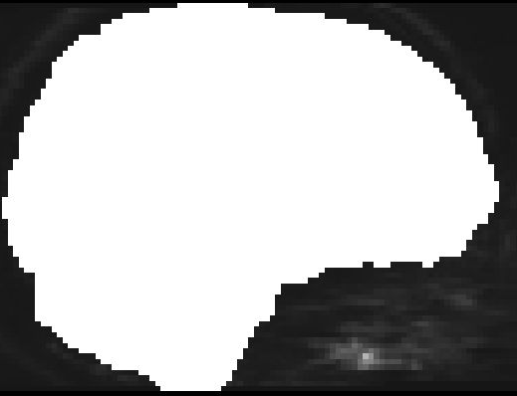 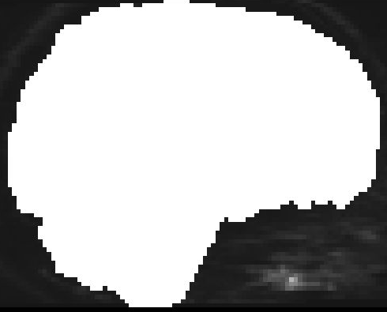

brain mask (no manual corrections) upsampled mask (less non-brain parts covered)

*note that upsampled images take a lot of space – 2.6 GB for main dwi data

Elapsed time: 3 sec

At this stage, it would be good to check *all* individual subject masks, in that they include *all* regions of the brain that are intended to be analysed.

1. **FOD estimation (multi-tissue SD)**

Use the group average response function estimates calculated from the previous step for this.

Command: dwi2fod msmt_csd

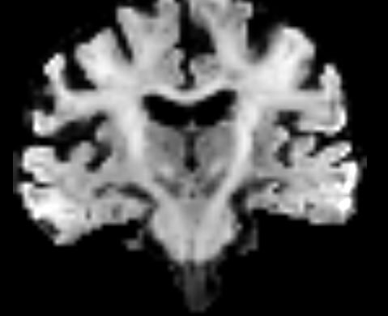 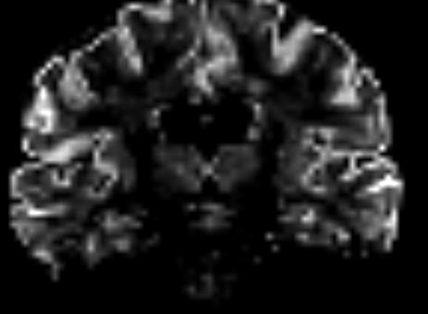 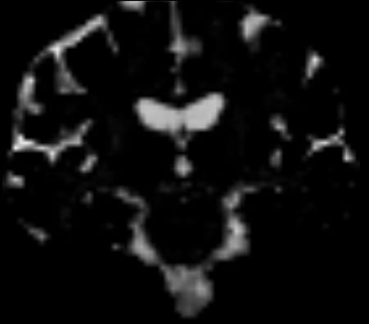

wmfod.mif gmfod.mif csffod.mif

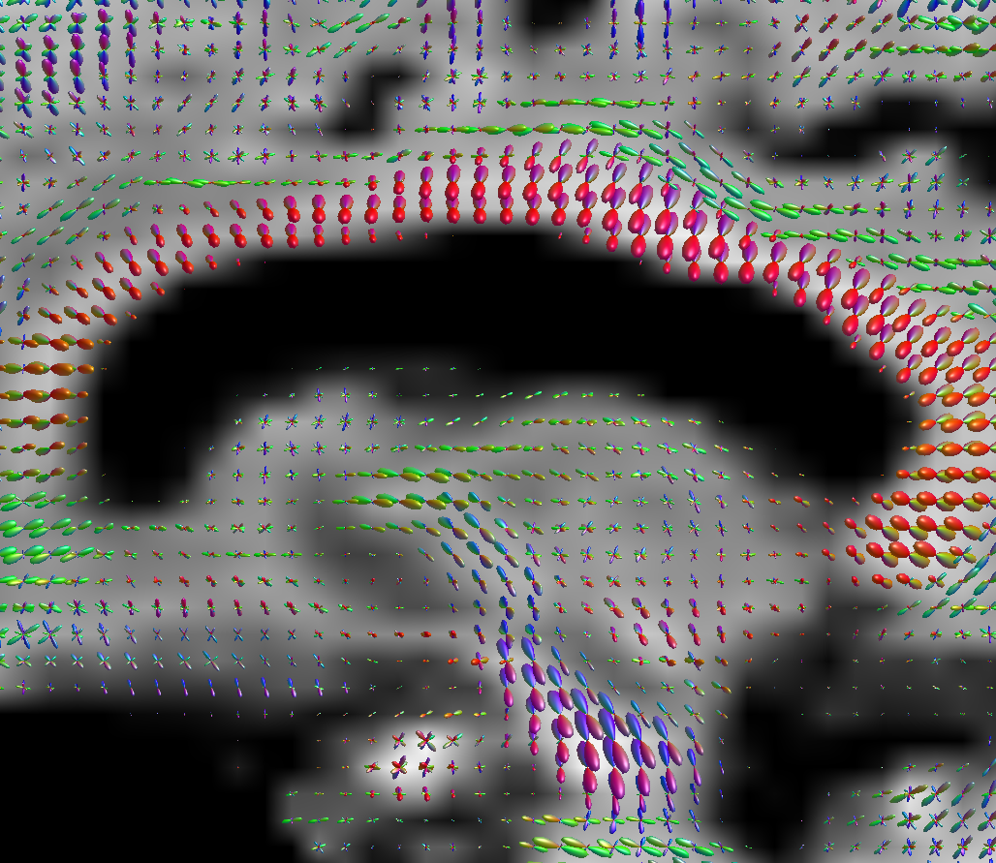

Image of the FOD loaded onto the wmfod template of a participant.

Elapsed time: 11 min

You can also compare this with to the diffusion data before spherical deconvolution was applied to it.

Command: amp2sh

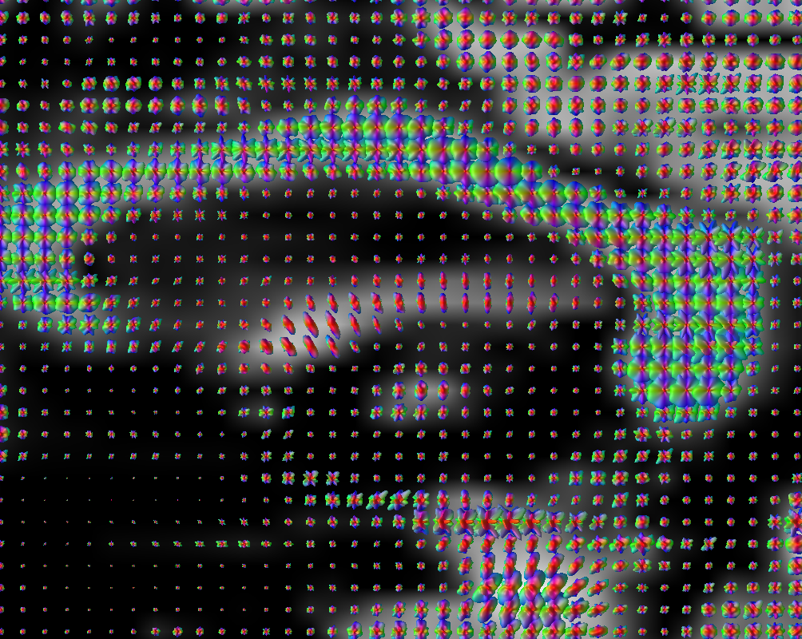

Preprocessed dwi with no spherical deconvolution applied.

You can view a stark difference within *a same, single ODF* as well.

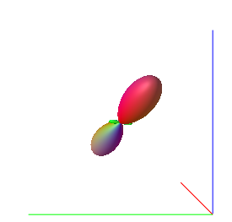 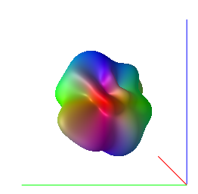

Spherical deconvolution no spherical deconvolution

Another thing you can do is check the FODs in a single image with all 3 tissues types together. Check this by loading the vf_[PAR_NAME].mif file into mrview and affix the odf file using the odf toolbox.

Command: mrconvert

mrcat

mrview

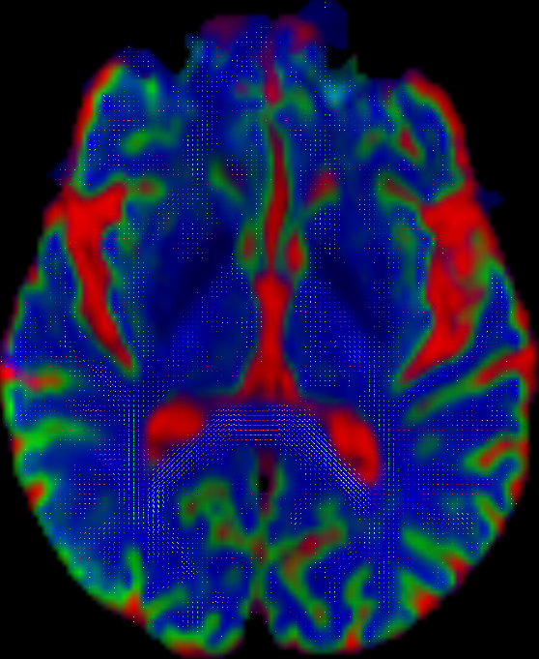

White matter FODs are overlayed in this colour-coded image for each tissue type. Green represents grey matter, blue represents white matter, and red represents CSF.

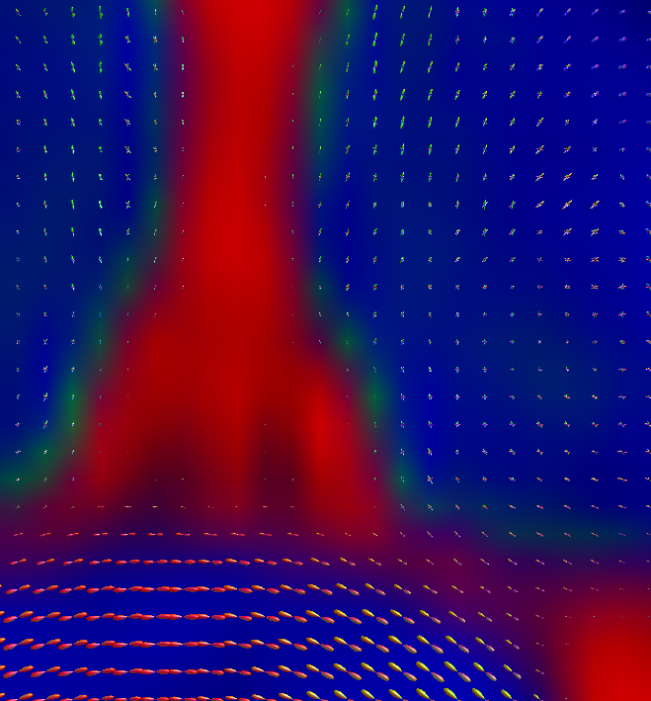

Elapsed time: 5 sec

1. **Joint bias field correction and intensity normalisation**

Perform joint bias field correction and global intensity normalisation of the multi-tissue compartment parameters. This command takes as input any number of tissue components (e.g. from multi-tissue CSD) and outputs corresponding normalised tissue components corrected for the effects of (residual) intensity inhomogeneities. Intensity normalisation is performed by optimising the voxel-wise sum of all tissue compartments towards a constant value, under constraints of spatial smoothness (polynomial basis of a given order). Different to the Raffelt et al. 2017 abstract, this algorithm performs this task in the log-domain instead, with added gradual outlier rejection, different handling of the balancing factors between tissue compartments and a different iteration structure. This step is crucial for the FBA pipeline. Use the upsampled masks in this command. This was also done with a similar cohort (HC, MCI, and AD) in Mito et al. (2018) *Fibre-specific white matter reductions in Alzheimer’s disease and mild cognitive impairment*.

Command: mtnormalise

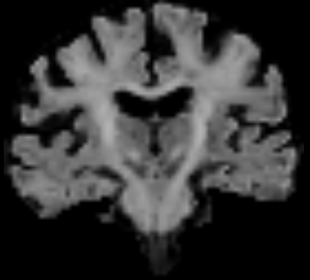viewed in *mrview*

wmfod.mif normalised (wmfod_norm.mif)

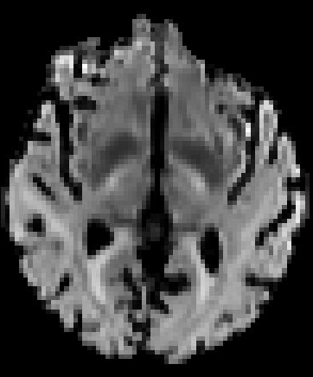 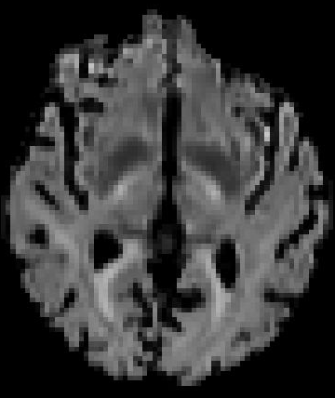 viewed in *fsleyes*

wmfod.mif normalised (wmfod_norm.mif)

Elapsed time: 14 sec

mtnormalise is appropriate for handling different tissue types and even pathological tissue: <https://community.mrtrix.org/t/global-intensity-normalisation-and-white-matter-hyperintensities/3976>

Read more about the different types of intensity normalisation options with some comparison here:

<https://community.mrtrix.org/t/optimal-approach-for-intensity-normalization-in-multi-shell-data-for-quantitative-analysis/1425>

1. **Generate FOD population template**

Generate a study-specific unbiased FOD template. Generating a population template is one of the most time consuming steps in a fixel-based analysis. If you have a very large number of subjects in your study, you can opt to create the template from a limited subset of 30-40 individuals. Typically, subjects are chosen so the generated template is representative of your population (e.g. similar number of patients and controls, though avoid patients with excessive abnormalities compared to the rest of the population). To build a template, you will use all FOD images, which are segregated into separate folder (e.g. wmFODimages) and put a set of corresponding mask images (with the same prefix as the FOD images) in another folder (using masks speeds up registration significantly).

You should pick around ~40 participants total to compose the population template. For my interested study, for example, I would run 8 participants from each of the 5 groups (HC, SCD, aMCI, mMCI, AD) to create the template to represent them all. Note that when selecting from the clinical group (e.g. AD), you need to be wary *not* to select AD participants who have a lot of degeneration. You should select participants who are ‘representative’ of each group.

Command: population_template

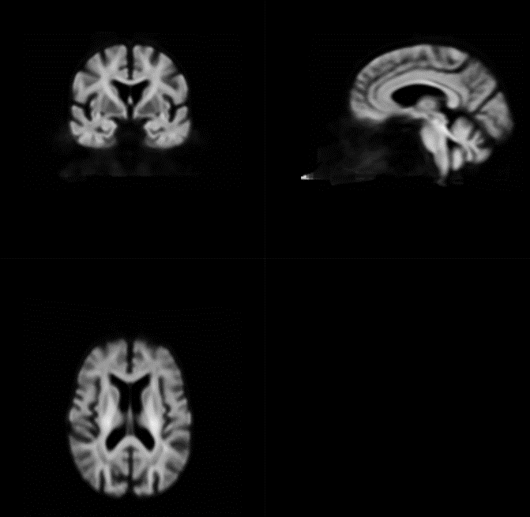

wmfod_template.mif (with 36 participants)

Elapsed time: 33 hours and 16 min with 36 participants.

**If 2 people on the dementia vm (Nikki and I) are simultaneously running intensive mrtrix commands, then the processing time would increase to 55 hours with 36 participants.

1. **Register all subjects to FOD template**
2. **Register all subjects to FOD template**

Command: mrregister

Elapsed time: 20 min

1. **Warp mask to template**

Different subjects have different brain coverage. To ensure subsequent analysis is performed in voxels that contain data from all subjects, we warp all subject masks into template space and compute the template mask as the intersection of all subject masks in template space.

Command: mrtransform

Elapsed time: 3 sec

1. **Compute intersection of masks in template space**

Compute the template mask as the intersection of all warped masks.

Command: mrmath

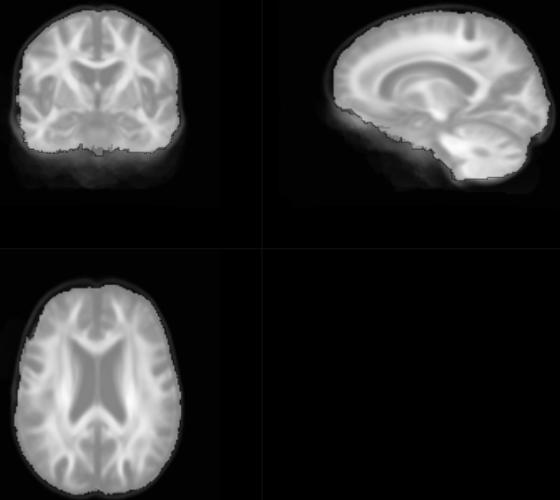

Fixel mask (template_mask.mif) overlayed on the white matter FOD population template (wmfod_template.mif).

Elapsed time: 11 sec for 36 participants

References

Mito, R., Raffelt, D., Dhollander, T., Vaughan, D. N., Tournier, J. D., Salvado, O., … Connelly, A. (2018). Fibre-specific white matter reductions in Alzheimer’s disease and mild cognitive impairment. *Brain*, *141*(3), 888–902. https://doi.org/10.1093/brain/awx355