Incident Management — Status Model Design
Updated following client review (Shin Feng), 2026-07-06: Controller return is now per-Responder (multi-select) with per-Responder Completion Remarks; a new Responder-level status, Completed, has been added.

1. Propose summary
- Incident-level status is reduced to five values: Live, Live (Assigned), Pending Endorsement, Returned, Closed.
- Responder-level status is tracked per assignment (multiple Responders in parallel): Assigned, Acknowledged, On-Site, Pending Controller Review, Completed — with a revision loop to Live (Incomplete).
- Live (Completed) is removed from the model; its role is absorbed into Pending Controller Review.
- Live (Incomplete) is retained, and now functions as the Controller's revision loop back to the Responder(s).
- Updated per client review: a Controller return is per-Responder, not applied to the full assigned set. The Controller selects one or more specific Responders (multi-select) to return for rework.
- Each returned Responder receives its own Completion Remarks — remarks are captured per Responder, not shared across a multi-select return.
- A new Responder-level status, Completed, is added — distinct from the earlier Live (Completed) status removed above. It is set when the Controller submits or resubmits the Incident for endorsement, and applies to every assigned Responder at that moment regardless of individual stage, including Responders still at Acknowledged or On-Site when the record is locked via Force Submit.
- Force Submit is introduced as a standing Controller capability: the Controller may submit an Incident to Pending Endorsement at any time, independent of how many Responders have reached Pending Controller Review.
- A new “Responder Progress” indicator (e.g. “2/3 On-Site”) is introduced as a display-only field on the Incident List View and Detail View, preserving visibility of Responder progress without reintroducing status conflicts.

2. Process flow
The diagram below shows the end-to-end flow across the three actors involved: Controller, Responder(s), and Duty Manager.
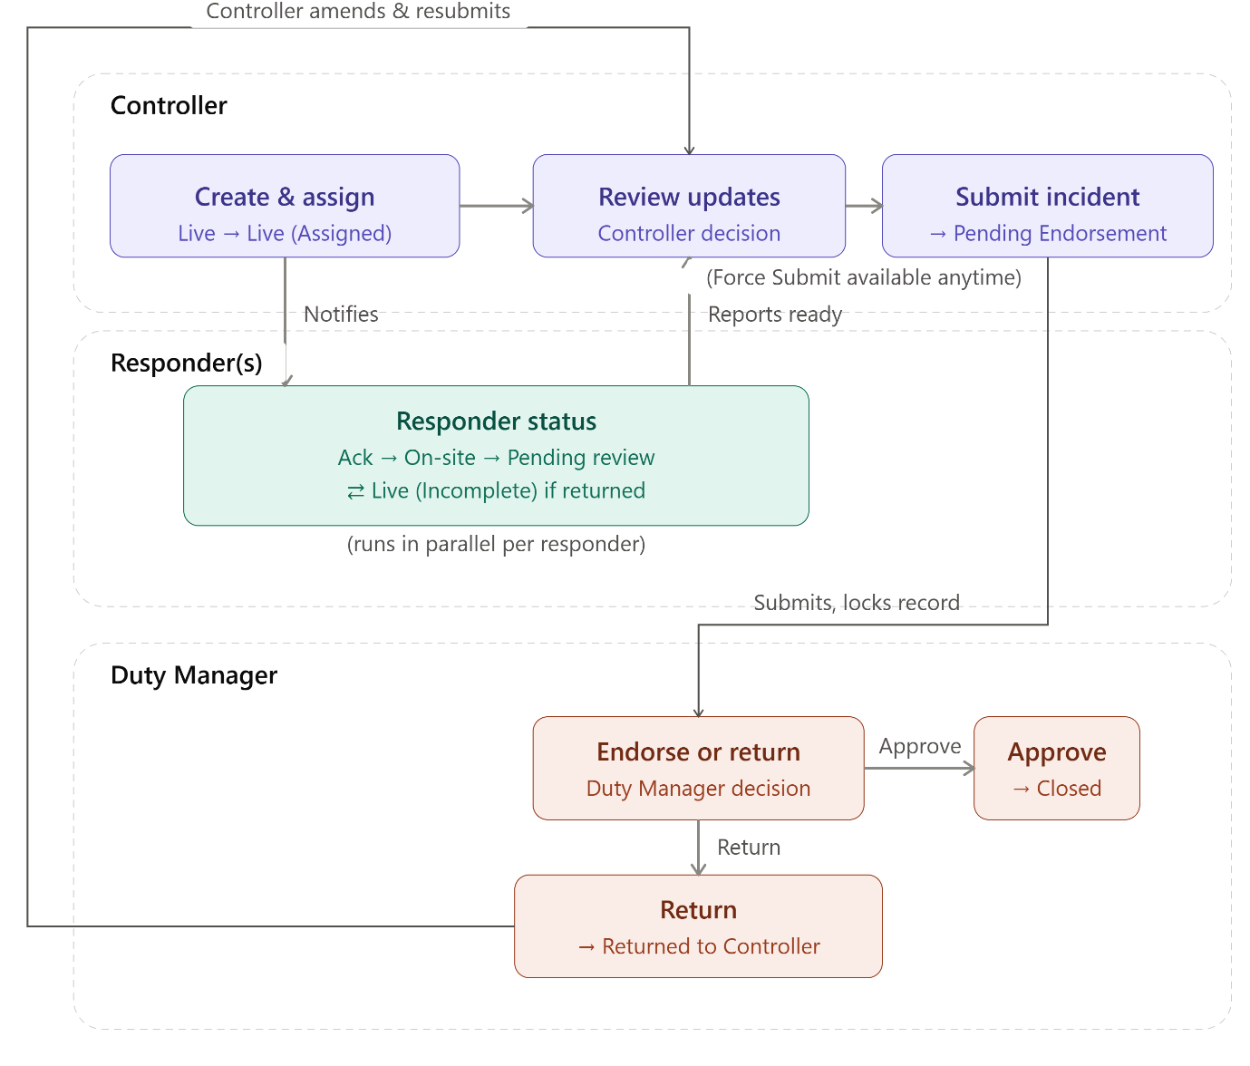

3. Incident-level status
Status | Description | Trigger
Live | Incident created; no Responder assigned yet. | Incident creation
Live (Assigned) | One or more Responders assigned and actively working. The label remains constant regardless of individual Responder progress. | Controller assigns Responder(s)
Pending Endorsement | Submitted for Duty Manager approval to close. | Controller submits (standard or Force Submit)
Returned | Duty Manager has returned the Incident; Controller must amend and resubmit. | Duty Manager selects Return
Closed | Approved for closure; record is read-only. | Duty Manager approves

4. Responder-level status
Tracked per Responder assignment. Where multiple Responders are assigned to the same Incident, each progresses through this status independently and in parallel.
Status | Description | Recorded by
Assigned | Responder has been assigned; awaiting acknowledgement. | Controller
Acknowledged | Responder has acknowledged the assignment. | Responder
On-Site | Responder has confirmed arrival and logged on-site information. | Responder
Pending Controller Review | Responder has completed ground activity and submitted for Controller review. | Responder
Live (Incomplete) | Controller requires further information or amendment from one or more selected Responders (multi-select); applies only to the Responder(s) chosen for return, each with its own Completion Remarks. | Controller
Completed | Controller submits or resubmits the Incident for endorsement. Applied to every assigned Responder at that moment, regardless of individual stage — including Responders still at Acknowledged or On-Site under a Force Submit. | Controller

5. Force Submit
Force Submit allows the Controller to move an Incident to Pending Endorsement without waiting for all assigned Responders to reach Pending Controller Review.
Aspect | Behaviour
Availability | Available to the Controller at any point while the Incident is in Live (Assigned), regardless of Responder progress.
Confirmation | A confirmation prompt is shown before submission proceeds. No mandatory justification text is required.
Record lock | Submission immediately locks the Incident record; assigned Responders lose further input access.
Responder status on lock | Every assigned Responder is set to Completed at submission, regardless of individual stage (Assigned/Acknowledged/On-Site/Pending Controller Review). Data already entered remains on the record as-is; no separate “force closed” flag is applied.
Responder notification | Assigned Responders are notified that the Incident has been submitted and locked.

6. Responder Progress indicator
To preserve visibility of Responder progress on the Incident List View and Detail View without reintroducing conflicts on the Incident-status field, a new display-only field, “Responder Progress”, is introduced (for example, “2/3 On-Site” or “1/3 Pending Review”). This field is a UI aggregation only — it does not participate in the workflow state machine, permission gating, or reporting logic, and does not replace the Incident-level status field.

