Here are examples from the new game manager with which it is possbile to have different policies play against each other.

This can be found in the jupyter notebook file that is adequately named.

Lets start with a game, where I have the currently newest (29.03) policy play against the dumbest one (update 50 from the first training). Specifically:
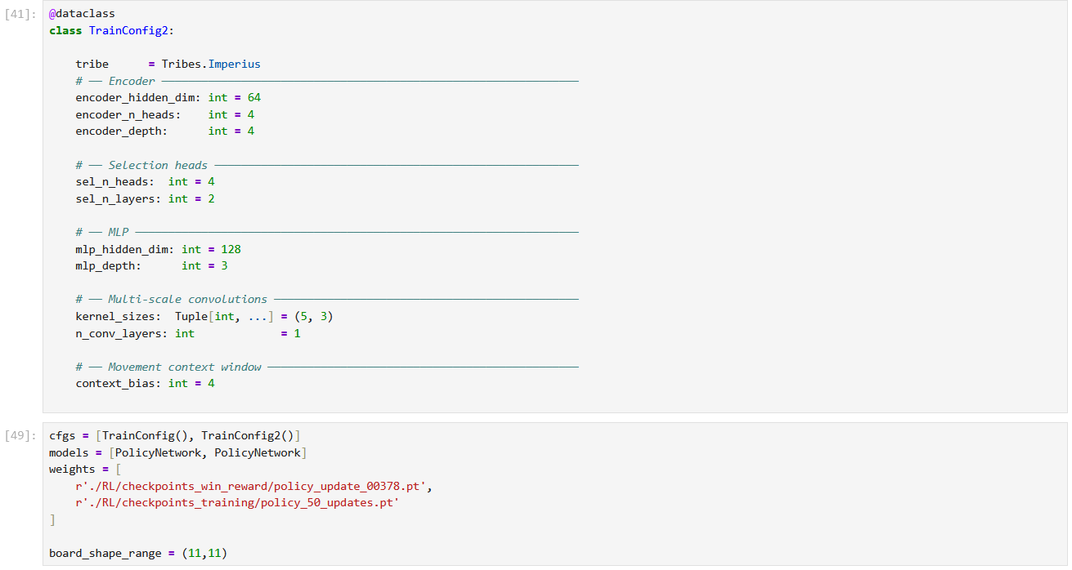

BLUE player: FIRST policy (the newer one)
RED player: SECOND policy (oldest one)

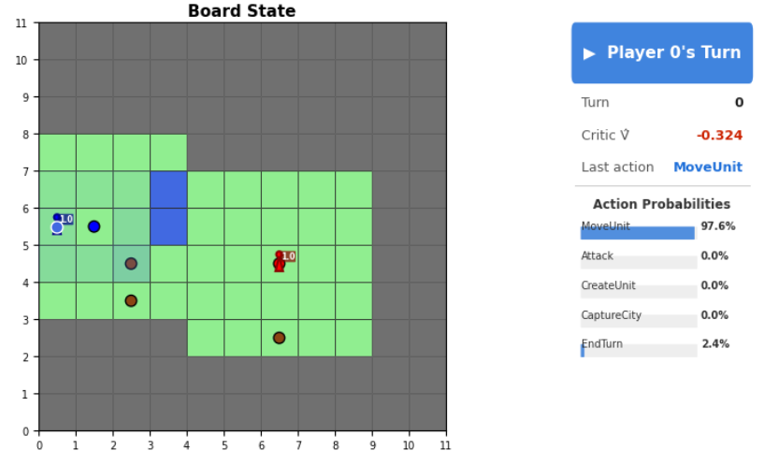
Better spawn for blue, red has a lot of option to explore...

Idk why blue still does not directly step on the village, I guess this is still a problem with unclaimed villages within city borders...

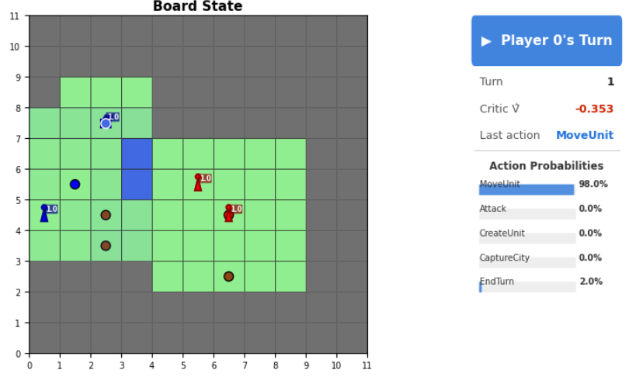
Blue goes with a rider for fast expansion.

Red does not ever chooses to create a rider. It also has a constant 10% chance to end the turn mid-play...

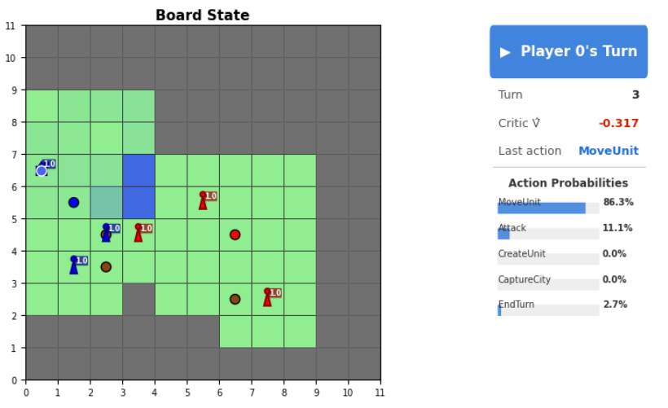
Blue sadly does not sample the partner-attack, but it had the highest chance

Also, I have to give it to red, they actually expand quite good for only using warriors

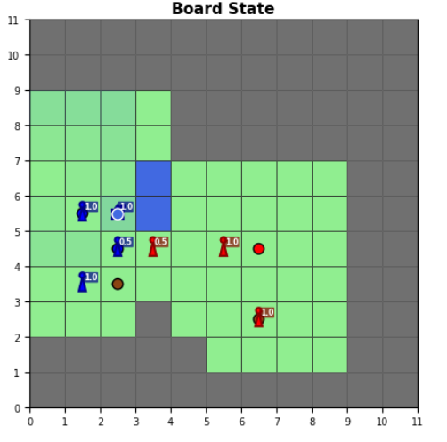
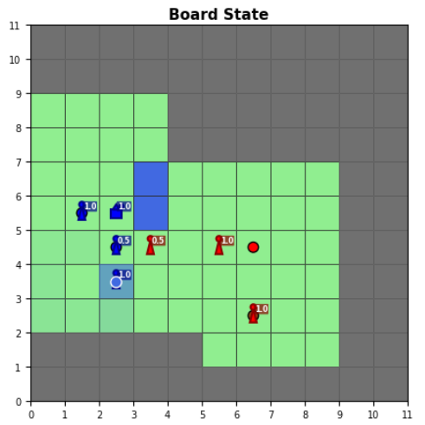

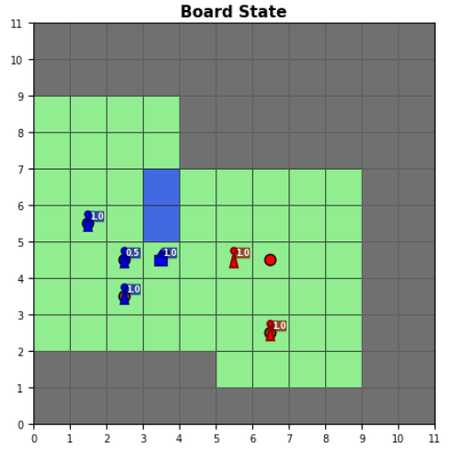
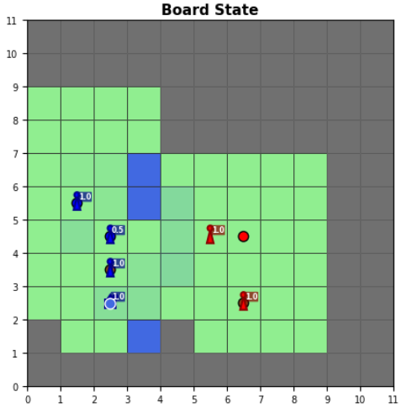

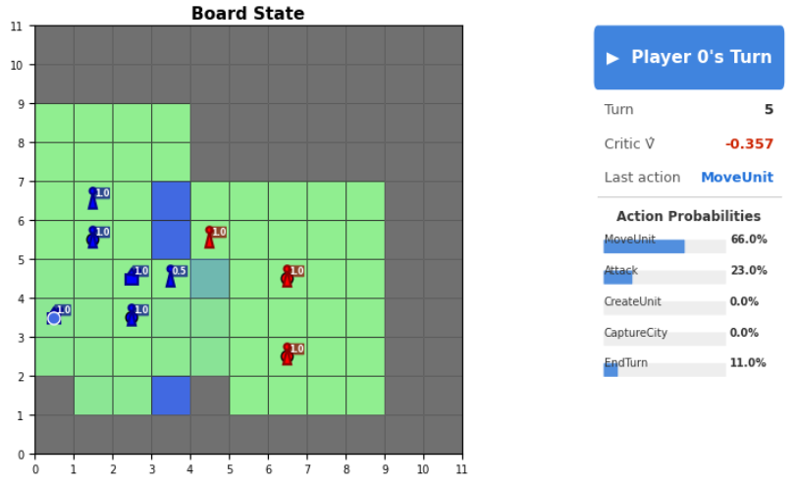
Here, the 5HP warrior moved into the enemy warrior, and the agent actually wants to bring in the 10HP rider for a partner attack, but it does not sample sadly.

Still very interesting (and good) decision by the agent

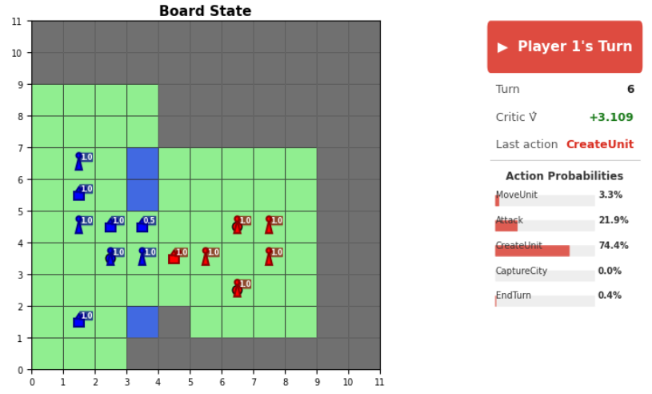
Red also trained a rider?? This usually does not happen...

Also right now, red is doing pretty well here for being the dumbest agent...

This needs investigation en mass...

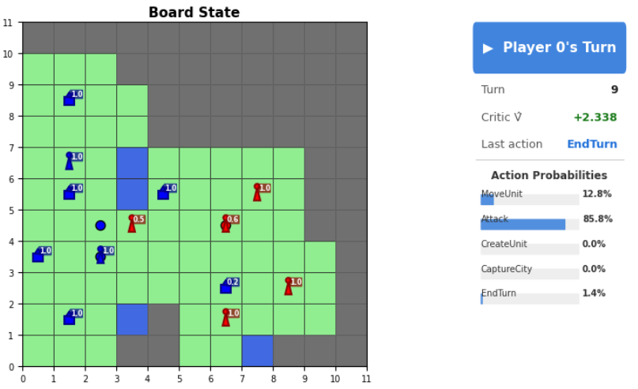
And then, red just ends his turn and therefore looses the village to the 2HP rider...

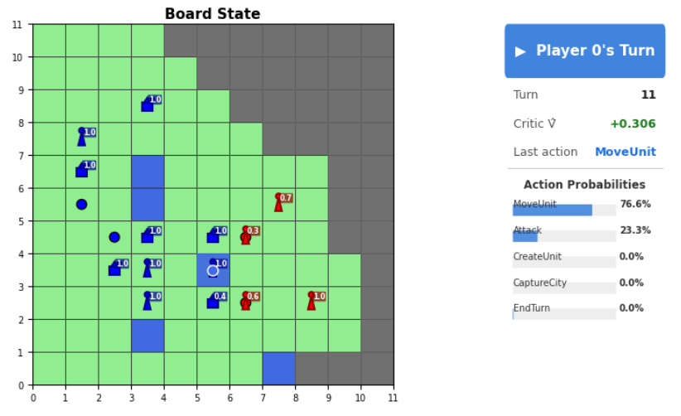

Look, how blue brings in his units to
secure the cities

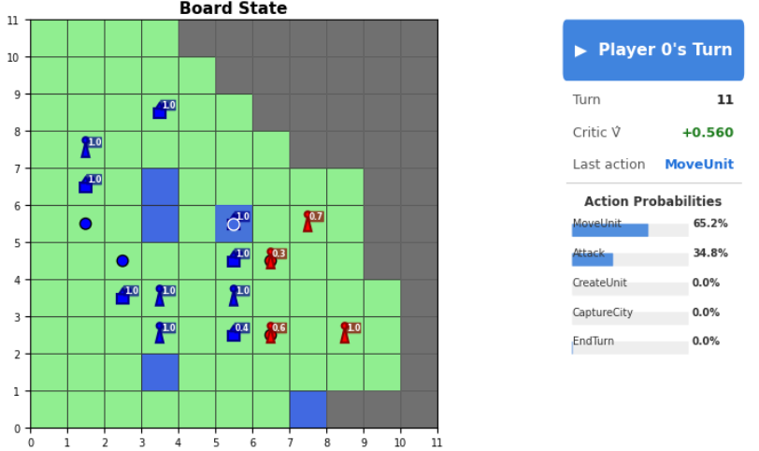
Also, it learned to first move in the units and then attack

...
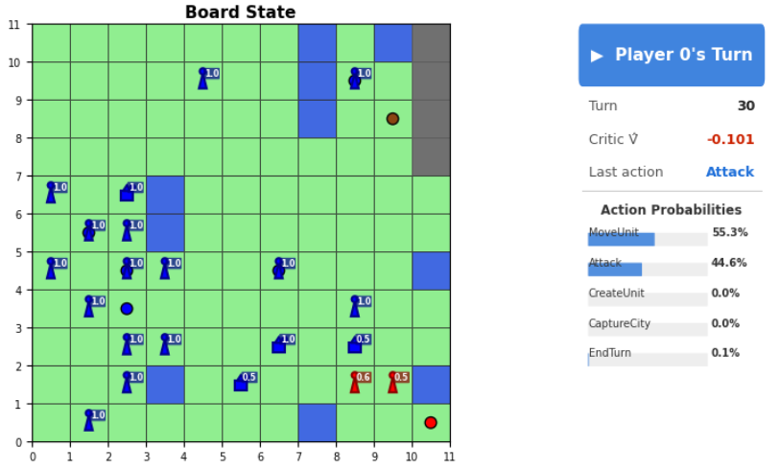
This takes quite a while...

At this point, we are so far into the game, that no model has been trained for a sequence of this length.

SUMMARY: Blue wins at turn 41. Red mostly looses because it randomly attacks when on city

Close vicinity game:
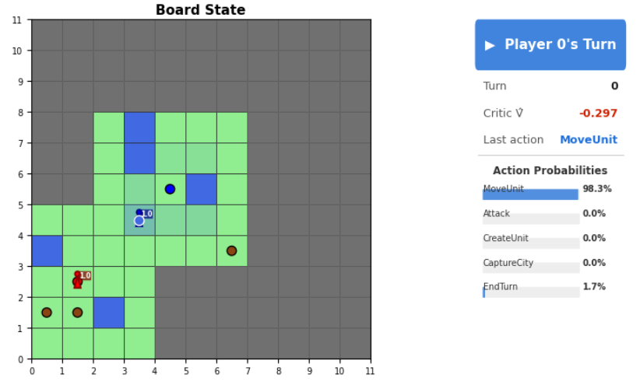
Red already sees blue at turn 0.

Blue doesnt see red yet.

Also the choice of movement of blue is very interesing...

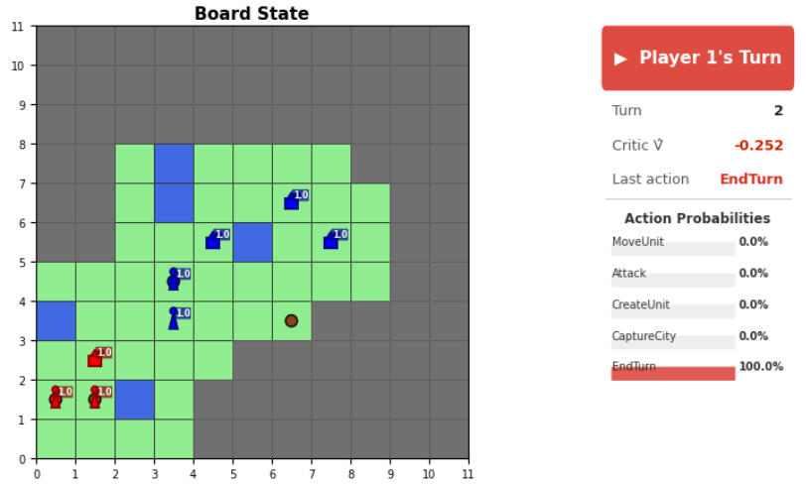

Red plays much better than I expected...
it appears that training picks up quite quickly from the start...

Blue doesnt know about red yet but has started to expand into east.

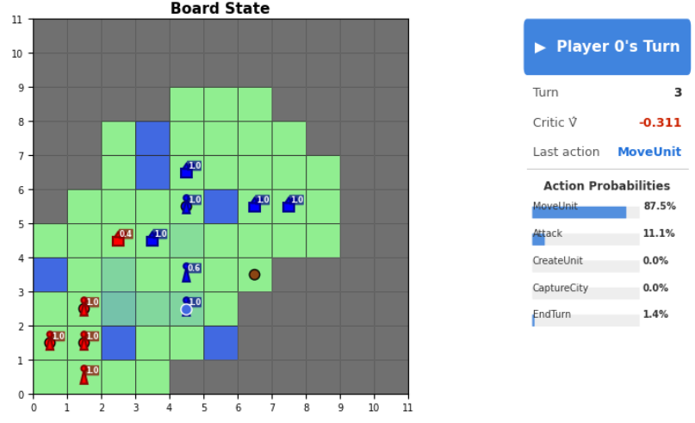

Here, blue moves away, if he couldve attacked and killed the rider.

This does not make much sense.

The sampled movement target also is quite unlucky...

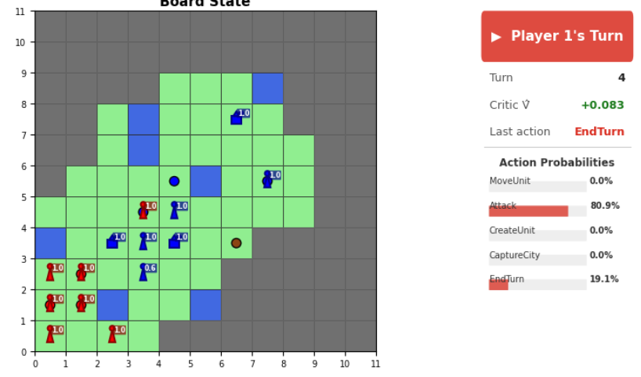
Blue surrounds the enemy capturing its own city just to end the turn then instead of attacking...

This is stupid. There are so many ways that the model gets pushed into ending the turn...

We need to find a way to punish this even with non-dense rewards...

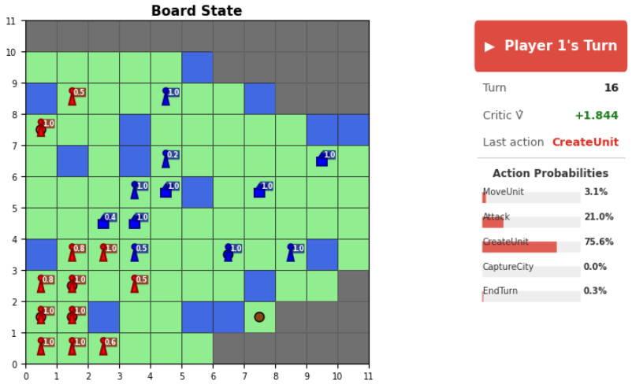

This game will go on forever once again...

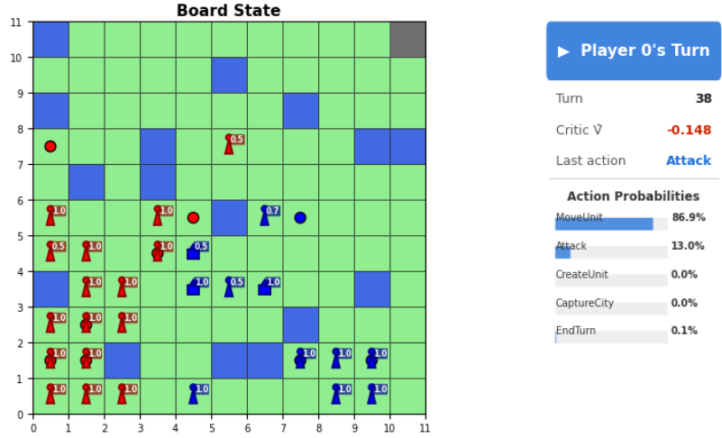

SUMMARY: The advanced policy still doesnt know how to secure a win and actually drive a game.
This poses a problem; Am I ever going to train a really competent agent?

