Test test

13.03.------------------------------------------------------------------------------------

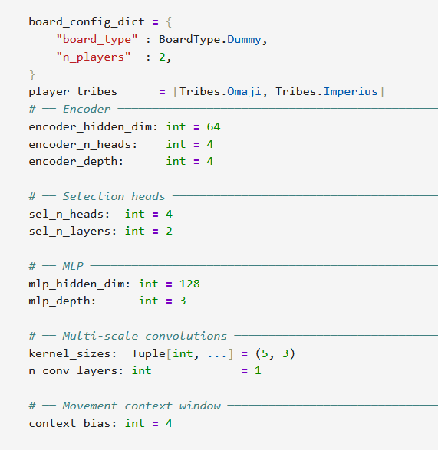

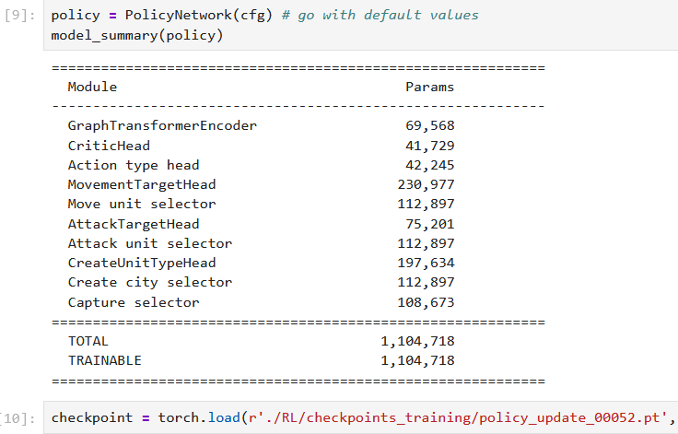

Close vicinity game:

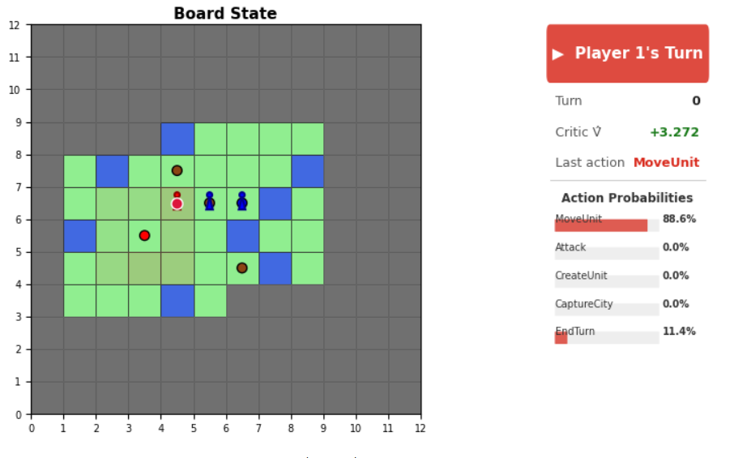

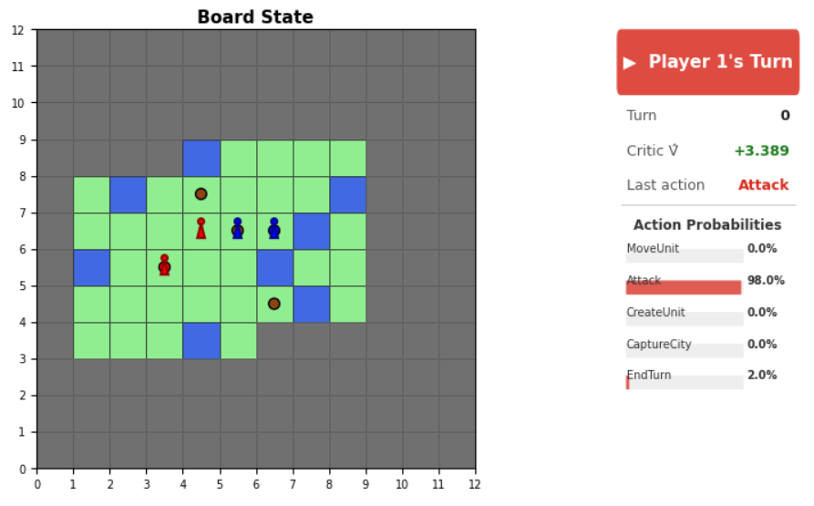

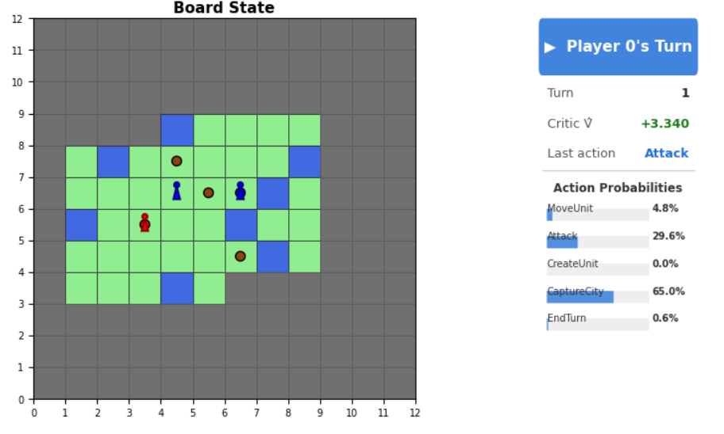
He sampled to attack, even tho the odds were rougly 1:2 for capturing city.

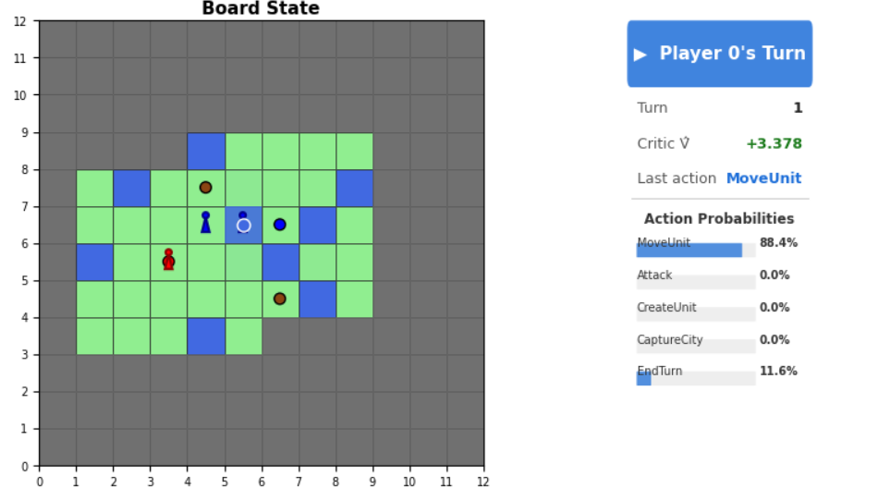

Here, the move is with a lot of certainty, following the other pawn. This shows first signs of strategic attacking in pairs.
STOP: there is actually an unclaimed village, this is why he is so certain to move on there.

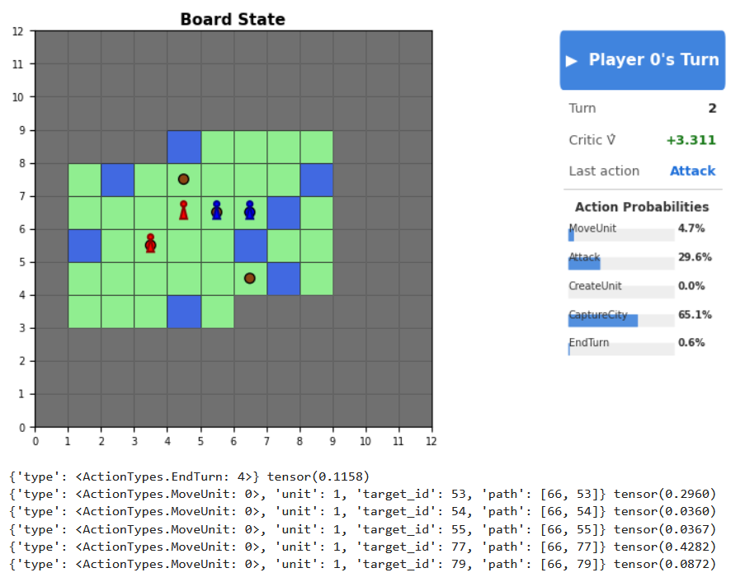

Player 0 unfortunately samples end turn with a chance of 11.58%. This is still not really reasonable that its above 1%...

These are the trajectory probs for the NEXT action

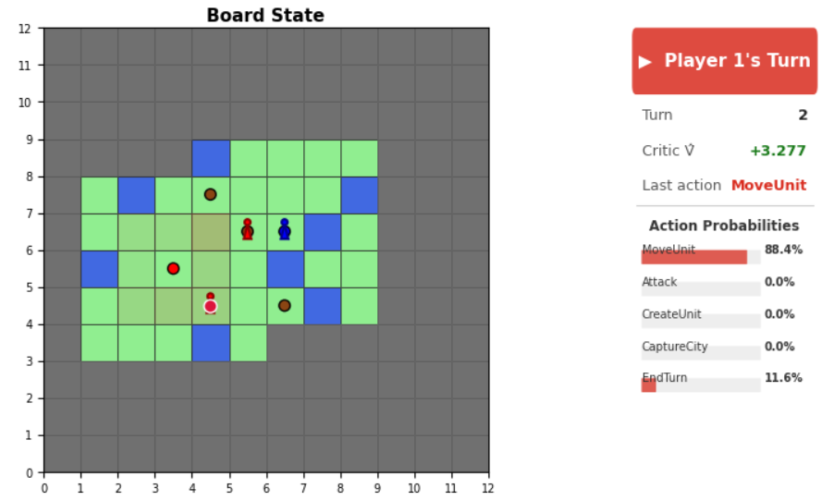

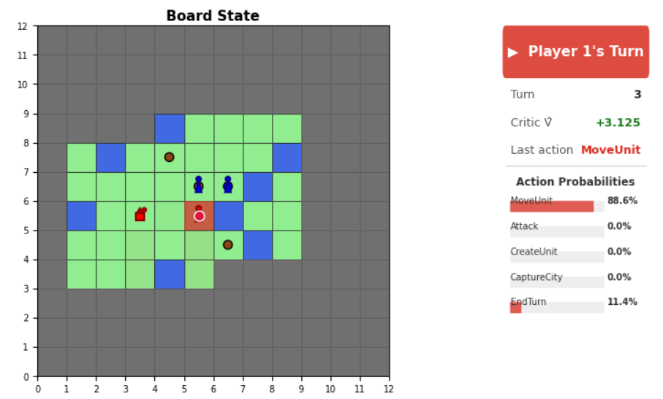

This is also really interesting. Why is he so sure to move here?

The warrior then attacks…

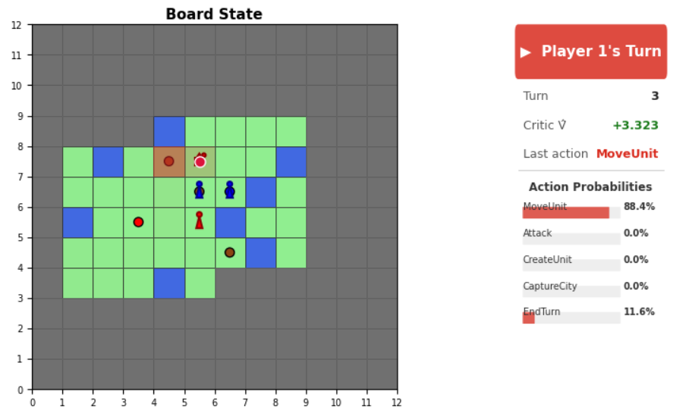

Very good movement. It didnt even sample the most likely position.

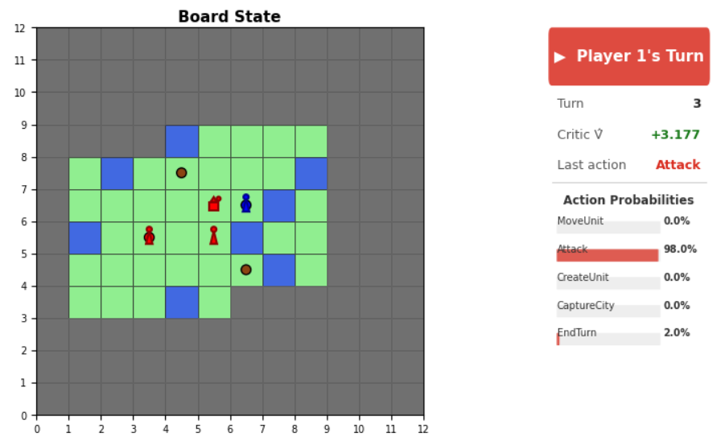
Then the rider actually takes the kill after the warrior did the initial damage.

The rider then proceeds to move onto the unclaimed village; a real powerplay. At the current state, where units are free and there is no negative reward for loosing a unit, the agents play very careless when it comes to unit persevation. But this does make sense at this point in time. It will probably learn to play much different, when the units actually cost a form of payment.

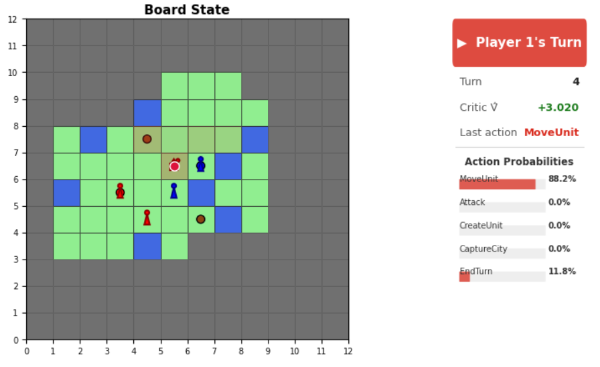

Very interesting here, that the rider chooses to move into the units in order to attack rather than moving onto the city. This is indeed very interesting! A long term strategy decision.

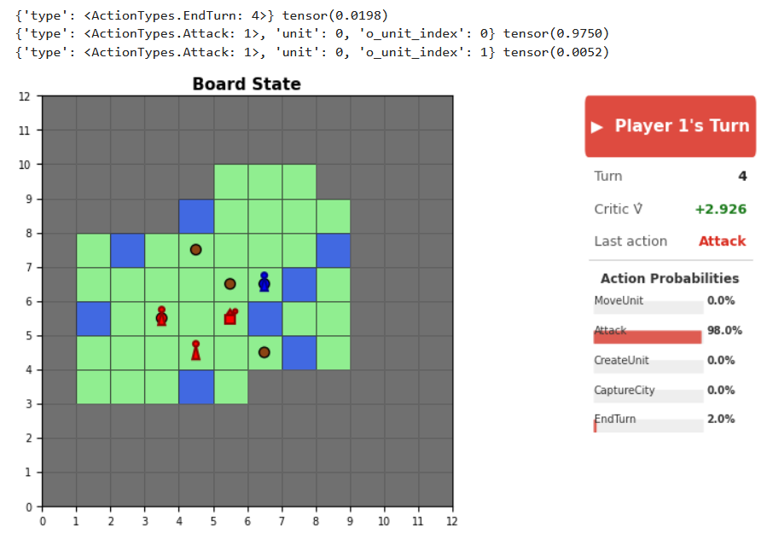

And he is 97.5% certain to kill the warrior rather than damaging the other one. This makes a lot of sense too.

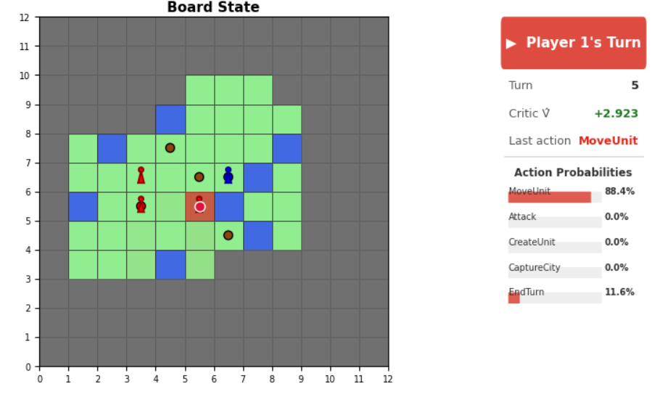
Then, blue makes the error to attack from its capital and red goes in with the dash kill with the warrior. Very nicely played by red!

gg

With long setup:
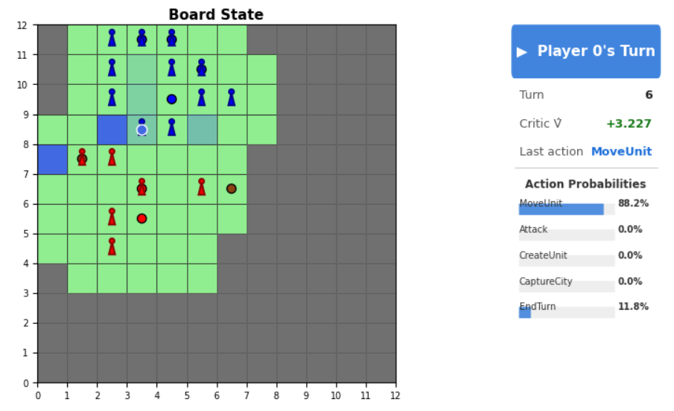

This is the first time
they meet each other in the
game

I have also drawn the individual lines of vision, so they currently see only one single unit of each other.

Lets see, how this evolves...
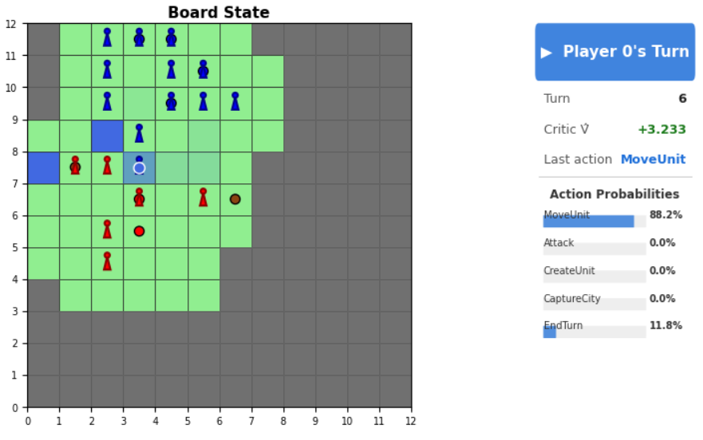
He ofc immediately attacks and brings in the other warrior to go for the kill; at this point, its save to assume he has learned pairing up for taking kills.

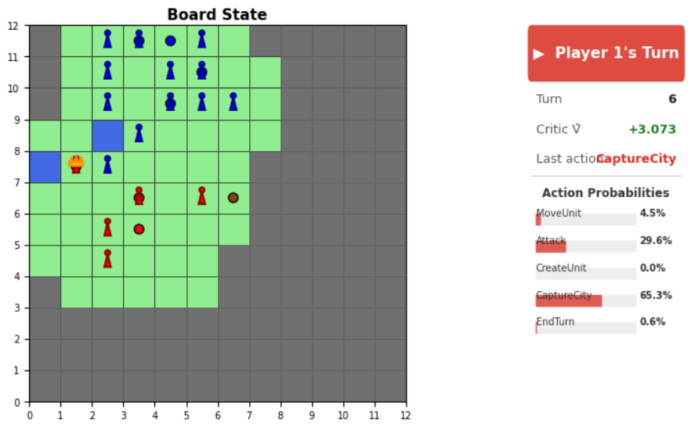

Red captures the village in return. Probably what I wouldve also done. Or maybe not?
--> He has to handle difficult situations already!

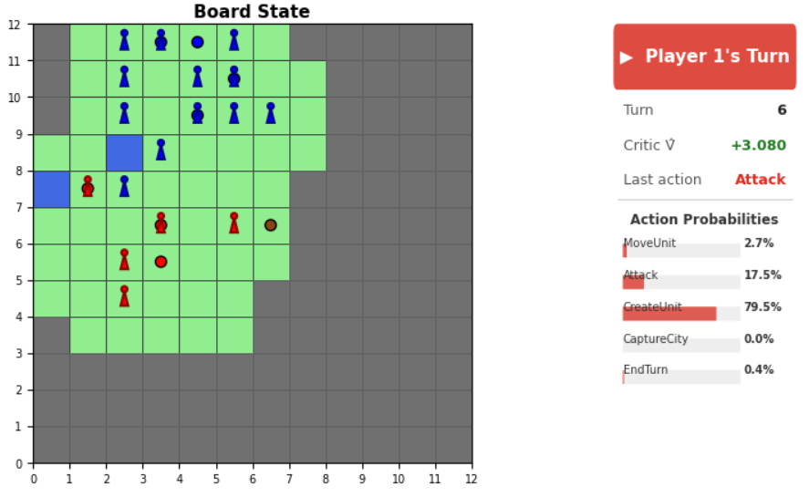
This is one central problem; it has not figured out yet, that it can move, attack then and then create another unit.

Now, its quite hard to get into learning this <5%

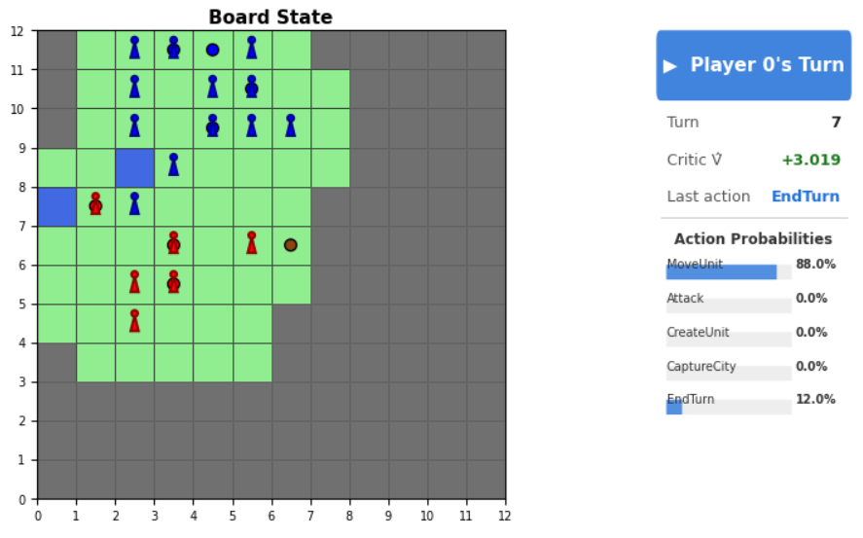
And then it just samples end turn. Such a waste of potential; I have to punish this decision more at this state of the game.

Blue does the same mistake a couple of decisions later.

...
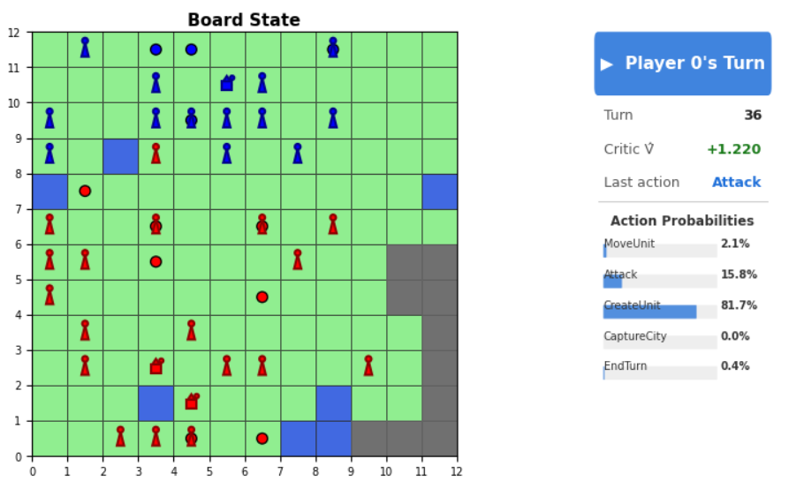

I let it run for a while, but given that the agents sometimes just randomly end their turn, further analysis is not really doing much.

Summary-------------------------------------------------------------------------

So, in summary, I am actually positively surprised by the microtatctics learned at this point;
We have attacking in pairs, dash kills and solid unit lines via a lot of unit creation.

The biggest problem rn is that the agent has a roughly 12% chance to randomly end a turn which does not make any kind of sense.
--> In order to fix this, I will now punish any turn endings with -5.0 instead of -0.5
This should solve the problem.

Additionally, exploring is very slow and he does not at all like to create riders when creating units (<5%) which surprised me at first.
However, since there is no cost involved at this point, for anything in fact, riders loose their utility if you so want. They probably failed when creating them in a scenario where the spawns are close and one player actually collects the win reward and happened to create warriors (in this case the right choice actually). This couldve been evaded by changing the map generation to enforce distant capitals, but rn, im gonne leave it like it is.

Something that I could do fairly soon is to include enemy zone of control, but this only makes sense, when the model starts to use riders.

After tuning up the punishment for ending turns, it now never ends the turn prematurely.

More games, later updates:

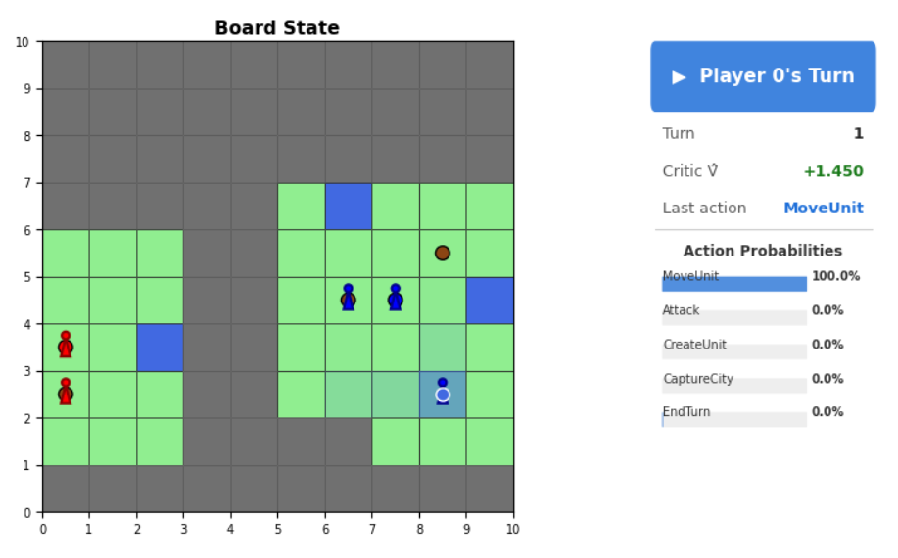
This situation I just dont understand; His goal is to clear some fog, but he always prefers to walk towards the edge of the map rather than into the center.

Does this have to do with this "reflective" padding? Because then, this form of padding is very wrong and I need to think about introducing a new dimension for fog, because it needs to be distinguishable with the edge of the map during padding.

The other idea is to introduce a a continuous dimenstion for x and y of the board that goes cont from 0.0 to 1.0 in the center (or centers) and then back to 0.0
---> The policy should learn, especially when it comes to the utility tradeoff between eco and army, to move toward the CENTER of the map to ensure a better strategic position (there will naturally be more contested villages and better opportunity to spread attacks/ use scout).
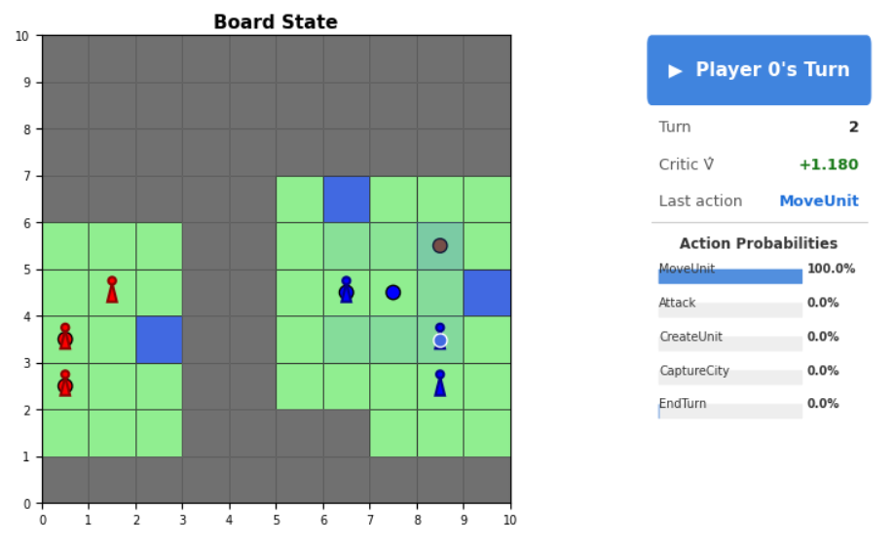

Why is blue unsure where to move here? He should be pretty determined to move onto the village...

This problem emerged often when the village is one tile from the capital...
One explanation could be that there is
an additional 1 for the player control
here and maybe that confuses the agent

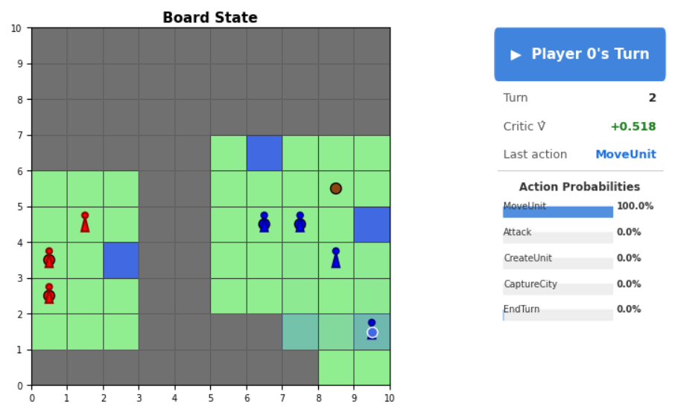
Once again, we see the warrior moving to the edge rather than to the center of the map (even tho its close in probs, but it shouldnt be)

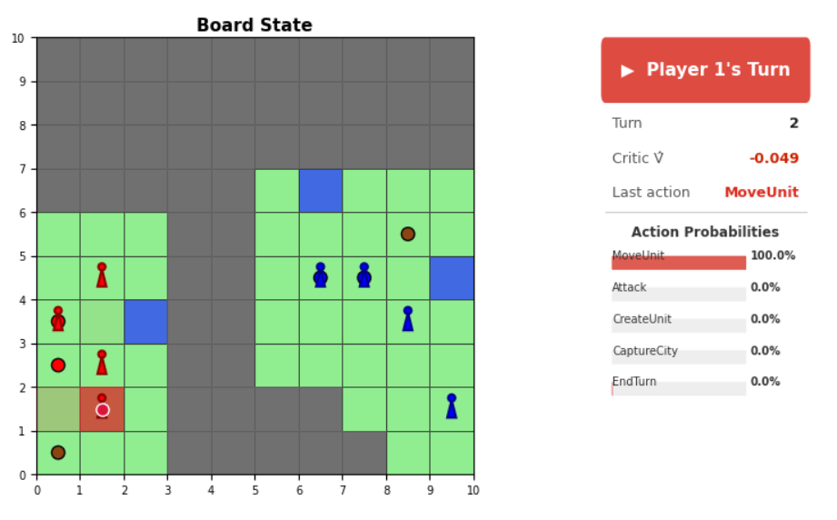

However, red warrior doesnt seem to have that problem here...

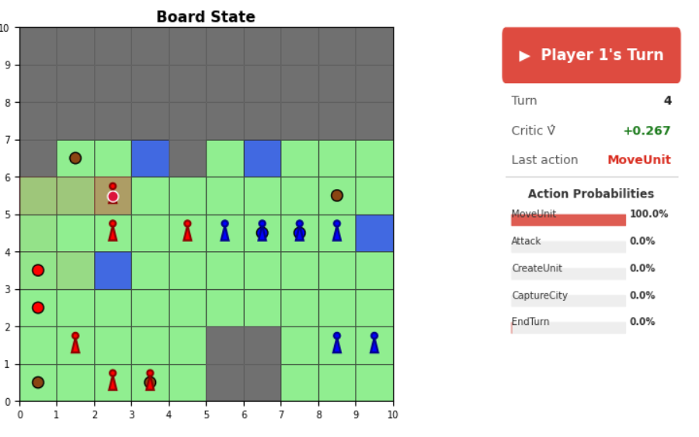

I love how red brings in the backup
here to revenge the kill blue will do
with its forefront warr in the
next turn.

Generally, I also think I identifiy a pattern, which is really really cool;
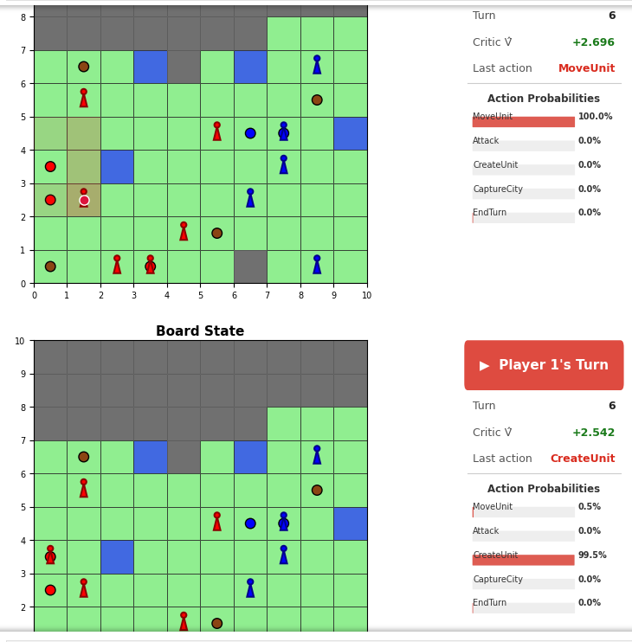
In the beginning; the agent starts to move units that either

- are on an active city and blocking new unit creation

- ... to create new units

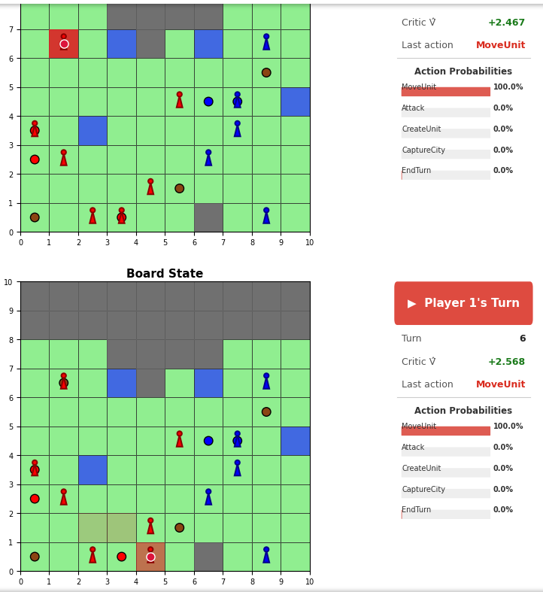

- are eligible to move on an unclaimed village tile

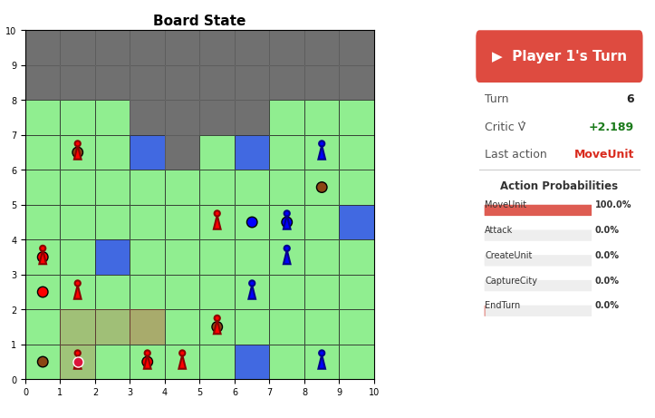

... and only then is he moving the units with high entropy
in their movement

I attribute this behaviour to my architecture, which includes the entropy in the hierarchical decision making process. This automatically favors the important moves in the order.

Question: How good are they exploring a big map?
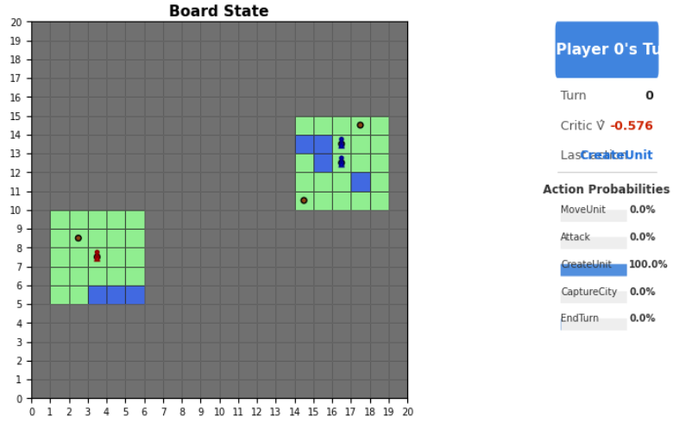

Pay attention to the turn number

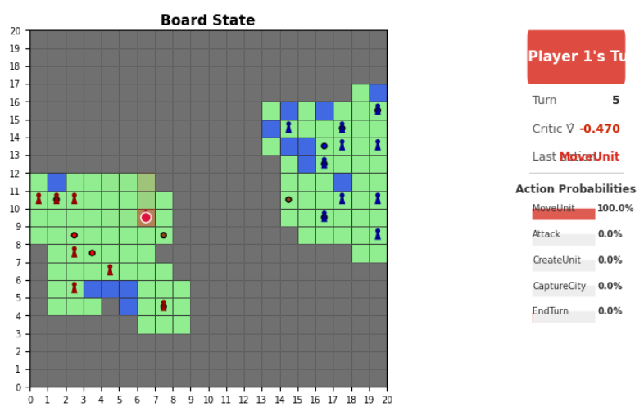

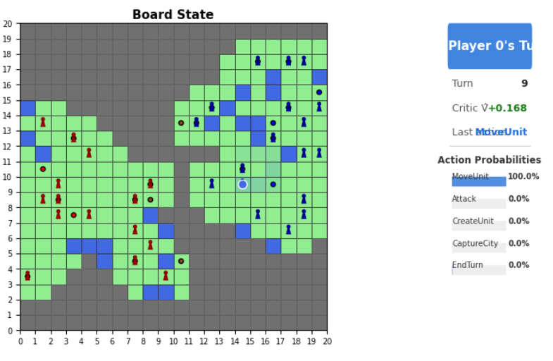

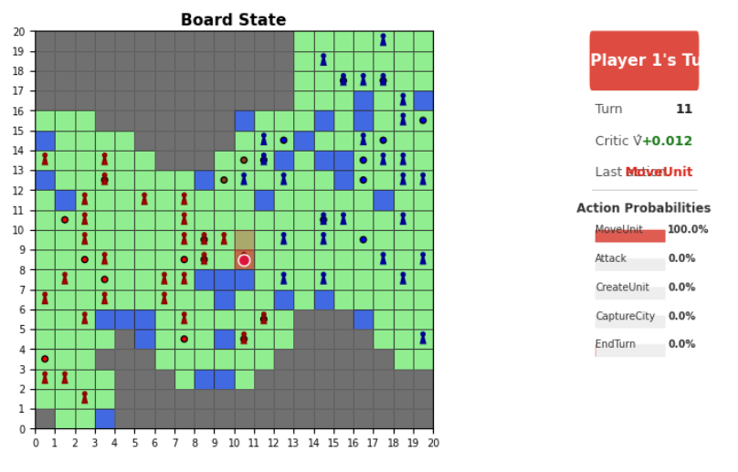
The shared fog barrier is broken
(they still dont see each other tho)

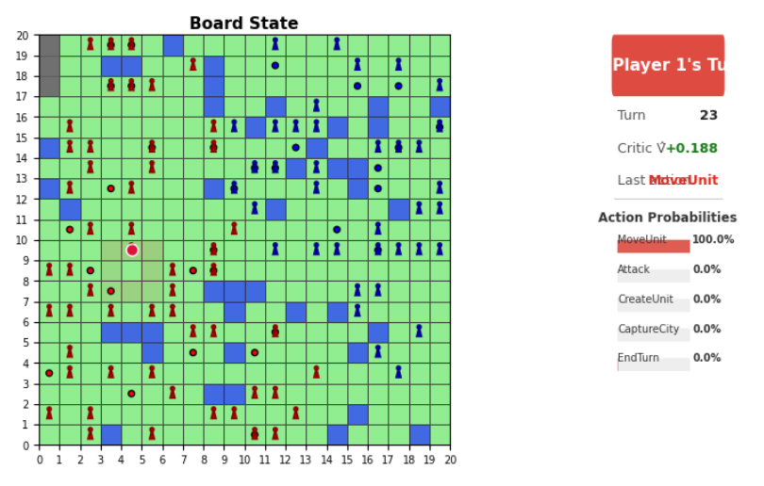

At this point, we are so far into the late
game, that he doesnt really know what to
do... Thats fair.

Imagine the knight chains that
he is currently offering XD

Summary-----------------------------------------------------

I will reduce the punishment value for turn ending again down to -1.5
I think if the value is too large, it outvalues any learned featurs when it comes to learning long term strategic decisions.

All in all, I think it is then time to include more options into the game, especially a price for units so that the agent has to consider utility of a unit aswell. Then, riders should be coming back into the game.

16.03.

Close vicinity game with side exploring:
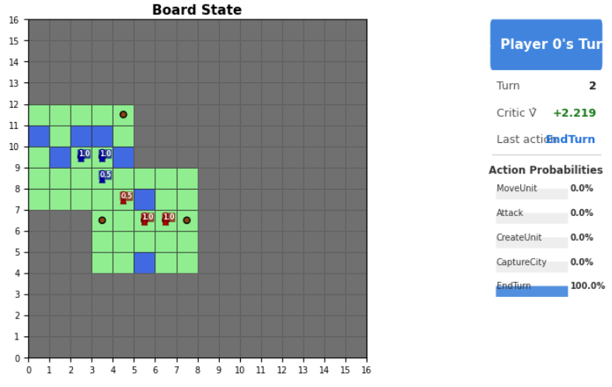
Ausgangssituation; Close spawns, they play it pretty much symmetrically.

Very interesting game to watch develop

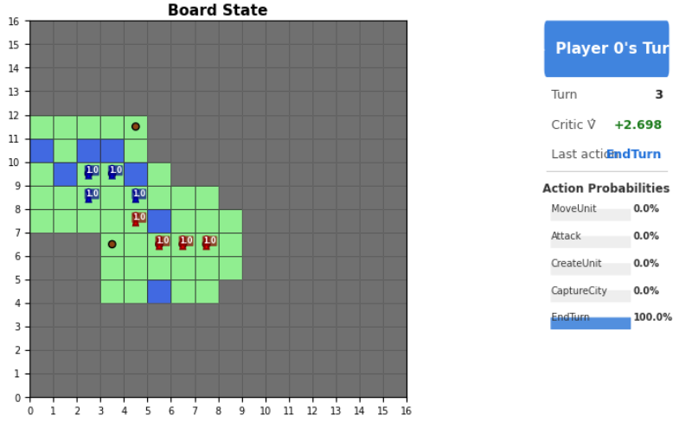

Still, everything is perfectly mirrored.

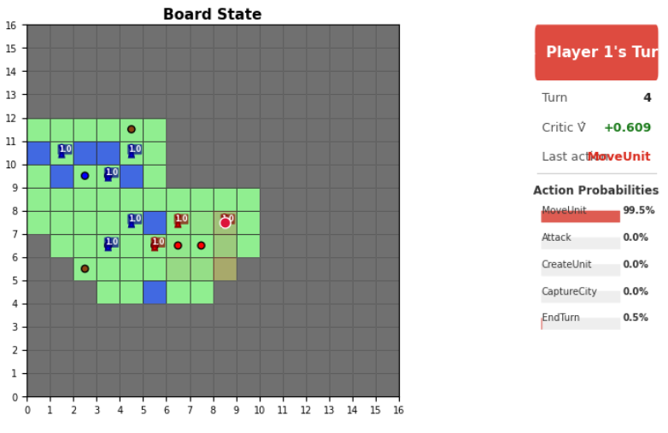

Here, both players actually start exploring away
from the action. Have they learned, that
too many units can just overcrowd the place?

Why are they starting to explore in the opposite
direction?

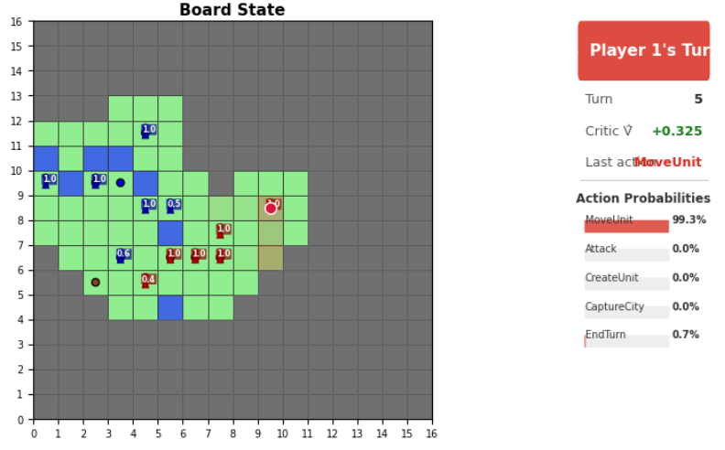

Are we actually seeing the tactics of a flank here?

Really exciting!

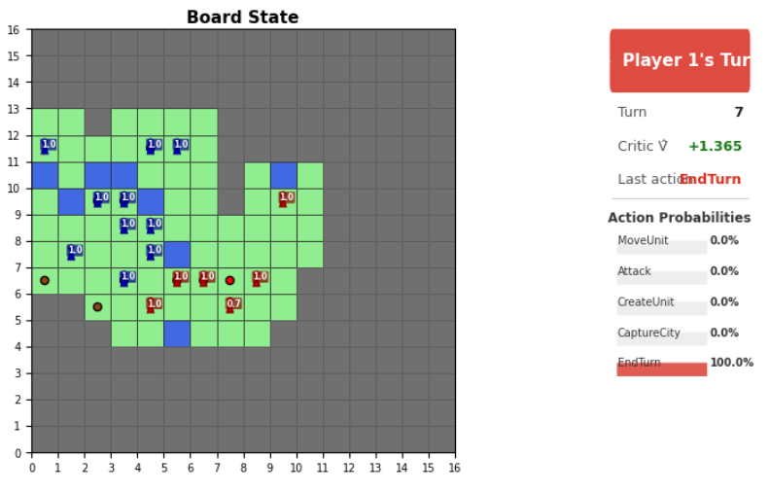

They are extending the flanks!

...
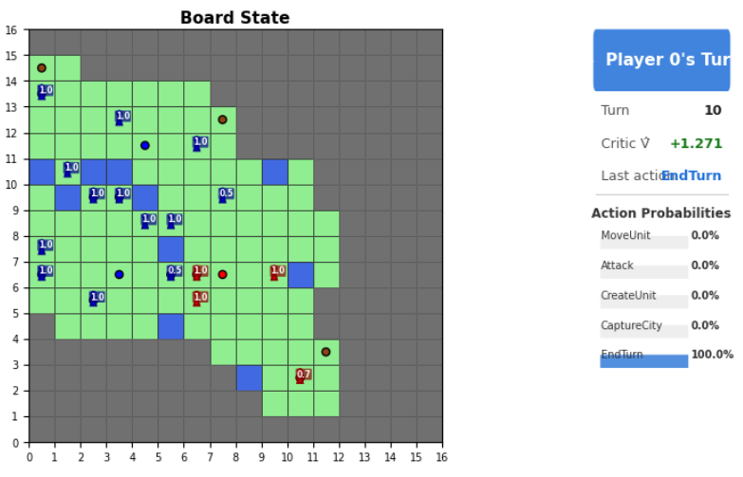

Blue got the upper hand, reds flank
was a little to little, blue brought a group of units

Very interesting indeed, the tactics are getting
more refined!

New era of trained models:

Now, instead of training with dense rewards, the only two involving rewards are win reward (+30) and loose penalty (-10)

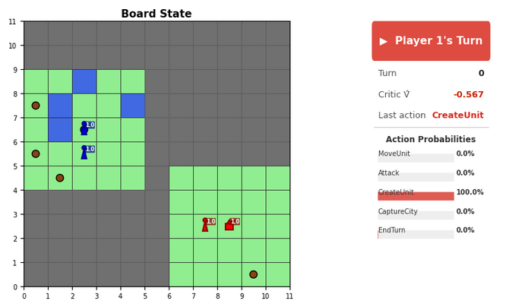

Well, look at whos back:
After only a hundred updates, the
rider has reemerged from being
completely forgotten.

Its still rather unlikely, I would guess
<5%, but it still seems to show up
in certain situations.

In this case: Maybe red understands
it needs to expand quickly, so it trains a rider.

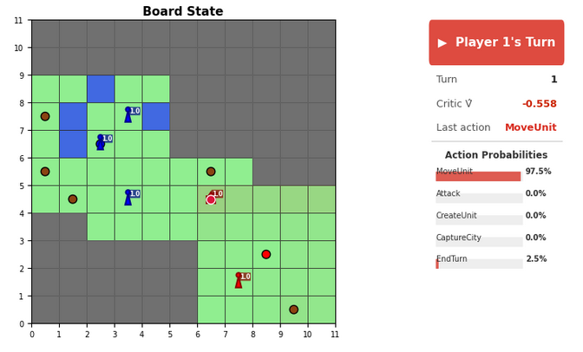
Reds rider instantly does the best imaginable move in this situation.
I must say, I am impressed by red here.

Blue struggles a bit with unlucky sampling in this game...

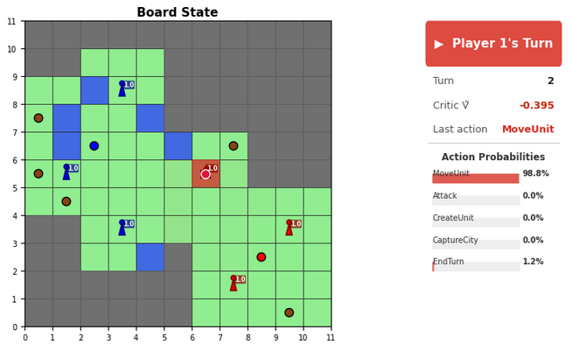
Reds quick expansion instantly bears
fruit and wins her a lot of
advantage.

If red were to win this, this would a
wonderful gradient for the PPO.

Likely, for blue the gradient would
suggest reducing the entropy
in the movement decisions and walking
right onto the village tiles.
(they had increased probs but not enough
apparently)

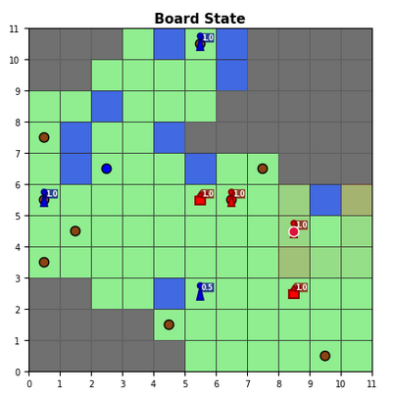
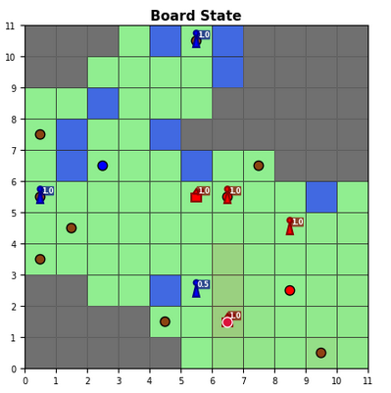

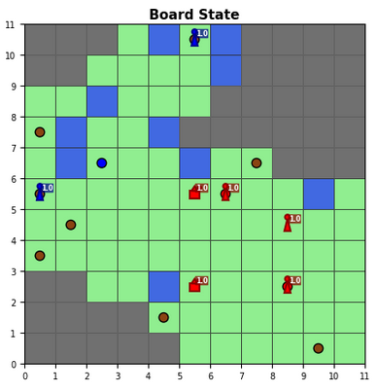
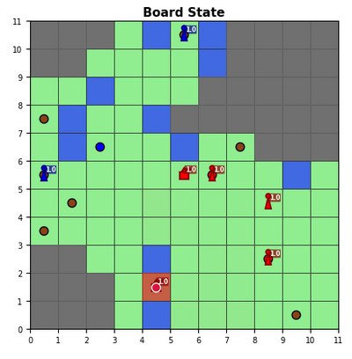

Look at this beautiful hit and enter village play by reds second rider.

I think this style of training will bring back the rider big time. Its such a high utility class compared to the warrior.

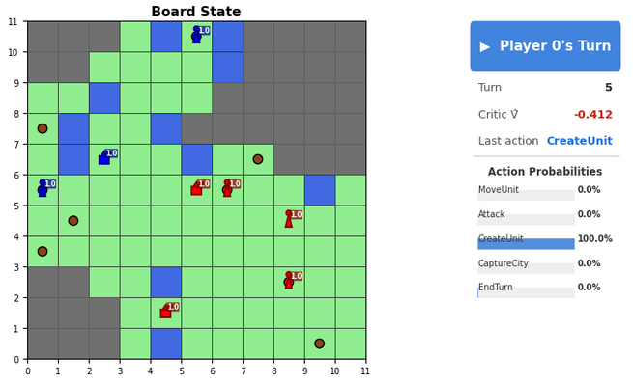
Blue now responds with his own rider
in the capital.

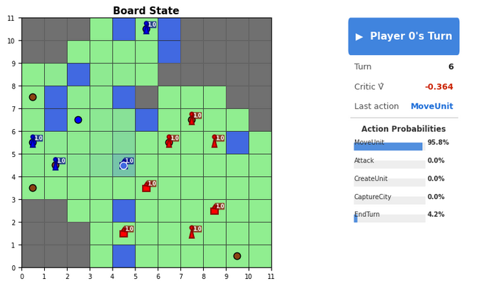
It will go for reds rider immediately.

Red meanwhile builds a lot of riders
on her own.

...
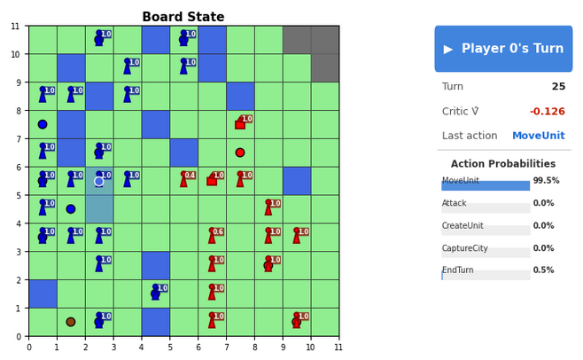
Letting the game progress reveals that
there probably wont ever be a winner.

Blue catches up via the means of all the free cities in its spawn area and red cant really advance against blues warriors.

In view range spawns:
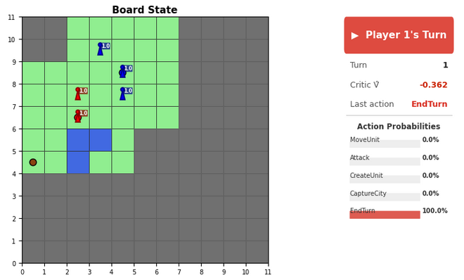
Warning: This game shows, how dumb
the agent still is...

So they spawn in close vicinity, right?

Start of turn 1, blue critic: -0.364
Start of turn 1, red critic: -0.253

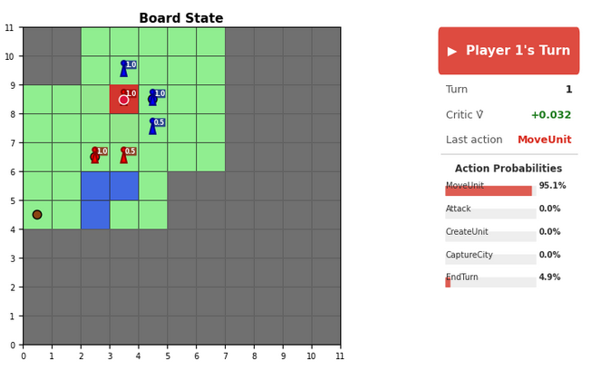
Good tactic by red: dash dancing spotted!

--> get vision with dash, then attack.

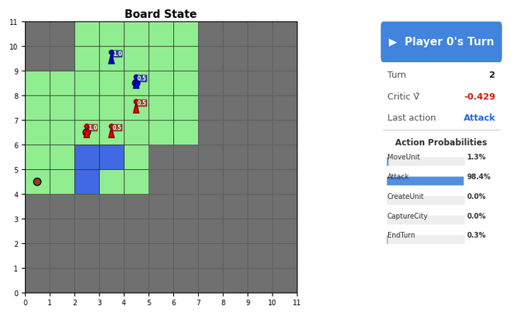
Central mistake: Blue attacks from her
own capital with a warrior.

This makes the 5hp warrior on the capital a sitting duck and red will immediatly capitalize on this and win the game on turn 3.

