Cross Gesture Transfer After Single Gesture Calibration in High Density Electromyography
Charles Lu
Independent Researcher
San Diego, California, United States
charles.lu.2027@gmail.com
Abstract—Calibration with one gesture may reduce labeling effort, but its effect on the remaining vocabulary requires separate evaluation. We examine one fixed Spatial Adaptation Layer implementation on an eight-gesture CSL-HDEMG task, using participant 1 for development and four participants for evaluation over all 80 ordered session pairs and eight calibration choices. Calibration requires three seconds of labeled activity plus 90 seconds of target-session rest. Spatial and gain adaptation achieves 96.99% accuracy on held-out trials of the calibrated gesture but 34.51% on the other gestures, versus 60.71% for frozen models. A post-hoc error decomposition finds that 36.46% of other-gesture trials receive the calibration label, versus 5.61% before adaptation. Spatial-related other-class contrasts are negative in all four participants, but exact two-sided sign-flip tests yield p = 0.125; descriptive bootstrap intervals do not establish population effects. Revision follow-ups test an identity penalty and preprocessing changes on one fixed session pair. The findings concern this small cohort and implementation, not all single-gesture algorithms. Calibration fitting and held-out calibrated-class accuracy should be reported separately from other-class transfer, alongside a frozen comparator.
Keywords—Cross-session adaptation, High-density electromyography, Negative transfer, Single-gesture calibration

I. Introduction
A myoelectric interface trained in one recording session may perform differently in another. Calibration from one gesture could reduce labeling effort, provided that the resulting update preserves recognition of the full intended vocabulary. We distinguish calibration-frame accuracy, the fraction of calibration-recording frames classified correctly, from held-out calibrated-gesture accuracy and accuracy on the other gestures. Negative transfer here means lower overall trial accuracy than the matched frozen recognizer; a decline on the other classes is reported separately.
We study this distinction in one public Spatial Adaptation Layer (SAL) implementation using four evaluation participants from CSL-HDEMG. All eight classes are represented during source training; “other” means absent from target calibration, not a previously unseen class. The contribution is a component evaluation of gain, spatial adaptation, and classifier fine-tuning, with exhaustive calibration choices and implementation controls. It is not a new recognizer or a claim that all single-gesture calibration fails. Different architectures, objectives, bounds, or optimizers may behave differently.

II. Related work and scope
Pereira et al. introduce SAL for biosignal arrays [1]. Their later public code already includes single-gesture calibration, gain correction, and prototype search [2]. We credit those components. Our pinned implementation and disclosed preprocessing differences do not constitute an exact reproduction of the original paper's headline experiment.
Prior work studies flexible subset-gesture calibration [3], single-gesture fine-tuning under electrode interference [4], unknown calibration gestures [5], and source reprojection [6]. These studies precede the general motivation and prevent a broad novelty claim for limited-class calibration. Our narrower question is cross-gesture retention under matched within-person, cross-session scoring conditions. We do not claim a matched comparison with these different pipelines.

III. Methods

A. Data and evaluation design
CSL-HDEMG contains five participants with five sessions [7]. Participant 1, sessions 1 and 2, supplies development data. Participants 2–5 supply the primary evaluation. Each source model is trained on one session of the evaluated person; holding participants out from development does not make this cross-user recognition.
The eight provider gesture IDs are 8, 9, 12, 13, 16, 21, 23, and 24. Each person contributes 20 ordered session pairs. The first actual target repetition of one gesture supplies calibration; later repetitions of all eight gestures supply scoring. Repeating all eight calibration choices gives 640 cases. The first repetitions of other target gestures are unused. No target score selected the original method, gesture, setting, or checkpoint. The revision analyses and follow-up experiments described below were added after the original outcomes were known.
The evaluation uses 1,598 active and 600 rest trials. Participant 4, session 4, gestures 8 and 9 each have nine rather than ten repetitions. Outcome-blind raw-data checks identified these omissions before original training. Actual trials are retained without duplication, giving 70 scoring trials for that target session and 72 elsewhere. Whole-trial roles are assigned before frame extraction and scoring identities are matched across methods.

B. Preprocessing and recording cost
Each raw trial has 192 channels and 6,144 samples at 2,048 Hz. Provider mapping removes every eighth channel and arranges 168 channels as a 7 × 24 grid with spatial row reversal and preserved time order. This corrects the inspected upstream loader, which removes its first grid row and reverses time. Supplementary Fig. S1 diagrams the grid and trial roles.
Processing uses trial-wise centering, causal 20–380 Hz band-pass and 45–55 Hz band-stop filters, activity segmentation, a 1,025-sample centered RMS window, and a zero-padded 3 × 3 spatial median filter. The original literal “mean_square” flag does not activate the upstream “mean-square” subtraction branch. Scoring data do not fit model normalization statistics. Segmentation uses 30 three-second rest trials from the target session, so three seconds of labeled activity requires 90 additional seconds of rest. Centered RMS and whole-trial voting make the experiment offline.

C. Adaptation conditions and objective
The source recognizer uses batch normalization, dropout 0.5, and a linear eight-class classifier. Source training uses 15 epochs of Adam at 0.001, batch size 128, a three-epoch warm-up, seed 42, and the final checkpoint. The upstream revision and complete settings are recorded in the reproduction package [2].
Frozen preserves the source model. Gain applies a source/calibration mean ratio at each grid position, clamped to [0.5, 2], using only the matching source gesture. Spatial updates seven bounded affine parameters with classifier and normalization state fixed. Spatial + gain combines these components. Fine-tuning, with or without gain, updates classifier and batch-normalization parameters and statistics.
SAL resamples the electrode grid using horizontal and vertical translations, rotation, two scales, and two shears. Its calibration objective is cross-entropy for the single known label on an RMS calibration prototype. Search evaluates 16,384 Latin-hypercube candidates plus identity, then performs 500 Adam updates at 0.01. Search and scoring use bicubic interpolation; optimization uses bilinear interpolation. Translation bounds are ±8/23 and ±8/6; scales are [1/1.1, 1.1], shears ±0.1, and the literal rotation bound ±15/180 radians. Gain is estimated using a transformed target mean but applied before normalization and resampling. These parameters are algorithmic, not identified physiological quantities.
Fine-tuning uses 150 epochs of Adam at 0.001, batch size 128, and a 30-epoch warm-up. A contextual all-class reference uses the first repetition of all eight gestures at the same epoch count. It receives more labels and more optimizer updates, so it does not isolate data quantity alone.

D. Outcomes and statistical interpretation
Trial predictions use frame-majority voting, resolving tied counts by first occurrence. The primary endpoint is accuracy on the seven gestures absent from calibration; overall accuracy, held-out calibrated-class accuracy, and calibration-frame fitting are also reported. Calibration choices are averaged within pairs, pairs within participants, and the four participants equally.
We retain descriptive 95% intervals from 10,000 participant bootstrap resamples and emphasize participant effects and sign consistency. Four participants allow only 35 distinct bootstrap count compositions; these have unequal probabilities. Post-hoc two-sided sign-flip tests enumerate all 16 sign assignments using the absolute mean paired effect. Their validity assumes sign exchangeability under a symmetric null. The smallest attainable two-sided p-value is 0.125, so these tests cannot establish conventional 5% significance. Neither intervals nor repeated cases justify population-wide claims.
The revision error analysis partitions other-class trials into correct predictions, errors to the calibration label, and errors to another wrong label. Confusion matrices are row-normalized within each case and averaged over pairs and participants separately for each calibration gesture (Supplementary Figs. S2–S7). These are descriptive post-hoc analyses.

E. Controls and revision follow-up
The original controls prefer identity in exact initialization-loss ties, change processing order to resampling then gain then normalization, and vary candidate-search seed (42, 43, 44) on session pair 1→2. The first two cover all 640 cases; seed checks cover 32 cases. They were fixed before inspection of the original cohort summaries. The order control changes both gain and normalization placement.
Revision follow-ups use the same fixed pair 1→2, all four participants, and all eight calibration gestures. One safeguard adds a unit-weight mean squared identity penalty to calibration cross-entropy in both candidate selection and optimization. Each physical parameter deviation is divided by its maximum allowed deviation from identity; the seven squared terms are averaged. The weight is fixed at 1 without an outcome-based sweep. Classifier parameters and normalization state remain frozen. Separate preprocessing runs activate mean-square subtraction with provider mapping, or retain inactive subtraction and use the literal upstream mapping, including its time reversal. Each preprocessing variant retrains its source model and has its own frozen reference. These exploratory 32-case checks do not establish robustness over all session pairs or new participants.

IV. Results

A. Calibrated and other gesture outcomes
Table I and Fig. 1 report the original four-participant means for this implementation. Spatial + gain achieves 96.99% on held-out calibrated-class trials but 34.51% on other gestures, versus 60.71% frozen. The distinction therefore extends beyond fitting the calibration recording.
TABLE I. Accuracy across four participants
Condition | All (%) | Calibrated (%) | Other (%)
Frozen | 60.71 | 60.70 | 60.71
Gain | 62.80 | 87.06 | 59.34
Spatial | 52.12 | 96.63 | 45.77
Spatial + gain | 42.32 | 96.99 | 34.51
Fine-tuning | 41.64 | 99.20 | 33.41
Fine-tuning + gain | 41.31 | 99.03 | 33.06
All classes were seen during source training. “Other” means absent only from target calibration. Missing repetitions and rounding explain small deviations from a balanced eight-class weighted average.
Gain increases overall accuracy by 2.09 percentage points while other-class accuracy changes by −1.37 points (descriptive interval −3.92 to +2.18). Participant 5 improves, and the sign-flip p-value is 0.625. Thus an aggregate improvement does not establish improved transfer to uncalibrated classes.
TABLE II. Other gesture accuracy by participant
Participant | Frozen (%) | Gain (%) | Spatial (%) | Spatial + gain (%)
2 | 78.61 | 76.77 | 48.71 | 38.33
3 | 57.64 | 53.73 | 36.30 | 26.24
4 | 56.52 | 52.58 | 48.65 | 33.20
5 | 50.07 | 54.28 | 49.41 | 40.28
Participant means average all 20 ordered pairs and eight calibration choices. Participants, not cases or frames, are the independent observations.
Spatial + gain is below frozen for all four participants, a mean other-class difference of −26.20 points. Adding spatial adaptation to gain changes other-class accuracy by −24.83 points (descriptive interval −33.67 to −16.69). The interaction, combined − spatial − gain + frozen, is −9.89 points (−12.43 to −7.34). Each spatial-related contrast is negative in all four participants and has unadjusted two-sided sign-flip p = 0.125. These descriptive intervals are not precise population uncertainty bounds.
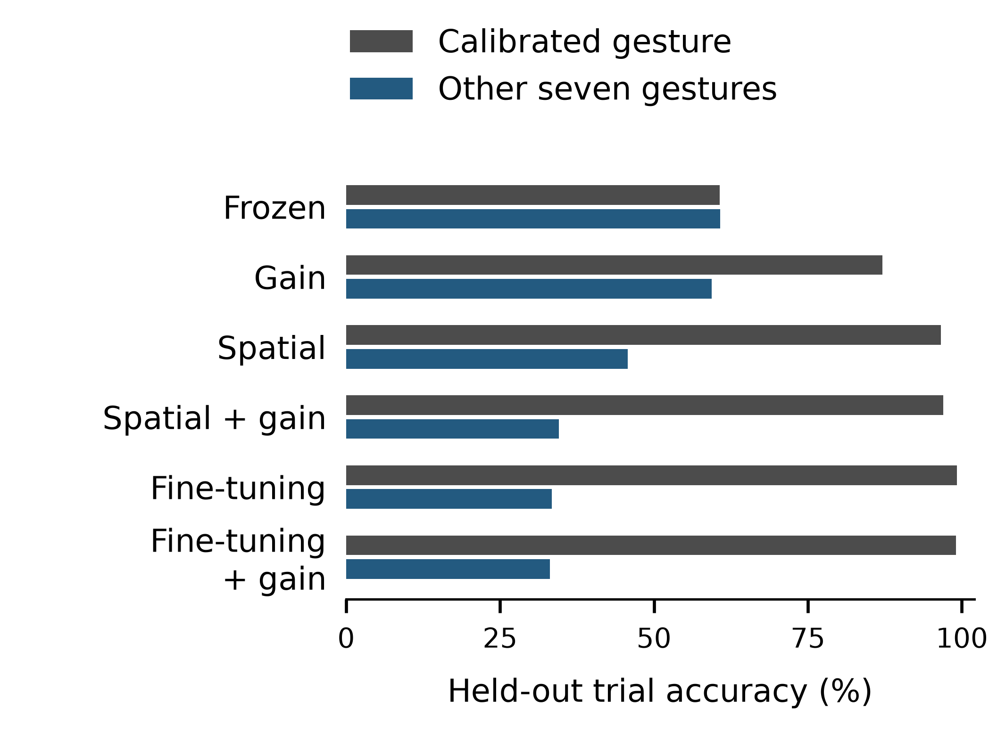
Fig. 1. Held-out calibrated and other-gesture trial accuracies, equally averaged across four participants. Exact values are in Table I.

B. High calibration fit and negative transfer
Of 570 spatial + gain cases with calibration-frame accuracy at least 99%, 398 have lower overall scoring accuracy than frozen. Corresponding counts are 223/473 for gain, 317/542 for spatial, 489/638 for fine-tuning, and 494/640 for fine-tuning + gain. These correlated case counts are not independent population risk estimates. The all-class fine-tuning reference reaches 89.14% overall, with the extra-data and extra-update caveats above.

C. Implementation and search controls
TABLE III. Other gesture accuracy under implementation controls
Spatial procedure | Spatial (%) | Spatial + gain (%)
Original | 45.77 | 34.51
Identity preference | 47.57 | 36.96
Resample → gain → normalize | 35.65 | 28.85
Both controls cover all 640 cases. The matched frozen other-class mean is 60.71%.
Identity preference improves other-class accuracy by 1.80 points for spatial and 2.45 for spatial + gain. It replaces the initial candidate in 64/640 and 105/640 cases, respectively, without changing the initial calibration loss. Final transfer can improve or worsen (Fig. 2). The order change reduces other-class accuracy by 10.12 and 5.66 points; its effect cannot be attributed solely to gain placement.
TABLE IV. Other gesture accuracy by search seed
Seed (1→2) | Spatial (%) | Spatial + gain (%)
42 | 50.50 | 36.11
43 | 56.10 | 37.60
44 | 56.35 | 35.47
Frozen reference | 45.49 | 45.49
Frozen is 45.49% for the restricted pair 1→2, versus 60.71% across all pairs. These 32-case seed results must not be interpreted as full-cohort all-pair means.
Spatial alone exceeds its matched frozen comparator on this pair at all three seeds, whereas spatial + gain remains below it. Thus all-pair mean degradation is not failure on every pair. All seeds are retained; this check does not establish seed invariance across all pairs.

D. Errors toward the calibration label
TABLE V. Error destinations on other gestures
Condition | Correct (%) | To calib. (%) | Other error (%)
Frozen | 60.71 | 5.61 | 33.68
Gain | 59.34 | 11.39 | 29.27
Spatial | 45.77 | 23.79 | 30.44
Spatial + gain | 34.51 | 36.46 | 29.02
Fine-tuning | 33.41 | 44.35 | 22.23
Fine-tuning + gain | 33.06 | 44.47 | 22.46
Percentages partition all other-gesture trials and use equal participant weighting. They are not percentages conditional on being incorrect; rounding may affect the sum.
Spatial + gain assigns 36.46% of other-gesture trials to the calibration label, versus 5.61% frozen. It predicts that label on every scoring trial in 6/640 cases; fine-tuning does so in 67/640. Other errors remain, so the outcome is not solely total collapse. Calibration-specific matrices are provided in the supplement. They characterize output bias but do not by themselves identify a representation-level mechanism.
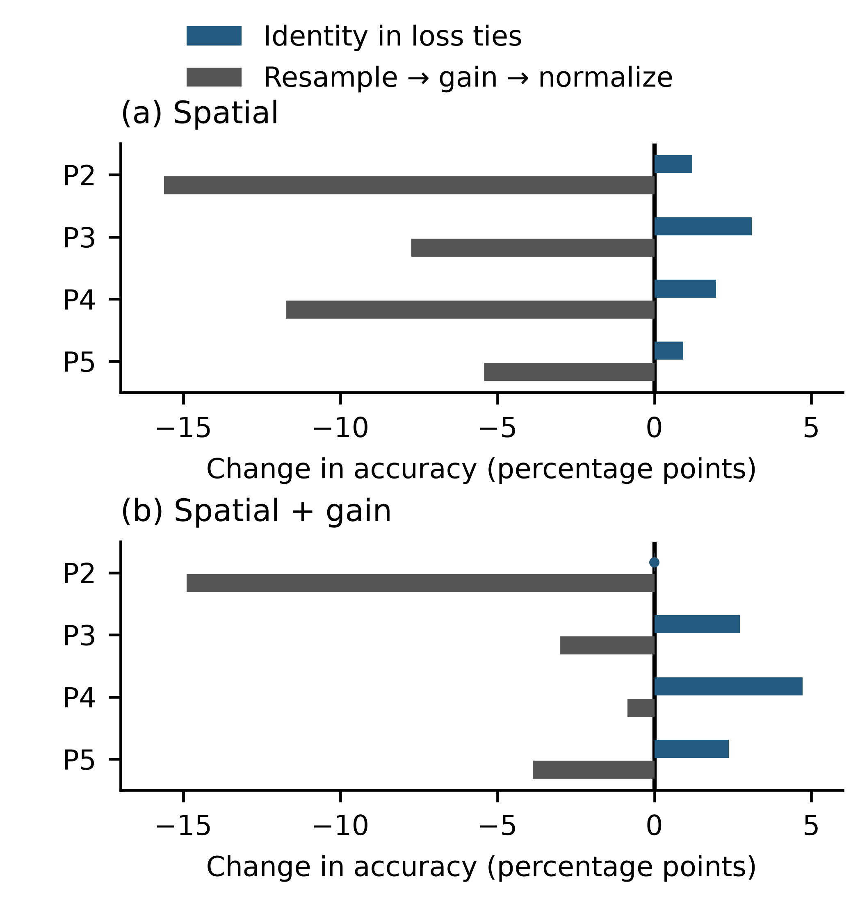
Fig. 2. Participant changes in other-class accuracy relative to each original spatial procedure. Each bar averages 20 pairs and eight calibration choices. A dark vertical line marks zero; a dot marks the near-zero effect at its actual location. The two panels share one scale.

E. Safeguard and preprocessing follow-up
Identity regularization raises spatial other-class accuracy from 50.50% to 56.30% on this pair and spatial + gain from 36.11% to 37.95% (Table VI). The latter remains below frozen at 45.49%. Its held-out calibrated-class accuracy falls from 97.57% to 88.54%, illustrating the retention/fit tradeoff. Activating baseline subtraction gives spatial + gain 36.11% versus its retrained frozen reference of 45.14%; literal upstream mapping gives 37.45% versus 43.75%. Thus the combined procedure remains below its matched frozen other-class mean in both preprocessing checks, although absolute accuracy changes. This is a restricted-pair observation, not a full-pair robustness result.
TABLE VI. Other gesture accuracy in revision follow-up
Condition | Frozen (%) | Spatial (%) | Spatial + gain (%)
Original | 45.49 | 50.50 | 36.11
Identity penalty | 45.49 | 56.30 | 37.95
Baseline subtraction | 45.14 | 54.07 | 36.11
Literal mapping | 43.75 | 44.99 | 37.45
Exploratory session-pair 1→2 checks only, with 32 calibration cases and four participant means. Frozen references are specific to each preprocessing condition; the regularized condition reuses original preprocessing. Full calibrated/other/overall outcomes and participant effects are in the supplement.
Original checkpoint, data-role, gain-statistic, and raw-frame verification is documented in the supplement. New adapted checkpoints are reloaded and their frame predictions checked using a different batch size. Verification establishes computational consistency, not additional independent participants.

V. Discussion
In these four CSL-HDEMG participants and this implementation, high calibrated-gesture recall accompanies substantial attraction toward its label. The single-class objective gives a direct reason for caution: cross-entropy constrains predictions only on the supplied class and does not penalize errors on omitted classes. An unrestricted classifier can reduce that objective by favoring the calibration label broadly. A bounded spatial model need not realize that global solution, but it still lacks an explicit omitted-class retention term.
Stored search logs show computed zero minimum cross-entropy in 188/640 spatial cases and 292/640 spatial + gain cases. This is consistent with finite-precision loss saturation; exact ties alone would not prove it. Loss equality at calibration therefore cannot certify transfer. In an idealized positive-template setting, different spatial transforms W can also match one template by an admissible gain g = u/(Wv), giving g ⊙ Wv = u. Clipping and interpolation limit this illustration; it is not a general identifiability theorem or proof of the observed physiological mechanism.
The identity penalty shows that a simple constraint can improve mean transfer in this bounded follow-up, but it does not restore the combined method to frozen other-class performance. Spatial alone already exceeds frozen on this pair. The result supports testing source-preserving safeguards, not recommending this weight as a validated remedy. Future work should compare source replay and other constraints on new participants, with settings selected independently of final scoring data. The appropriate practical default is to retain the frozen comparator rather than assume calibration fitting certifies retention of the remaining vocabulary.
The recording burden is also consequential: 90 seconds of rest exceeds the labeled gesture duration thirtyfold, and both must be available in the target session. This limits claims of rapid practical recalibration. Centered RMS and full-trial voting do not model causal streaming, feedback, fatigue, or user adaptation. Closed-loop control could behave differently and requires separate evaluation.

VI. Limitations and conclusion
The primary evidence is limited to four evaluation participants, one dataset, eight selected gestures, one source-training seed, and one fixed implementation. Revision follow-ups reuse known participants and one session pair; they are exploratory and do not replace an independent larger-cohort, multi-session HD-EMG replication. Architecture, bounds, objectives, and optimizer changes could reduce or remove the observed degradation. Natural session variation does not isolate controlled electrode displacement.
Within this scope, calibrated-class success does not establish preservation of the remaining vocabulary. Retain a frozen comparator and report calibration fitting, disjoint calibrated-class performance, other-class performance, and recording cost separately. The results support this reporting practice, not a universal failure claim or a new state-of-the-art recognizer.

Reproducibility material
A separate BIBE analysis package accompanies this revision. It includes original per-case tables, saved trial predictions, calibration-specific confusion analyses, exact sign-flip calculations, and revision follow-up summaries with reproduction scripts. It is separate from the later GRABMyo/SeNic study. Public repository publication is pending author authorization; a public release is not claimed here. The package reproduces numerical analyses from saved records and does not provide a turnkey retraining pipeline or public checkpoint archive. Full protocols, hashes, and verification scope are included.
The original data are available through the CSL-HDEMG provider's registration process [7]. Raw recordings and checkpoint banks are excluded from the analysis distribution. This study reanalyzes existing recordings without new recruitment; no new consent or institutional ethics approval is claimed.

References
[1] J. Pereira, M. Alummoottil, D. Halatsis, and D. Farina, “Spatial Adaptation Layer: Interpretable Domain Adaptation For Biosignal Sensor Array Applications,” arXiv:2409.08058, ver. 2, 2025. [Online]. Available: https://arxiv.org/abs/2409.08058v2
[2] J. Pereira, “Spatial Adaptation Layer source code,” revision 7c5a075a58dff06566b82965f8235ba744377fb8. Accessed: Sep. 6, 2026. [Online]. Available: https://github.com/joao-binenbojm/spatial-adaptation-layer
[3] Y. Yuan, Z. Chen, J. Liu, C. H. Chou, C. Dai, and X. Jiang, “Toward Highly Flexible Inter-User Calibration of Myoelectric Control Models With User-Defined Hand Gestures,” IEEE Trans. Med. Robot. Bionics, vol. 7, no. 1, pp. 359–367, 2025, doi: 10.1109/TMRB.2024.3504737.
[4] Y. Zhang, Z. Bao, R. Huang, X. Yin, B. He, and Y. Liu, “SE-CNN integrated with transfer learning: Enhancing myoelectric pattern recognition amid electrode shift and damage interferences,” Biomed. Signal Process. Control, vol. 111, Art. no. 108411, 2026, doi: 10.1016/j.bspc.2025.108411.
[5] H. Shi, X. Jiang, C. Dai, and W. Chen, “EMG-based Multi-User Hand Gesture Classification via Unsupervised Transfer Learning Using Unknown Calibration Gestures,” IEEE Trans. Neural Syst. Rehabil. Eng., vol. 32, pp. 1119–1131, 2024, doi: 10.1109/TNSRE.2024.3372002.
[6] D. Li, P. Chen, S. Togo, H. Yokoi, and Y. Jiang, “SRM: A Source-Reprojection Module for Cross-Day sEMG Gesture Recognition,” Sensors, vol. 26, no. 12, Art. no. 3870, 2026, doi: 10.3390/s26123870.
[7] C. Amma, T. Krings, J. Böer, and T. Schultz, “Advancing Muscle-Computer Interfaces with High-Density Electromyography,” in Proc. 33rd Annu. ACM Conf. Human Factors Comput. Syst. (CHI), 2015, pp. 929–938, doi: 10.1145/2702123.2702501.

