Supplementary material for BIBE paper 54
Cross Gesture Transfer After Single Gesture Calibration in High Density Electromyography
Charles Lu
This supplement documents the original CSL-HDEMG experiment and the post-hoc analyses and exploratory experiments added during revision. The independent primary evaluation sample remains four participants. Revision checks reuse their data and are not a new confirmation cohort.

S1 Pipeline and recording requirements
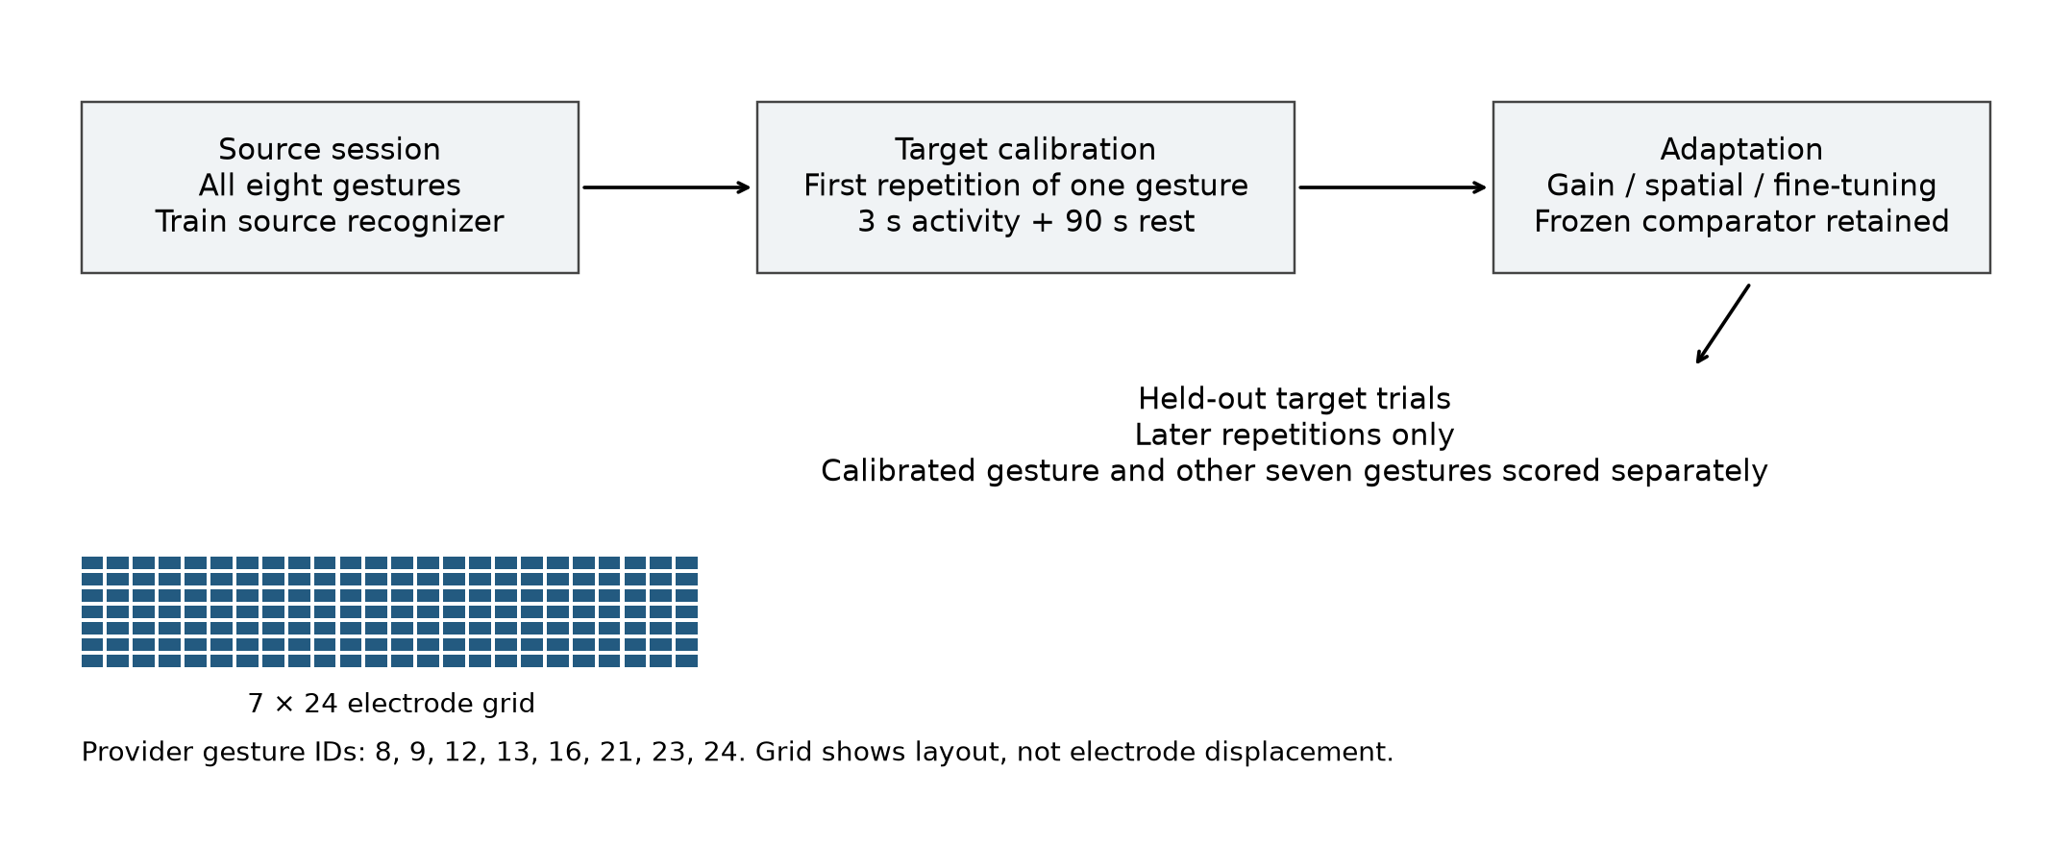
Figure S1. Whole-trial roles, the provider-correct 7 × 24 grid, and the eight provider gesture IDs. Calibration uses one first repetition. Later target repetitions supply disjoint scoring trials. The schematic does not identify physical electrode displacement or infer gesture names from IDs.

SAL objective and parameters
The original spatial search minimizes cross-entropy on the single-class RMS prototype. Its seven parameters are horizontal translation, vertical translation, rotation, horizontal scale, vertical scale, horizontal shear, and vertical shear. The same bounds and interpolation conventions described in Section III.C of the paper apply. Corrective gain remains class-matched and clipped to [0.5, 2].
The new safeguard uses J = CE + (1/7) Σ_j [(θ_j − θ_identity,j)/d_j]², where d_j is the maximum distance from identity to either allowed parameter bound. Identity is (0, 0, 0, 1, 1, 0, 0). The weight is exactly 1. The penalty is applied to physical constrained parameters during both candidate selection and 500-step optimization. No hyperparameter sweep was performed. This is a revision follow-up specified after the original outcomes were known, not a claim of historical preregistration.
The 90 seconds of target rest are used by segmentation and must be included in the recording budget. Baseline-subtraction sensitivity activates sqrt(max(RMS² − rest mean-square, 0)) before mapping and spatial median filtering. The original provider mapping is retained for that condition. The separate literal-mapping condition retains inactive subtraction and uses upstream get_images, including its row removal and time reversal, in both segmentation and frame extraction. It is a mapping sensitivity, not a full reproduction of every upstream configuration choice.

S2 Error destinations and participant statistics
Method | Correct other % | To calibration % | Wrong other %
Frozen | 60.71 | 5.61 | 33.68
Gain | 59.34 | 11.39 | 29.27
Spatial | 45.77 | 23.79 | 30.44
Spatial + gain | 34.51 | 36.46 | 29.02
Fine-tuning | 33.41 | 44.35 | 22.23
Fine-tuning + gain | 33.06 | 44.47 | 22.46

The three outcome columns partition all trials whose true class was absent from target calibration. Equal participant weighting is used after averaging calibration choices and session pairs. Spatial + gain collapses completely to the calibration label in 6 of 640 cases; fine-tuning in 67; fine-tuning + gain in 41. These repeated cases are correlated.
Other class contrast | Mean pp | Negative participants | Two sided p
Gain − frozen | -1.37 | 3/4 | 0.625
Spatial − frozen | -14.94 | 4/4 | 0.125
Spatial + gain − frozen | -26.20 | 4/4 | 0.125
Spatial + gain − gain | -24.83 | 4/4 | 0.125
Combined − spatial − gain + frozen | -9.89 | 4/4 | 0.125

These post-hoc tests use the absolute mean participant effect and all 16 sign assignments. P-values are unadjusted descriptive supplements, require a symmetric sign-exchangeable null, and do not establish significance. Their minimum possible two-sided value is 0.125. The primary four-participant bootstrap intervals are also descriptive; 35 possible count compositions do not represent 35 independent observations and are not equally weighted.
Contrast | P2 pp | P3 pp | P4 pp | P5 pp
Gain − frozen | -1.85 | -3.91 | -3.94 | 4.21
Spatial − frozen | -29.90 | -21.34 | -7.87 | -0.65
Spatial + gain − frozen | -40.28 | -31.40 | -23.32 | -9.79
Spatial + gain − gain | -38.43 | -27.49 | -19.38 | -14.00
Combined − spatial − gain + frozen | -8.53 | -6.15 | -11.52 | -13.34

Stored candidate-search diagnostics report zero minimum computed cross-entropy in 188/640 spatial and 292/640 spatial + gain cases. The original identity-tie controls intervene in 64/640 and 105/640 cases, respectively. Zero computed loss supports a finite-precision saturation interpretation; it does not show a uniquely recovered physical correction.

S3 Revision follow-up outcomes
All results below use session pair 1→2 for participants 2–5 and all eight calibration gestures: 32 cases per variant. This pair is the one used in the original search-seed control, not a newly selected best pair. The original frozen means differ from the all-pair mean. New preprocessing conditions retrain the source model under the original training schedule and use their own frozen comparators.
Condition | Method | Overall % | Calibrated % | Other %
Original | Frozen | 45.49 | 45.49 | 45.49
Original | Spatial | 56.34 | 97.22 | 50.50
Original | Spatial + gain | 43.79 | 97.57 | 36.11
Identity penalty | Frozen | 45.49 | 45.49 | 45.49
Identity penalty | Spatial | 61.02 | 94.10 | 56.30
Identity penalty | Spatial + gain | 44.27 | 88.54 | 37.95
Baseline subtraction | Frozen | 45.14 | 45.14 | 45.14
Baseline subtraction | Spatial | 59.33 | 96.18 | 54.07
Baseline subtraction | Spatial + gain | 43.75 | 97.22 | 36.11
Literal mapping | Frozen | 43.75 | 43.75 | 43.75
Literal mapping | Spatial | 51.78 | 99.31 | 44.99
Literal mapping | Spatial + gain | 44.66 | 95.14 | 37.45

Identity regularization increases other-class mean accuracy for both spatial conditions on this pair, but spatial + gain remains below frozen. It lowers held-out calibrated-class accuracy, so the apparent safeguard benefit is not a free improvement on every endpoint. This result does not identify an optimal penalty or establish a deployment guarantee. Activating baseline subtraction and reverting to literal mapping change absolute performance; the combined method remains below its matched frozen other-class mean in these two restricted checks.
A second multi-session HD-EMG dataset was not added. The separate later GRABMyo/SeNic study is not substituted for a matched replication of this BIBE protocol. The main paper explicitly limits generalization and calls for independent validation.

S4 Participant follow-up and verification
Condition | Participant | Frozen other % | Spatial other % | Spatial gain other %
Original | 2 | 50.00 | 56.94 | 40.67
Original | 3 | 4.17 | 33.33 | 29.96
Original | 4 | 50.00 | 54.17 | 32.54
Original | 5 | 77.78 | 57.54 | 41.27
Identity penalty | 2 | 50.00 | 67.86 | 49.60
Identity penalty | 3 | 4.17 | 28.77 | 15.87
Identity penalty | 4 | 50.00 | 57.94 | 20.63
Identity penalty | 5 | 77.78 | 70.63 | 65.67
Baseline subtraction | 2 | 55.56 | 64.48 | 47.02
Baseline subtraction | 3 | 5.56 | 41.07 | 41.07
Baseline subtraction | 4 | 43.06 | 46.43 | 21.23
Baseline subtraction | 5 | 76.39 | 64.29 | 35.12
Literal mapping | 2 | 55.56 | 64.88 | 46.43
Literal mapping | 3 | 0.00 | 18.25 | 22.62
Literal mapping | 4 | 47.22 | 49.21 | 33.13
Literal mapping | 5 | 72.22 | 47.62 | 47.62

Original verification completed 640 cases with six conditions and 80 all-class references. Its recorded checkpoint replay matched 445,653,040 scoring and 5,886,096 calibration predictions; it also recorded 1,598 cache-hash checks, 3,840 allowed-data gain-statistic checks, eight raw-frame reconstructions, trial-role checks, and parameter/buffer-mask checks. These are historical verification results, not reruns claimed for this revision. The separate original bias audit voted 436,558,080 frame predictions for the six main methods, excluding all-class-reference scoring.
The revision executed three portable analysis scripts: original table reproduction, error/confusion/sign-flip analysis, and follow-up summary reproduction. Each passed numerical checks to 1e-12. New experiments produced 192 adapted checkpoints; each was reloaded and produced exactly matching frame labels with inference batch size 257 instead of 1,024. Saved frame votes were independently reconstructed for all 288 new method-case records; trial IDs matched the original pair. Original and regularized frozen trial predictions agreed exactly. These checks do not make the four participants statistically independent of prior analyses.
The analysis package includes saved trial predictions and full numerical tables but excludes raw signals, processed caches, and model banks. Follow-up run settings and script hashes are recorded in followup_protocol.json. Historical upstream source is pinned to revision 7c5a075a58dff06566b82965f8235ba744377fb8. The existing public repository for the later manuscript was not edited.

S5 Confusion matrices for frozen
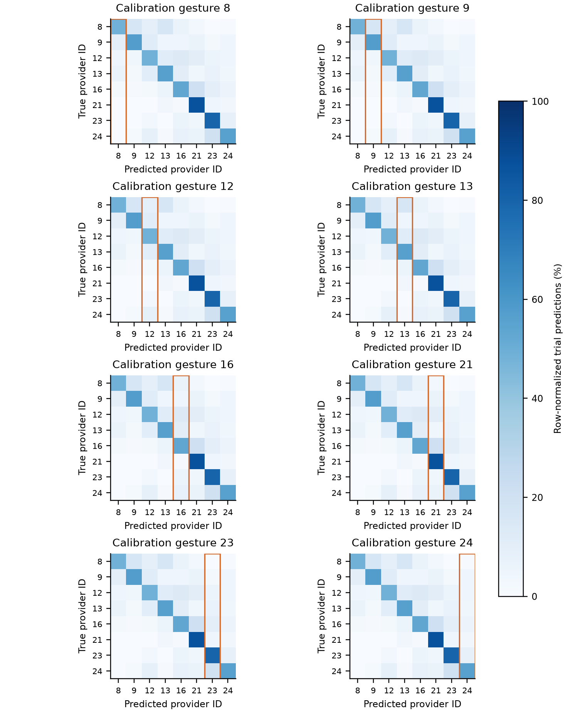
Figure S2. Frozen predictions conditioned on each calibration gesture. Rows are true provider IDs and columns predicted IDs. Orange outlines identify the calibration-label column. Each row is normalized within a case, then averaged over 20 pairs within participant and equally over four participants. Every panel uses the same 0–100% scale. These matrices describe errors and do not prove a representation-level mechanism.

S6 Confusion matrices for gain
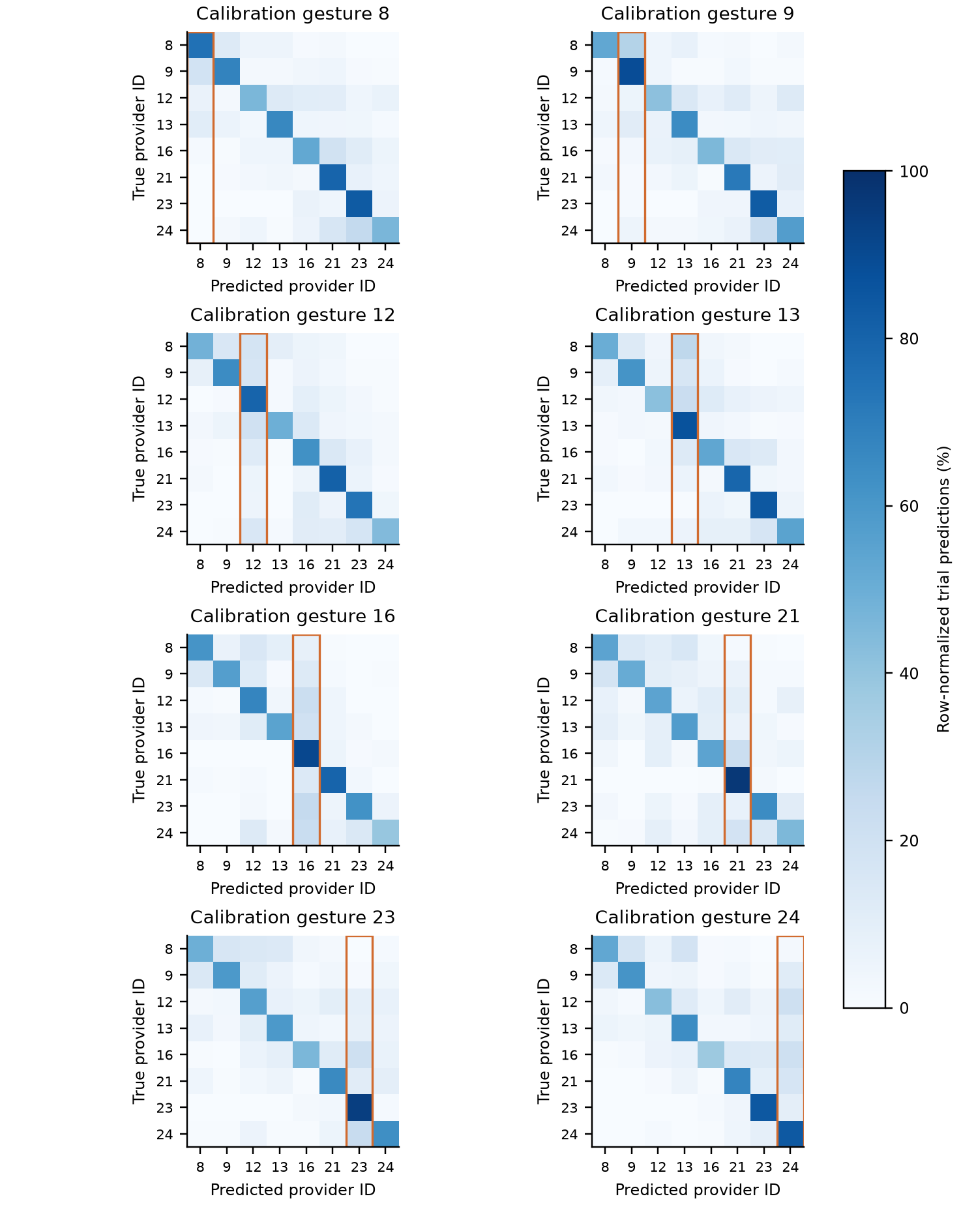
Figure S3. Gain predictions conditioned on each calibration gesture. Rows are true provider IDs and columns predicted IDs. Orange outlines identify the calibration-label column. Each row is normalized within a case, then averaged over 20 pairs within participant and equally over four participants. Every panel uses the same 0–100% scale. These matrices describe errors and do not prove a representation-level mechanism.

S7 Confusion matrices for spatial
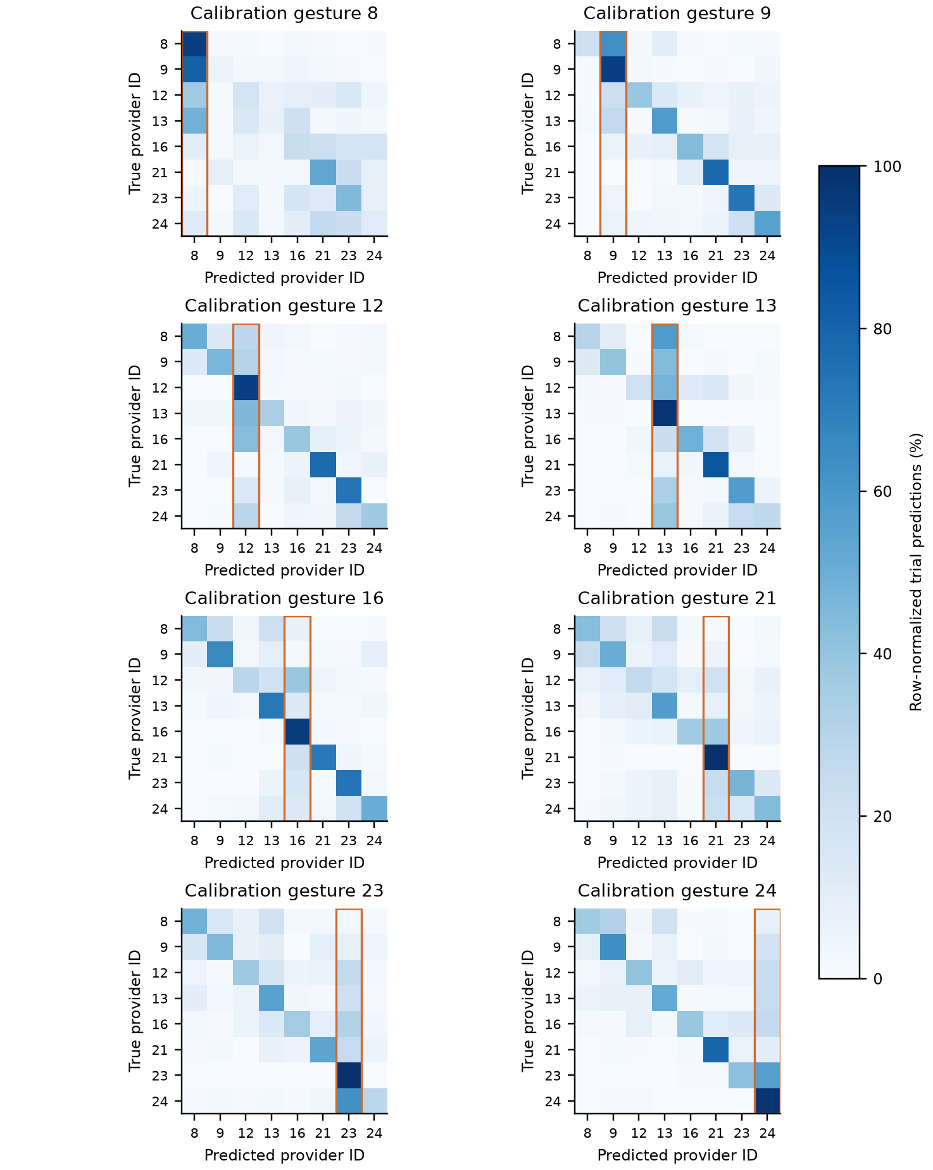
Figure S4. Spatial predictions conditioned on each calibration gesture. Rows are true provider IDs and columns predicted IDs. Orange outlines identify the calibration-label column. Each row is normalized within a case, then averaged over 20 pairs within participant and equally over four participants. Every panel uses the same 0–100% scale. These matrices describe errors and do not prove a representation-level mechanism.

S8 Confusion matrices for spatial + gain
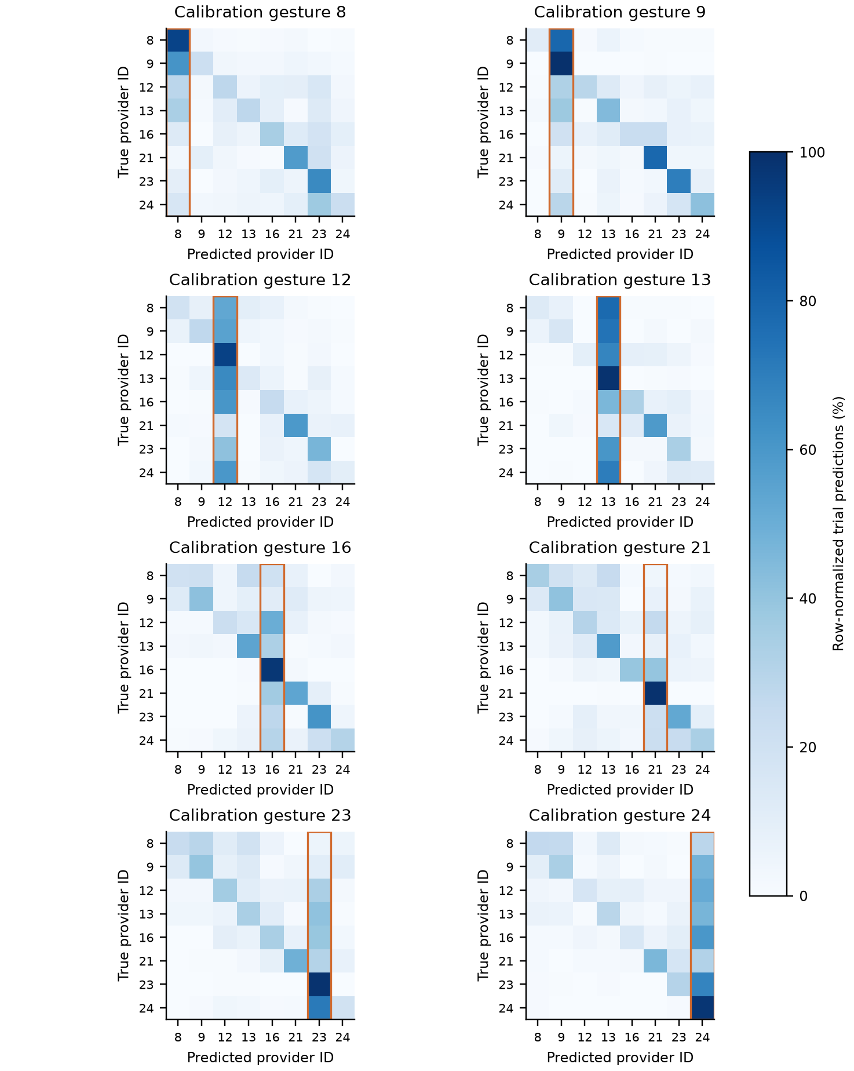
Figure S5. Spatial + gain predictions conditioned on each calibration gesture. Rows are true provider IDs and columns predicted IDs. Orange outlines identify the calibration-label column. Each row is normalized within a case, then averaged over 20 pairs within participant and equally over four participants. Every panel uses the same 0–100% scale. These matrices describe errors and do not prove a representation-level mechanism.

S9 Confusion matrices for fine-tuning
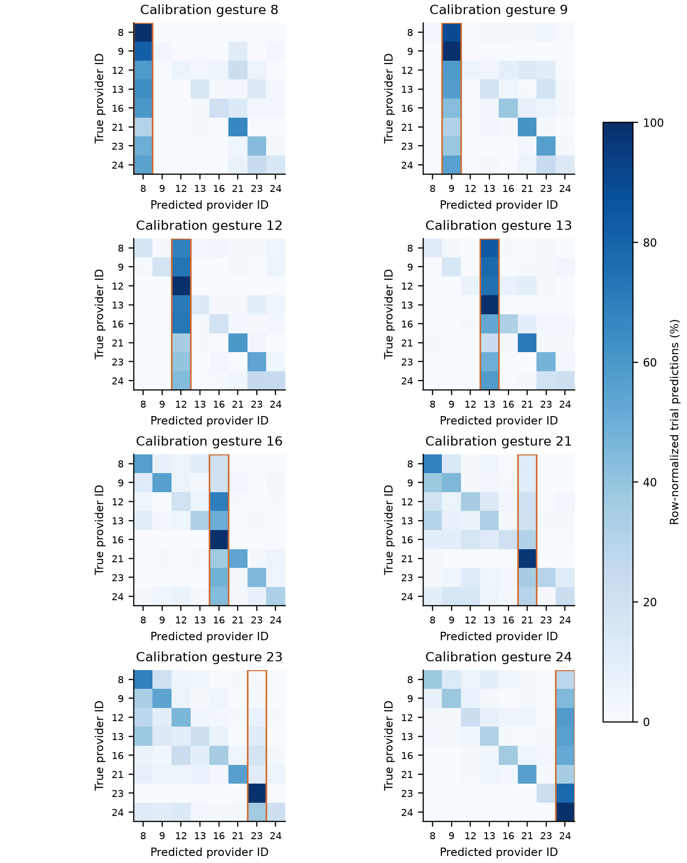
Figure S6. Fine-tuning predictions conditioned on each calibration gesture. Rows are true provider IDs and columns predicted IDs. Orange outlines identify the calibration-label column. Each row is normalized within a case, then averaged over 20 pairs within participant and equally over four participants. Every panel uses the same 0–100% scale. These matrices describe errors and do not prove a representation-level mechanism.

S10 Confusion matrices for fine-tuning + gain
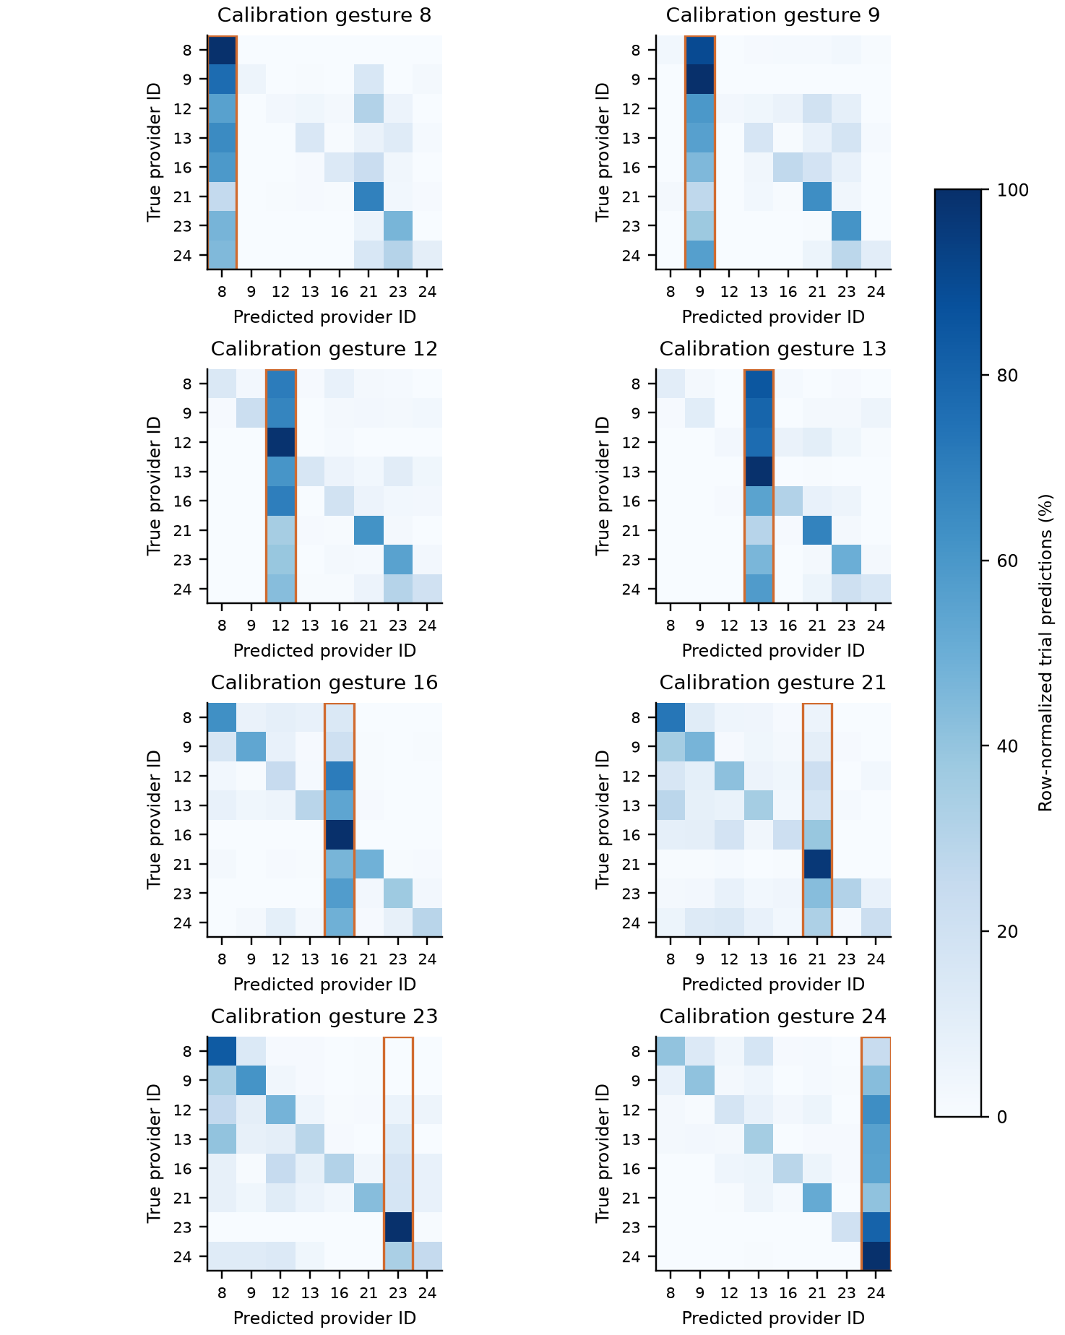
Figure S7. Fine-tuning + gain predictions conditioned on each calibration gesture. Rows are true provider IDs and columns predicted IDs. Orange outlines identify the calibration-label column. Each row is normalized within a case, then averaged over 20 pairs within participant and equally over four participants. Every panel uses the same 0–100% scale. These matrices describe errors and do not prove a representation-level mechanism.

