Cross Gesture Transfer After Single Gesture Calibration in High Density Electromyography
Charles Lu
Independent Researcher
San Diego, California, United States
charles.lu.2027@gmail.com
Abstract—Single-gesture calibration reduces the number of labeled gestures required for adaptation, but its effect on the remaining vocabulary is uncertain. We evaluate gain correction, spatial adaptation, and classifier fine-tuning in one Spatial Adaptation Layer implementation on an eight-gesture high-density electromyography task. One participant from the CSL-HDEMG dataset provides development data; four provide evaluation data covering 80 ordered session pairs and eight calibration choices. Spatial adaptation with gain achieves 96.99% accuracy on held-out trials of the calibrated gesture and 34.51% on the other gestures, compared with 60.71% for frozen models. Errors toward the calibration label account for 36.46% of other-gesture trials, compared with 5.61% before adaptation. Spatial-related other-class contrasts are negative in all four participants, although exact two-sided sign-flip tests yield p = 0.125 and bootstrap intervals remain descriptive. Exploratory experiments on one session pair test identity regularization and preprocessing changes. Calibration requires three seconds of labeled activity and 90 seconds of target-session rest, with offline processing. Within this small cohort and fixed implementation, calibrated-gesture accuracy does not establish cross-gesture retention. Evaluation should report both outcomes separately against a frozen reference.
Keywords—Cross-session adaptation, High-density electromyography, Negative transfer, Single-gesture calibration

I. Introduction
A myoelectric interface trained in one recording session may perform differently in another. Calibration from one gesture could reduce labeling effort, provided that the resulting update preserves recognition of the full intended vocabulary. We distinguish calibration-frame accuracy, the fraction of calibration-recording frames classified correctly, from held-out calibrated-gesture accuracy and accuracy on the other gestures. Negative transfer here means lower overall trial accuracy than the matched frozen recognizer; a decline on the other classes is reported separately.
We evaluate cross-gesture transfer in one public Spatial Adaptation Layer (SAL) implementation using four participants from CSL-HDEMG. Source training includes all eight classes; the other gestures are absent only from target calibration. By separating gain correction, spatial adaptation, and classifier fine-tuning, we assess whether improved recognition of the calibrated gesture preserves the remaining vocabulary. The evaluation covers every ordered session pair and calibration gesture, with controls for implementation and search choices. Its conclusions are specific to this cohort and implementation.

II. Related work
Pereira et al. introduced SAL for biosignal arrays [1]. Their public implementation includes single-gesture calibration, gain correction, and prototype search [2], which form the basis of our component evaluation. We pin the source revision and document preprocessing differences; these differences preclude an exact reproduction of the original paper's main experiment.
Related approaches use flexible subsets of calibration gestures [3], single-gesture fine-tuning under electrode interference [4], unknown calibration gestures [5], and source reprojection [6]. We examine a complementary question: how adaptation to one target gesture affects recognition of the other gestures under matched within-person, cross-session scoring. These earlier methods provide context rather than directly comparable benchmarks because their datasets and evaluation protocols differ.

III. Methods

A. Data and evaluation design
CSL-HDEMG contains five participants recorded in five sessions [7]. Participant 1, sessions 1 and 2, provides development data; participants 2–5 provide the primary evaluation. Each source model is trained on one session of the person being evaluated. The task therefore measures within-person transfer between sessions.
The eight provider gesture IDs are 8, 9, 12, 13, 16, 21, 23, and 24. Each participant contributes 20 ordered session pairs. The first available target repetition of one gesture supplies calibration, and later repetitions of all eight gestures supply scoring. Evaluating all eight calibration choices yields 640 cases. The first repetitions of the remaining target gestures are unused. Original methods, settings, gestures, and checkpoints were selected without target scoring results. Error analyses and exploratory follow-up experiments were added after the original outcomes were known.
The evaluation uses 1,598 active and 600 rest trials. Participant 4, session 4, has nine rather than ten repetitions of gestures 8 and 9. Raw-data checks identified these omissions before training or inspection of outcomes. Retaining the available trials gives 70 scoring trials for that target session and 72 elsewhere. Trial roles are assigned before frame extraction, and scoring trials are identical across methods.

B. Preprocessing and recording cost
Each raw trial has 192 channels and 6,144 samples at 2,048 Hz. Provider mapping removes every eighth channel and arranges 168 channels as a 7 × 24 grid with spatial row reversal and preserved time order. This corrects the inspected upstream loader, which removes its first grid row and reverses time. Supplementary Fig. S1 diagrams the grid and trial roles.
Processing uses trial-wise centering, causal 20–380 Hz band-pass and 45–55 Hz band-stop filters, activity segmentation, a 1,025-sample centered RMS window, and a zero-padded 3 × 3 spatial median filter. The original literal “mean_square” flag does not activate the upstream “mean-square” subtraction branch. Scoring data do not fit model normalization statistics. Segmentation uses 30 three-second rest trials from the target session, so three seconds of labeled activity requires 90 additional seconds of rest. Centered RMS and whole-trial voting make the experiment offline.

C. Adaptation conditions and objective
The source recognizer uses batch normalization, dropout 0.5, and a linear eight-class classifier. Source training uses 15 epochs of Adam at 0.001, batch size 128, a three-epoch warm-up, seed 42, and the final checkpoint. The upstream revision and complete settings are recorded in the reproduction package [2].
Frozen preserves the source model. Gain applies a source/calibration mean ratio at each grid position, clamped to [0.5, 2], using only the matching source gesture. Spatial updates seven bounded affine parameters with classifier and normalization state fixed. Spatial + gain combines these components. Fine-tuning, with or without gain, updates classifier and batch-normalization parameters and statistics.
SAL resamples the electrode grid using horizontal and vertical translations, rotation, two scales, and two shears. Its calibration objective is cross-entropy for the single known label on an RMS calibration prototype. Search evaluates 16,384 Latin-hypercube candidates plus identity, then performs 500 Adam updates at 0.01. Search and scoring use bicubic interpolation; optimization uses bilinear interpolation. Translation bounds are ±8/23 and ±8/6; scales are [1/1.1, 1.1], shears ±0.1, and the literal rotation bound ±15/180 radians. Gain is estimated using a transformed target mean but applied before normalization and resampling. These parameters are algorithmic, not identified physiological quantities.
Fine-tuning uses 150 epochs of Adam at 0.001, batch size 128, and a 30-epoch warm-up. A contextual all-class reference uses the first repetition of all eight gestures at the same epoch count. It receives more labels and more optimizer updates, so it does not isolate data quantity alone.

D. Outcomes and statistical interpretation
Trial predictions use frame-majority voting, resolving tied counts by first occurrence. The primary endpoint is accuracy on the seven gestures absent from calibration; overall accuracy, held-out calibrated-class accuracy, and calibration-frame fitting are also reported. Calibration choices are averaged within pairs, pairs within participants, and the four participants equally.
We retain descriptive 95% intervals from 10,000 participant bootstrap resamples and emphasize participant effects and sign consistency. Four participants allow only 35 distinct bootstrap count compositions; these have unequal probabilities. Post-hoc two-sided sign-flip tests enumerate all 16 sign assignments using the absolute mean paired effect. Their validity assumes sign exchangeability under a symmetric null. The smallest attainable two-sided p-value is 0.125, so these tests cannot establish conventional 5% significance. Neither intervals nor repeated cases justify population-wide claims.
A post-hoc error analysis partitions other-class trials into correct predictions, errors to the calibration label, and errors to another label. Confusion matrices are row-normalized within each case, then averaged over pairs and participants separately for each calibration gesture (Supplementary Figs. S2–S7).

E. Controls and exploratory experiments
The original controls prefer identity in exact initialization-loss ties, change processing order to resampling then gain then normalization, and vary candidate-search seed (42, 43, 44) on session pair 1→2. The first two cover all 640 cases; seed checks cover 32 cases. They were fixed before inspection of the original cohort summaries. The order control changes both gain and normalization placement.
Exploratory follow-up experiments use the same fixed pair 1→2, four participants, and eight calibration gestures. To test a safeguard, we add a unit-weight identity penalty to cross-entropy during candidate selection and optimization. Each physical parameter deviation is divided by its maximum allowed deviation from identity, and the seven squared deviations are averaged. The weight is fixed at 1 without an outcome-based sweep; classifier parameters and normalization state remain frozen. Separate preprocessing experiments activate mean-square subtraction with provider mapping, or use the literal upstream mapping, including time reversal, with subtraction inactive. Each preprocessing variant retrains the source model and uses its own frozen reference. These checks cover 32 cases per variant on previously evaluated participants.

IV. Results

A. Accuracy on calibrated and other gestures
Table I and Fig. 1 report the original four-participant means for this implementation. Spatial + gain achieves 96.99% on held-out calibrated-class trials but 34.51% on other gestures, versus 60.71% frozen. The distinction therefore extends beyond fitting the calibration recording.
TABLE I. Accuracy across four participants
Condition | All (%) | Calibrated (%) | Other (%)
Frozen | 60.71 | 60.70 | 60.71
Gain | 62.80 | 87.06 | 59.34
Spatial | 52.12 | 96.63 | 45.77
Spatial + gain | 42.32 | 96.99 | 34.51
Fine-tuning | 41.64 | 99.20 | 33.41
Fine-tuning + gain | 41.31 | 99.03 | 33.06
All classes were seen during source training. “Other” means absent only from target calibration. Missing repetitions and rounding explain small deviations from a balanced eight-class weighted average.
Gain increases overall accuracy by 2.09 percentage points, but other-class accuracy changes by −1.37 points (descriptive interval −3.92 to +2.18). Only participant 5 improves on the other classes (Table II); the two-sided sign-flip p-value is 0.625. The overall gain therefore reflects improved recognition of the calibrated gesture.
TABLE II. Other gesture accuracy by participant
Participant | Frozen (%) | Gain (%) | Spatial (%) | Spatial + gain (%)
2 | 78.61 | 76.77 | 48.71 | 38.33
3 | 57.64 | 53.73 | 36.30 | 26.24
4 | 56.52 | 52.58 | 48.65 | 33.20
5 | 50.07 | 54.28 | 49.41 | 40.28
Participant means average all 20 ordered pairs and eight calibration choices. Participants, not cases or frames, are the independent observations.
Spatial + gain is below frozen for all four participants, a mean other-class difference of −26.20 points. Adding spatial adaptation to gain changes other-class accuracy by −24.83 points (descriptive interval −33.67 to −16.69). The interaction, combined − spatial − gain + frozen, is −9.89 points (−12.43 to −7.34). Each spatial-related contrast is negative in all four participants and has unadjusted two-sided sign-flip p = 0.125. These descriptive intervals are not precise population uncertainty bounds.
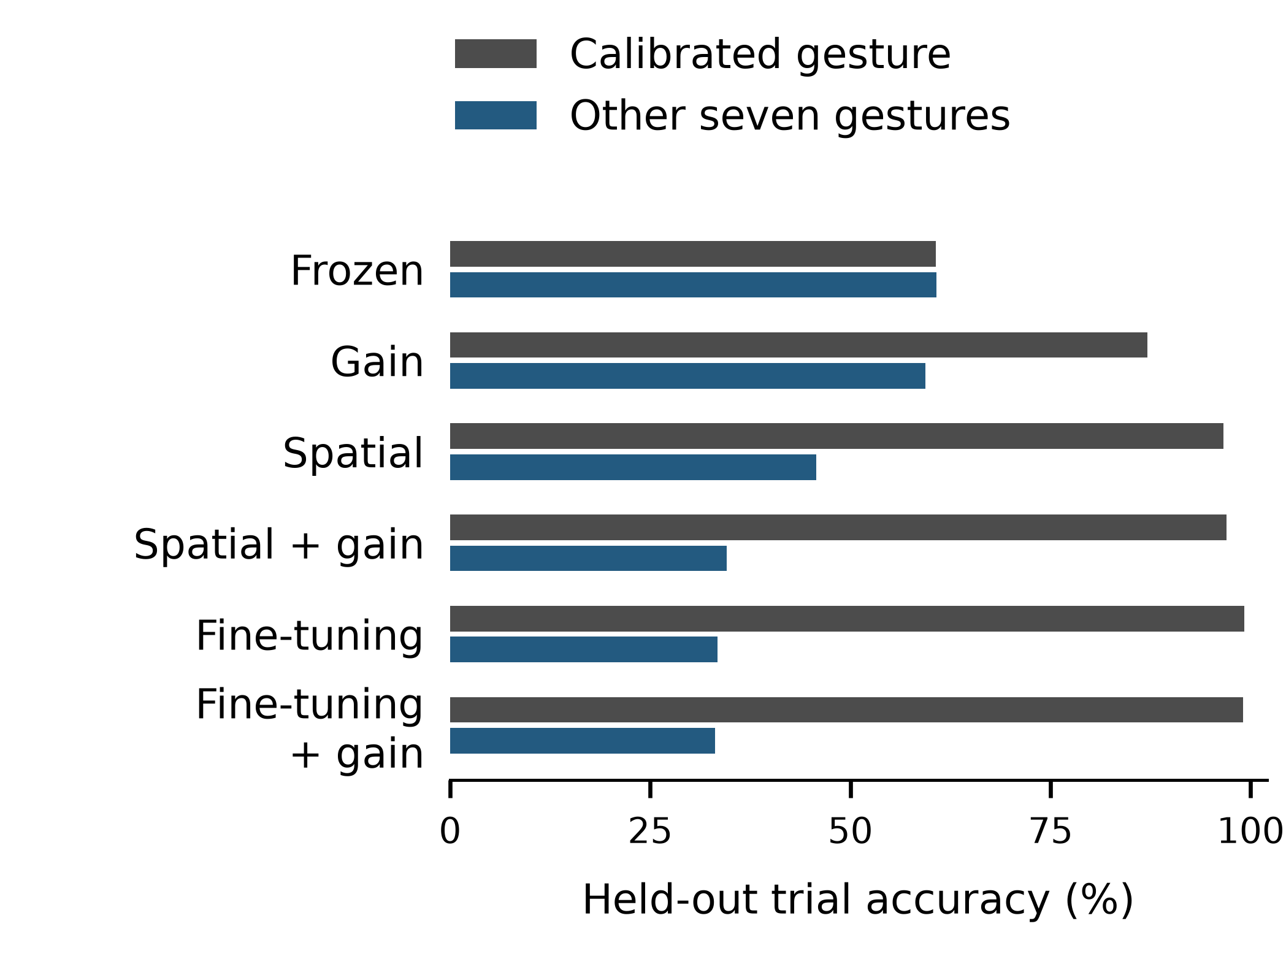
Fig. 1. Held-out calibrated and other-gesture trial accuracies, equally averaged across four participants. Exact values are in Table I.

B. High calibration fit and negative transfer
Of 570 spatial + gain cases with calibration-frame accuracy at least 99%, 398 have lower overall scoring accuracy than frozen. Corresponding counts are 223/473 for gain, 317/542 for spatial, 489/638 for fine-tuning, and 494/640 for fine-tuning + gain. These correlated case counts are not independent population risk estimates. The all-class fine-tuning reference reaches 89.14% overall, with the extra-data and extra-update caveats above.

C. Implementation and search controls
TABLE III. Other gesture accuracy under implementation controls
Spatial procedure | Spatial (%) | Spatial + gain (%)
Original | 45.77 | 34.51
Identity preference | 47.57 | 36.96
Resample → gain → normalize | 35.65 | 28.85
Both controls cover all 640 cases. The matched frozen other-class mean is 60.71%.
Identity preference improves other-class accuracy by 1.80 points for spatial and 2.45 for spatial + gain. It replaces the initial candidate in 64/640 and 105/640 cases, respectively, without changing the initial calibration loss. Final transfer can improve or worsen (Fig. 2). The order change reduces other-class accuracy by 10.12 and 5.66 points; its effect cannot be attributed solely to gain placement.
TABLE IV. Other gesture accuracy by search seed
Seed (1→2) | Spatial (%) | Spatial + gain (%)
42 | 50.50 | 36.11
43 | 56.10 | 37.60
44 | 56.35 | 35.47
Frozen reference | 45.49 | 45.49
Each seed is evaluated on 32 cases from session pair 1→2. The matched frozen accuracy is 45.49%, compared with 60.71% across all pairs.
Spatial adaptation alone exceeds frozen on pair 1→2 at all three seeds, whereas spatial + gain remains below it. The all-pair decrease therefore coexists with improvements on individual pairs. All seeds are reported; seed sensitivity on other pairs remains untested.

D. Errors toward the calibration label
TABLE V. Error destinations on other gestures
Condition | Correct (%) | To calib. (%) | Other error (%)
Frozen | 60.71 | 5.61 | 33.68
Gain | 59.34 | 11.39 | 29.27
Spatial | 45.77 | 23.79 | 30.44
Spatial + gain | 34.51 | 36.46 | 29.02
Fine-tuning | 33.41 | 44.35 | 22.23
Fine-tuning + gain | 33.06 | 44.47 | 22.46
Percentages partition all other-gesture trials and use equal participant weighting. They are not percentages conditional on being incorrect; rounding may affect the sum.
Spatial + gain assigns 36.46% of other-gesture trials to the calibration label, compared with 5.61% for frozen models. It predicts that label on every scoring trial in 6/640 cases; fine-tuning does so in 67/640 cases. The remaining errors show that total label collapse accounts for only part of the observed degradation. Calibration-specific confusion matrices in the supplement describe this output bias, although they cannot determine its mechanism within the model.
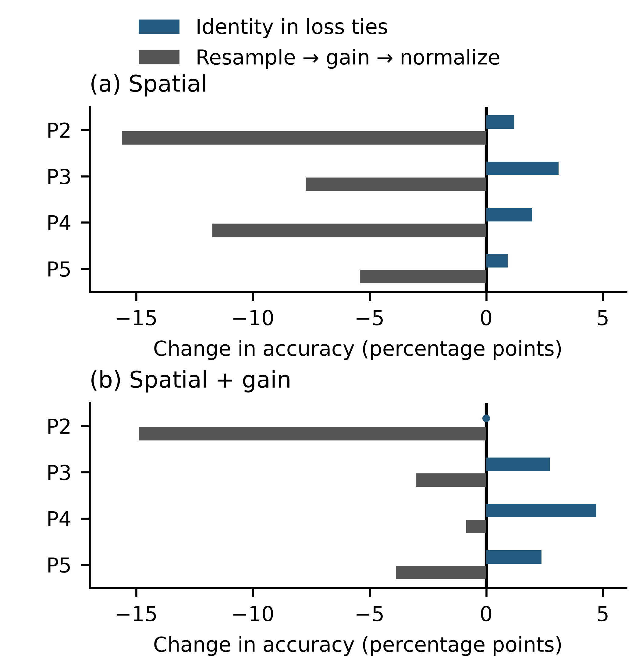
Fig. 2. Change in other-class accuracy relative to the original spatial procedure for each participant, averaged over 20 session pairs and eight calibration gestures. Both panels use the same scale. The vertical line indicates zero; the dot identifies a near-zero effect at its measured value.

E. Identity regularization and preprocessing
On pair 1→2, identity regularization raises spatial other-class accuracy from 50.50% to 56.30% and spatial + gain from 36.11% to 37.95% (Table VI). The combined method remains below frozen at 45.49%, while its held-out calibrated-class accuracy falls from 97.57% to 88.54%. With baseline subtraction, spatial + gain achieves 36.11% against a retrained frozen reference of 45.14%. With literal upstream mapping, the corresponding accuracies are 37.45% and 43.75%. The other-class deficit persists under both preprocessing variants on this session pair.
TABLE VI. Other gesture accuracy in exploratory experiments
Condition | Frozen (%) | Spatial (%) | Spatial + gain (%)
Original | 45.49 | 50.50 | 36.11
Identity penalty | 45.49 | 56.30 | 37.95
Baseline subtraction | 45.14 | 54.07 | 36.11
Literal mapping | 43.75 | 44.99 | 37.45
Other-class accuracy (%) on session pair 1→2, averaged equally across four participants and eight calibration choices. Frozen references are specific to each preprocessing condition; identity regularization uses the original preprocessing. The supplement reports overall and calibrated-class accuracies and participant effects.
The supplement documents checkpoint, trial-role, gain-statistic, and raw-frame verification. Follow-up checkpoints were reloaded, and their frame predictions were reproduced with a different batch size.

V. Discussion
For these four participants, improved recognition of the calibrated gesture was accompanied by more frequent assignment of other gestures to its label. This behavior is consistent with the single-class objective: calibration cross-entropy rewards the supplied label without penalizing errors on omitted classes. An unrestricted classifier can reduce the objective by favoring the calibration label broadly. Bounded spatial adaptation restricts the available transformations, but likewise contains no explicit term for retaining other classes.
Stored search logs contain computed zero minimum cross-entropy in 188/640 spatial cases and 292/640 spatial + gain cases, consistent with finite-precision loss saturation. Exact ties alone do not establish saturation, and equal calibration losses need not imply equal transfer. Gain and spatial transformations may also compensate for one another: for positive templates u and v, an admissible gain g = u/(Wv) gives g ⊙ Wv = u for a transform W. This example illustrates possible ambiguity in fitting one template. Gain clipping and interpolation restrict the equivalence, so it does not establish general non-identifiability or a physiological explanation for the observed errors.
Identity regularization improved mean other-class accuracy in the exploratory follow-up, but the combined method remained below frozen. Spatial adaptation alone already exceeded frozen on that pair. Evaluating source replay and other retention constraints across new participants and session pairs would help determine whether this improvement generalizes. Such comparisons should select settings independently of final scoring data and retain a frozen reference.
The protocol also requires 90 seconds of target-session rest in addition to three seconds of labeled activity. This recording burden limits the practical benefit of reducing labeled calibration data. Centered RMS and whole-trial voting support offline evaluation; they do not represent causal streaming or closed-loop control with feedback, fatigue, and user adaptation.

VI. Limitations and conclusion
The primary evaluation comprises four participants, one dataset, eight selected gestures, one source-training seed, and one fixed implementation. The exploratory follow-ups reuse those participants and a single session pair. Replication on a larger independent cohort and a second multi-session dataset is needed to assess generalizability. Changes to architecture, bounds, objectives, or optimization may alter the observed degradation, and natural session variation does not isolate controlled electrode displacement.
In this evaluation, high accuracy on the calibrated gesture did not ensure retention of the remaining vocabulary. Reporting calibration fit, held-out calibrated-class accuracy, other-class accuracy, and recording cost separately makes this distinction visible. A frozen comparator remains necessary to quantify the benefit or loss associated with adaptation.

Code and data availability
Analysis code, numerical records, and protocols are available in the private repository https://github.com/Lu-Charles/bibe-single-gesture-transfer. The scripts reproduce the tables, error analyses, confusion matrices, sign-flip tests, and follow-up summaries from saved records. Repeating model training requires the raw dataset and original experiment workspace.
CSL-HDEMG recordings are available through the provider's registration process [7]. Raw recordings and model checkpoints are excluded from the repository. This secondary analysis uses existing recordings and involved no new participant recruitment.

References
[1] J. Pereira, M. Alummoottil, D. Halatsis, and D. Farina, “Spatial Adaptation Layer: Interpretable Domain Adaptation For Biosignal Sensor Array Applications,” arXiv:2409.08058, ver. 2, 2025. [Online]. Available: https://arxiv.org/abs/2409.08058v2
[2] J. Pereira, “Spatial Adaptation Layer source code,” revision 7c5a075a58dff06566b82965f8235ba744377fb8. Accessed: Sep. 6, 2026. [Online]. Available: https://github.com/joao-binenbojm/spatial-adaptation-layer
[3] Y. Yuan, Z. Chen, J. Liu, C. H. Chou, C. Dai, and X. Jiang, “Toward Highly Flexible Inter-User Calibration of Myoelectric Control Models With User-Defined Hand Gestures,” IEEE Trans. Med. Robot. Bionics, vol. 7, no. 1, pp. 359–367, 2025, doi: 10.1109/TMRB.2024.3504737.
[4] Y. Zhang, Z. Bao, R. Huang, X. Yin, B. He, and Y. Liu, “SE-CNN integrated with transfer learning: Enhancing myoelectric pattern recognition amid electrode shift and damage interferences,” Biomed. Signal Process. Control, vol. 111, Art. no. 108411, 2026, doi: 10.1016/j.bspc.2025.108411.
[5] H. Shi, X. Jiang, C. Dai, and W. Chen, “EMG-based Multi-User Hand Gesture Classification via Unsupervised Transfer Learning Using Unknown Calibration Gestures,” IEEE Trans. Neural Syst. Rehabil. Eng., vol. 32, pp. 1119–1131, 2024, doi: 10.1109/TNSRE.2024.3372002.
[6] D. Li, P. Chen, S. Togo, H. Yokoi, and Y. Jiang, “SRM: A Source-Reprojection Module for Cross-Day sEMG Gesture Recognition,” Sensors, vol. 26, no. 12, Art. no. 3870, 2026, doi: 10.3390/s26123870.
[7] C. Amma, T. Krings, J. Böer, and T. Schultz, “Advancing Muscle-Computer Interfaces with High-Density Electromyography,” in Proc. 33rd Annu. ACM Conf. Human Factors Comput. Syst. (CHI), 2015, pp. 929–938, doi: 10.1145/2702123.2702501.

