Supplementary material
Cross Gesture Transfer After Single Gesture Calibration in High Density Electromyography
Charles Lu
This supplement describes the CSL-HDEMG evaluation, post-hoc error analyses, and exploratory experiments on identity regularization and preprocessing. The primary evaluation and follow-up experiments use the same four participants.

S1 Pipeline and recording requirements
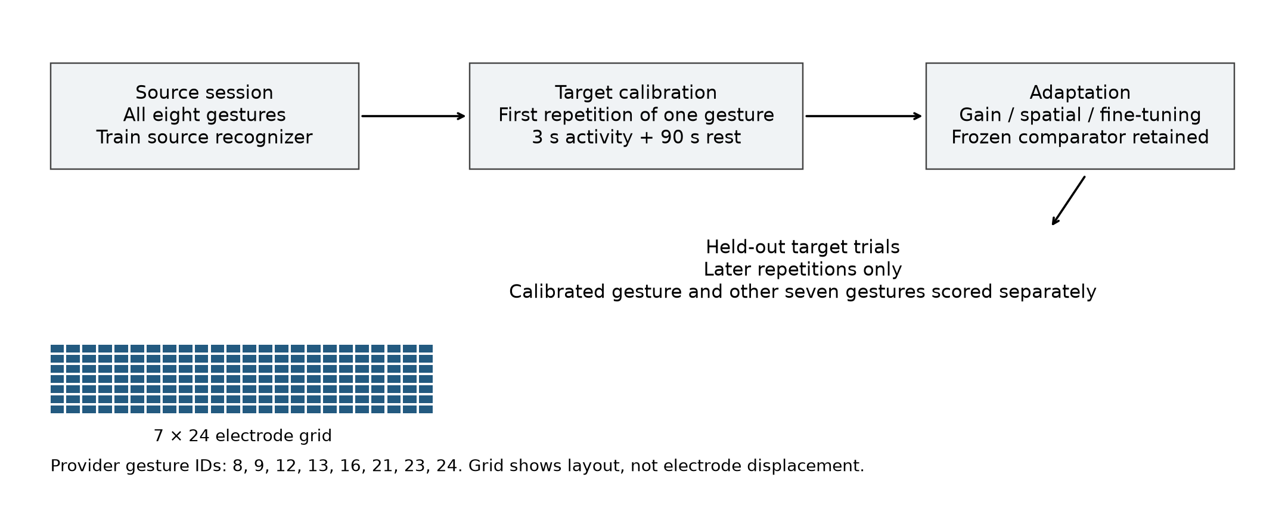
Figure S1. Whole-trial roles, the provider-correct 7 × 24 grid, and the eight provider gesture IDs. Calibration uses one first repetition. Later target repetitions supply disjoint scoring trials. The schematic does not identify physical electrode displacement or infer gesture names from IDs.

SAL objective and parameters
The original spatial search minimizes cross-entropy on the single-class RMS prototype. Its seven parameters are horizontal translation, vertical translation, rotation, horizontal scale, vertical scale, horizontal shear, and vertical shear. The same bounds and interpolation conventions described in Section III.C of the paper apply. Corrective gain remains class-matched and clipped to [0.5, 2].
Identity regularization uses the objective
$$J = CE + \frac{1}{7}\sum_{j = 1}^{7}{{\left[\frac{θ_{j} − θ_{identity,j}}{d_{j}}\right]}^{2}}$$
where dⱼ is the maximum distance from identity to either allowed parameter bound. Identity is (0, 0, 0, 1, 1, 0, 0). The penalty has unit weight and acts on the physical constrained parameters during candidate selection and 500-step optimization. This experiment was specified after the original outcomes were known, with no hyperparameter sweep.
The 90 seconds of target rest are used by segmentation and must be included in the recording budget. Baseline-subtraction sensitivity activates sqrt(max(RMS² − rest mean-square, 0)) before mapping and spatial median filtering. The original provider mapping is retained for that condition. The separate literal-mapping condition retains inactive subtraction and uses upstream get_images, including its row removal and time reversal, in both segmentation and frame extraction. It is a mapping sensitivity, not a full reproduction of every upstream configuration choice.

S2 Error destinations and participant statistics
Method | Correct other % | To calibration % | Wrong other %
Frozen | 60.71 | 5.61 | 33.68
Gain | 59.34 | 11.39 | 29.27
Spatial | 45.77 | 23.79 | 30.44
Spatial + gain | 34.51 | 36.46 | 29.02
Fine-tuning | 33.41 | 44.35 | 22.23
Fine-tuning + gain | 33.06 | 44.47 | 22.46

The three outcome columns partition all trials whose true class was absent from target calibration. Equal participant weighting is used after averaging calibration choices and session pairs. Spatial + gain collapses completely to the calibration label in 6 of 640 cases; fine-tuning in 67; fine-tuning + gain in 41. These repeated cases are correlated.
Other class contrast | Mean pp | Negative participants | Two sided p
Gain − frozen | -1.37 | 3/4 | 0.625
Spatial − frozen | -14.94 | 4/4 | 0.125
Spatial + gain − frozen | -26.20 | 4/4 | 0.125
Spatial + gain − gain | -24.83 | 4/4 | 0.125
Combined − spatial − gain + frozen | -9.89 | 4/4 | 0.125

These post-hoc tests use the absolute mean participant effect and all 16 sign assignments. P-values are unadjusted descriptive supplements, require a symmetric sign-exchangeable null, and do not establish significance. Their minimum possible two-sided value is 0.125. The primary four-participant bootstrap intervals are also descriptive; 35 possible count compositions do not represent 35 independent observations and are not equally weighted.
Contrast | P2 pp | P3 pp | P4 pp | P5 pp
Gain − frozen | -1.85 | -3.91 | -3.94 | 4.21
Spatial − frozen | -29.90 | -21.34 | -7.87 | -0.65
Spatial + gain − frozen | -40.28 | -31.40 | -23.32 | -9.79
Spatial + gain − gain | -38.43 | -27.49 | -19.38 | -14.00
Combined − spatial − gain + frozen | -8.53 | -6.15 | -11.52 | -13.34

Stored candidate-search diagnostics report zero minimum computed cross-entropy in 188/640 spatial and 292/640 spatial + gain cases. The original identity-tie controls intervene in 64/640 and 105/640 cases, respectively. Zero computed loss supports a finite-precision saturation interpretation; it does not show a uniquely recovered physical correction.

S3 Exploratory experiment outcomes
All results below use session pair 1→2 for participants 2–5 and all eight calibration gestures, giving 32 cases per variant. The session pair was retained from the original search-seed control. Its frozen accuracy differs from the all-pair mean. Each preprocessing condition retrains the source model under the original training schedule and uses its own frozen comparator.
Condition | Method | Overall % | Calibrated % | Other %
Original | Frozen | 45.49 | 45.49 | 45.49
Original | Spatial | 56.34 | 97.22 | 50.50
Original | Spatial + gain | 43.79 | 97.57 | 36.11
Identity penalty | Frozen | 45.49 | 45.49 | 45.49
Identity penalty | Spatial | 61.02 | 94.10 | 56.30
Identity penalty | Spatial + gain | 44.27 | 88.54 | 37.95
Baseline subtraction | Frozen | 45.14 | 45.14 | 45.14
Baseline subtraction | Spatial | 59.33 | 96.18 | 54.07
Baseline subtraction | Spatial + gain | 43.75 | 97.22 | 36.11
Literal mapping | Frozen | 43.75 | 43.75 | 43.75
Literal mapping | Spatial | 51.78 | 99.31 | 44.99
Literal mapping | Spatial + gain | 44.66 | 95.14 | 37.45

Identity regularization increases mean other-class accuracy for both spatial conditions on this pair, while reducing held-out calibrated-class accuracy. Spatial + gain remains below frozen. The fixed penalty weight was not optimized, and its performance on other session pairs remains untested. Baseline subtraction and literal mapping change absolute accuracy, but the combined method remains below its matched frozen other-class mean under both preprocessing conditions.
These experiments assess sensitivity within the original cohort. Generalization to new participants and a second multi-session dataset requires independent evaluation.

S4 Participant follow-up and verification
Condition | Participant | Frozen other % | Spatial other % | Spatial gain other %
Original | 2 | 50.00 | 56.94 | 40.67
Original | 3 | 4.17 | 33.33 | 29.96
Original | 4 | 50.00 | 54.17 | 32.54
Original | 5 | 77.78 | 57.54 | 41.27
Identity penalty | 2 | 50.00 | 67.86 | 49.60
Identity penalty | 3 | 4.17 | 28.77 | 15.87
Identity penalty | 4 | 50.00 | 57.94 | 20.63
Identity penalty | 5 | 77.78 | 70.63 | 65.67
Baseline subtraction | 2 | 55.56 | 64.48 | 47.02
Baseline subtraction | 3 | 5.56 | 41.07 | 41.07
Baseline subtraction | 4 | 43.06 | 46.43 | 21.23
Baseline subtraction | 5 | 76.39 | 64.29 | 35.12
Literal mapping | 2 | 55.56 | 64.88 | 46.43
Literal mapping | 3 | 0.00 | 18.25 | 22.62
Literal mapping | 4 | 47.22 | 49.21 | 33.13
Literal mapping | 5 | 72.22 | 47.62 | 47.62

Original verification completed 640 cases with six conditions and 80 all-class references. Its recorded checkpoint replay matched 445,653,040 scoring and 5,886,096 calibration predictions; it also recorded 1,598 cache-hash checks, 3,840 allowed-data gain-statistic checks, eight raw-frame reconstructions, trial-role checks, and parameter/buffer-mask checks. These are historical verification results, not reruns claimed for this revision. The separate original bias audit voted 436,558,080 frame predictions for the six main methods, excluding all-class-reference scoring.
Three analysis scripts reproduce the original tables, error and sign-flip analyses, and follow-up summaries, with numerical comparisons at an absolute tolerance of 1e-12. The follow-up experiments produced 192 adapted checkpoints. After reloading, each checkpoint reproduced its frame labels exactly with inference batch size 257 instead of 1,024. Frame votes were independently reconstructed for all 288 follow-up method-case records, and trial identities matched the original pair. Frozen predictions agreed exactly between the original and regularized conditions.
The repository includes trial predictions and numerical summaries; raw signals, processed caches, and model checkpoints are excluded. Experiment settings and script hashes are recorded in protocols/followup_protocol.json. The upstream source is pinned to revision 7c5a075a58dff06566b82965f8235ba744377fb8.

S5 Confusion matrices for frozen
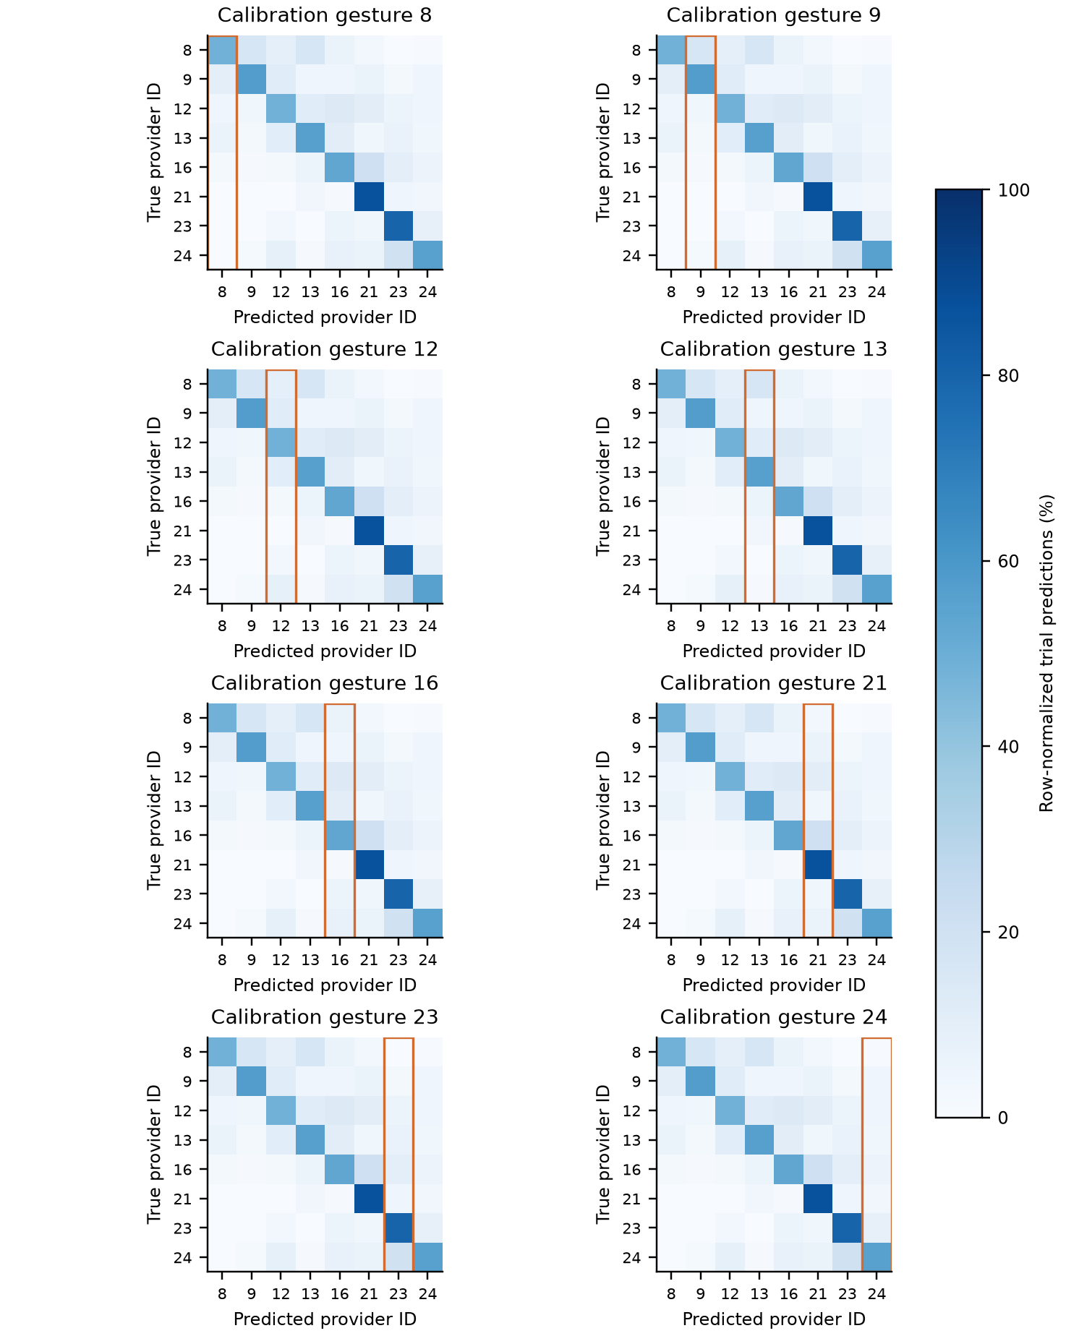
Figure S2. Frozen predictions conditioned on each calibration gesture. Rows are true provider IDs and columns predicted IDs. Orange outlines identify the calibration-label column. Each row is normalized within a case, then averaged over 20 pairs within participant and equally over four participants. Every panel uses the same 0–100% scale. These matrices describe errors and do not prove a representation-level mechanism.

S6 Confusion matrices for gain
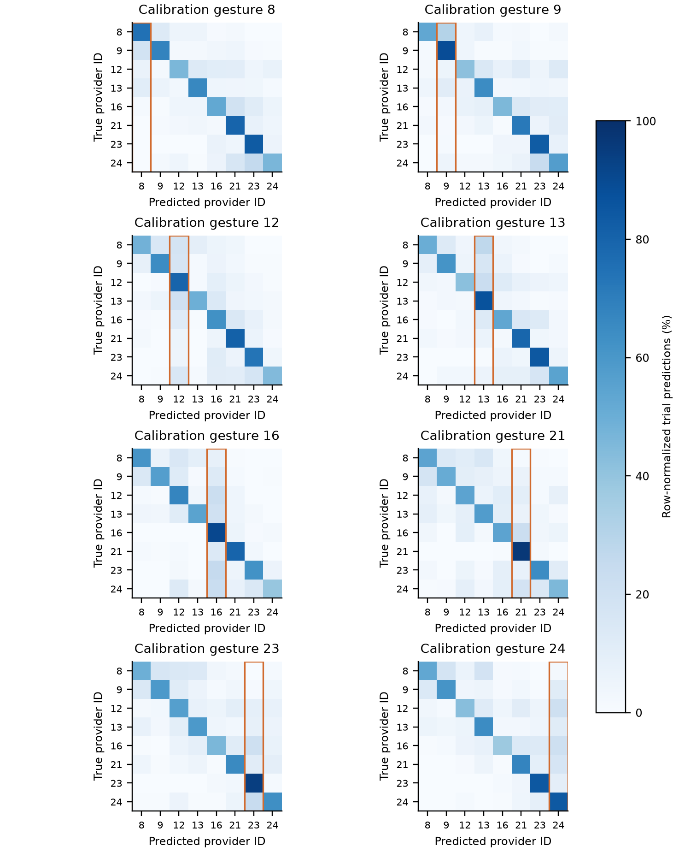
Figure S3. Gain predictions conditioned on each calibration gesture. Rows are true provider IDs and columns predicted IDs. Orange outlines identify the calibration-label column. Each row is normalized within a case, then averaged over 20 pairs within participant and equally over four participants. Every panel uses the same 0–100% scale. These matrices describe errors and do not prove a representation-level mechanism.

S7 Confusion matrices for spatial
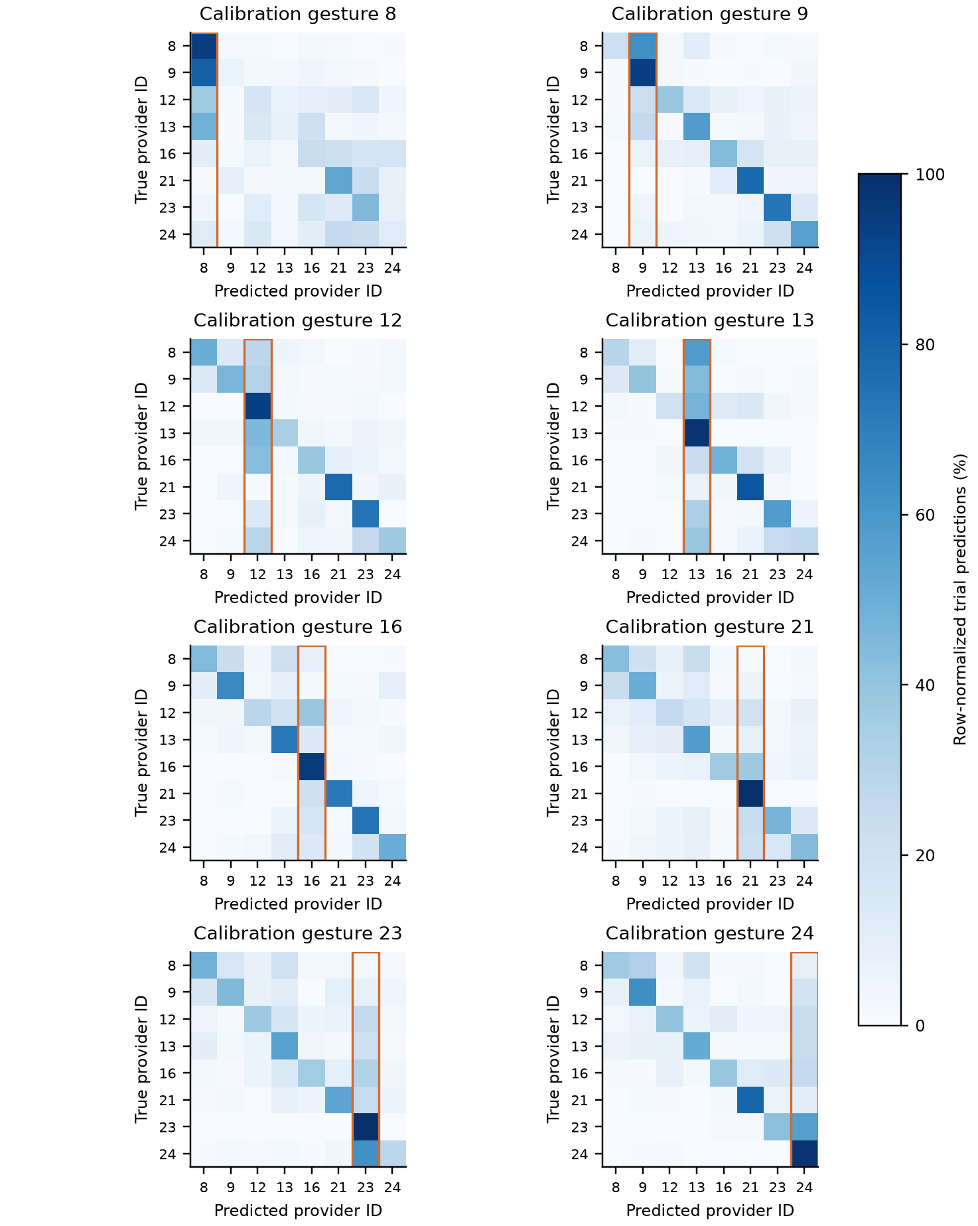
Figure S4. Spatial predictions conditioned on each calibration gesture. Rows are true provider IDs and columns predicted IDs. Orange outlines identify the calibration-label column. Each row is normalized within a case, then averaged over 20 pairs within participant and equally over four participants. Every panel uses the same 0–100% scale. These matrices describe errors and do not prove a representation-level mechanism.

S8 Confusion matrices for spatial + gain
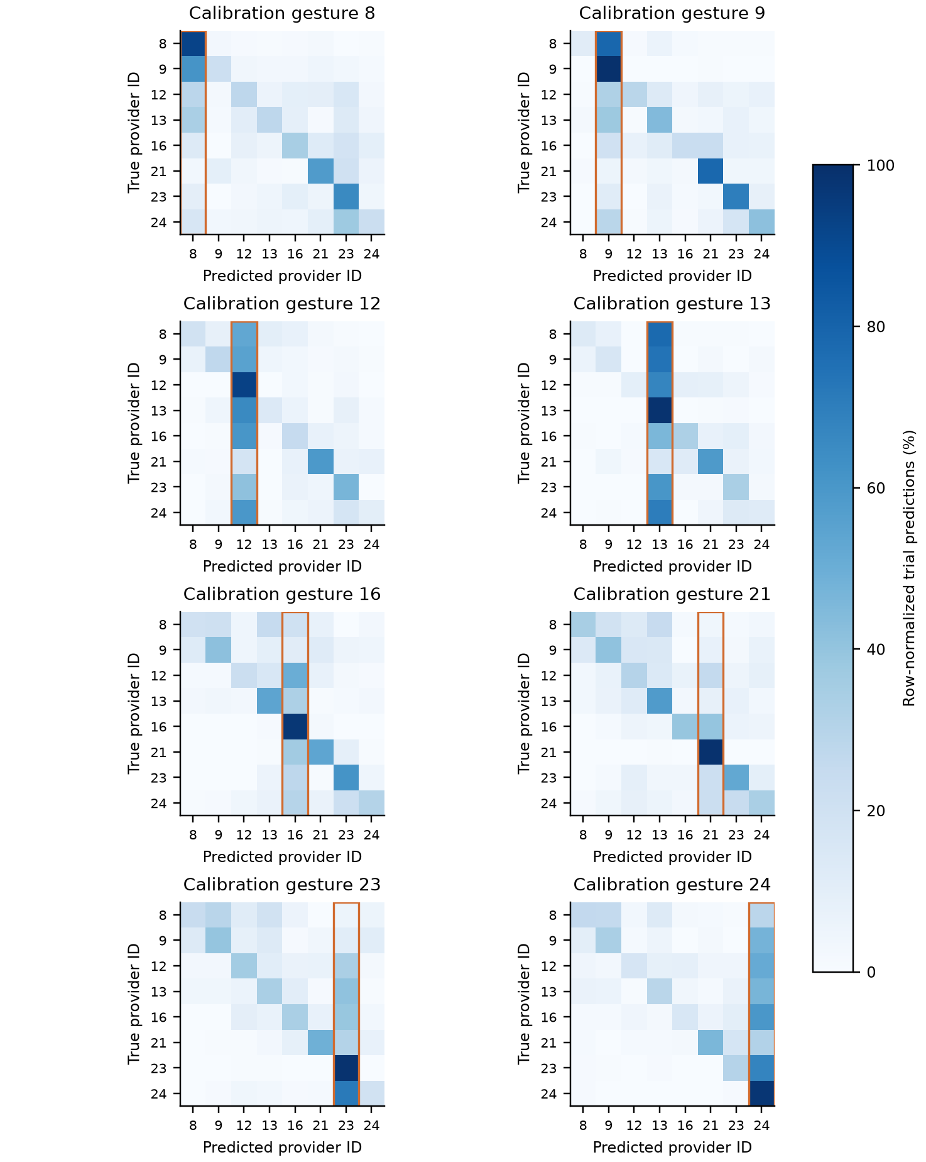
Figure S5. Spatial + gain predictions conditioned on each calibration gesture. Rows are true provider IDs and columns predicted IDs. Orange outlines identify the calibration-label column. Each row is normalized within a case, then averaged over 20 pairs within participant and equally over four participants. Every panel uses the same 0–100% scale. These matrices describe errors and do not prove a representation-level mechanism.

S9 Confusion matrices for fine-tuning
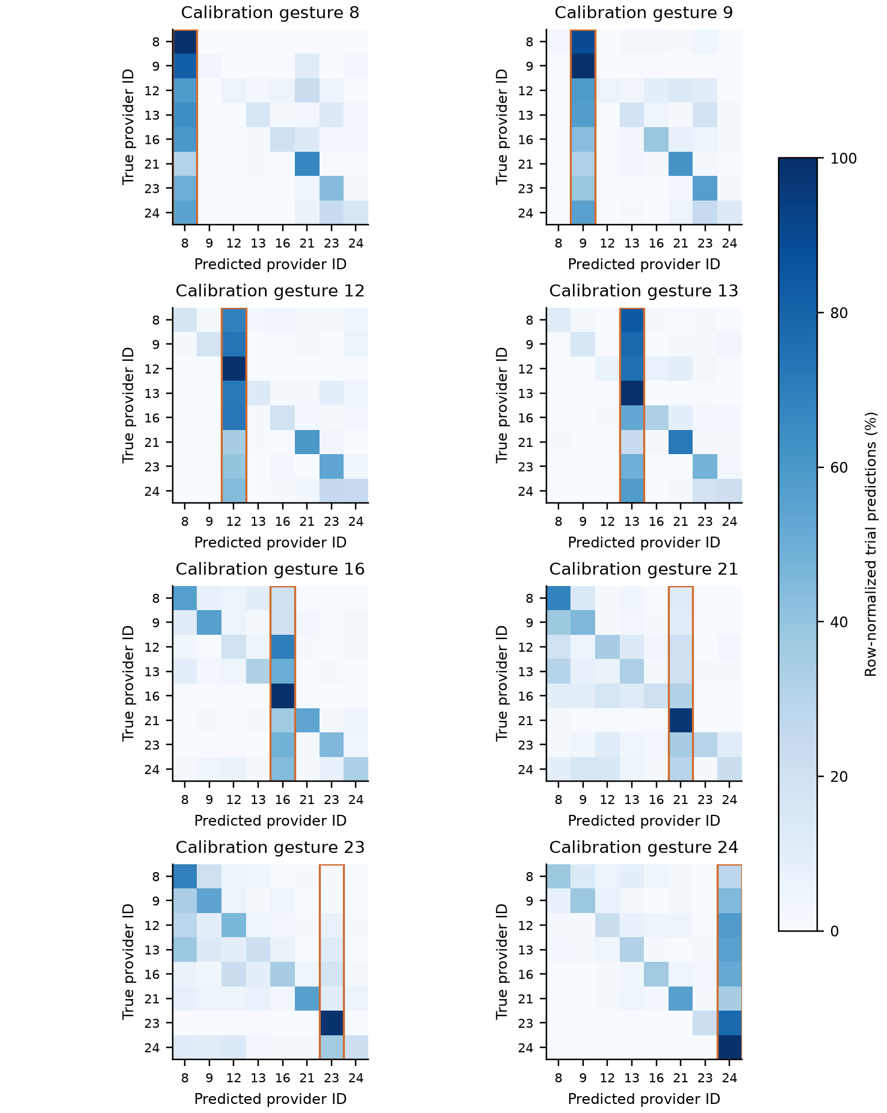
Figure S6. Fine-tuning predictions conditioned on each calibration gesture. Rows are true provider IDs and columns predicted IDs. Orange outlines identify the calibration-label column. Each row is normalized within a case, then averaged over 20 pairs within participant and equally over four participants. Every panel uses the same 0–100% scale. These matrices describe errors and do not prove a representation-level mechanism.

S10 Confusion matrices for fine-tuning + gain
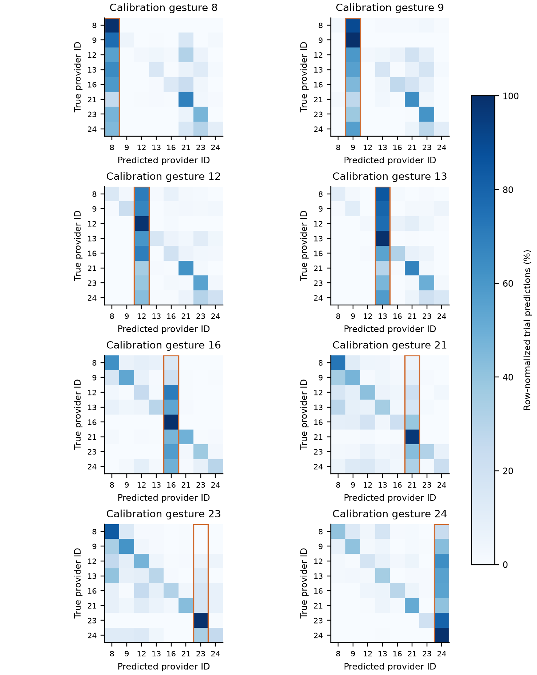
Figure S7. Fine-tuning + gain predictions conditioned on each calibration gesture. Rows are true provider IDs and columns predicted IDs. Orange outlines identify the calibration-label column. Each row is normalized within a case, then averaged over 20 pairs within participant and equally over four participants. Every panel uses the same 0–100% scale. These matrices describe errors and do not prove a representation-level mechanism.

