Numerical Methods Homework-2

B10602110 四電子三乙 呂和軒

1 Find the Taylor series for f (x) = x3 −10x2 +6 about x =5.

ANS :

1. Result :

在x=5處展開

f(5) = 3*125 – 10*25 + 6 = -119

f(1)(5) = 3*25 – 20*5 = -25

f(2)(5) = 6 *5 – 20 = 10

f(3)(5) = 6

f(x) = -119 + (-25)*(x-5) + (10/2!)*(x-5)^2 + (6/3!)*(x-5)^3

2 Show that $\frac{de^{x}}{dx}=e^{x}$ from the viewpoint of Taylor expansion.

ANS :

1. Result :

$e^{x}=1+\frac{1}{1!}x+\frac{1}{2!}x^{2}+\frac{1}{3!}x^{3}+...+\frac{1}{n!}x^{n} , n→ ∞$

$\frac{de^{x}}{dx}=0+1+\frac{1}{1!}x+\frac{1}{2!}x^{2}+...+\frac{1}{n-1!}x^{n-1} , n→∞$

因此 $e^{x}=\frac{{de}^{x}}{dx}$

3(a) Find the Taylor series of sin(x) , and then plot the error as a function of the

number of iteration.

ANS :

1. Code_function :

Sin_taylor.m

function [result] = sin_taylor(x,n)

sign = 1;

result = 0;

fac = 1;

x_m = x;

for i = 1:n

result = result + sign.*x_m./fac;

fac = fac*(2*i)*(2*(i)+1);

sign = sign*-1;

x_m = x_m .* x .* x;

end

end

1. Code_main :

close all

clear all

format long

iter_n = 30;

posi_x = 1;

error = [];

for i = 1:iter_n

result = sin_taylor(posi_x,i);

real_r = sin(1);

error = [error,real_r - result]

end

plot(1:30,error,'x-')

hold on

set(gca,'xtick',-1:2:30)

set(gca,'ytick',-1:0.1:+1)

ylim([-0.5,0.5])

1. Result :

圖(3-a)

3(b) Also find the Taylor series for the even function cos(x) , and then plot it as

family curves ranging from n=0 to n=4.

ANS :

1. Code_function :

cos_taylor.m

function [result] = cos_taylor(x,n)

sign = 1;

result = 0;

fac = 1;

x_m = x.^0;

for i = 1:n

result = result + sign.*x_m./fac;

fac = fac*(2*i)*(2*(i)-1);

sign = sign*-1;

x_m = x_m .* x .* x;

end

end

1. Code_main :

close all

clear all

format long

iter_n =5;

posi_x = -2*pi:0.1:2*pi

M = [];

for i = 1:iter_n

result = cos_taylor(posi_x,i);

plot(posi_x,result,'-')

M = [M;'iter = '+string(i-1)]

hold on

end

real_r = cos(posi_x);

plot(posi_x,real_r,'k--')

M = [M;'real cos']

legend(M)

y_axis = 5;

x_axis = 7;

set(gca,'xtick',-x_axis:1:x_axis)

xlim([-x_axis,x_axis])

set(gca,'ytick',-y_axis:0.5:+y_axis)

ylim([-y_axis,y_axis])

xlabel('x')

ylabel('cos(x)')

1. Result :

圖(3-b)

3(c) Plot the real part and imaginary part of the complex function f (x, y) = $e^{x+iy}$.

ANS :

1. Code_main :

close all

clear all

i = sqrt(-1)

func =@(x,y) exp(x+i.*y);

x_range = -pi:0.1:pi;

y_range = -2*pi:0.1:2*pi;

[xx,yy] = meshgrid(x_range,y_range);

zz = func(xx,yy);

z_r = real(zz);

z_i = imag(zz);

figure(1)

mesh(xx,yy,z_r)

xlabel('x')

ylabel('y')

zlabel('z_r')

figure(2)

mesh(xx,yy,z_i)

xlabel('x')

ylabel('y')

zlabel('z_i')

figure(3)

mesh(xx,yy,sqrt(z_r.^2+z_i.^2))

xlabel('x')

ylabel('y')

zlabel('radius')

figure(4)

mesh(xx,yy,atan(z_i./z_r))

xlabel('x')

ylabel('y')

zlabel('agnle')

1. Result :

實部圖(3-c)、虛部圖(3-d)、絕對值長度圖(3-e)、角度圖(3-f)

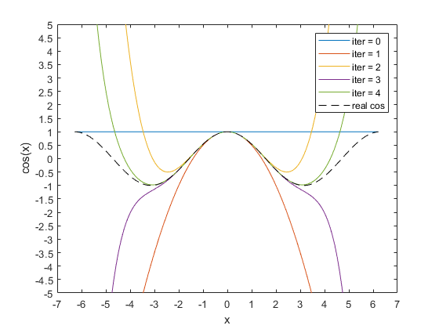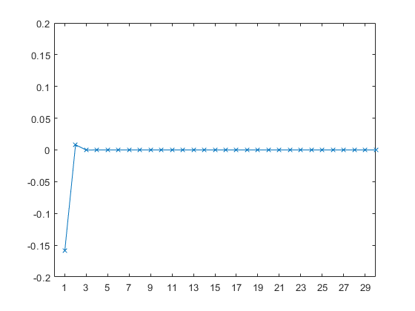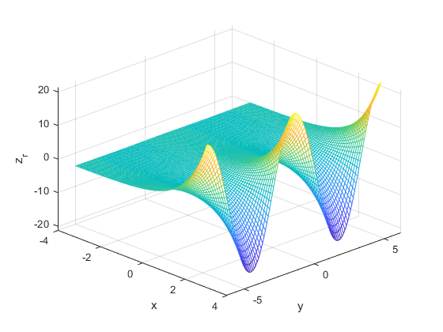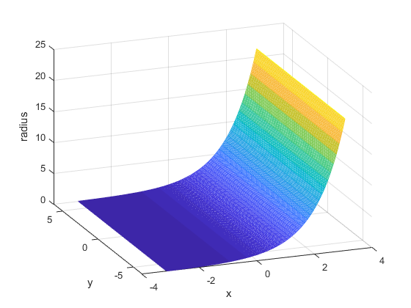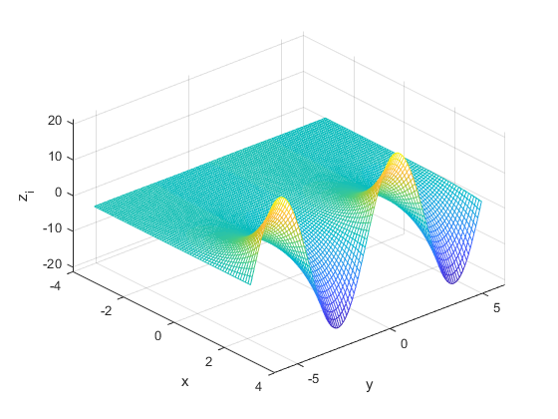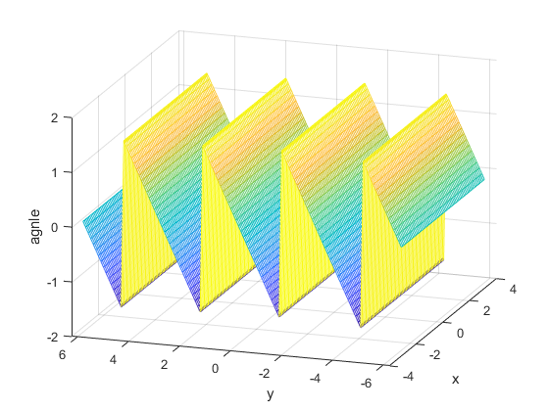

圖3-a Taylor_sin error of sin(1)

圖3-b Taylor_cos

圖3-c real part of $e^{x+iy}$

圖3-d imaginary part of $e^{x+iy}$

圖3-e  absolute value of $e^{x+iy}$

圖3-f   angle of $e^{x+iy}$