Numerical Methods Homework-2

B10602110 四電子三乙 呂和軒

1. Consider the following equation:



(a) Iterate parabolic interpolation 10 times to locate the minimum.

ANS :

1. Code_function :

function [xe]= parabolic(f,x1,x2,x3,iter)

x_m = [x1;x2;x3];

for n = 1:iter

n

f_m = f(x_m);

ai_2 = f_m(1)*(x_m(2)^2-x_m(3)^2)+f_m(2)*(x_m(3)^2-x_m(1)^2)+f_m(3)*(x_m(1)^2-x_m(2)^2)

ai_3 = f_m(1)*(x_m(2)-x_m(3))+f_m(2)*(x_m(3)-x_m(1))+f_m(3)*(x_m(1)-x_m(2))

xe = ai_2/(2*ai_3)

if(ismember(xe,x_m))

break;

end

[f_max,pos]= max(f_m,[],1);

x_m(pos) = xe;

end

end

1. Code_main :

close all

clear all

format long

x1 = 0.1

x2 = 1

x3 = 5

f = @(x) 2.*x+3./x;

iter = 10;

[x_min]= parabolic(f,x1,x2,x3,iter)

x=-5:0.01:5;

plot(x,f(x),'-k')

hold on

plot(x_min,f(x_min),'o')

text(x_min,f(x_min)+25,'min:('+string(x_min)+','+string(f(x_min))+')')

xlabel('x')

ylabel('f(x)')

1. Result :

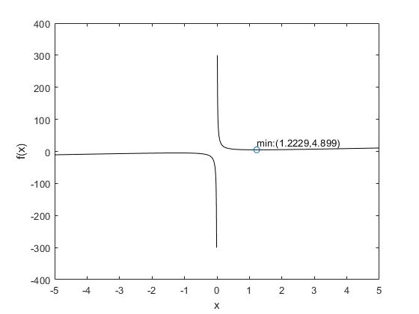

使用0.1、1、5作為初始值，迭代10-次的結果。

在x=1.2229時有區域最小值4.899

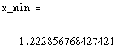

圖4-1-a local minimum

(b) Comment on the convergence of your results ( x1 =0.1, x2 =0.5, x3 =5).

ANS :

1. Result :

在0到點最小值之間為單調下降曲線，而點最小值至5之間為單調上升 曲線，符合二次曲線特徵，因此可以使用拋物線插值找出最小值，但經過插 值得出的頂點必須也落在0至5之間，若落在負區間則結果會發散。

2. Find the local minima and maxima of the following function ranging from 0 to 2.



(a) Use golden-section search.

ANS :

1. Code_function :

function [x]= golden_section(f,x1,x2,iter)

gr = (sqrt(5) + 1) / 2;

x3 = x1+(x2-x1)/gr

x4 = x2-(x2-x1)/gr

for n=1:iter

n

if(f(x3)>f(x4))

x2 = x3;

else

x1 = x4;

end

x3 = x1+(x2-x1)/gr

x4 = x2-(x2-x1)/gr

end

x = (x3+x4)/2

end

1. Code_main :

close all

clear all

format long

x1 = 0

x2 = 2

f = @(x) (9*exp(-x).*sin(2*pi*x)-3.5);

inv_f = @(x) -(9*exp(-x).*sin(2*pi*x)-3.5);

iter = 50;

[x_min]= golden_section(f,x1,x2,iter)

[x_max]= golden_section(inv_f,x1,x2,iter)

figure(1)

x=-0.5:0.01:2.5;

plot(x,f(x),'-k')

hold on

text(x_min,f(x_min)-0.6,'min:('+string(x_min)+','+string(f(x_min))+')')

text(x_max+0.1,f(x_max),'max:('+string(x_max)+','+string(f(x_max))+')')

plot(x_min,f(x_min),'ro')

plot(x_max,f(x_max),'gx')

xlabel('x')

ylabel('f(x)')

1. 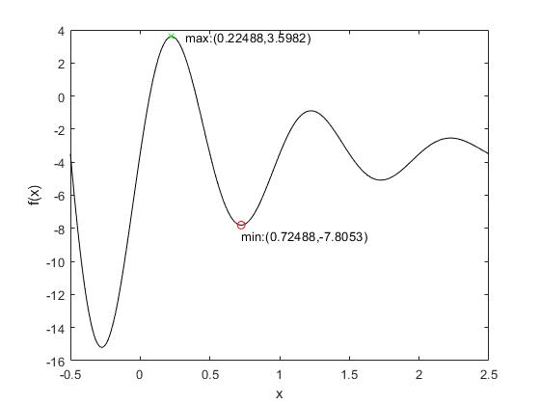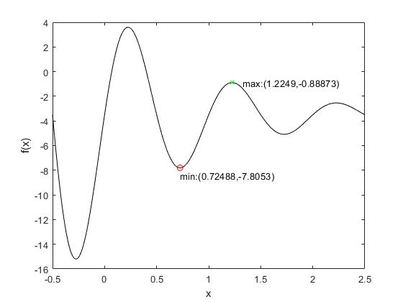Result :

圖4-2-a-2 local minimum and maxima

with initial value 0、1

圖4-2-a-1 local minimum and maxima

with initial value 0、2

若初始值使用0、2，則會因為計算得出的步幅過大而直接跨過最大值所在的位置，而找到錯誤的值。

(b) Use the brute force stepwise.

ANS :

1. Code_function :

function [x_min,x_max]= brute(f,x1,x2,precise)

x_range = x1:precise:x2;

f_m = f(x_range);

[f_min,pos_min] = min(f_m);

[f_max,pos_max] = max(f_m);

x_min = x_range(pos_min);

x_max = x_range(pos_max);

end

1. Code_main :

close all

clear all

format long

x1 = 0

x2 = 2

f = @(x) (9*exp(-x).*sin(2*pi*x)-3.5);

precise = 0.0001;

x=-0.5:0.01:2.5;

[x_min,x_max]=brute(f,x1,x2,precise)

plot(x,f(x),'-k')

hold on

text(x_min,f(x_min)-0.6,'min:('+string(x_min)+','+string(f(x_min))+')')

text(x_max+0.1,f(x_max),'max:('+string(x_max)+','+string(f(x_max))+')')

plot(x_min,f(x_min),'ro')

plot(x_max,f(x_max),'gx')

xlabel('x')

ylabel('f(x)')

1. Result :

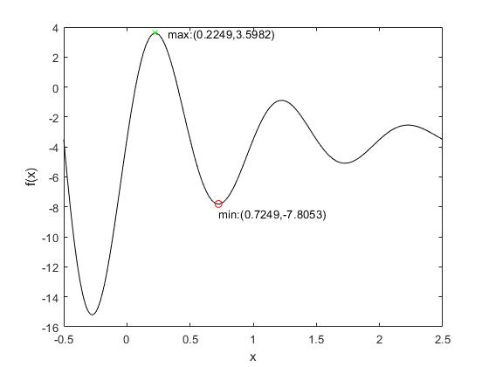

使用精度為0.0001，範圍從0到2。

圖4-2-b local minimum and maxima

3. Given:



Use a root-location technique to determine the maximum of this function.

ANS :

1. Code_function :

function[root] = newton(f,x0,c,iter,error_std)

eps = 1e-6;

for n = 1:iter

n;

m = (f(x0+eps,c)-f(x0,c))/eps;

x1 = x0-f(x0,c)/m;

error = abs(x1-x0)/x0;

x0 = x1;

end

root = x1;

end

1. Code_main :

close all

clear all

format long

f = @(x,c) -2.*x.^6-1.5.*x.^4+10.*x+2+c

%f_b = @(x) -2.*x.^6-1.5.*x.^4+10.*x+2

x0 = 5;

c = 0;

iter = 20

error_std = 0.00

c_iter = 0

x= -0.5:0.01:1;

plot(x,f(x,0))

hold on

root0 = 0;

root1 = 0;

root = [];

while(1)

x0 = 5;

root0 = newton(f,x0,c,iter,error_std);

x0 = -5;

root1 = newton(f,x0,c,iter,error_std);

if(root1 > root0)

max_range = root

break

end

root = [];

root = [root,root0,root1];

f_root = f(root,0);

plot(root(1),f_root(1),'ro')

hold on

plot(root(2),f_root(2),'bx')

c = c - 0.005;

c_iter = c_iter + 1

end

xlabel('x')

ylabel('f(x)')

figure(2)

x= max_range(2)-0.01:0.0001:max_range(1)+0.01;

plot(x,f(x,0))

hold on

plot(max_range(2),f(max_range(2),0),'bx')

hold on

plot(max_range(1),f(max_range(1),0),'ro')

xlabel('x')

ylabel('f(x)')

%[x_min,x_max]=brute(f_b,0.87,0.89,0.0000001)

1. 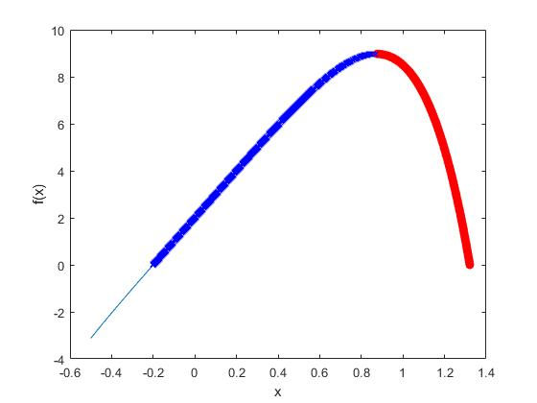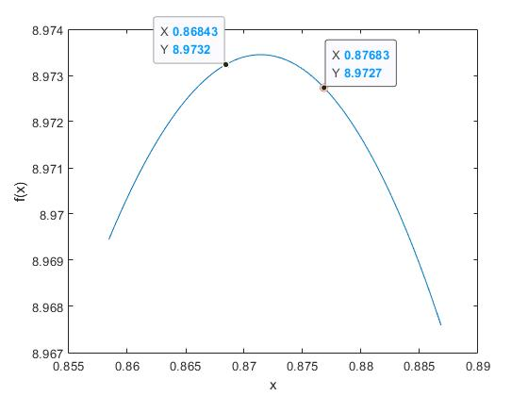Result :

圖4-3-a find roots per f(x)-c

圖4-2-b maxima range

使用牛頓法找根，先從左右兩邊各找出一個根，接下來將函數減去0.005的偏移量，使f(x)圖形下降，再找出兩個根，漸漸逼近最大值，直到兩根交錯而停止，就可得到最大值的區間範圍。使用牛頓法的原因是因為函數為連續的，且在最大值附近的斜率變化較為平緩，沒有劇烈的變化，圖形凹口一致向下，使用牛頓法可以較穩定的找到根。