Numerical Methods Homework-5

B10602110 四電子三乙 呂和軒

1. Solve the following system:

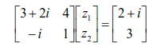

ANS :

1. Code_function :

function [X]=Cramer(A,B)

row = size(A,1);

col = size(A,2);

if(row ~= col)

fprintf('row != col')

X = [];

return

end

X = [];

d_A = det(A);

for j = 1:col

A_temp = A;

for i = 1:row

A_temp(i,j) = B(i,1);

end

x_ = det(A_temp)/d_A;

X = [X;x_];

end

end

1. Code_main :

close all

clear all

format long

i = sqrt(-1)

A = [3+2i,4;-i,1]

b = [2+i;3]

x_ans = Cramer(A,b)

1. Result:

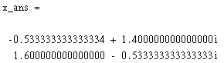

2. Solve the following tridiagonal system:

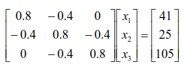

ANS :

1. Code_function :

function [X]=Tridiagonal(e,f,g,r)

n = size(f,2)

X = []

for k = 2:n

factor = e(k)/f(k-1);

f(k) = f(k) - factor*g(k-1);

r(k) = r(k) - factor*r(k-1);

end

X(n) = r(n)/f(n);

for k = n-1:-1:1

X(k) = (r(k)-g(k)*X(k+1))/f(k)

end

end

1. Code_main :

close all

clear all

format long

i = sqrt(-1)

e = [0,-0.4,-0.4]

f = [0.8,0.8,0.8]

g = [-0.4,-0.4,0]

b = [41,25,105]

[X]=Tridiagonal(e,f,g,b)

1. Result:

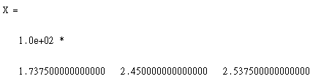

3. (a)Determine the LU factorization without pivoting by hand for the following matrix and check your results by validating that [L][U]=[A].

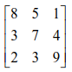

ANS :

(b). Employ the result of (a) to compute the determinant.

ANS:

(c). To verify your answer, repeat (a) and (b) using MATLAB.

ANS:

1. Code_main:

close all

clear all

format long

A = [8,5,1;

3,7,4;

2,3,9]

[L,U] = lu(A)

det_A = det(L)*det(U)

1. 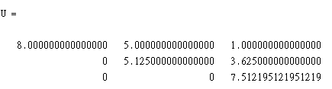Result:

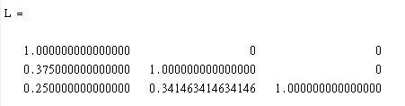

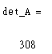

4. One of the ill-conditioned matrices is the Vandermonde matrix, which has the   
 following form:

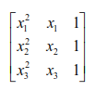

(a). Determine the condition number based on the row-sum norm for the case where

x1 = 4 , x2 = 2 , and x3 = 7 .

ANS:

1. Code_main:

close all

clear all

format long

A = [4^2,4,1;

2^2,2,1;

7^2,7,1]

inv_A = inv(A)

row_sum_A = norm(A,inf)

row_sum_inv_A = norm(inv_A,inf)

cond_row_sum = row_sum_A*row_sum_inv_A

1. Result:

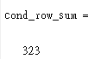

(b). Find the spectral and Frobenius condition numbers.

ANS:

1. Code_main:

close all

clear all

format long

A = [4^2,4,1;

2^2,2,1;

7^2,7,1]

inv_A = inv(A)

%spectral

sp_A = norm(A,2)

sp_inv_A = norm(inv_A,2)

cond_spe = sp_A*sp_inv_A

cond_2 = cond(A,2)

%Fro

Fro_A = norm(A,'fro')

Fro_inv_A = norm(inv_A,'fro')

cond_Fro = Fro_A*Fro_inv_A

cond_Fr = cond(A,'fro')

1. Result:

 