Numerical Methods Homework-6

B10602110 四電子三乙 呂和軒

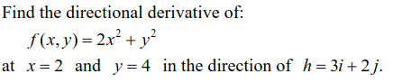1.

ANS :

1. Code\_main :

close all

clear all

format long

f =@(x,y) -(2.\*x.^2+y.^2)

[xx,yy]=meshgrid(-1:0.1:7);

mesh(xx,yy,f(xx,yy))

%% gradient

delta = 1e-6;

x\_p = 2;

y\_p = 4;

fx = (f(x\_p+delta,y\_p)-f(x\_p,y\_p))/delta;

fy = (f(x\_p,y\_p+delta)-f(x\_p,y\_p))/delta;

d\_f = [fx,fy];

%% directional derivative

dir\_v = [3,2]';

dir\_v = dir\_v./(dir\_v'\*dir\_v) ;

d\_d = d\_f\*dir\_v;

v\_x = linspace(x\_p,x\_p+3,50);

v\_y = linspace(y\_p,y\_p+2,50);

hold on

quiver3(x\_p,y\_p,0,3,2,0,'r','filled','LineWidth',2);

fprintf('directional derivative = %f\n',d\_d)

%% tangent line

lambda=linspace(-1,1);

m = sqrt(d\_f\*d\_f');

fz = f(x\_p,y\_p);

x\_t = x\_p+lambda\*(sqrt(4/((fy/fx)^2+1)))/2;

y\_t = y\_p+lambda\*(sqrt(4/((fy/fx)^2+1)))/2\*fy/fx;

if(fx <= 0)

z\_t = fz +lambda\*-m;

else

z\_t = fz +lambda\*m;

end

plot3(x\_t,y\_t,z\_t,'k-','LineWidth',2,'MarkerSize',15)

plot3(x\_p,y\_p,fz,'o')

xlabel('x')

ylabel('y')

zlabel('z')

1. Result:



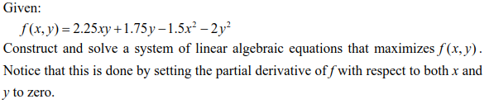2.

ANS :

1. Code\_main :

close all

clear all

format long

f =@(x,y) (2.25.\*x.\*y+1.75.\*y-1.5.\*x.^2-2\*y.^2)

[xx,yy]=meshgrid(-4:0.1:4);

mesh(xx,yy,f(xx,yy))

%% gradient

error = 1e-8;

fx = 1;

fy = 1;

lr = 1e-4;

delta = 1e-6;

x\_p = 7;

y\_p = 7;

while(abs(fx)>error || abs(fy)>error)

fx = (f(x\_p+delta,y\_p)-f(x\_p,y\_p))/delta

fy = (f(x\_p,y\_p+delta)-f(x\_p,y\_p))/delta

x\_p = x\_p + lr\*fx;

y\_p = y\_p + lr\*fy;

end

z\_p = f(x\_p,y\_p)

hold on

plot3(x\_p,y\_p,z\_p,'o')

xlabel('x')

ylabel('y')

zlabel('z')

fprintf("max point is (%f,%f,%f)\n",x\_p,y\_p,z\_p)

1. Result:

C:\Users\user\Desktop\pdf\數值方法\matlab\hw6_2jpg.JPG

3. 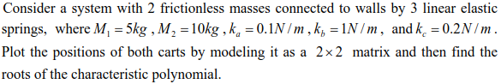

ANS :

1. Code\_main:

close all

clear all

format long

m1 = 5;

m2 = 10;

ka = 0.1;

kb = 1;

kc = 0.2;

syms w

A = [ka+kb-m1\*w^2, -kb;

-kb,ka+kb-m2\*w^2]

f = det(A)

root = double(solve(f));

w1 = root(1)

w2 = root(2)

B = [ka+kb-m1\*w2^2, -kb;

-kb,ka+kb-m2\*w2^2];

n\_v = null(B);

t = 0:0.1:50;

alpha = 1;

X = alpha .\* n\_v'

X1 = X(1)\*sin(w2.\*t);

X2 = X(2)\*sin(w2.\*t);

subplot('Position',[0.05 0.05 0.35 0.9]);

plot(X1,t)

set(gca,'xtick',[-1,-0.5,0,0.5])

set(gca,'YDir','reverse')

title('X1 sin wave')

subplot('Position',[0.4 0.05 0.35 0.9]);

plot(X2,t)

set(gca,'ytick',[])

set(gca,'YDir','reverse')

xlim([-1,1])

set(gca,'xtick',[-0.5,0,0.5,1])

title('X2 sin wave')

fprintf("w1 = %f , X1 = %f , X2 = %f \n",w1,X(1),X(2))

fprintf("w2 = %f , X1 = %f , X2 = %f \n",w2,X(1),X(2))

1. 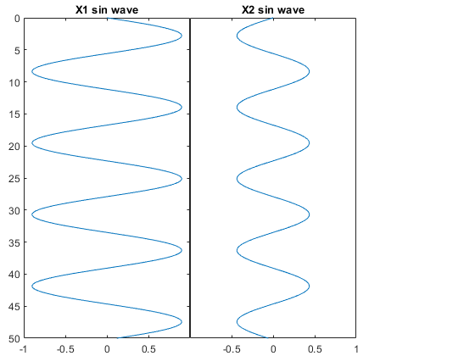C:\Users\user\Desktop\pdf\數值方法\matlab\hw6_3_3.JPGC:\Users\user\Desktop\pdf\數值方法\matlab\hw6_3.JPG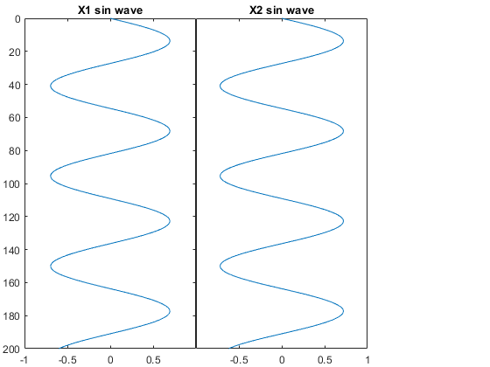Result:

**ω1** **ω2**

4. 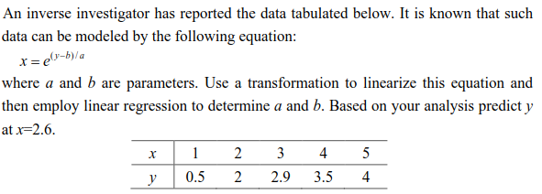

ANS:

1. Code\_main:

close all

clear all

format long

f = @(x,b,a) b+a.\*log(x)

f\_inv = @(y,b,a) exp((y-b)./a)

x = [1,2,3,4,5]

y = [0.5,2,2.9,3.5,4]'

A = [ones(size(x))',log(x)'] %\*[b;a]

cof = inv(A'\*A)\*A'\*y % b ; a

n = 0:0.01:7;

f\_y = f(n,cof(1),cof(2));

plot(n,f\_y,'--')

hold on

plot(x,y','o')

x\_p = 2.6;

y\_p = f(x\_p,cof(1),cof(2))

plot(x\_p,y\_p,'rx')

xlabel('x')

ylabel('y')

fprintf("a = %f , b = %f\n",cof(2),cof(1))

fprintf("x=2.6 , y\_predict = %f\n",y\_p)

1. Result:

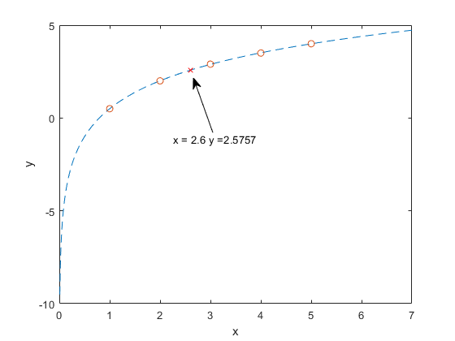 C:\Users\user\Desktop\pdf\數值方法\matlab\hw6_4_1.JPG

5.

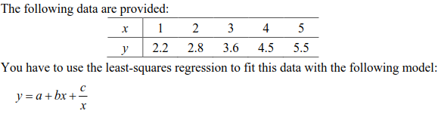

ANS :

1. Code\_main:

close all

clear all

format long

f = @(x,a,b,c) a+b.\*x+c./x

x = [1,2,3,4,5]

y = [2.2;2.8;3.6;4.5;5.5];

A = [ones(size(x))',x',1./x'] %\*[b;a]

cof = inv(A'\*A)\*A'\*y % b ; a

n = 0.1:0.01:7;

f\_y = f(n,cof(1),cof(2),cof(3));

plot(n,f\_y,'--')

hold on

plot(x,y','o')

xlabel('x')

ylabel('y')

fprintf("a = %f , b = %f , c = %f\n",cof(1),cof(2),cof(3))

1. Result:

C:\Users\user\Desktop\pdf\數值方法\matlab\hw6_5_1.JPG