圖像大小:224x320

Batchsize:16

GPU V100

|  |  |  |  |
| --- | --- | --- | --- |
| Model | Params(M) | Average Runtime(ms) | Mult-Adds(G) |
| YOLO_v3 | 61.94 | 2.2 | 13.64 |
| yoloatt_v3_split | 67.49 | 2.4 | 15.25 |

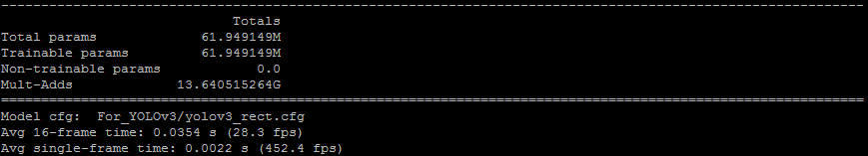

圖一、YOLO_v3

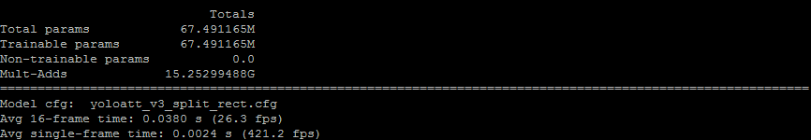

圖二、yoloatt_v3_split