Simple document

Waveley Qiu

2021-09-16

I’m an R Markdown document!

# Section 1

Here’s a **code chunk** that samples from a *normal distribution*:

samp = rnorm(100)  
length(samp)

## [1] 100

# Section 2

I can take the mean of the sample, too! The mean is -0.1304654.

# Section 3

Let’s write a new code chunk.

This code chunk imports the tidyverse, creates a data frame and makes a histogram.

set.seed(1234)  
  
plot_df =   
 tibble(  
 x = rnorm(1000, sd = 0.5),  
 y = 1 + 2*x + rnorm(1000),  
 y_quad = 1 + 2 * x^2 + rnorm(1000)  
 )  
plot_df  
## # A tibble: 1,000 x 3  
## x y y_quad  
## <dbl> <dbl> <dbl>  
## 1 -0.604 -1.41 0.755   
## 2 0.139 1.58 0.939   
## 3 0.542 0.545 1.48   
## 4 -1.17 -0.710 4.94   
## 5 0.215 2.13 -0.564   
## 6 0.253 -0.400 0.0824  
## 7 -0.287 1.36 -0.575   
## 8 -0.273 0.229 1.66   
## 9 -0.282 -0.238 0.713   
## 10 -0.445 0.556 -0.443   
## # ... with 990 more rows  
ggplot(plot_df, aes(x = x)) + geom_histogram()

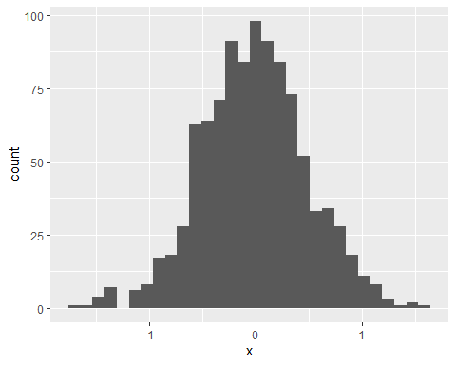

ggplot(plot_df,aes(x = x, y = y)) + geom_point()

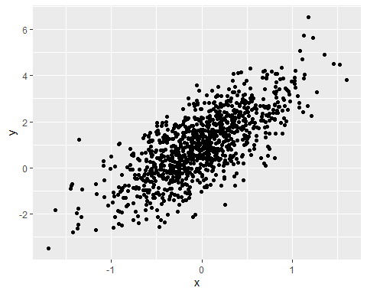

ggsave("output/scatterplot.pdf", height = 4, width = 6)

# Section 4

This is the learning assessment from the course website.

set.seed(20210916)  
plot_df2 <-  
 tibble(  
 vec_rand = rnorm(500, mean = 1),  
 vec_log = vec_rand > 0,  
 vec_absnum = abs(vec_rand)  
 )  
  
ggplot(data = plot_df2, aes(x = vec_absnum)) + geom_histogram() + theme_minimal()  
## `stat_bin()` using `bins = 30`. Pick better value with `binwidth`.

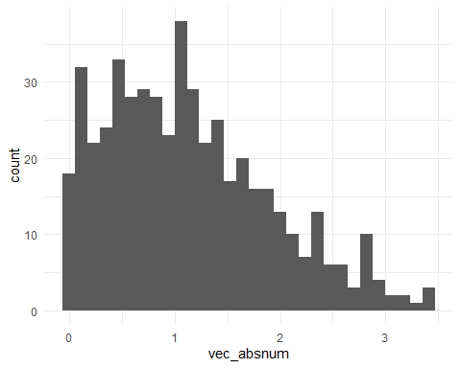

round(median(plot_df2$vec_absnum), 2)  
## [1] 1.05

The rounded median of the absolute values of the random sample from the normal distribution is 1.05.

# YAML header options for html_document output

output: html_document: toc: TRUE toc_float: TRUE code_folding: hide