Background
Schema-based decision making requires participants to combine prior familiarity, reward value, and accumulated evidence under time pressure. In the present task, participants first explore different schemas, such as authors of paintings or quotes, and then make repeated decisions by selecting a schema and choosing four matching items.

The supplied model describes schema-based learning and decision-making in which participants repeatedly alternate between exploration and choice. At the start of the simulation, it initializes schema-specific and generic confidence using information such as familiarity, payoff, and novelty status. During exploration, participants gather information from different schemas, and this updates confidence through a nonlinear learning rule. In the decision phase, the model combines confidence and payoff to compute the value of each schema, which guides the selection of four matching items. After each decision, accuracy and performance are evaluated, and the resulting feedback is used to update confidence for future rounds. The model outputs both final choices and process measures, such as reaction times, attention shifts, and dwell times.

Aims and Results
This project focused on two related questions: whether some participants may give up pursuing the schema-matching bonus and instead adopt a faster, payoff-oriented strategy, and whether different initial confidence settings, especially for familiar and novel schemas, shape later performance.

To examine the first question, I compared a baseline model with two reduced-threshold variants, medium and fast. In these variants, thres_schema, thres_item_inter, and thres_item_final were progressively reduced, and decay_speed_thres was slightly lowered. These changes were expected to produce faster and less schema-consistent responding. Each condition was simulated with 20 subjects, and mean accuracy (AC), schema decision time (Schema_RT), first-item reaction time (RT_1), performance, and selected schema payoff were compared across conditions.
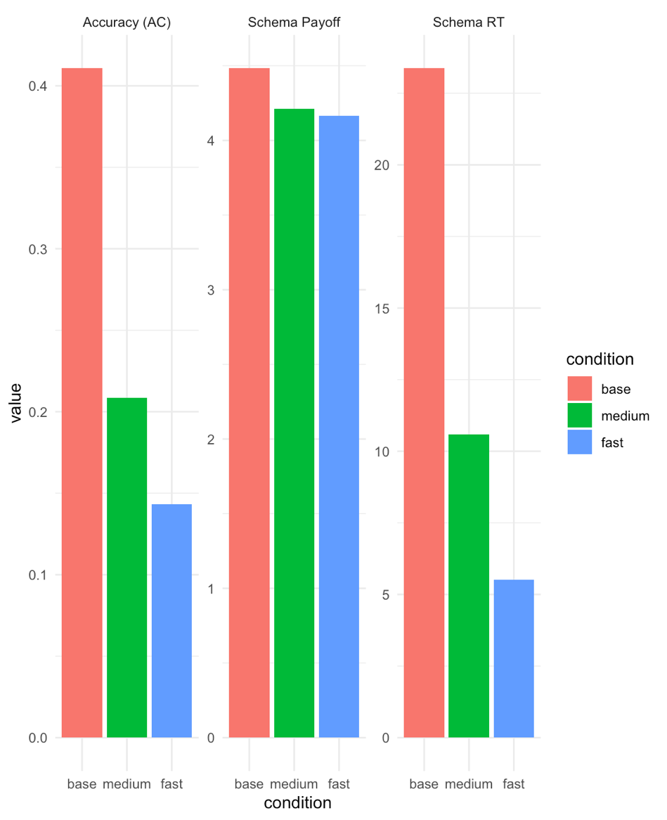

Figure 1. Mean accuracy, schema decision time, and selected schema payoff under different threshold settings
The figure compares mean accuracy (AC), mean schema decision time (Schema_RT), and mean selected schema payoff (schema_payoff) across the baseline, medium, and fast conditions.

As shown in Figure 1, progressively lowering schema and item thresholds produced a clear shift toward faster but less accurate responding across the 20 simulated subjects. Mean schema decision time decreased from 23.4 in the baseline condition to 10.6 in the medium condition and 5.52 in the fast condition, while mean first-item reaction time decreased from 28.1 to 13.4 and 7.72. At the same time, mean accuracy declined from 0.411 to 0.209 and 0.143, and mean performance decreased from 31.6 to 23.1 and 20.3. Mean selected schema payoff also fell slightly, from 4.48 in the baseline condition to 4.21 in the medium condition and 4.17 in the fast condition.

Thus, lowering thresholds reproduced faster and less schema-consistent behavior, but did not increase preference for higher-paid schemas, suggesting that threshold reduction alone captures a speed–accuracy trade-off rather than a true reward-rate maximizing strategy.

To examine how initial confidence settings affect performance, I compared four initialization conditions: familiarity_same, familiarity_low, fixed_low, and payoff_low. These differed in how confidence was initialized for familiar schemas and for novel schemas introduced after the break. Each condition was simulated with 20 subjects, and mean accuracy, schema decision time, performance, and selected schema payoff were compared across the full task, the early rounds, and the early post-break phase.
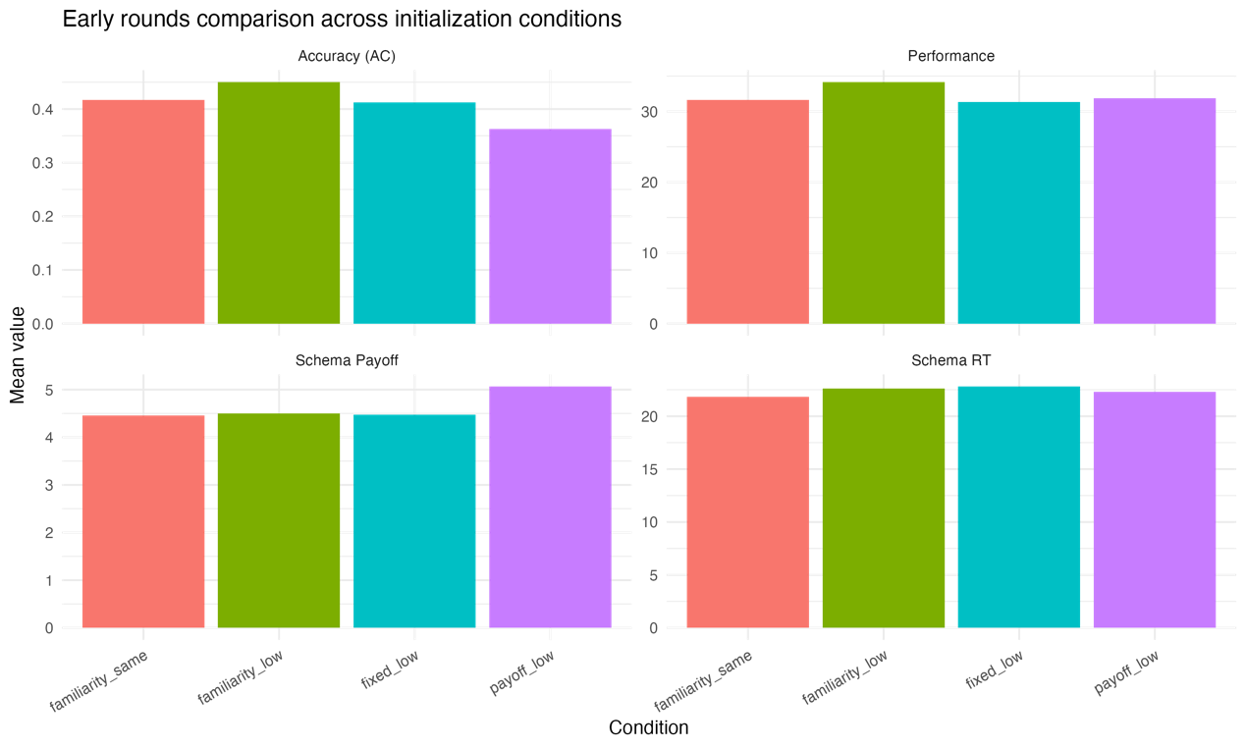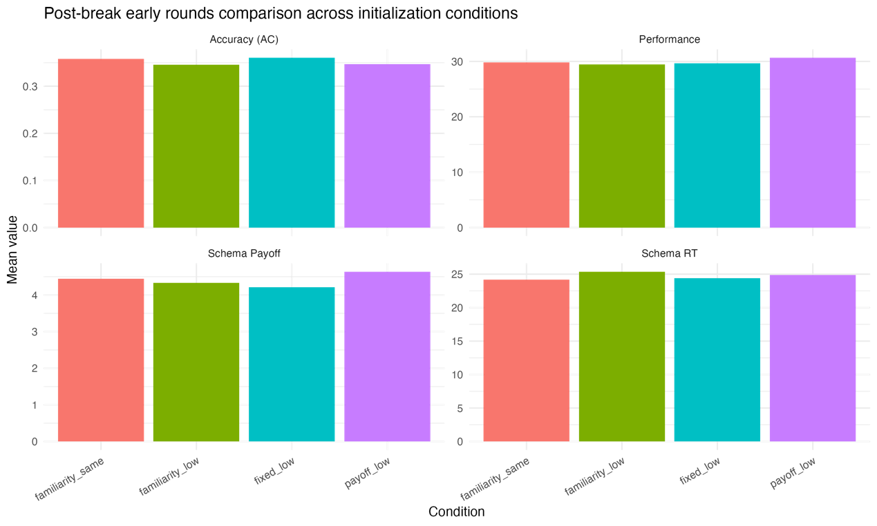
Figure 2. Effects of initialization settings on overall, early, and post-break model performance
The figure compares mean accuracy (AC), mean schema decision time (Schema_RT), mean performance, and mean selected schema payoff (schema_payoff) across initialization conditions for the overall task, the early rounds, and the early post-break phase.

As shown in Figure 2, differences between initialization conditions were modest overall. Mean accuracy ranged from 0.373 in payoff_low to 0.411 in familiarity_same, mean performance varied only slightly from 31.10 to 31.63, and schema decision time remained similar across conditions. The clearest overall difference was in selected schema payoff, which was highest in payoff_low (4.61), suggesting that payoff-based initialization increased selection of highly rewarded schemas without improving overall accuracy or performance. Initialization effects were more visible in the early rounds, where familiarity_low produced the highest mean accuracy (0.450) and performance (34.14), whereas payoff_low produced the highest early schema payoff (5.07) but the lowest early accuracy (0.363). This suggests that familiarity-based initialization with lower confidence for novel schemas supported better early learning, while payoff-based initialization mainly biased selection toward high-value schemas. After the break, differences became smaller: post-break accuracy ranged only from 0.346 to 0.360, performance from 29.44 to 30.65, and schema decision time remained similar across conditions. The main remaining difference was again in schema payoff, which stayed highest in payoff_low (4.64).

Overall, these results suggest that initialization had its strongest effects early in the task, with familiarity_low supporting better early performance and payoff_low increasing selection of high-payoff schemas, whereas post-break differences were comparatively modest.

Discussion

These results suggest that the current model captures some important features of schema-based decision-making, but not all of them. For Question 1, lowering thresholds made the model respond faster and less consistently, which supports the idea that some participants may shift from accuracy to speed when schema matching becomes too costly. However, this manipulation did not increase the selection of higher-paid schemas. This means that threshold reduction alone captures a general speed–accuracy trade-off, but not a true reward-rate maximizing strategy.

For Question 3, the effects of initialization were strongest in the early phase of the task. Familiarity-based initialization with lower confidence for novel schemas produced the best early accuracy and performance, which is consistent with the idea that prior familiarity can be translated into higher starting confidence. In contrast, payoff-based initialization consistently increased selection of high-payoff schemas, but did not improve accuracy, suggesting that it mainly introduced reward bias rather than better schema learning. After the break, differences between conditions became smaller, implying that continued learning gradually reduced the influence of initial settings.

Overall, the findings suggest that both strategy and prior confidence contribute to behavior in this task. Threshold parameters mainly influenced speed and consistency, whereas initialization rules mainly influenced early learning and early preferences. A limitation of the current model is that it does not fully reproduce payoff-oriented behavior, and the post-break differences remained relatively small. Future work could therefore include a more explicit reward-rate mechanism and more flexible rules for initializing novel schemas.

Supplementary methods
The mini-project used the supplied R model of schema-based learning and decision-making and focused on two sets of model manipulations. For Question 1, threshold-related parameters were altered while the rest of the model structure was kept unchanged. Specifically, thres_schema, thres_item_inter, and thres_item_final were progressively lowered, together with a small reduction in decay_speed_thres, to create medium and fast variants relative to the baseline condition.

For Question 3, the initialization of schema-specific confidence was modified. Four initialization conditions were created: familiarity_same, familiarity_low, fixed_low, and payoff_low. These conditions differed in how confidence was assigned to familiar schemas and to novel schemas introduced after the break. Familiar schemas were initialized either from prior familiarity, from payoff, or from a fixed value, while novel schemas were either initialized using the same rule as familiar schemas or with lower schema-specific confidence.

Each condition was simulated with 20 subjects using the same baseline parameter set unless explicitly changed. Model outputs were extracted from allresult_processed.csv and summarized in R. For Question 1, condition means were compared for AC, Schema_RT, RT_1, performance, and selected schema payoff. For Question 3, condition means were compared across the full task, the early phase (Round <= 3), and the early post-break phase (afterbreak == 1, Round <= 8). Subject-level means were computed first and then averaged across conditions. Figures were produced in ggplot2 as multi-panel bar plots.

Reflection
This mini-project helped me understand how computational models can be used not only to describe behavior but also to test specific theoretical questions. A key lesson was that a model manipulation may successfully reproduce one aspect of behavior without explaining the full phenomenon. For example, lowering thresholds captured faster and less consistent responding, but not stronger preference for high-payoff schemas. This made me think more carefully about the difference between a speed–accuracy trade-off and a true reward-oriented strategy.

Another important insight was that initialization matters mainly in the early phase of learning. Working on Question 3 showed me how prior familiarity, payoff, and novelty can be translated into model assumptions and then compared systematically. This strengthened my confidence in modifying existing code and designing targeted simulation conditions rather than only using default settings.

In future work, I would like to explore more flexible strategy parameters, especially mechanisms for reward-rate maximization and strategy switching. The course content on reinforcement-learning-like updating, decision processes, and model-based analysis was particularly helpful for showing autonomy and initiative, because it allowed me to move from a general research question to concrete computational tests and interpretable results.

Supplementary Table 1. Mean model outputs across baseline, medium, and fast conditions
Condition | Mean AC | Mean Schema_RT | Mean RT_1 | Mean Performance | Mean Schema Payoff
Base | 0.411 | 23.4 | 28.1 | 31.6 | 4.48
Medium | 0.209 | 10.6 | 13.4 | 23.1 | 4.21
Fast | 0.143 | 5.52 | 7.72 | 20.3 | 4.17

Supplementary Table 2. Mean model outputs across initialization conditions
Condition | Mean AC | Mean Schema_RT | Mean RT_1 | Mean Performance | Mean Schema Payoff
Familiarity_same | 0.4108 | 23.3728 | 28.1160 | 31.6063 | 4.4830
Familiarity_low | 0.3884 | 24.2292 | 28.6550 | 31.3771 | 4.4878
Fixed_low | 0.3949 | 23.4925 | 28.3278 | 31.6260 | 4.4748
Payoff_low | 0.3725 | 24.3602 | 82.3184 | 31.0985 | 4.6110

