A Computational Analysis of Bonus Abandonment and Confidence Initialization in Schema-Based Decision-Making

Roll number: 3021

Word counts: 972

Abstract
This mini-project used a computational model of schema-based learning and decision-making to examine strategy and initialization effects. Lowering decision thresholds produced faster but less accurate responding, indicating a speed–accuracy trade-off rather than a true payoff-maximizing strategy. Meanwhile, different confidence initialization rules had modest overall effects, but familiarity-based initialization with lower confidence for novel schemas produced better early performance, whereas payoff-based initialization biased selection toward high-payoff schemas.

Background
Schema-based decision making requires prior familiarity, reward value, and accumulated evidence during the exploration phase. In this task, participants repeatedly cycle between exploring different schemas, updating confidence, and making decisions by selecting a schema and choosing matching items(De Martino et al., 2013).

The supplied model can simulate schema-based learning and decision-making in which participants repeatedly alternate between exploration and choice. At the start of the simulation, it initializes the schema and generic confidence using familiarity, payoff, and novelty status. During exploration, participants learn information from different schemas, and this updates confidence through a nonlinear learning rule. In the decision phase, the model uses learned confidence together with accumulated evidence to select matching items(Bogacz et al., 2006). After each decision, accuracy and performance are evaluated, and the result is used to update confidence for future rounds. The model can output both final choices and process measures, such as reaction times, attention shifts, and dwell times.

Aims and Results
This project focused on two related questions: whether some participants may give up pursuing the schema-matching bonus and adopt a faster, payoff-oriented strategy, and whether different initial confidence settings (familiar and novel) could shape model performance.

To examine the first question, I compared a baseline model with two reduced-threshold types, medium and fast. In these types, thres_schema, thres_item_inter, and thres_item_final were reduced, and decay_speed_thres was slightly lowered. Each type was simulated with 20 repeats, and finally mean accuracy (AC), schema decision time (Schema_RT), first-item reaction time (RT_1), performance, and selected schema payoff were compared across conditions.
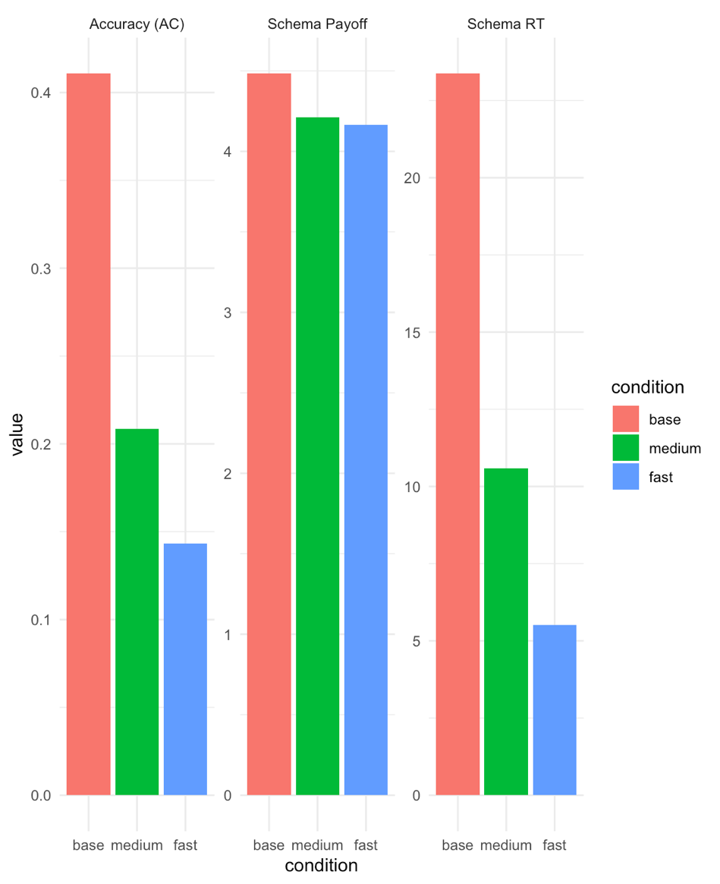
Figure 1. Mean accuracy, schema decision time, and selected schema payoff under different threshold settings
The figure compares mean accuracy (AC), mean schema decision time (Schema_RT), and mean selected schema payoff (schema_payoff) across the baseline, medium, and fast conditions.

As shown in Figure 1, lowering schema and item thresholds produced a clear shift toward faster but less accurate responding across the 20 repeats. Mean schema decision time decreased from 23.4 in the baseline condition to 10.6 in the medium condition and 5.52 in the fast condition, while mean first-item reaction time decreased from 28.1 to 13.4 and 7.72. At the same time, mean accuracy declined from 0.411 to 0.209 and 0.143, and mean performance decreased from 31.6 to 23.1 and 20.3. Mean selected schema payoff also fell slightly, from 4.48 in the baseline condition to 4.21 in the medium condition and 4.17 in the fast condition. Corresponding summary values for these comparisons are reported in Supplementary Table 1.

Thus, lowering thresholds led to faster and less schema-consistent behavior, but did not increase preference for higher-paid schemas, which suggests that making bonus pursuit too difficult leads to a speed–accuracy trade–off.

Then, to examine how initial confidence settings affect performance, I compared four initialization conditions: familiarity_same, familiarity_low, fixed_low, and payoff_low. These conditions differed in how starting confidence was set for familiar schemas and for new schemas after the break. In familiarity_same, both familiar and novel schemas followed the same familiarity-based rule. In familiarity_low, familiar schemas were initialized from prior familiarity, but novel schemas were assigned lower initial confidence. In fixed_low, familiar schemas all started from the same confidence level, whereas novel schemas again started lower. In payoff_low, familiar schemas were initialized according to payoff, and novel schemas were initialized with lower confidence. Each condition was simulated with 20 repeats, and after that, mean accuracy, schema decision time, performance, and selected schema payoff were compared in the early rounds and the early post-break phase.
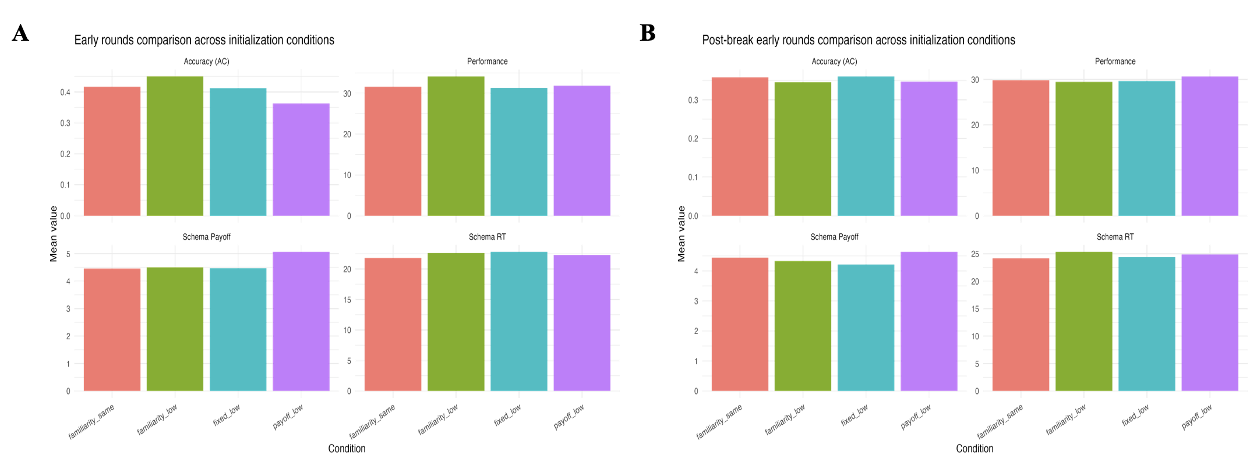
Figure 2. A: effects of initialization settings in the early rounds. B: effects of initialization settings in the early post-break phase. AC, accuracy; Schema_RT, schema decision time; schema_payoff, selected schema payoff.

Overall condition means (Supplementary Table 2) showed only modest differences between initialization conditions. Figure 2 shows the corresponding effects in the early rounds and the early post-break phase. Mean accuracy ranged from 0.373 in payoff_low to 0.411 in familiarity_same, mean performance varied only slightly from 31.10 to 31.63, and schema decision time remained similar across conditions. The clearest overall difference was in selected schema payoff, which was highest in payoff_low (4.61), suggesting that payoff-based initialization increased selection of highly rewarded schemas without improving overall performance. Initialization effects were more visible in the early rounds, where familiarity_low produced the highest mean accuracy (0.450) and performance (34.14), whereas payoff_low produced the highest early schema payoff (5.07) but the lowest early accuracy (0.363). This suggests that familiarity-based initialization with lower confidence for novel schemas supported better early learning, while payoff-based initialization mainly biased selection toward high-value schemas. After the break, differences became smaller: post-break accuracy ranged only from 0.346 to 0.360, performance from 29.44 to 30.65, and schema decision time remained similar across conditions. The main remaining difference was again in schema payoff, which stayed highest in payoff_low (4.64).

These results suggest that initialization had its strongest effects early in the task, with familiarity_low supporting better early performance and payoff_low increasing selection of high-payoff schemas, whereas post-break differences were comparatively modest.

Discussion
Overall, these findings may generalize to decision-making in two ways. First, when obtaining a reward becomes too difficult or time-consuming, people may shift toward faster but less reliable decisions rather than truly optimal reward-maximizing behavior. Second, prior familiarity may strongly shape early performance in real learning tasks, although this influence may weaken as experience accumulates(van Kesteren et al., 2012).

However, the model also has some important limitations. It did not fully reproduce a genuine payoff-oriented strategy, because faster responding was not accompanied by a stronger preference for high-payoff schemas(Bogacz et al., 2010). In addition, the post-break differences between initialization conditions remained relatively small, so the model provided only limited evidence about the best way to initialize novel schemas. Future work could therefore include a more explicit reward-rate mechanism, stronger payoff sensitivity, or strategy switching, as well as more flexible ways of initializing novel schemas after the break.

References:
Bogacz, R., Brown, E., Moehlis, J., Holmes, P., Cohen, J.D., 2006. The physics of optimal decision making: a formal analysis of models of performance in two-alternative forced-choice tasks. Psychol. Rev. 113, 700–765. https://doi.org/10.1037/0033-295X.113.4.700
Bogacz, R., Hu, P.T., Holmes, P.J., Cohen, J.D., 2010. Do humans produce the speed-accuracy trade-off that maximizes reward rate? Q. J. Exp. Psychol. 63, 863–891. https://doi.org/10.1080/17470210903091643
De Martino, B., Fleming, S.M., Garrett, N., Dolan, R.J., 2013. Confidence in value-based choice. Nat. Neurosci. 16, 105–110. https://doi.org/10.1038/nn.3279
van Kesteren, M.T.R., Ruiter, D.J., Fernández, G., Henson, R.N., 2012. How schema and novelty augment memory formation. Trends Neurosci. 35, 211–219. https://doi.org/10.1016/j.tins.2012.02.001

