Resultados Taller - Problem Set 1

Figura 1. Relación entre edad e ingreso laboral (log)
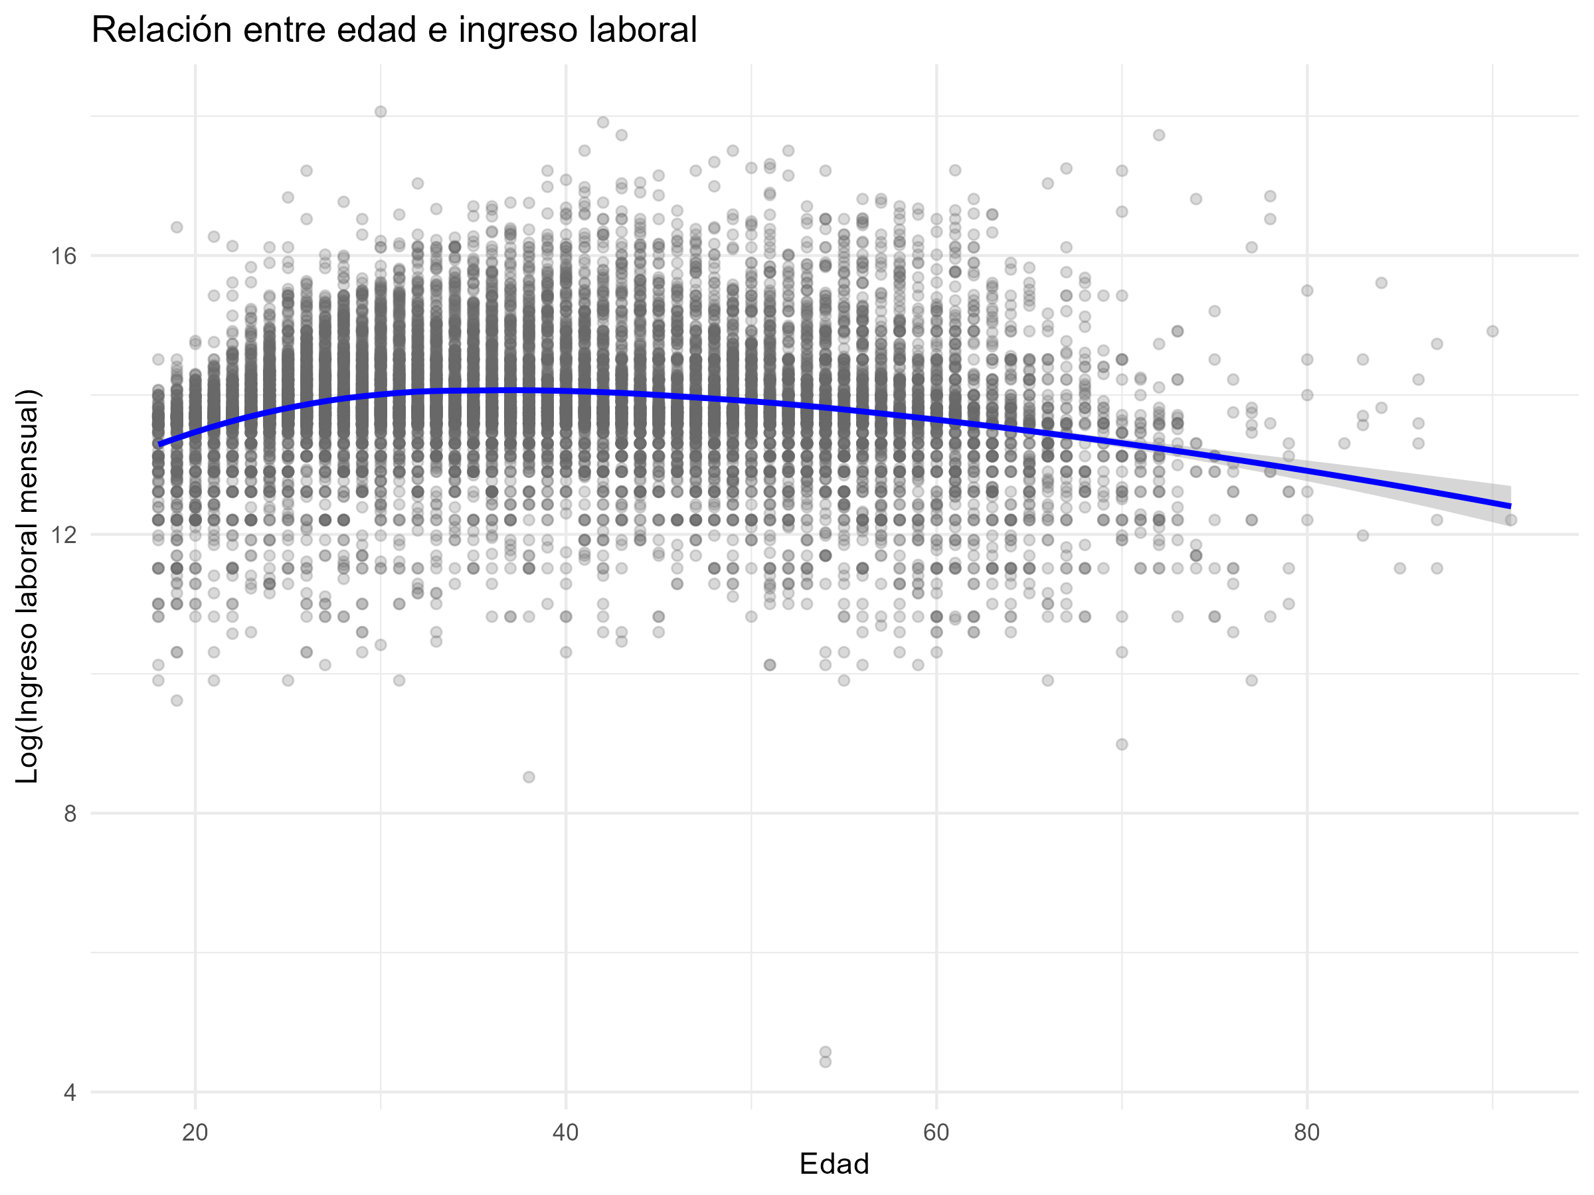

Section 1 - Punto 4: Regresiones edad–ingreso

Tabla 1. Coeficientes clave (Intercept, age, age2)
modelo | term | estimate | std.error | statistic | p.value
Lin sin controles | (Intercept) | 13.9827 | 0.0229 | 609.6328 | 0
Lin sin controles | age | -0.0029 | 0.0006 | -5.2624 | 0
Quad sin controles | (Intercept) | 12.3545 | 0.0636 | 194.2410 | 0
Quad sin controles | age | 0.0835 | 0.0032 | 26.0330 | 0
Quad sin controles | age2 | -0.0010 | 0.0000 | -27.3466 | 0
Lin con controles | (Intercept) | 13.2231 | 0.0304 | 435.2990 | 0
Lin con controles | age | 0.0026 | 0.0005 | 4.9751 | 0
Quad con controles | (Intercept) | 12.0231 | 0.0595 | 202.1032 | 0
Quad con controles | age | 0.0698 | 0.0029 | 23.8462 | 0
Quad con controles | age2 | -0.0008 | 0.0000 | -23.3164 | 0

Tabla 2. Ajuste del modelo (N y R²)
modelo | nobs | r.squared
Lin sin controles | 14,764 | 0.0019
Quad sin controles | 14,764 | 0.0500
Lin con controles | 14,764 | 0.1979
Quad con controles | 14,764 | 0.2264

Tabla 3. Peak age (bootstrap percentil 95%)
estimacion | peak_age_hat | ci95_low_perc | ci95_high_perc | B
Peak age (quad sin controles) | 40.6178 | 40.0587 | 41.1661 | 10,000

Section 2 - Punto 5: Gender labor income gap

Tabla 4. Coeficiente de género (no condicional vs condicional)
modelo | beta_female
No condicional: log_w ~ female | -0.2379
Condicional (directo): log_w ~ female + relab + informal | -0.2044
Condicional (FWL): y_resid ~ sex_resid | -0.2044

Tabla 5. Errores estándar del coeficiente de género (FWL)
objeto | se_analitico | se_bootstrap | B
Coeficiente género (FWL: sex_resid) | 0.0127 | 0.0129 | 10,000

