Переводы*

Если вы хотели бы работать с документацией на английском языке, опишите, пожалуйста, любой экран мобильного приложения Ozon на английском языке.

**Product Details Screen in the Ozon Mobile App**

The Product Details screen in the Ozon mobile app provides comprehensive information about a specific product.

At the top of the screen, there is a carousel of high-quality images showcasing the product from various angles. Users can swipe through these images to get a better visual understanding of the item.

Below the images, the product's name is prominently displayed. The price is clearly visible, along with any discounts or promotions currently applicable to the product.

Users can also view the product's availability and estimated delivery time based on their location.

If the user decides to purchase the product, they can select the desired quantity and add it to their cart using the "Add to Cart" button. Alternatively, they can save the item to their wishlist for future reference.

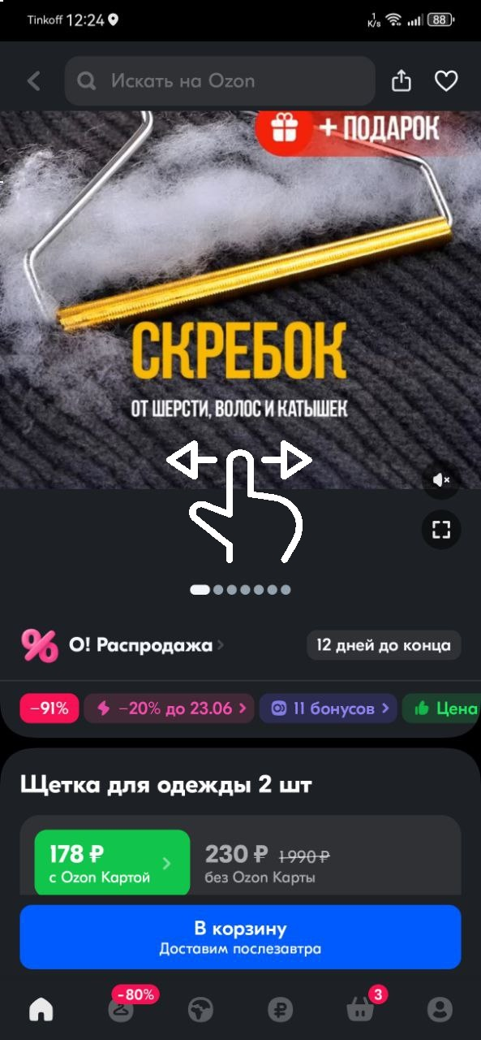

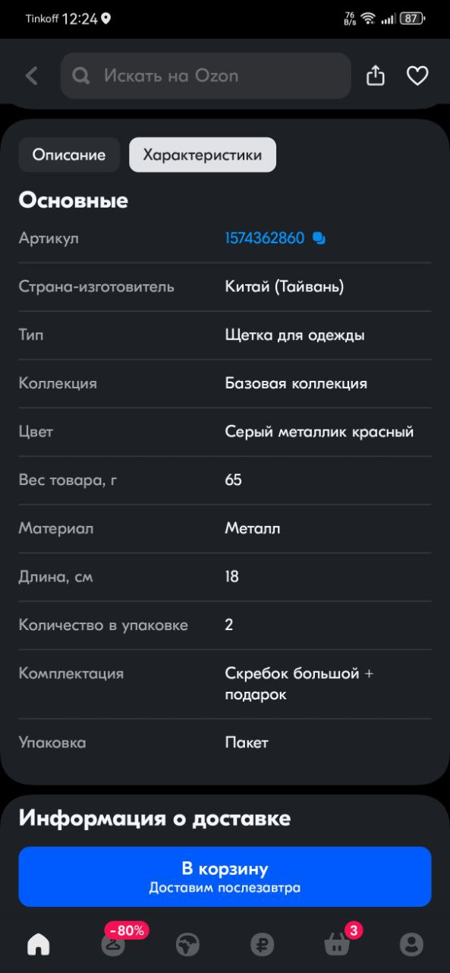Scrolling down, users can find a detailed description of the product, including its specifications, materials, dimensions, and any other relevant information. This section helps users make informed decisions about the product's suitability for their needs.

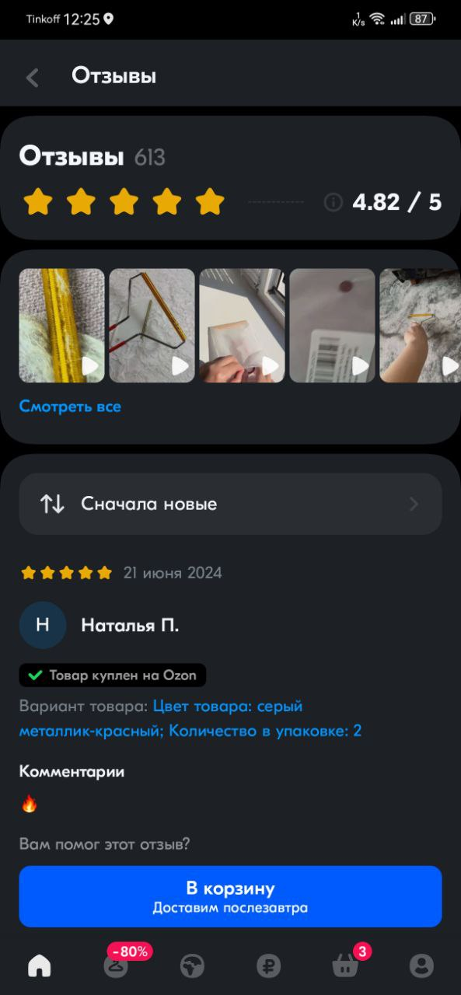Customer reviews and ratings are also accessible on this screen, enabling users to read feedback from other buyers who have purchased the same product. This feature helps build trust and confidence in the product's quality and performance.

The Product Details screen may also display related products or recommendations based on the user's browsing history, encouraging further exploration and potential purchases within the app.

Overall, the Product Details screen in the Ozon mobile app is designed to provide users with all the necessary information they need to make informed purchasing decisions, while also offering a user-friendly and visually appealing interface.