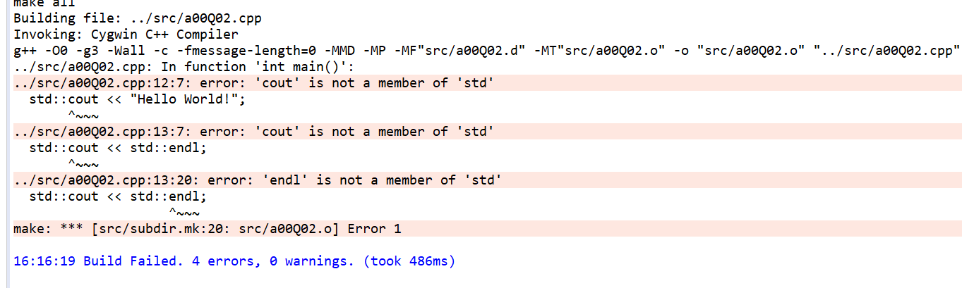

The complier cannot find ‘cout’ and ‘endl’ int ‘std’