**Nume**: Botizan

**Prenume**: Thomas

**E-mail**: Botizan.Co.Thomas@student.utcluj.ro

**Poza**: 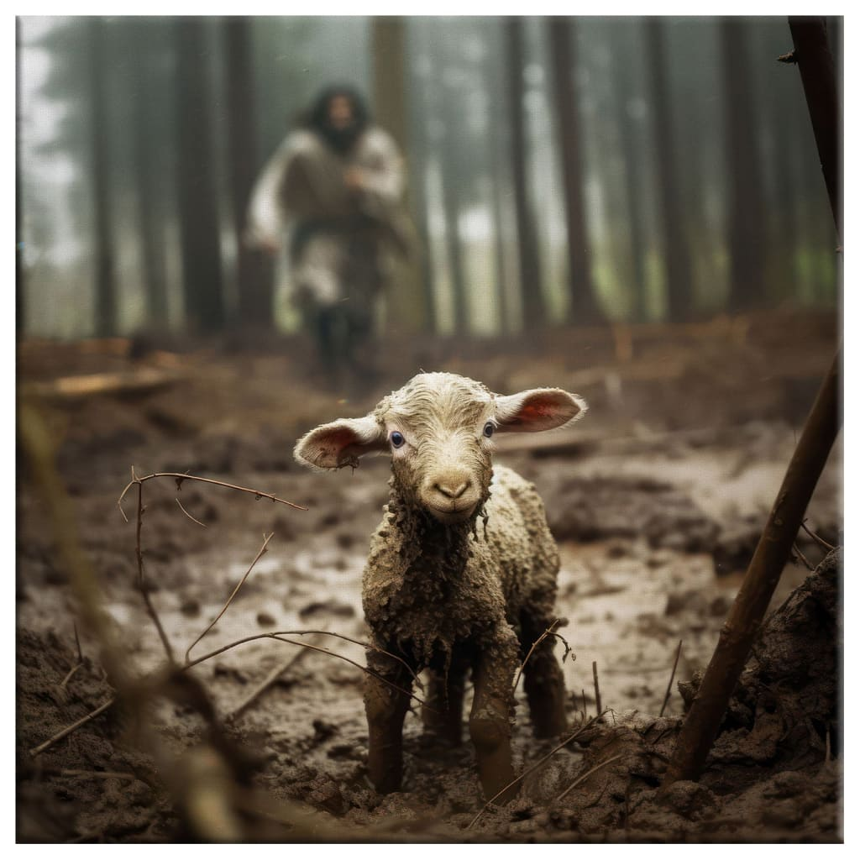

**Asteptari legate de educatie**:

* Ma astept ca la finalul facultatii sa gasesc un job in IT care sa nu necesite cautarea unui alt job pe langa.

**Discipline**: <https://etti.utcluj.ro/planuri-de-invatamant.html>

|  |  |  |
| --- | --- | --- |
| Disciplina | An | Link |
| Informatica Aplicata | 1 | https://etti.utcluj.ro/files/Acasa/Site/FiseDisciplina/EaRo/06.pdf |
| Programare C | 1 | https://etti.utcluj.ro/files/Acasa/Site/planuri-invatamant/PI_TST.pdf |
| CCP | 1 | https://etti.utcluj.ro/files/Acasa/Site/planuri-invatamant/PI_TST.pdf |
| Fizica | 1 | https://etti.utcluj.ro/files/Acasa/Site/planuri-invatamant/PI_TST.pdf |
|  |  |  |

**Hobby-uri**:

* Citit
* Cub Rubik
* Viata de credinta