**Webex Teams Hackathon 2018**

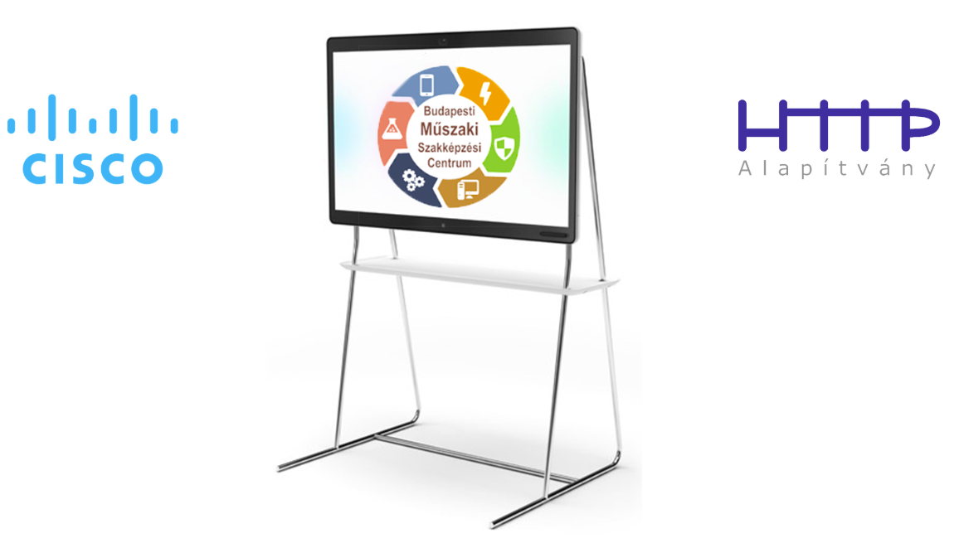

Lab1 - Creating REST API Back End in Python

Lab2 – Using SQLite to Store Data in Python REST API Back End

Lab3 - Creating Back End to Serve Static Content

Lab4 – Using Heroku to Deploy Python REST API Back End

Lab5 – Creating Webex Teams Bot

Lab6 – Creating Webhook and REST API End Point for Webhook

Lab7 – Creating Front End for Webex Teams Bot App

