About this Paper

1. Project Summary.
2. Academic Concepts

3) System Requirement and Specification.

**Project Summary:** This Project Aims To summarize all the knowledge we gained from the “Python for Beginners” course.

Document Implements the model of how the code will work.

**Concepts Covered with This Document:**

1. Taxi Service System Specification and Features
2. Use Case Diagram
3. Class Diagram
4. Activity Diagram

1. ***Taxi Service System Specification***

**System Definition:**

This Prescribed System Will Help To request A Taxi online by choosing an Available Taxi, managing the Previous Rides, managing Frequent Locations, giving a Feedback to Driver and many more described below.

**System Features:**

**a)** General Features:

Manage their User profile.

Manage their E-Wallet.

Cancel Trips.

Set home, work, school, market and many other regular travel places.

User can book a taxi on behalf of another User too.

**b)** PreRequest Features

Find the available type of taxi In nearby location.

Check estimate fare.

**c)** Post Service Features:

Manage their previous rides.

Rate their service by giving a Feedback to driver

Pay using different types of payment methods.

**Projects Usage Flow:**

1. Requesting for a Taxi

User will need to Login to His / Her account. After which User will have an option to request for a car.

User can input The Location, so Location will be detected and on that Parameters User will be shown with All available nearby cars.

User will also have an Option to choose Destination from frequent or Pre-Marked Location.

User then will be shown with Estimated Fare on the basis of Selected Destination Location.

User then can confirm The Request and will be able to get the Car’s features and driver details.

As soon as journey is finished, final fare will be shown to user and payments methods will be presented.

Only Then User will be able to give Feedback about the Driver.

B) Cancel A Trip.

User with this feature will be able to cancel the booked ride within the PreDecided time span.

Use Case Diagra

Login/Register User

RequestTaxi

Location

Chat/Call

Payment

Feedback

Admin

Customer

Driver

Cash/CreditCard

Search Taxi

Destination Type

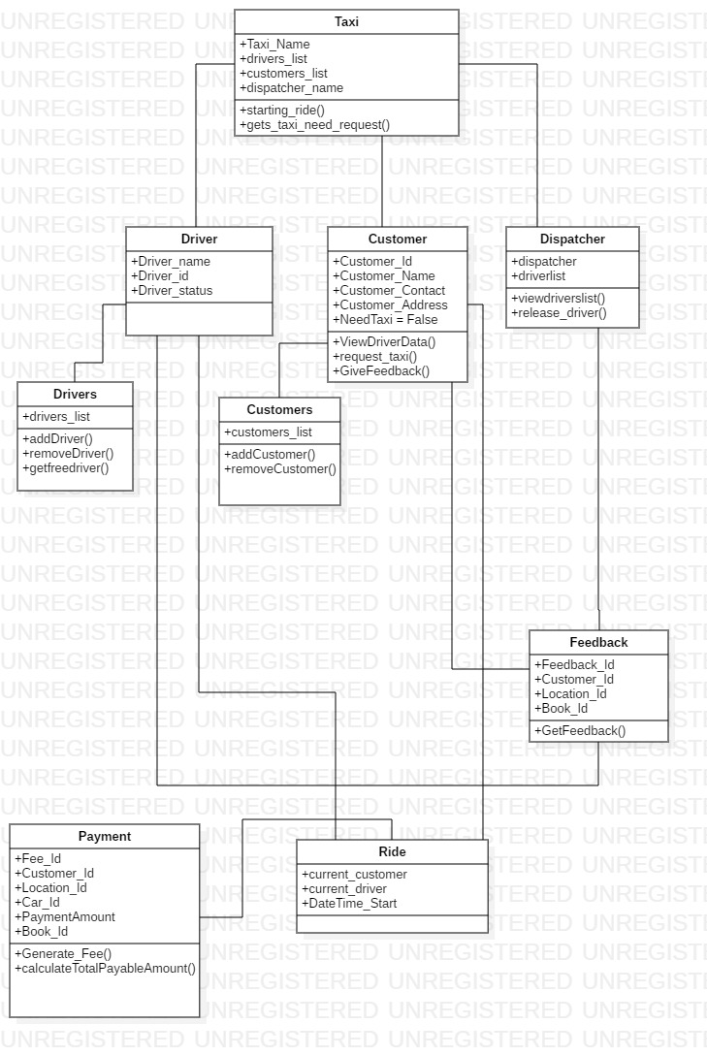

|  |  |  |
| --- | --- | --- |
| Number | 1 | |
| Name | SearchCar | |
| Summary | User will search for available cars in the nearby area. | |
|  |  | |
| Precondition | 1. User Logged In or Registered. | |
| Post condition | User Will be able to book for taxi | |
| Primary Actor | Registered User | |
| Secondary Actor | Admin, Database Server | |
| Trigger | Login | |
| Main Scenario | 1. Application will determine location of the user. 2. User will be offered with possible cars | |
| Name | | Book Car |
| Summary | | User will be able to book the searched car. |
|  | |  |
| Precondition | | 1) User will search car as per requirement. |
| Post condition | | User Will be able to reserve car. |
| Primary Actor | | Registered User |
| Secondary Actor | | Database Server, Driver |
| Main Scenario | | 1. By this user will be able to reserve pre chosen car. 2. User will also be given details about the estimated fare on determined location. 3. No other user can avail the car if booked by another user. 4. Notification to be send to the driver for the reservation. |
| Number | | 3 |
| Name | | Booking |
| Summary | | User will be able to book the searched car. |
|  | |  |
| Precondition | | User needs to conform the booking |
| Post condition | | No another user then can reserve the opted car |
| Primary Actor | | Registered User |
| Secondary Actor | | Database Server, Driver, Admin |
| Trigger | | Book Car |
| Main Scenario | | 1. By this user will be shared driver contact details for the ride. 2. Booking Type (Special or Normal) 3. Calculate Price 4. Apply Offers 5. Generate Invoice |