Bologna coding evidence report
Qualitative Content Analysis
Saved version 1 · 2026-10-20

Research design

Research question
How are research materials described in this saved Bologna coding record?
Case definition — This English teaching subset contains selected translated passages from three public Bologna interviews. The Notebook covers all excerpts selected from interview02.txt, not the full original interview.

Method and decisions
Method used: Qualitative Content Analysis

Analytic approach
Qualitative Content Analysis

Analysis unit
An existing quotation and its saved code path, read in the context of the full source document.

Approach and decisions
This is a worked software example using translated Bologna excerpts and source-linked teaching associations. Translated offsets refer to the English teaching documents, not the Italian originals. This is not a new empirical analysis. Table labels retain the saved ancestry. Method steps show the workflow; unchecked review stages remain unconfirmed.

Method map M1
Qualitative Content Analysis
Procedure overview, not a completion record. Record your approach and decisions; researcher confirmations remain separate.
01 Declare unit and approach
Document what is analysed and the chosen content analysis approach.
↓
02 Select meaning units
Identify relevant passages while retaining their surrounding context.
↓
03 Condense when appropriate
Shorten meaning units only when this fits the analytic design.
↓
04 Code and review categories
Compare codes and refine categories with explicit analytic decisions.
↓
05 Interpret in context
Consider meaning and abstraction; themes are optional, design-dependent.
↓
06 Write with evidence
Connect categories, interpretation and source quotations in the report.
Revisit 05 → 02 · Select meaning units
Content analysis is a complete method. It is not a compulsory preliminary stage for TA or Comparative QCA.

Method sources
Graneheim and Lundman (2004) · concepts and procedures
https://doi.org/10.1016/j.nedt.2003.10.001
Saved report version 1
method-map schema v1
Coding source SHA256 41dc40a938873e1710d074b85f545f008812e4865616a74f8dc4f54df8a7f3d6

Findings

Analysis Table
Themes Categories and Codes
Themes | Categories | Codes
materials | ancient manuscripts and early printed books | printed books and manuscripts from the Renaissance
materials | publications, modern and contemporary > publications stemming from the project > critical editions > structure of a critical edition | critically-reconstructed text
materials | digital representations of cultural objects > pros of using facsimiles and photographs | digitisation has changed the way of working on the documents

Narrative Analysis
The selected passages describe different forms of research material. Their saved paths place these distinctions inside the materials group. Read the exact quotations before judging how well each code fits. [E2] [E3] [E1]
The five figures summarize all existing codings across the corpus. They support checking the record; they do not substitute for interpretation of the interviews.

ancient manuscripts and early printed books
The saved code distinguishes a form of research material in this passage. [E2]
Table row 1 · Evidence E2

publications, modern and contemporary > publications stemming from the project > critical editions > structure of a critical edition
The saved code distinguishes a form of research material in this passage. [E3]
Table row 2 · Evidence E3

digital representations of cultural objects > pros of using facsimiles and photographs
The saved code distinguishes a form of research material in this passage. [E1]
Table row 3 · Evidence E1

Review and limitations

Counterexamples and variation
Only selected material-related passages are interpreted here. Contrasting perspectives across the other interviews require further contextual reading.

Limitations
This small writing example does not establish a complete analysis or saturation. Counts describe saved coding activity rather than importance or prevalence among people.

Reflexivity
The short illustrative narrative was prepared for the QT demonstration. It is not an independently validated analysis of this corpus.

Quality and review
Quoted characters and code identities were checked against the saved source. All five figures use only this three-document translated teaching subset and the unchanged counting rules.

Research and assistance disclosure
Public Bologna CC0 data only. No private interviews or model calls were used. Editing the downloaded Word documents does not change the QT project.

Figures

Figure 1
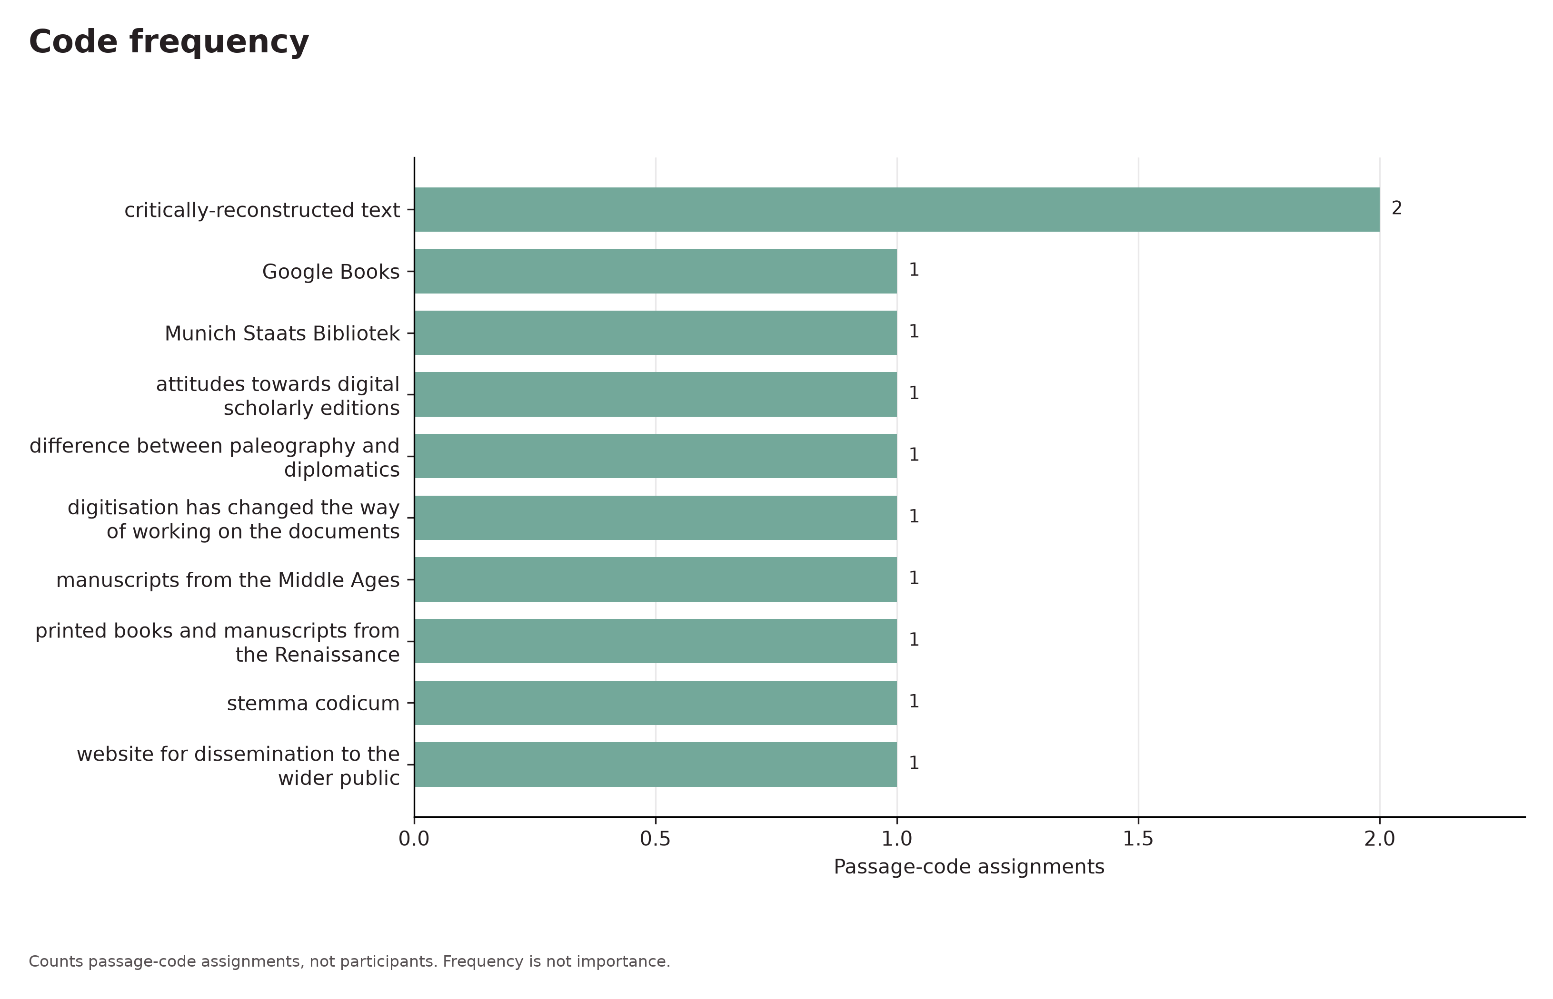
Code frequency. Code frequency from the English translation teaching subset.
Counts passage-code assignments, not participants. Frequency is not importance.

Figure 2
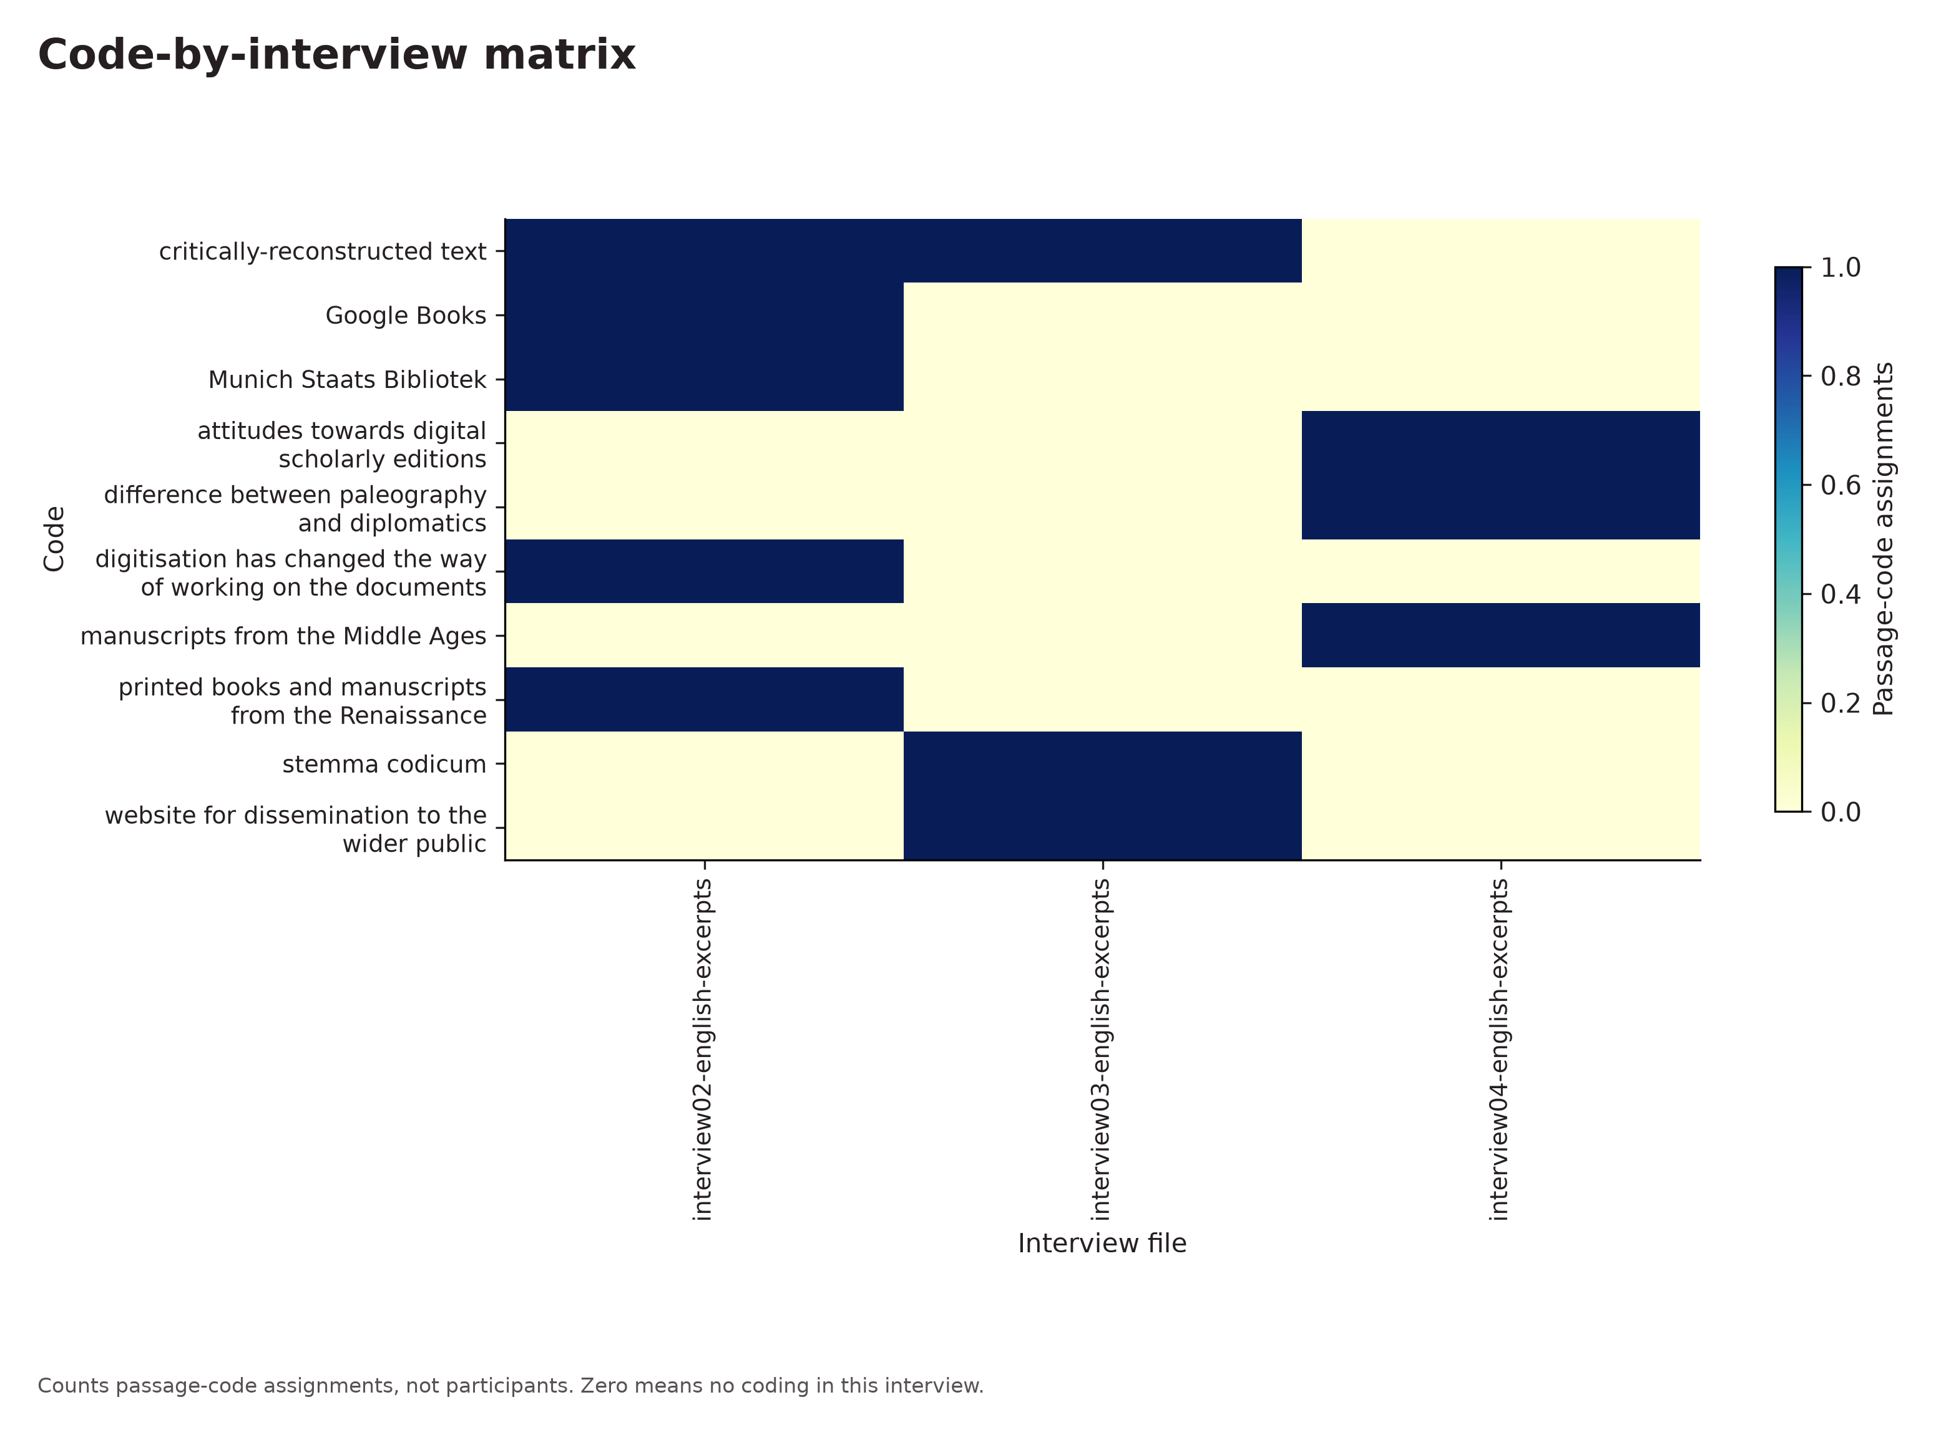
Code-by-interview matrix. Code by interview from the English translation teaching subset.
Counts passage-code assignments, not participants. Zero means no coding in this interview.

Figure 3
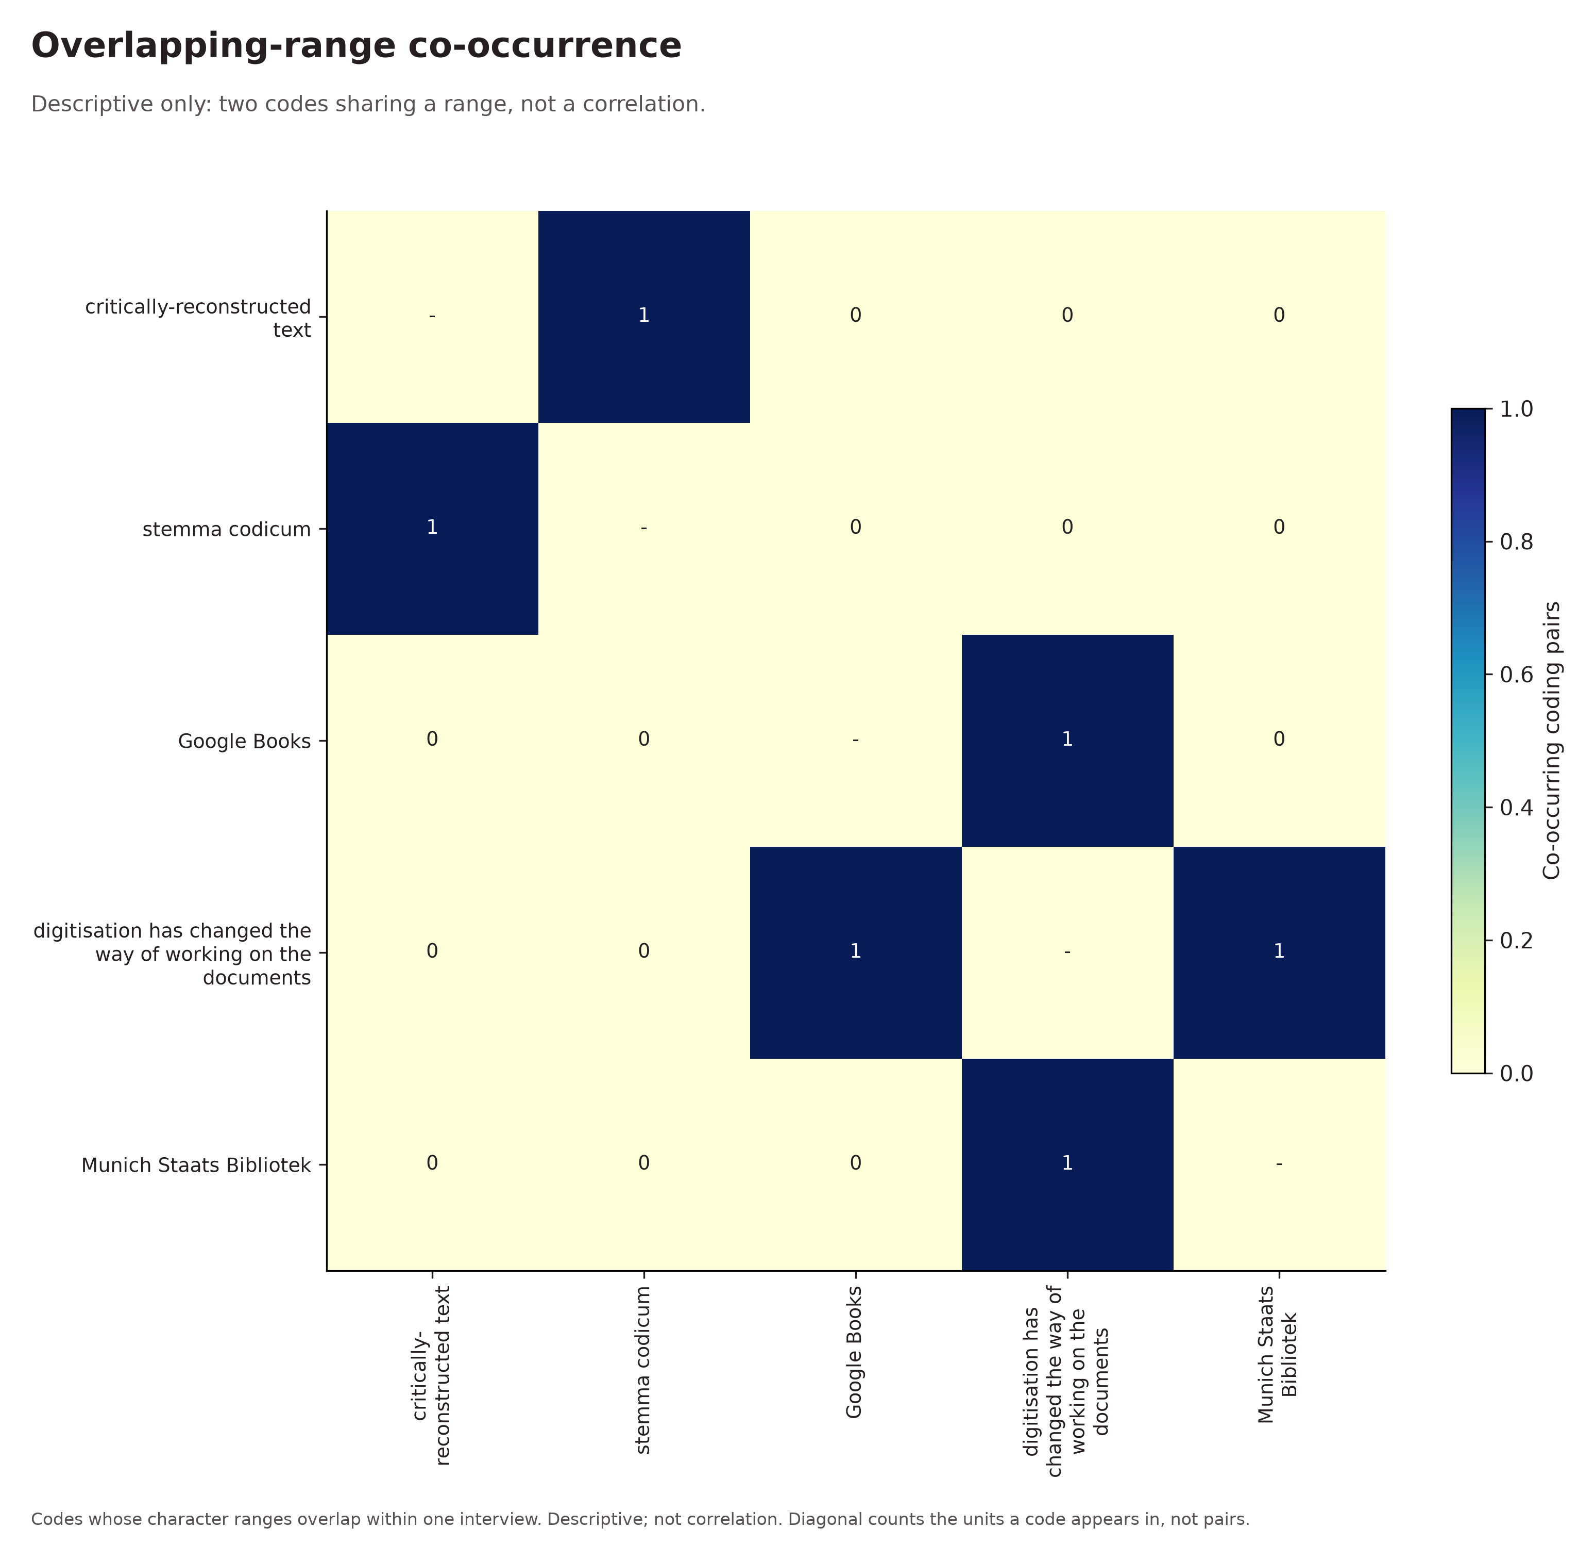
Overlapping-range co-occurrence. Code co-occurrence from the English translation teaching subset.
Codes whose character ranges overlap within one interview. Descriptive; not correlation. Diagonal counts the units a code appears in, not pairs.

Figure 4
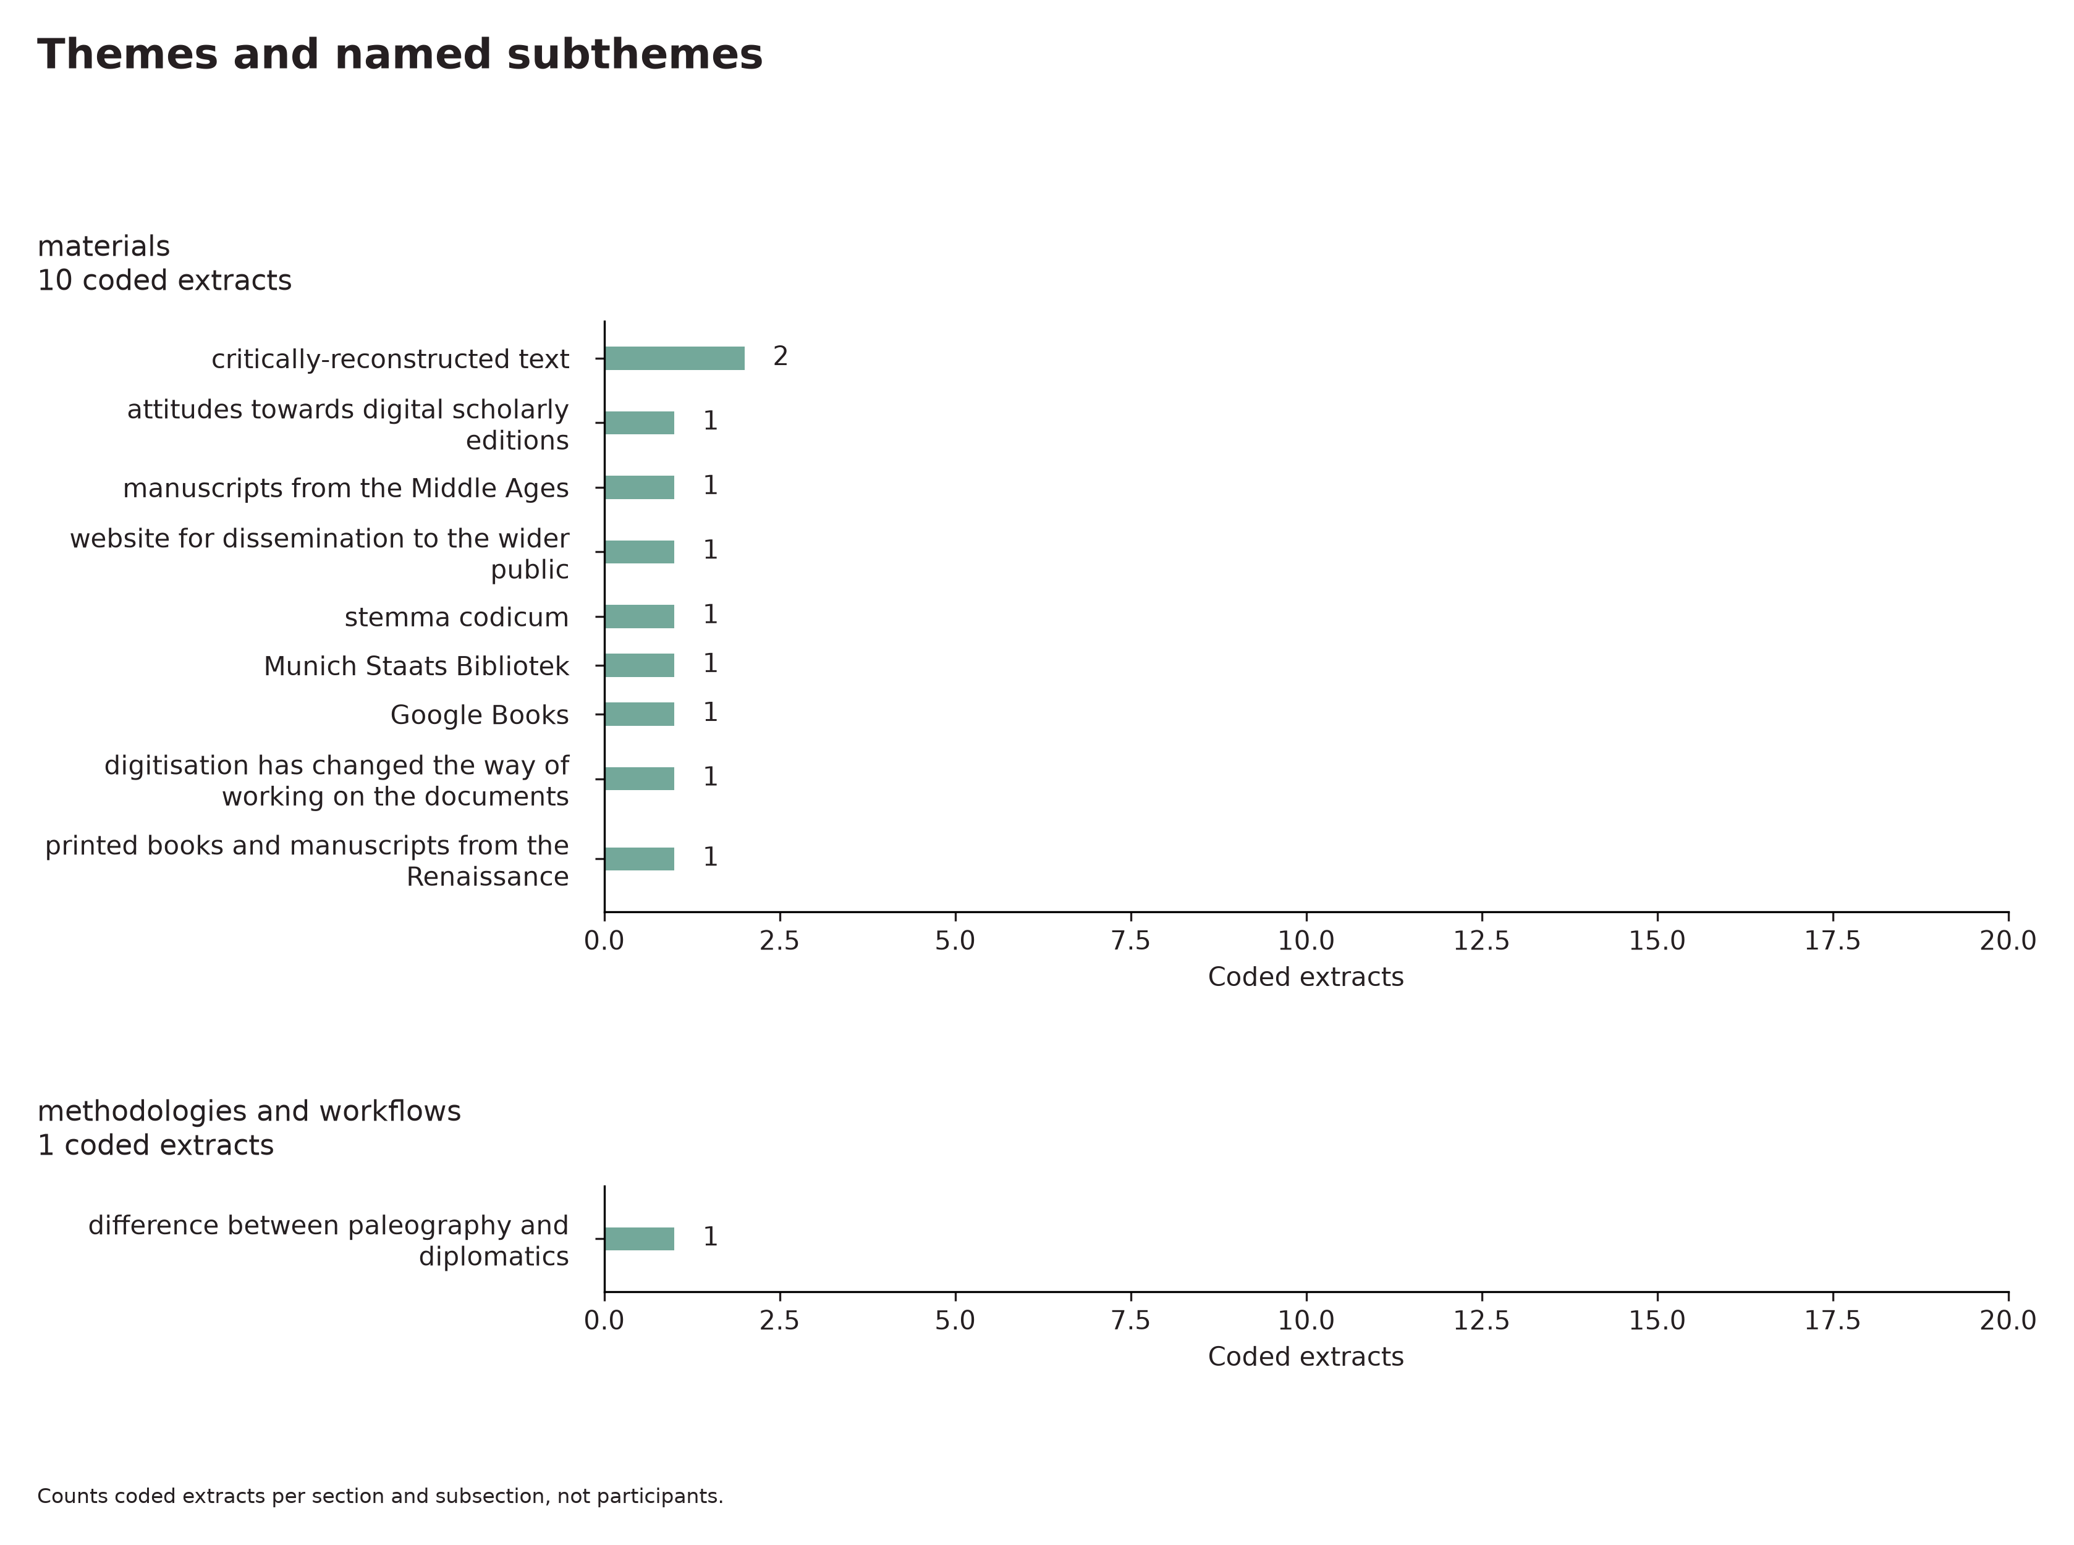
Themes and named subthemes. Theme hierarchy from the English translation teaching subset.
Counts coded extracts per section and subsection, not participants.

Figure 5
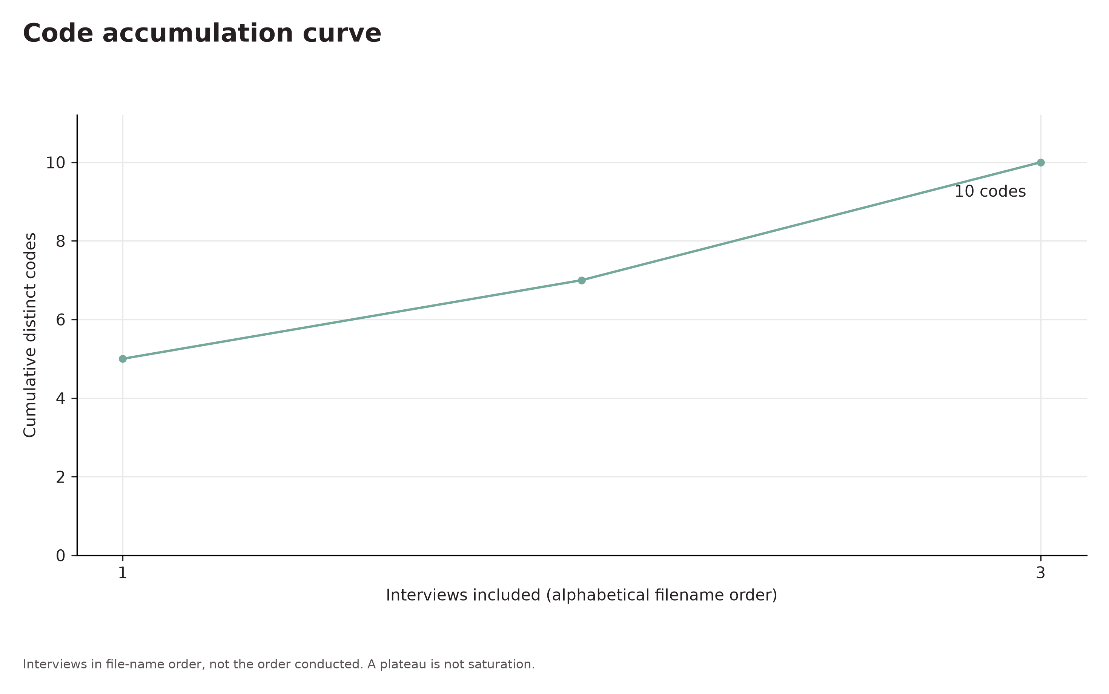
Code accumulation curve. Code accumulation from the English translation teaching subset.
Interviews in file-name order, not the order conducted. A plateau is not saturation.

Evidence appendix
Verbatim quotations are italic. The E references connect them to the findings.

E1 interview02-english-excerpts.txt
This is [something new] compared with when I began this kind of research. Fifteen years ago I would of course have had to go to the library. Now one edition has been digitised by Google Books, while for the 1502 edition we used the digitised print from the Bavarian State Library in Munich, which is an exceptional repository of early printed books. Seventy per cent of what we look for among incunabula, late-fifteenth-century printed books and sixteenth-century editions can be found there.
interview02-english-excerpts.txt · [402, 894)

E2 interview02-english-excerpts.txt
So, moving on to the method, we worked on the printed text — on two printed editions, let us say.
interview02-english-excerpts.txt · [0, 97)

E3 interview02-english-excerpts.txt
Sometimes there are errors that need to be corrected in the Latin text, or things that are not understood. Sometimes there are gaps because something was lost during printing, in the passage from manuscript to print, and so the text has to be critically restored with the help of two printed editions.
interview02-english-excerpts.txt · [99, 400)

Review record

Researcher confirmations
Units · confirmed
Coding rules · not confirmed
Category development · not confirmed
Category review · not confirmed
Context · not confirmed
Writing · not confirmed

Evidence identity
Report 970ff886243e408fa49a5e0c1b26bd4b
Content SHA256 254609bb6f0cd7762d53719f24cd38637967a6debcff54e25039c68300ff408b
Evidence SHA256 41dc40a938873e1710d074b85f545f008812e4865616a74f8dc4f54df8a7f3d6
External Word edits stay in Word. Restore the complete workspace from project JSON.

E1 · interview02-english-excerpts.txt
Annotation 385e5468906559869404264689236561
Document 8c17e627c7d85f7c8967047bfa92531b
SHA256 be1817ce96cd101e2ecf98b1bdcb6cdd257b98251deb502633d002e00913e46a
Code 72b86059824e4ed5973875f0ee7ddff3 · manual

E2 · interview02-english-excerpts.txt
Annotation 3f029191a6885f0e9fdef6174d572dff
Document 8c17e627c7d85f7c8967047bfa92531b
SHA256 be1817ce96cd101e2ecf98b1bdcb6cdd257b98251deb502633d002e00913e46a
Code 177098f805974bae8e589c1cb2fae553 · manual

E3 · interview02-english-excerpts.txt
Annotation 9ebf2d198c4b5376b175ec0e8a4af023
Document 8c17e627c7d85f7c8967047bfa92531b
SHA256 be1817ce96cd101e2ecf98b1bdcb6cdd257b98251deb502633d002e00913e46a
Code 6cb80dbc23ce489e8da9428666efe6a0 · manual

Figure 1 · frequency
Asset SHA256 5672504a9e6bb4aada57abd22e518c201efdd158be37941dba0ed63001a262ca
Level code · top 15 · mode overlap · YlGnBu · 300 dpi
Python 3.14.6 · matplotlib 3.11.2 · font DejaVu Sans

Figure 2 · coverage
Asset SHA256 07b090cbcd0623c9fe23da5240f1a7371d0f96a621392022c02bab515289409b
Level code · top 15 · mode overlap · YlGnBu · 300 dpi
Python 3.14.6 · matplotlib 3.11.2 · font DejaVu Sans

Figure 3 · cooccurrence
Asset SHA256 06403d13c2e1e82da9251db7babecdfc4e1077785869eef7b7764f6d9d14b7fa
Level code · top 15 · mode overlap · YlGnBu · 300 dpi
Python 3.14.6 · matplotlib 3.11.2 · font DejaVu Sans

Figure 4 · hierarchy
Asset SHA256 97acc32af830a1c740a2d34970dd9174684713461e00a0fd651cf3c8b25f03ab
Level code · top 15 · mode overlap · YlGnBu · 300 dpi
Python 3.14.6 · matplotlib 3.11.2 · font DejaVu Sans

Figure 5 · accumulation
Asset SHA256 cbcb33c8e1983e9dfe40517949323d50b916607a7c8d1a067656af0b58a792d4
Level code · top 15 · mode overlap · YlGnBu · 300 dpi
Python 3.14.6 · matplotlib 3.11.2 · font DejaVu Sans
Complete figure settings, numeric results and hashes are embedded in this document and included with the original recipes in the report ZIP.

