Bologna coding evidence report
Qualitative Content Analysis
Saved version 2 · 2026-10-18

Research design

Research question
How are research materials described in this saved Bologna coding record?
Case definition — The corpus has 19 public interview documents. The short written example below reviews selected passages from interview02.txt.

Method and decisions
Method used: Qualitative Content Analysis

Analytic approach
Qualitative Content Analysis

Analysis unit
An existing quotation and its saved code path, read in the context of the full source document.

Approach and decisions
This is a worked software example using the original Bologna coding. No new coding or participant interpretation was generated. Table labels retain the saved ancestry. Method steps show the workflow; unchecked review stages remain unconfirmed.

Method map M1
Qualitative Content Analysis
Procedure overview, not a completion record. Record your approach and decisions; researcher confirmations remain separate.
01 Declare unit and approach
Document what is analysed and the chosen content analysis approach.
↓
02 Select meaning units
Identify relevant passages while retaining their surrounding context.
↓
03 Condense when appropriate
Shorten meaning units only when this fits the analytic design.
↓
04 Code and review categories
Compare codes and refine categories with explicit analytic decisions.
↓
05 Interpret in context
Consider meaning and abstraction; themes are optional, design-dependent.
↓
06 Write with evidence
Connect categories, interpretation and source quotations in the report.
Revisit 05 → 02 · Select meaning units
Content analysis is a complete method. It is not a compulsory preliminary stage for TA or Comparative QCA.

Method sources
Graneheim and Lundman (2004) · concepts and procedures
https://doi.org/10.1016/j.nedt.2003.10.001
Saved report version 2
method-map schema v1
Coding source SHA256 c41fb0c1685d251ca701f358aae3975d978bae146a0c0d50b5b91365d0e26b5d

Findings

Analysis Table
Themes Categories and Codes
Themes | Categories | Codes
materials | ancient manuscripts and early printed books | printed books and manuscripts from the Renaissance
materials | publications, modern and contemporary > publications stemming from the project > critical editions > structure of a critical edition | critically-reconstructed text
materials | digital representations of cultural objects > pros of using facsimiles and photographs | digitisation has changed the way of working on the documents

Narrative Analysis
The selected passages describe different forms of research material. Their saved paths place these distinctions inside the materials group. Read the exact quotations before judging how well each code fits. [E1] [E3] [E2]
The five figures summarize all existing codings across the corpus. They support checking the record; they do not substitute for interpretation of the interviews.

ancient manuscripts and early printed books
The saved code distinguishes a form of research material in this passage. [E1]
Table row 1 · Evidence E1

publications, modern and contemporary > publications stemming from the project > critical editions > structure of a critical edition
The saved code distinguishes a form of research material in this passage. [E3]
Table row 2 · Evidence E3

digital representations of cultural objects > pros of using facsimiles and photographs
The saved code distinguishes a form of research material in this passage. [E2]
Table row 3 · Evidence E2

Review and limitations

Counterexamples and variation
Only selected material-related passages are interpreted here. Contrasting perspectives across the other interviews require further contextual reading.

Limitations
This small writing example does not establish a complete analysis or saturation. Counts describe saved coding activity rather than importance or prevalence among people.

Reflexivity
The short illustrative narrative was prepared for the QT demonstration. It is not an independently validated analysis of this corpus.

Quality and review
Quoted characters and code identities were checked against the saved source. All five figures use the complete original 19-document coding record and their existing counting rules.

Research and assistance disclosure
Public Bologna CC0 data only. No private interviews or model calls were used. Editing the downloaded Word documents does not change the QT project.

Figures

Figure 1
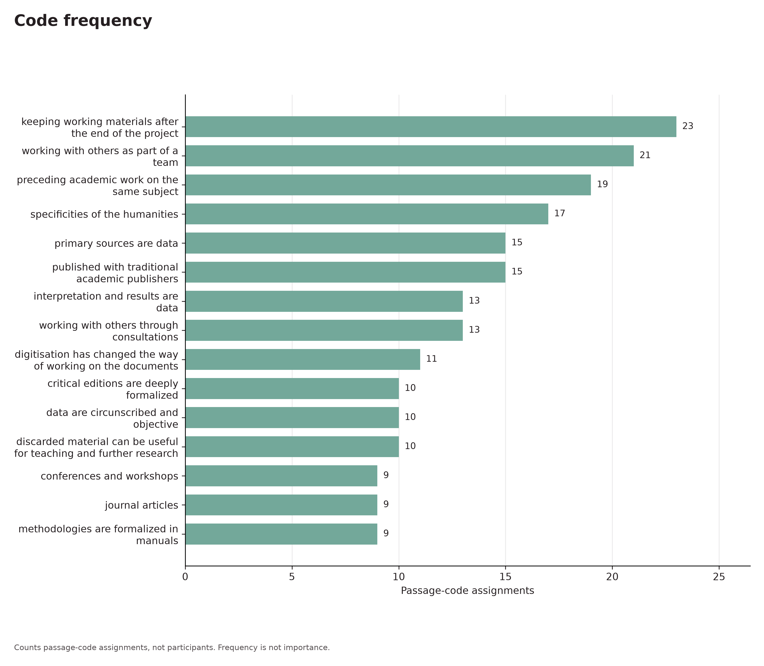
Code frequency. Code frequency from the original saved coding record.
Counts passage-code assignments, not participants. Frequency is not importance.

Figure 2
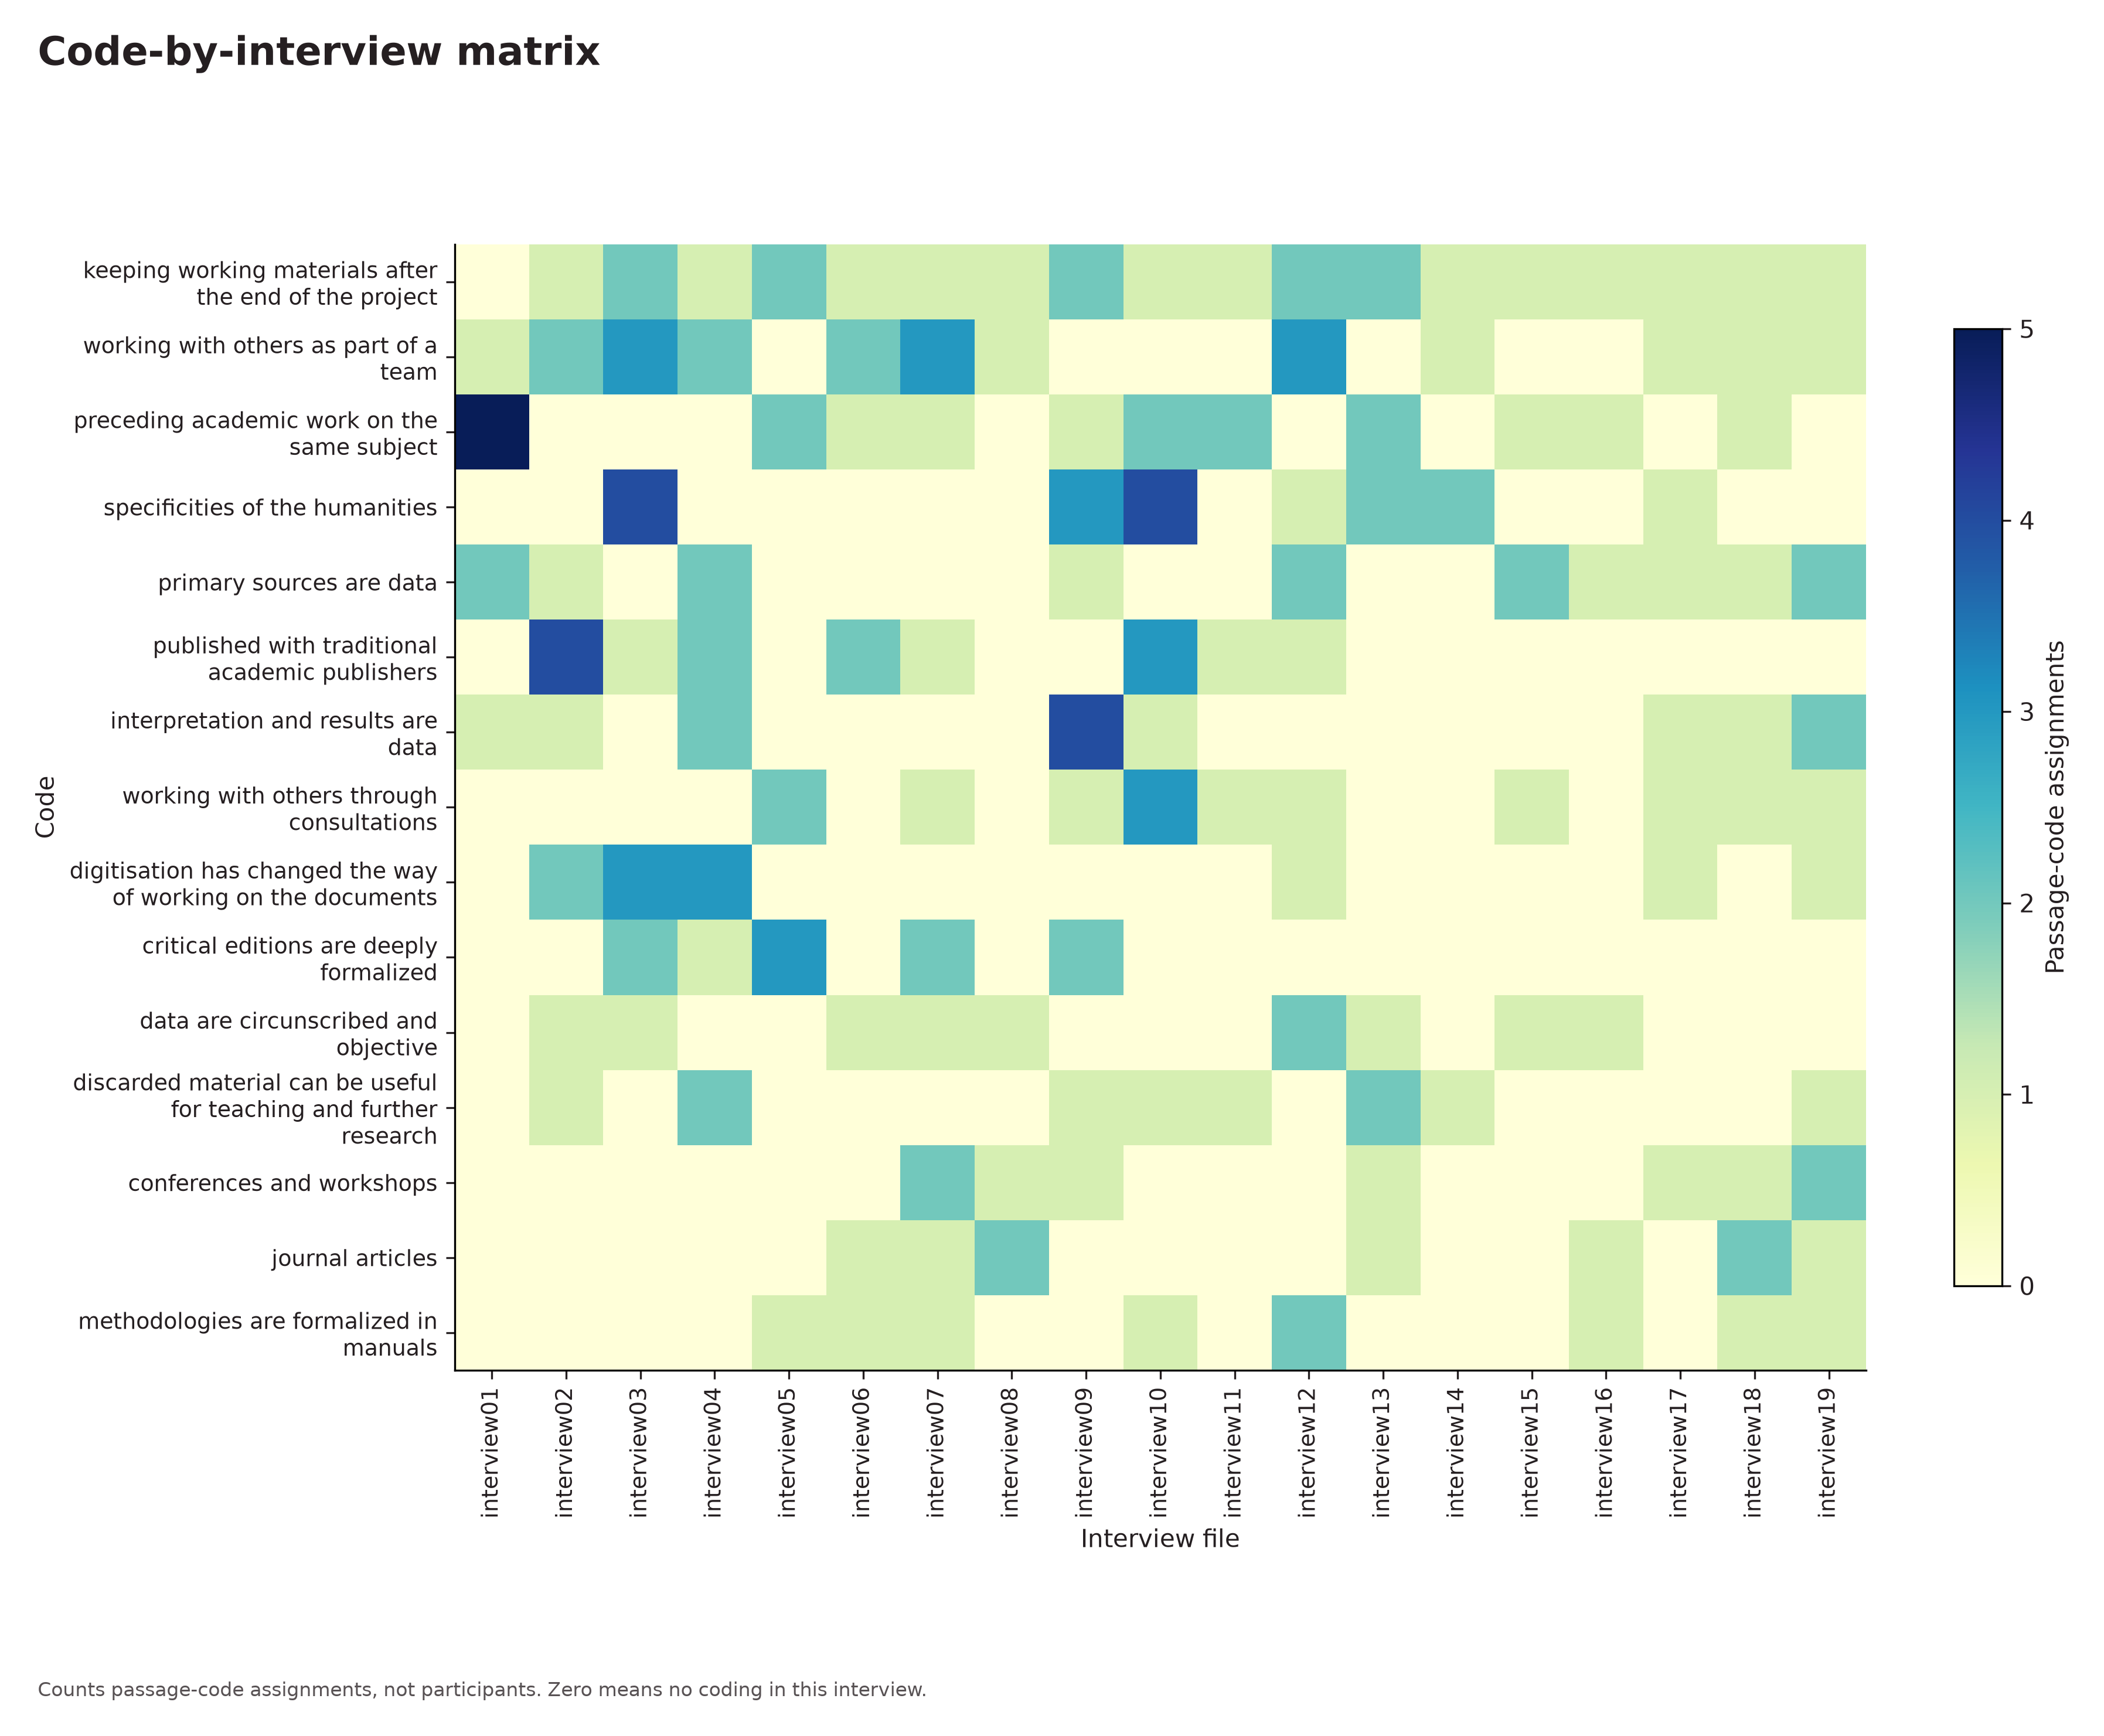
Code-by-interview matrix. Code by interview from the original saved coding record.
Counts passage-code assignments, not participants. Zero means no coding in this interview.

Figure 3
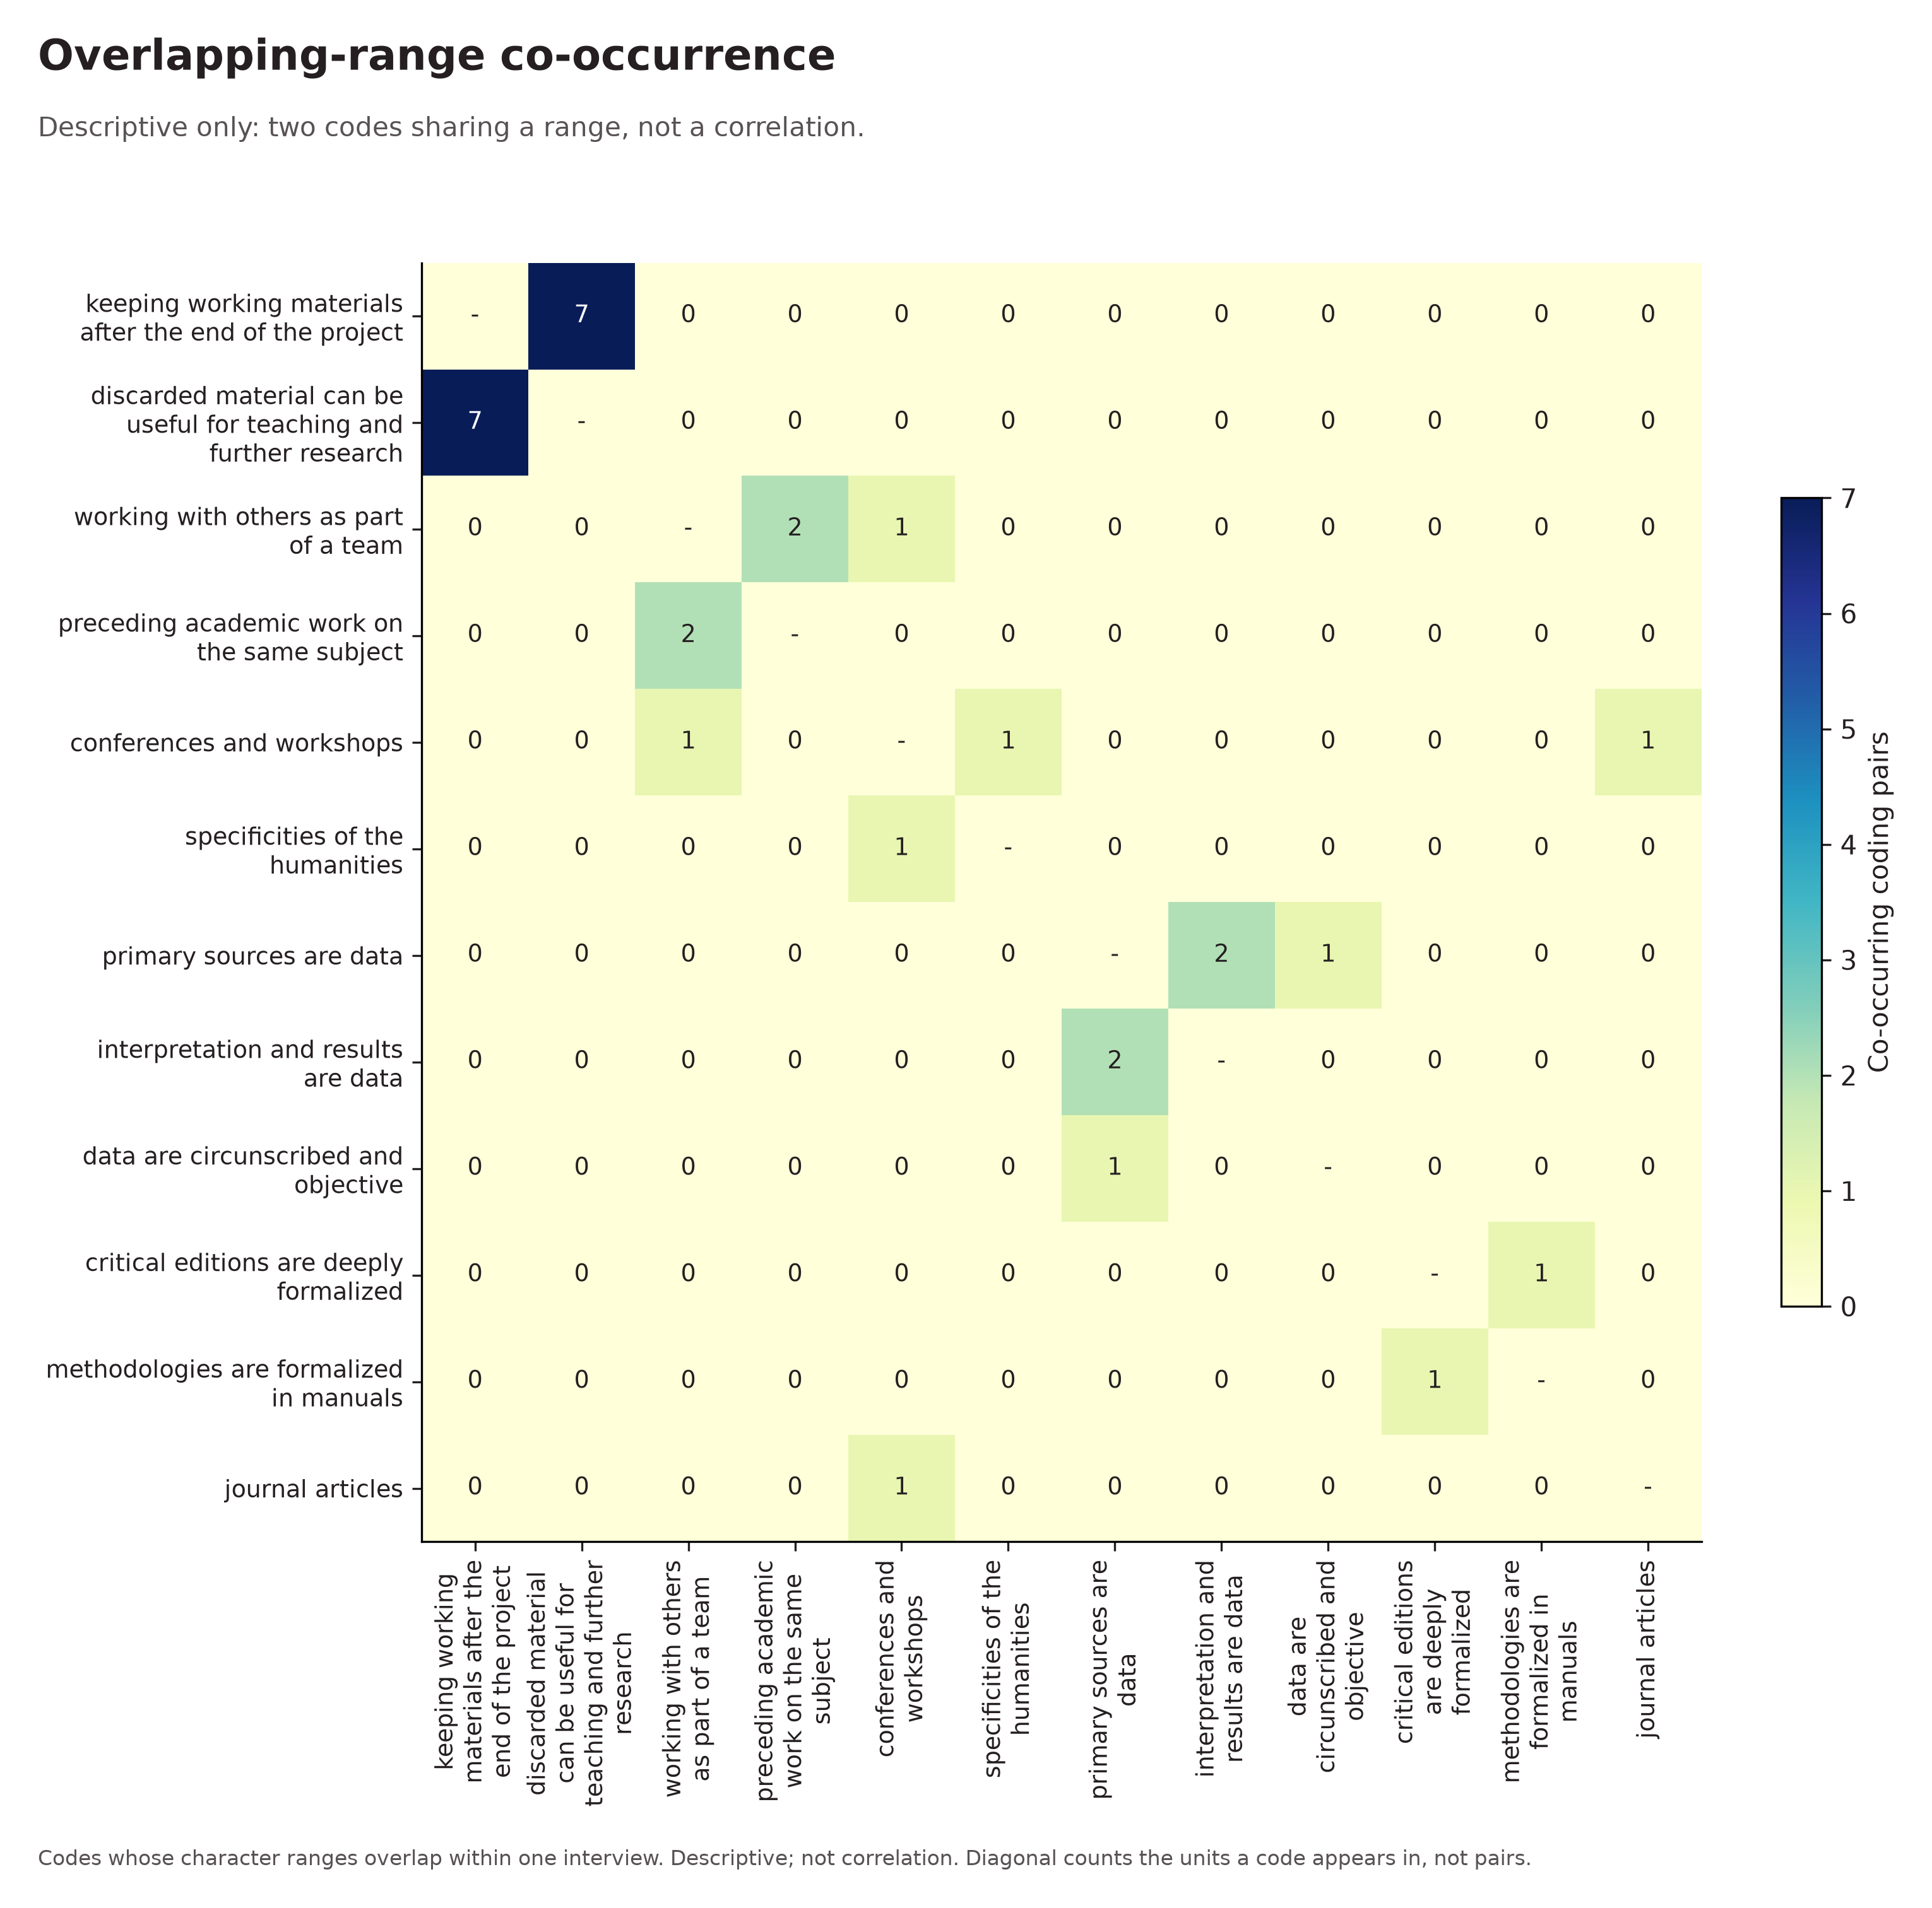
Overlapping-range co-occurrence. Code co-occurrence from the original saved coding record.
Codes whose character ranges overlap within one interview. Descriptive; not correlation. Diagonal counts the units a code appears in, not pairs.

Figure 4 · view 1 of 5
Themes and named subthemes. Theme hierarchy from the original saved coding record.
Counts coded extracts per section and subsection, not participants.
Unchanged original · continuous view 1 of 5. Complete SVG, PDF and PNG are in the report ZIP.

Figure 4 · view 2 of 5
Themes and named subthemes. Theme hierarchy from the original saved coding record.
Counts coded extracts per section and subsection, not participants.
Unchanged original · continuous view 2 of 5. Complete SVG, PDF and PNG are in the report ZIP.

Figure 4 · view 3 of 5
Themes and named subthemes. Theme hierarchy from the original saved coding record.
Counts coded extracts per section and subsection, not participants.
Unchanged original · continuous view 3 of 5. Complete SVG, PDF and PNG are in the report ZIP.

Figure 4 · view 4 of 5
Themes and named subthemes. Theme hierarchy from the original saved coding record.
Counts coded extracts per section and subsection, not participants.
Unchanged original · continuous view 4 of 5. Complete SVG, PDF and PNG are in the report ZIP.

Figure 4 · view 5 of 5
Themes and named subthemes. Theme hierarchy from the original saved coding record.
Counts coded extracts per section and subsection, not participants.
Unchanged original · continuous view 5 of 5. Complete SVG, PDF and PNG are in the report ZIP.

Figure 5
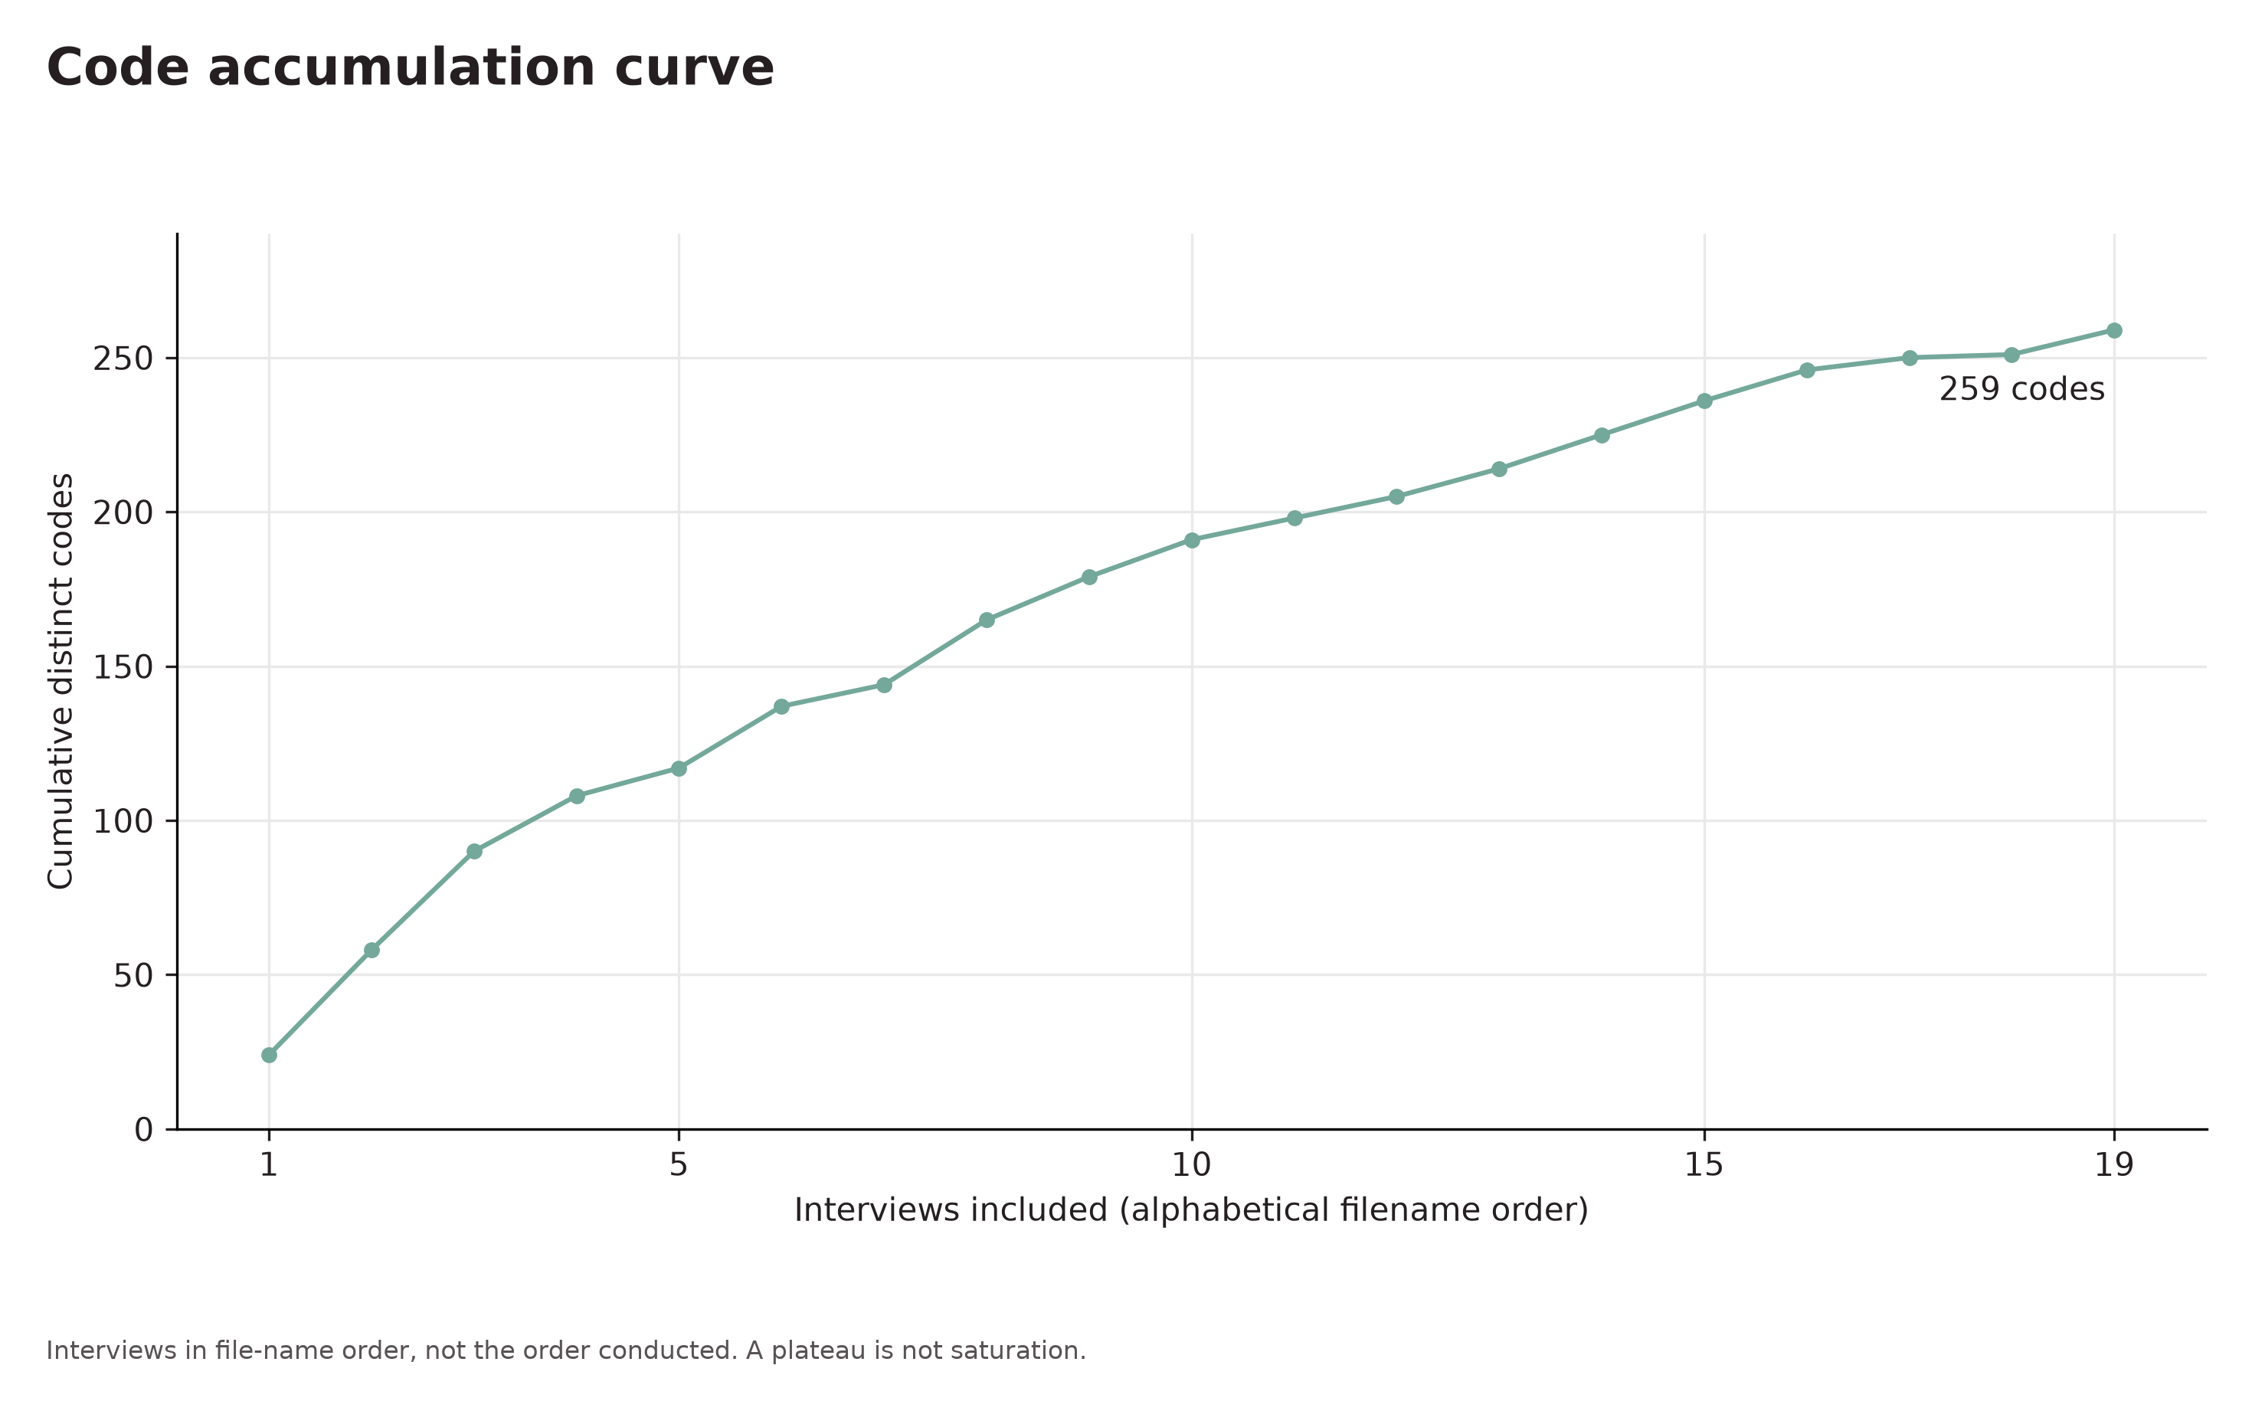
Code accumulation curve. Code accumulation from the original saved coding record.
Interviews in file-name order, not the order conducted. A plateau is not saturation.

Evidence appendix
Verbatim quotations are italic. The E references connect them to the findings.

E1 interview02.txt
Quindi noi abbiamo lavorato, per passare al metodo, sulla stampa diciamo su due stampe,
interview02.txt · [872, 960)

E2 interview02.txt
Questa rappresenta [una novità], rispetto a quando ho iniziato a fare ricerca di questo tipo, quindici anni fa ovviamente sarei dovuto andare in biblioteca, invece adesso una è stata digitalizzata da Google Libri e invece quella del 1502 abbiamo utilizzato la stampa digitalizzata dalla Staats Bibliotek di Monaco di Baviera, che è un repositore di stampe antiche eccezione, il 70% di quello che cerchiamo tra incunaboli e libri stampati di fine Quattrocento e cinquecentine lo si trova.
interview02.txt · [2860, 3348)

E3 interview02.txt
e a volte ci sono degli errori che vanno sanati nel testo latino o ci sono delle cose che non si comprendono. A volte ci sono delle lacune perché qualcosa è saltato nel processo di stampa, dal manoscritto alla stampa, e quindi bisogna ripristinarlo criticamente con l’aiuto di due stampe,
interview02.txt · [1177, 1466)

Review record

Researcher confirmations
Units · confirmed
Coding rules · not confirmed
Category development · not confirmed
Category review · not confirmed
Context · not confirmed
Writing · not confirmed

Evidence identity
Report 73509d4bf968476e85b590022a2020fe
Content SHA256 e9cbc41f4b971a70b15a0b46e0db94fad3e5b836f46840d54067af05d88cf040
Evidence SHA256 c41fb0c1685d251ca701f358aae3975d978bae146a0c0d50b5b91365d0e26b5d
External Word edits stay in Word. Restore the complete workspace from project JSON.

E1 · interview02.txt
Annotation 488bba0accd84c94ad2f904f241ad6ae
Document f153cc3e3f694f1ea763188d3535eebf
SHA256 f43f005420b55b9fb7c8346d7f9e5c4c0cfb73f46bc295c8ca9c45e561734036
Code 177098f805974bae8e589c1cb2fae553 · imported

E2 · interview02.txt
Annotation 7748cde944af49b88b8255f3fa0d67e2
Document f153cc3e3f694f1ea763188d3535eebf
SHA256 f43f005420b55b9fb7c8346d7f9e5c4c0cfb73f46bc295c8ca9c45e561734036
Code 72b86059824e4ed5973875f0ee7ddff3 · imported

E3 · interview02.txt
Annotation e7f3646a9d62439c803362907036227d
Document f153cc3e3f694f1ea763188d3535eebf
SHA256 f43f005420b55b9fb7c8346d7f9e5c4c0cfb73f46bc295c8ca9c45e561734036
Code 6cb80dbc23ce489e8da9428666efe6a0 · imported

Figure 1 · frequency
Asset SHA256 70f086aaabf4597e8b5cbdfe48556566d607a079fbe65a1ac48ffcad9c1f7a15
Level code · top 15 · mode overlap · YlGnBu · 300 dpi
Python 3.14.6 · matplotlib 3.11.2 · font DejaVu Sans

Figure 2 · coverage
Asset SHA256 7ffcaf37ea7e8a88c181799fc063df617369c8a7899f148114c3662c463d3b39
Level code · top 15 · mode overlap · YlGnBu · 300 dpi
Python 3.14.6 · matplotlib 3.11.2 · font DejaVu Sans

Figure 3 · cooccurrence
Asset SHA256 b1226b193aabd80cc6ed641bd7fe01ac0b1ca613cb27770b1016fcffdca8b65d
Level code · top 15 · mode overlap · YlGnBu · 300 dpi
Python 3.14.6 · matplotlib 3.11.2 · font DejaVu Sans

Figure 4 · hierarchy
Asset SHA256 607067d562d09e41c36e4794492d542124f039b9ee057465c0dc88de396a4a75
Level code · top 15 · mode overlap · YlGnBu · 300 dpi
Python 3.14.6 · matplotlib 3.11.2 · font DejaVu Sans

Figure 5 · accumulation
Asset SHA256 7ca3588b185bf8a63616c0794f7fca0ca1d3654295d486b95848697678744615
Level code · top 15 · mode overlap · YlGnBu · 300 dpi
Python 3.14.6 · matplotlib 3.11.2 · font DejaVu Sans
Complete figure settings, numeric results and hashes are embedded in this document and included with the original recipes in the report ZIP.

