## User Guide to FLUNETS

FLUNETS is a MATLAB-based tool built up in the form of 6 MATLAB functions. The aim of this tool is to provide a continuous channel network. The sorting hierarchy can be Gravelius/Hack ordering system or Horton hierarchy. Both systems offer a drainage network formed by continuous rivers. FLUNETS uses some functions from TopoToolbox (DOI: 10.5194/esurf-2-1-2014) and requires the Image Processing Toolbox for some of its functions. Also it requires MATLAB 2011b or higher version.

FLUNETS runs from the scrip streams_main. In this step, the user sets the values of the mandatory and optional parameters. The mandatory is a set of 3 parameters. This set should be fulfilled in order to process the tool, otherwise, an error message will show up. These parameters are the name of the DEM in ASCII format with the extension; the ordering system by which the rivers of the network will be sorted; and finally the hierarchy attribute, which may be upstream accumulation or upstream distance. This last parameter chooses the hierarchy of a river over another when they join in a confluence.

% mandatory parameters

[dem_namefile, extension] = strtok('arlanza.asc', '.');

sorting_type = 'horton'; hierarchy_attribute = 'distance';

In contrast, optional parameters can be left empty and a default value will be assigned to each of them. These are the following:

% optional parameters

max_trib_order = '';

min_drainage_area = '';

maxbase = '';

output_name = '';

internal_matrices = '';

junctions_points = '';

max_trib_order: It is the ultimate tributary order. If the value is set to 1, only the main stream and first-order tributaries will be extracted and ordered; if the value is set to 2, main stream river and first and second-order tributaries will be sorted, and so on. The value should be an integer.

min_drainage_area: Is the minimum area in m2 that must have a tributary at its pour point to be extracted. The area is calculated by multiplying the accumulation at the pour point by the spatial resolution of the DEM to the second power. If the computed value is equal or higher than the value set in this parameter, the pour point is gathered. This point then will be the starting point of a new river sorted upstream until reaching the headwater. The value is integer type.

maxbase: It is the lower elevation range to consider an outlet. For example, if the value is set to 20, only those outlets located at that certain height or above will be considered. On the other hand, if the parameter is left empty, all the outlets will be taken into account. The value is integer type.

output_name: Name given to the output ASCII and csv files containing the sorted fluvial network. Should be string type written without extension (‘.asc’ or ‘.txt’ at the end). If willing to give more than one chain of characters, join them by an underscore. If left empty, the name will be built by joining the DEM name with the parameter values, separated by an underscore.

internal_matrices: If the parameter is set to ‘yes’, a set of flow-related matrices will be given alongside the other outputs. In contrast, if left empty, flow-related matrices will not be provided. These matrices are as follows: the flow direction matrix, flow accumulation, flow distance (when choosing distance as hierarchy attribute) and Strahler's network (if Horton is selected).

junctions_points: This parameter enables to obtain the ASCII file containing the pour points of all the extracted rivers. If left empty, no ASCII file with the pour point information will be given as output. If willing to get the pour point matrix, set ‘yes’ as the value.

Output files:

The output files are given in raster fomat and in a CSV file. Both files can be drawn directly in any GIS software. These file will be located inside the 'outputs/images' and 'outputs' folders respectively. The raster info has the ordered value for each pixel, whereas the CSV file contains multiple information about the obtained network. There is a row (register) for each pixel of the channel network. The meaning of each of the columns is as follows:

* Field1: is the x coordinate (in a projected system).
* Field2: is the y coordinate (in a projected system).
* Field3: is the elevation.
* Field4: is the river value (Hack or Horton order).
* Field5: is the accumulation value upstream direction.
* Field6: is the drainage area in square meters.
* Field7: is the id number of each river (unique).
* Field8: is the distance upstream direction.

**Important tip!:** To convert an ASCII channel network to vector format, in most GIS environments you will need the flow direction matrix. This direction matrix is the one computed internally to extract the channel network. Therefore, you need to use the parameter 'internal_matrices' = ‘yes’ to obtain the flow direction matrix as an output.

The csv can be drawn directly in ArcMap.

## Outputs

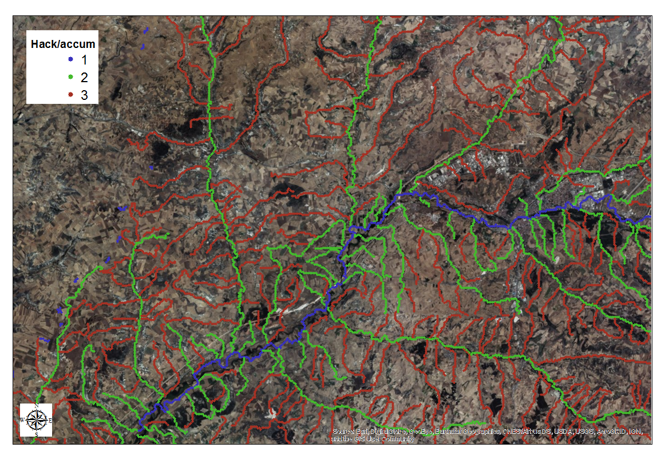

Figure 1: CSV loaded in ArcMap

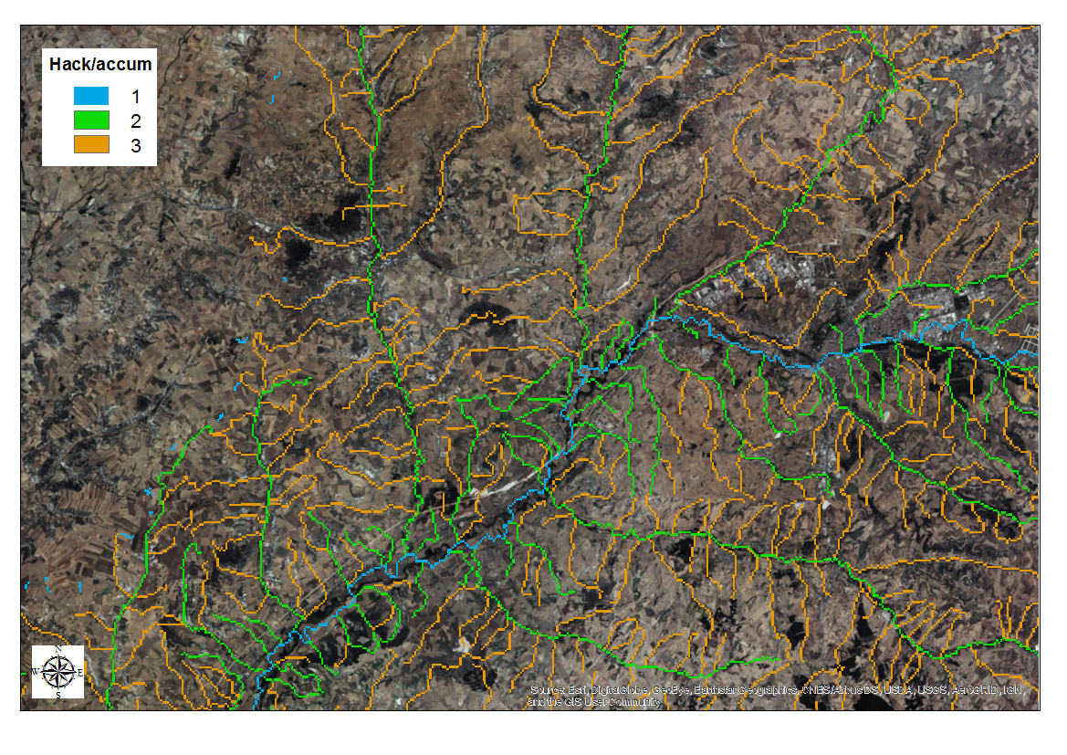

Figure 2 Raster loaded in ArcMap