Three folders:

1. **ChanLobeModel** (Dissertation Chapter 2) 🡺 The surface-based model with conventional probability map based depositional rules. Distributary channels are considered.

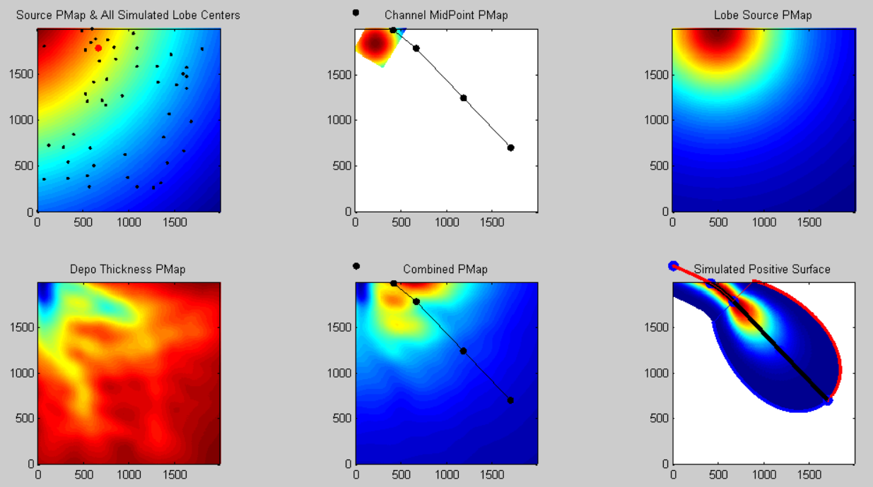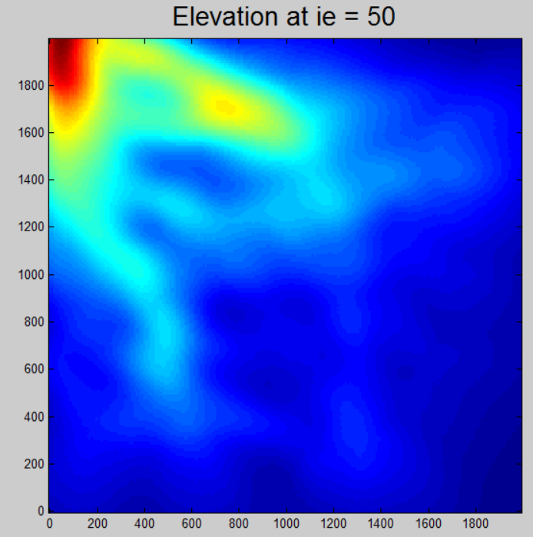

1. **ChannelLobeModel_CRWHierarchyControl** (Dissertation Chapter 4) 🡺 The surface-based model with Correlated Random Walk rules. Only lobes are considered.

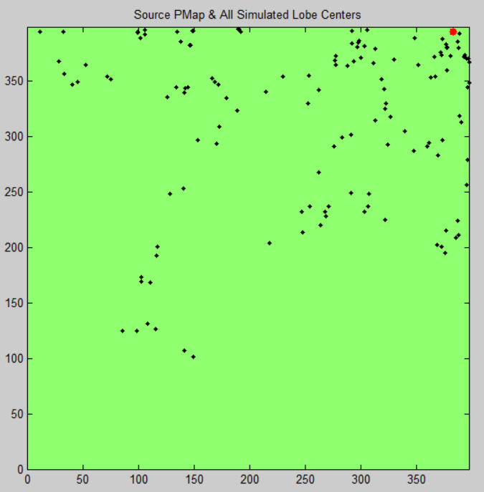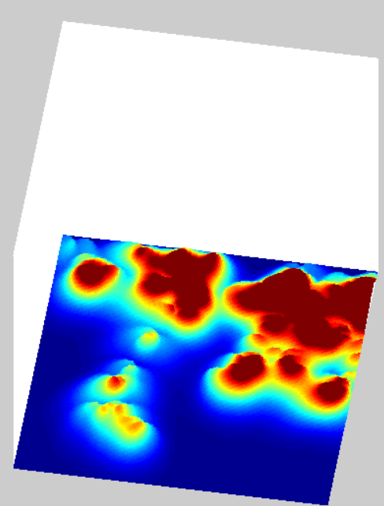

1. **Statistical Similarity Workflow** (Dissertation Chapter 3) 🡺 Scripts and demo data for the statistical scale dependent similarity test.

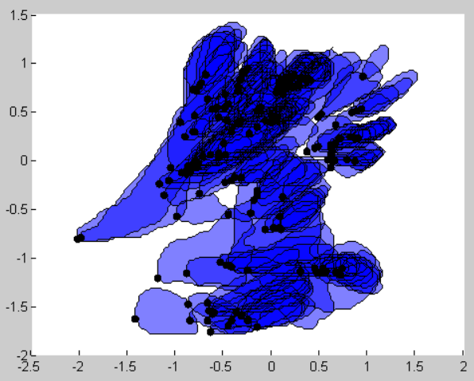

User’s Guide

All the scripts requires **Matlab R2012a (7.14.0.739)** with **ALL** toolboxes.

1. **ChanLobeModel**

Step 1: Extract the file in any folder;

Step 2: Run script

.\SiyaoXu\ChanLobeModel\Tests\TestSimulation.m

which is a demo script for all functions of ChanLobeModel

1. **ChannelLobeModel_CRWHierarchyControl**

Step 1: Extract the file in any folder;

Step 2: Run script

.\SiyaoXu\ ChannelLobeModel_CRWHierarchyControl \Tests\TestSimulation.m

which is a demo script for all functions of the model

1. **Statistical Similarity Workflow**

Step 1: Extract geometric information from lobe images

.\Siyao Xu\Statistical Similarity Workflow\ TestWorkFlow1__OrigDistExtractAndNND.m

Process 4 lobe sets, consisting of

1. Borneo - Kutai Basin
2. Amazon – Amazon Fan
3. Exp. A
4. Exp. B

Paths of lobe sets are commented in the script to be **MANUALLY selected**

Step 2: Extract masks of lobes are various scales of Exp. A and Exp. B

.\Siyao Xu\Statistical Similarity Workflow\ TestWorkFlow2_ChooseAndSaveClusters.m

Paths of Exp.A and Exp. B are commented in the script to be **MANUALLY selected**

Step 3: Extract geometric information of lobes at various scales (Step 2)

.\Siyao Xu\Statistical Similarity Workflow\ TestWorkFlow3__NNDForChosenScales.m

Paths of Exp.A and Exp. B are commented in the script to be **MANUALLY selected**

Step 4: Test similarity between Exp. A vs. Kutai Basin, Exp. A vs. Amazon, Exp. B vs. Kutai Basin, Exp. B vs. Amazon

.\Siyao Xu\Statistical Similarity Workflow\ TestWorkFlow4_CompareToRefs.m