**微算機系統**

實驗一

組別： 第16組

班級、姓名與學號： 資工二 陸詠涵 108590451

日期： 2020.09.23

1. 實驗內容：

本次實驗主旨目標

1. 實驗過程及結果：

撰寫你如何完成本次作業的流程方法。

請附上結果圖片(放置於此部分即可)。

目標一:

目標二:

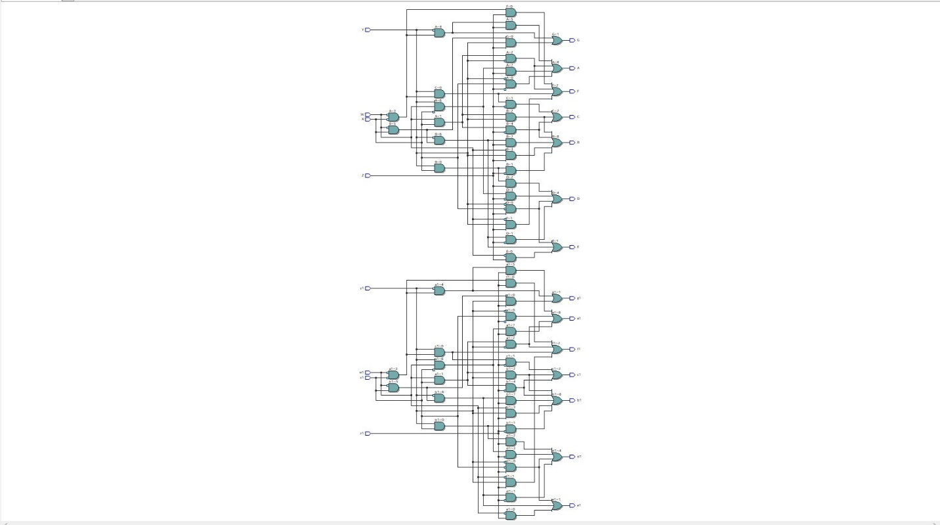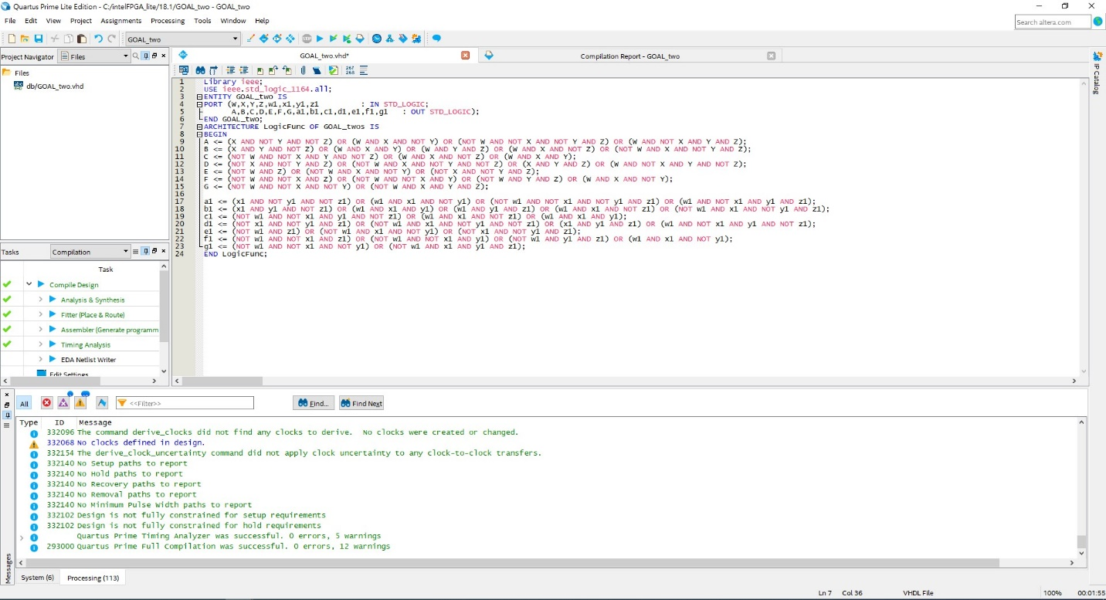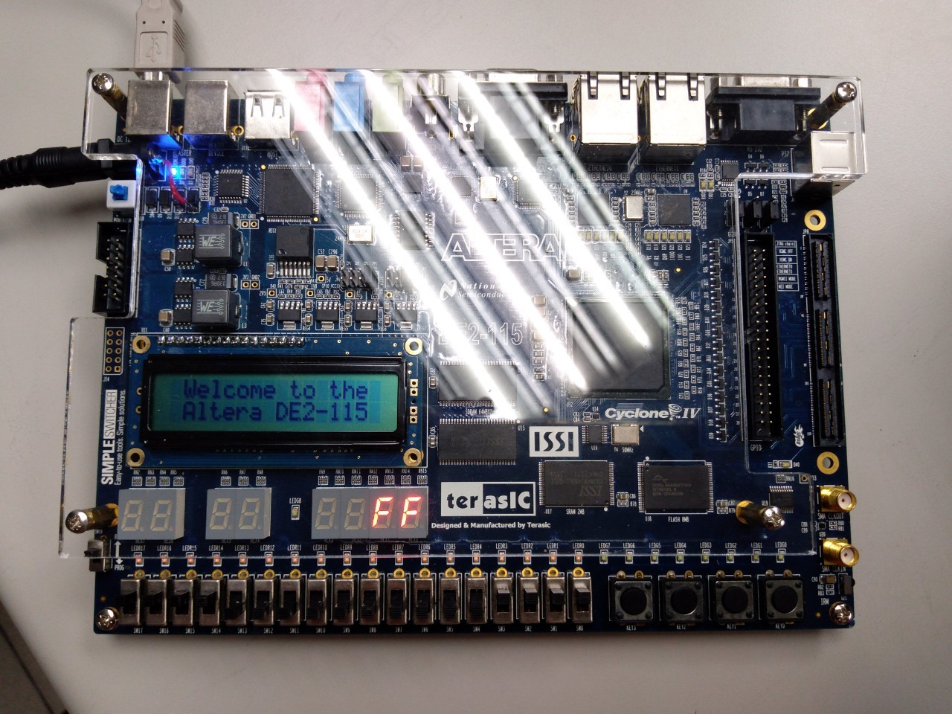

1. 程式碼（請調整成最小行高，行高0點）

|  |
| --- |
| 目標一 |
| (程式碼)  Library ieee;  USE ieee.std_logic_1164.all;  ENTITY seven_segment_display IS  PORT (W,X,Y,Z : IN STD_LOGIC;  A,B,C,D,E,F,G : OUT STD_LOGIC);  END seven_segment_display;  ARCHITECTURE LogicFunc OF seven_segment_display IS  BEGIN  A <= (X AND NOT Y AND NOT Z) OR (W AND X AND NOT Y) OR (NOT W AND NOT X AND NOT Y AND Z) OR (W AND NOT X AND Y AND Z);  B <= (X AND Y AND NOT Z) OR (W AND X AND Y) OR (W AND Y AND Z) OR (W AND X AND NOT Z) OR (NOT W AND X AND NOT Y AND Z);  C <= (NOT W AND NOT X AND Y AND NOT Z) OR (W AND X AND NOT Z) OR (W AND X AND Y);  D <= (NOT X AND NOT Y AND Z) OR (NOT W AND X AND NOT Y AND NOT Z) OR (X AND Y AND Z) OR (W AND NOT X AND Y AND NOT Z);  E <= (NOT W AND Z) OR (NOT W AND X AND NOT Y) OR (NOT X AND NOT Y AND Z);  F <= (NOT W AND NOT X AND Z) OR (NOT W AND NOT X AND Y) OR (NOT W AND Y AND Z) OR (W AND X AND NOT Y);  G <= (NOT W AND NOT X AND NOT Y) OR (NOT W AND X AND Y AND Z);  END LogicFunc; |
| 目標二 |
| (程式碼)  Library ieee;  USE ieee.std_logic_1164.all;  ENTITY GOAL_two IS  PORT (W,X,Y,Z,w1,x1,y1,z1 : IN STD_LOGIC;  A,B,C,D,E,F,G,a1,b1,c1,d1,e1,f1,g1 : OUT STD_LOGIC);  END GOAL_two;  ARCHITECTURE LogicFunc OF GOAL_two IS  BEGIN  A <= (X AND NOT Y AND NOT Z) OR (W AND X AND NOT Y) OR (NOT W AND NOT X AND NOT Y AND Z) OR (W AND NOT X AND Y AND Z);  B <= (X AND Y AND NOT Z) OR (W AND X AND Y) OR (W AND Y AND Z) OR (W AND X AND NOT Z) OR (NOT W AND X AND NOT Y AND Z);  C <= (NOT W AND NOT X AND Y AND NOT Z) OR (W AND X AND NOT Z) OR (W AND X AND Y);  D <= (NOT X AND NOT Y AND Z) OR (NOT W AND X AND NOT Y AND NOT Z) OR (X AND Y AND Z) OR (W AND NOT X AND Y AND NOT Z);  E <= (NOT W AND Z) OR (NOT W AND X AND NOT Y) OR (NOT X AND NOT Y AND Z);  F <= (NOT W AND NOT X AND Z) OR (NOT W AND NOT X AND Y) OR (NOT W AND Y AND Z) OR (W AND X AND NOT Y);  G <= (NOT W AND NOT X AND NOT Y) OR (NOT W AND X AND Y AND Z);  a1 <= (x1 AND NOT y1 AND NOT z1) OR (w1 AND x1 AND NOT y1) OR (NOT w1 AND NOT x1 AND NOT y1 AND z1) OR (w1 AND NOT x1 AND y1 AND z1);  b1 <= (x1 AND y1 AND NOT z1) OR (w1 AND x1 AND y1) OR (w1 AND y1 AND z1) OR (w1 AND x1 AND NOT z1) OR (NOT w1 AND x1 AND NOT y1 AND z1);  c1 <= (NOT w1 AND NOT x1 AND y1 AND NOT z1) OR (w1 AND x1 AND NOT z1) OR (w1 AND x1 AND y1);  d1 <= (NOT x1 AND NOT y1 AND z1) OR (NOT w1 AND x1 AND NOT y1 AND NOT z1) OR (x1 AND y1 AND z1) OR (w1 AND NOT x1 AND y1 AND NOT z1);  e1 <= (NOT w1 AND z1) OR (NOT w1 AND x1 AND NOT y1) OR (NOT x1 AND NOT y1 AND z1);  f1 <= (NOT w1 AND NOT x1 AND z1) OR (NOT w1 AND NOT x1 AND y1) OR (NOT w1 AND y1 AND z1) OR (w1 AND x1 AND NOT y1);  g1 <= (NOT w1 AND NOT x1 AND NOT y1) OR (NOT w1 AND x1 AND y1 AND z1);  END LogicFunc; |

1. 實驗心得：

每個人的心得報告至少150字以上，有關於此實驗所遇到的難題，解決方法或是對於實驗過程的分析等。（每名組員都要寫）