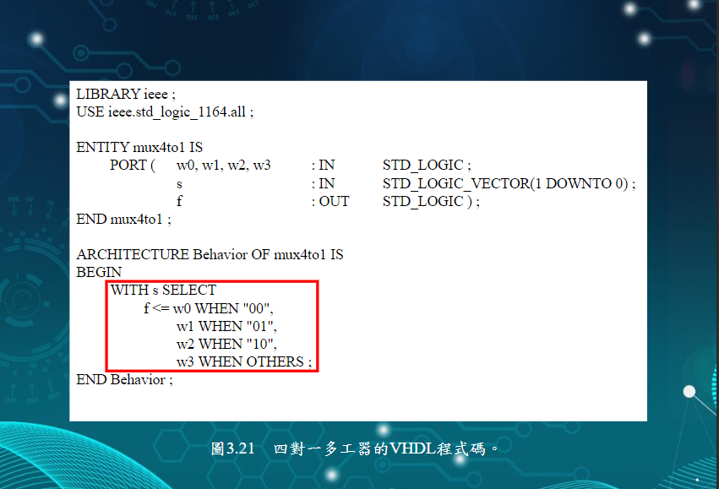

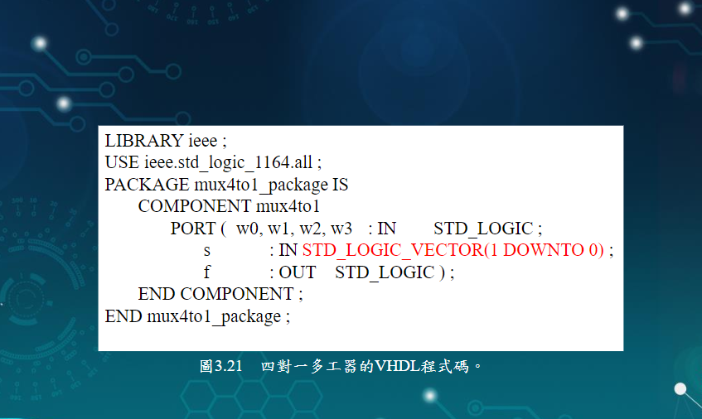

**One_bit_ALU**

**LIBRARY ieee ;**

**USE ieee.std_logic_1164.all ;**

**USE work.fulladd_package.all ;**

**USE work.seven_segment_display_package.all ;**

**USE work.mux4to1_package.all ;**

**USE ieee.std_logic_signed.all ;**

**ENTITY one_bit_ALU IS**

**PORT ( carryin : IN STD_LOGIC ;**

**w : IN STD_LOGIC_VECTOR(3 DOWNTO 0) ;**

**s : IN STD_LOGIC_VECTOR(1 DOWNTO 0) ;**

**f,set,carryout, : OUT STD_LOGIC ;**

**A,B,C,D,E,F,G : OUT STD_LOGIC_VECTOR(1 DOWNTO 0)) ;**

**END one_bit_ALU ;**

**ARCHITECTURE Structure OF one_bit_ALU IS**

**BEGIN**

**with s select**

**f <= w0 when "00",**

**w1 when "01",**

**w2 when "10",**

**w3 when OTHERS ;**

**W0 <= seven_segment_display PORT MAP (WW(0),XX(0),YY(0),ZZ(0),A(0),B(0),C(0),D(0),E(0),F(0),G(0));**

**m1: mux4to1 PORT MAP ( '0', X(0), Y(0), S(0), C(1) ) ;**

**END Structure ;**

**Mux4to1**

**LIBRARY ieee ;**

**USE ieee.std_logic_1164.all ;**

**ENTITY mux4to1 IS**

**PORT ( w0,w1,w2,w3 : IN STD_LOGIC ;**

**s : IN STD_LOGIC_VECTOR(1 DOWNTO 0) ;**

**f : OUT std_logic );**

**END mux4to1 ;**

**ARCHITECTURE LogicFunc OF mux4to1 IS**

**BEGIN**

**with s select**

**f <= w0 when "00",**

**w1 when "01",**

**w2 when "10",**

**w3 when OTHERS ;**

**END LogicFunc ;**

**Mux4to1_package**

**LIBRARY ieee ;**

**USE ieee.std_logic_1164.all ;**

**PACKAGE mux4to1_package IS**

**COMPONENT mux4to1**

**PORT ( w0,w1,w2,w3 : IN STD_LOGIC ;**

**s : IN STD_LOGIC_VECTOR(1 DOWNTO 0) ;**

**f : OUT std_logic );**

**END COMPONENT ;**

**END fulladd_package ;**