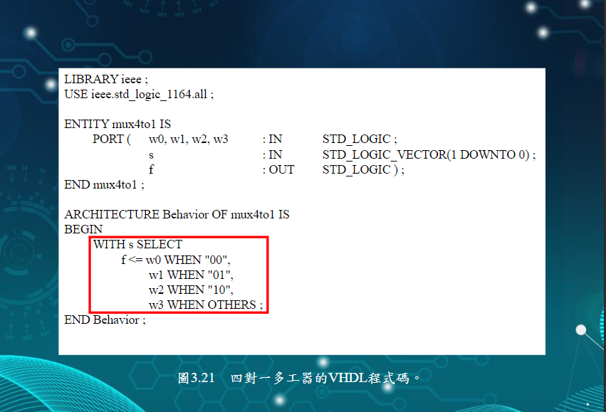

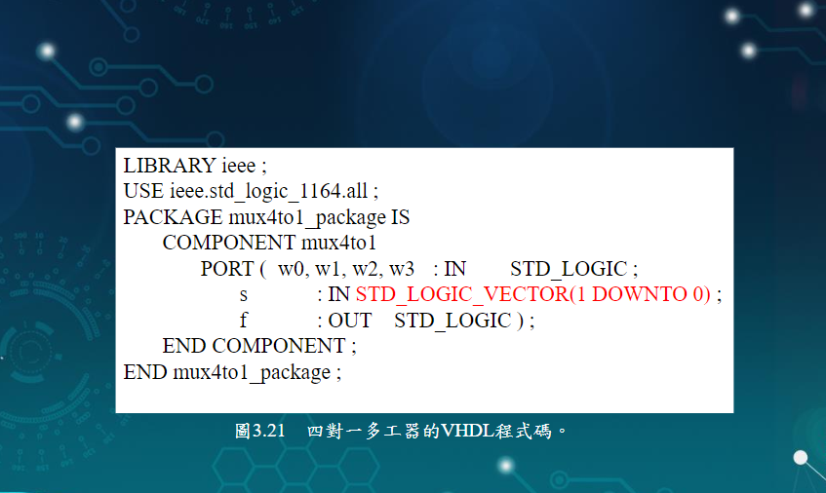

**One_bit_ALU**

**LIBRARY ieee ;**

**USE ieee.std_logic_1164.all ;**

**USE work.fulladd_package.all ;**

**USE work.seven_segment_display_package.all ;**

**USE work.mux4to1_package.all ;**

**USE ieee.std_logic_signed.all ;**

**ENTITY one_bit_ALU IS**

**PORT ( carryin : IN STD_LOGIC ;**

**w : IN STD_LOGIC_VECTOR(3 DOWNTO 0) ;**

**s : IN STD_LOGIC_VECTOR(1 DOWNTO 0) ;**

**f,set,carryout, : OUT STD_LOGIC ;**

**A,B,C,D,E,F,G : OUT STD_LOGIC_VECTOR(1 DOWNTO 0)) ;**

**END one_bit_ALU ;**

**ARCHITECTURE Structure OF one_bit_ALU IS**

**BEGIN**

**with s select**

**f <= w0 when "00",**

**w1 when "01",**

**w2 when "10",**

**w3 when OTHERS ;**

**W0 <= seven_segment_display PORT MAP (WW(0),XX(0),YY(0),ZZ(0),A(0),B(0),C(0),D(0),E(0),F(0),G(0));**

**m1: mux4to1 PORT MAP ( '0', X(0), Y(0), S(0), C(1) ) ;**

**END Structure ;**

**Mux4to1**

**LIBRARY ieee ;**

**USE ieee.std_logic_1164.all ;**

**ENTITY mux4to1 IS**

**PORT ( w0,w1,w2,w3 : IN STD_LOGIC ;**

**s : IN STD_LOGIC_VECTOR(1 DOWNTO 0) ;**

**f : OUT std_logic );**

**END mux4to1 ;**

**ARCHITECTURE LogicFunc OF mux4to1 IS**

**BEGIN**

**with s select**

**f <= w0 when "00",**

**w1 when "01",**

**w2 when "10",**

**w3 when OTHERS ;**

**END LogicFunc ;**

**Mux4to1_package**

**LIBRARY ieee ;**

**USE ieee.std_logic_1164.all ;**

**PACKAGE mux4to1_package IS**

**COMPONENT mux4to1**

**PORT ( w0,w1,w2,w3 : IN STD_LOGIC ;**

**s : IN STD_LOGIC_VECTOR(1 DOWNTO 0) ;**

**f : OUT std_logic );**

**END COMPONENT ;**

**END fulladd_package ;**

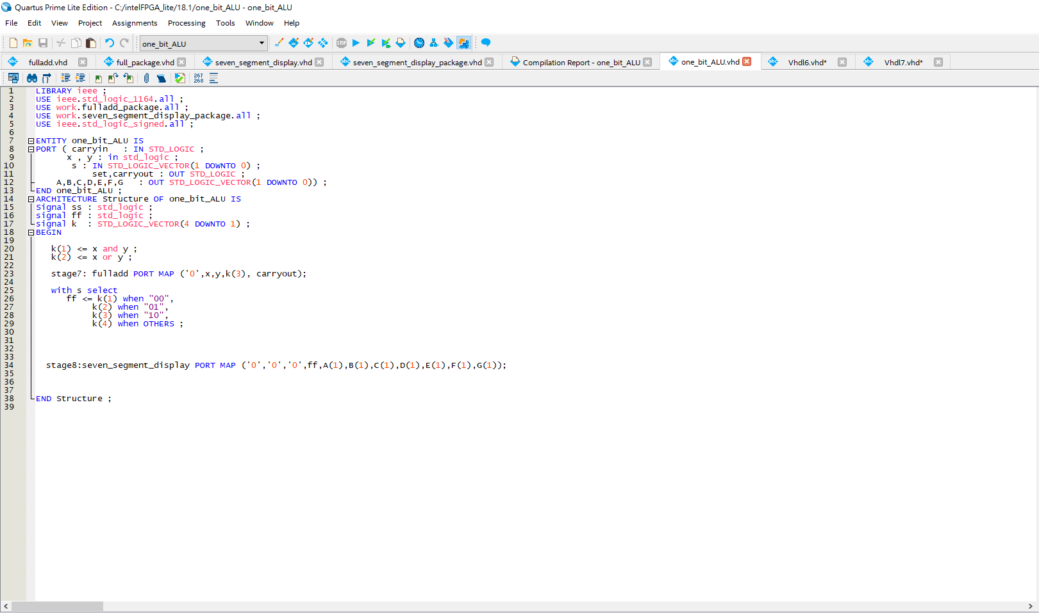

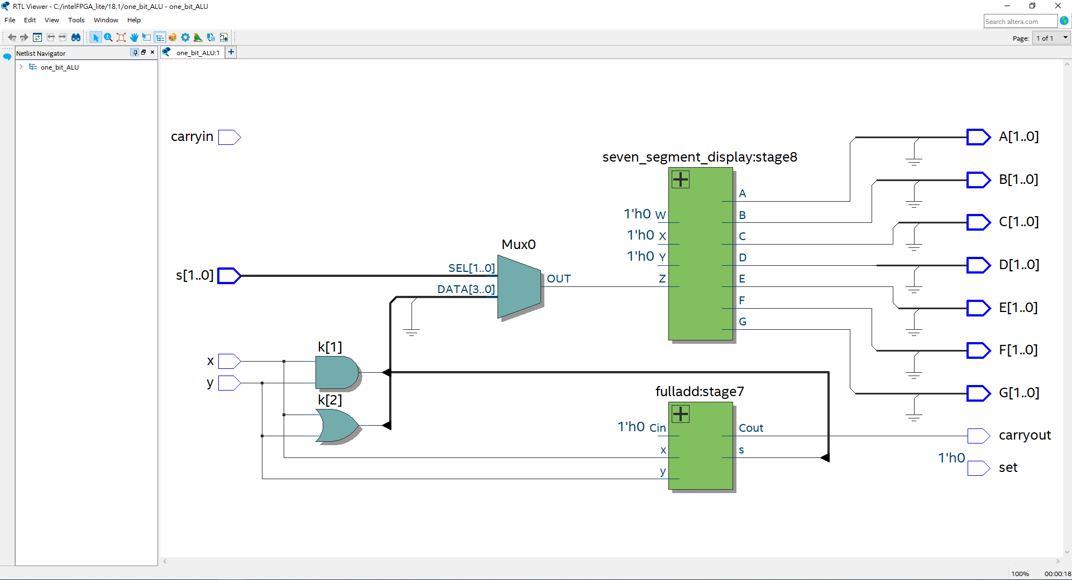

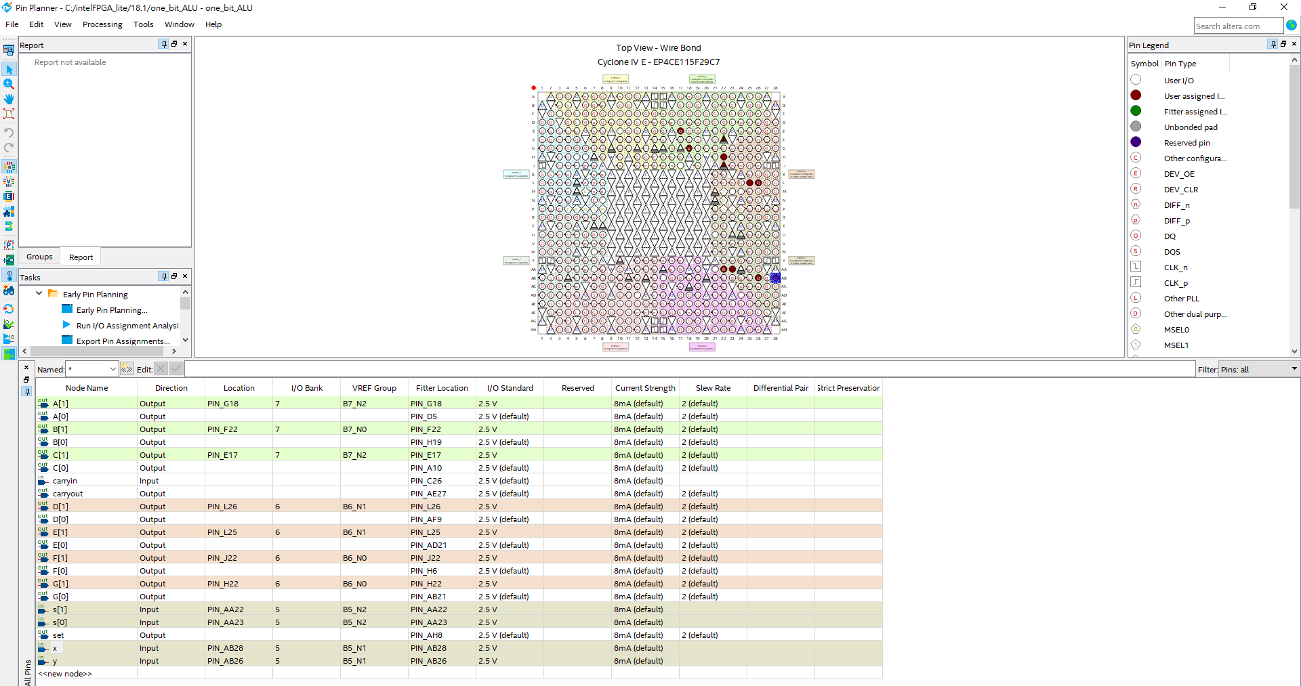

**LIBRARY ieee ;**

**USE ieee.std_logic_1164.all ;**

**USE work.fulladd_package.all ;**

**USE work.seven_segment_display_package.all ;**

**USE ieee.std_logic_signed.all ;**

**ENTITY one_bit_ALU IS**

**PORT ( carryin : IN STD_LOGIC ;**

**x , y : in std_logic ;**

**s : IN STD_LOGIC_VECTOR(1 DOWNTO 0) ;**

**set,carryout : OUT STD_LOGIC ;**

**A,B,C,D,E,F,G : OUT STD_LOGIC_VECTOR(1 DOWNTO 0)) ;**

**END one_bit_ALU ;**

**ARCHITECTURE Structure OF one_bit_ALU IS**

**Signal ss : std_logic ;**

**signal ff : std_logic ;**

**signal k : STD_LOGIC_VECTOR(4 DOWNTO 1) ;**

**BEGIN**

**k(1) <= x and y ;**

**k(2) <= x or y ;**

**stage7: fulladd PORT MAP ('0',x,y,k(3), carryout);**

**with s select**

**ff <= k(1) when "00",**

**k(2) when "01",**

**k(3) when "10",**

**k(4) when OTHERS ;**

**stage8:seven_segment_display PORT MAP ('0','0','0',ff,A(1),B(1),C(1),D(1),E(1),F(1),G(1));**

**END Structure ;**

**LIBRARY ieee ;**

**USE ieee.std_logic_1164.all ;**

**USE work.fulladd_package.all ;**

**USE work.seven_segment_display_package.all ;**

**USE ieee.std_logic_signed.all ;**

**ENTITY one_bit_ALU IS**

**PORT ( carryin : IN STD_LOGIC ;**

**x , y : in std_logic ;**

**s : IN STD_LOGIC_VECTOR(1 DOWNTO 0) ;**

**set,carryout : OUT STD_LOGIC ;**

**A,B,C,D,E,F,G : OUT STD_LOGIC_VECTOR(1 DOWNTO 0)) ;**

**END one_bit_ALU ;**

**ARCHITECTURE Structure OF one_bit_ALU IS**

**Signal ss : std_logic ;**

**signal ff : std_logic ;**

**signal k : STD_LOGIC_VECTOR(4 DOWNTO 1) ;**

**BEGIN**

**k(1) <= x and y ;**

**k(2) <= x or y ;**

**stage7: fulladd PORT MAP ('0',x,y,k(3), carryout);**

**with s select**

**ff <= k(1) when "00",**

**k(2) when "01",**

**k(3) when "10",**

**k(4) when OTHERS ;**

**stage8:seven_segment_display PORT MAP ('0','0','0',ff,A(1),B(1),C(1),D(1),E(1),F(1),G(1));**

**END Structure ;**

**LIBRARY ieee ;**

**USE ieee.std_logic_1164.all ;**

**USE work.one_ALU_package.all ;**

**ENTITY mux16to1 IS**

**PORT ( w : IN STD_LOGIC_VECTOR(0 TO 15) ;**

**s : IN STD_LOGIC_VECTOR(3 DOWNTO 0) ;**

**f : OUT STD_LOGIC ) ;**

**END mux16to1 ;**

**ARCHITECTURE Structure OF mux16to1 IS**

**SIGNAL m : STD_LOGIC_VECTOR(0 TO 3) ;**

**BEGIN G1:**

**FOR i IN 0 TO 3 GENERATE**

**Muxes: one_ALU PORT MAP ( w(4*i), w(4*(i+1)), w(4*(i+2)), w(4*(i+3)), s(1 DOWNTO 0), m(i) ) ;**

**END GENERATE ;**

**Mux5: one_ALU PORT MAP ( m(0), m(1), m(2), m(3), s(3 DOWNTO 2), f ) ;**

**stage8:seven_segment_display PORT MAP (m(0), m(1), m(2), m(3),A(1),B(1),C(1),D(1),E(1),F(1),G(1));**

**stage8:seven_segment_display PORT MAP ('0', '0', '0', f,A(1),B(1),C(1),D(1),E(1),F(1),G(1));**

**END Structure ;**

**LIBRARY ieee ;**

**USE ieee.std_logic_1164.all ;**

**USE work.fulladd_package.all ;**

**USE ieee.std_logic_signed.all ;**

**ENTITY one_ALU IS**

**PORT (w : IN STD_LOGIC_VECTOR(0 TO 3) ;**

**x , y : in std_logic ;**

**s : IN STD_LOGIC_VECTOR(1 DOWNTO 0) ;**

**set,carryout : OUT STD_LOGIC ;**

**A,B,C,D,E,F,G : OUT STD_LOGIC_VECTOR(1 DOWNTO 0)) ;**

**END one_ALU ;**

**ARCHITECTURE Structure OF one_ALU IS**

**Signal ss : std_logic ;**

**signal ff : std_logic ;**

**BEGIN**

**w(0) <= x and y ;**

**w(1) <= x or y ;**

**stage7: fulladd PORT MAP ('0',x,y,w(2), carryout);**

**with s select**

**ff <= w(0) when "00",**

**w(1) when "01",**

**w(2) when "10",**

**w(3) when OTHERS ;**

**END Structure ;**