# 160 Meters (1800-2000 kHz)

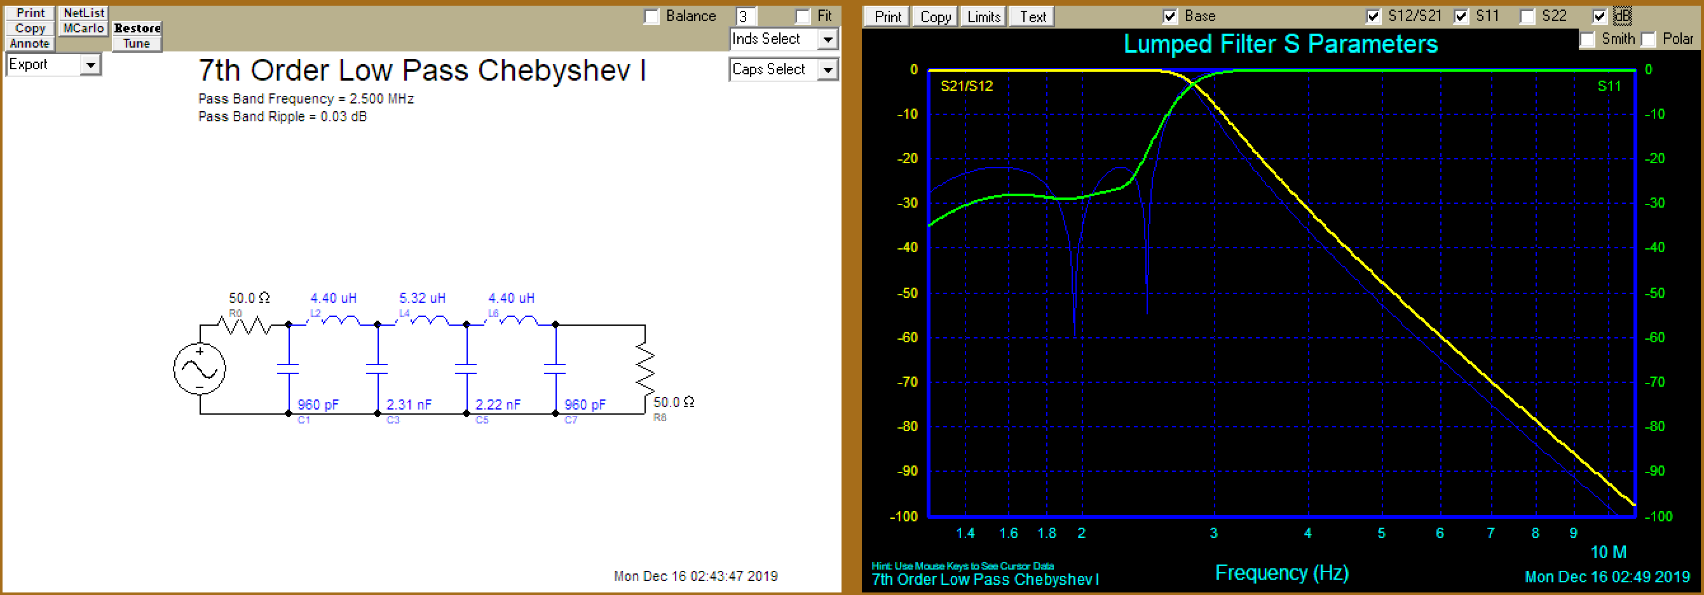

|  |  |
| --- | --- |
| Cap | Equiv |
| 960 pF | 330 pF * 2 + 100 pF * 3 |
| 2.31 nF | 330 pF * 7 |
| 2.31 nF | 330 pF * 7 |
| Ind | Turns (T130-2) |
| 4.4 uH | 20 |
| 5.32 uH | 22 |

# 80 Meters (3500-3900 kHz)

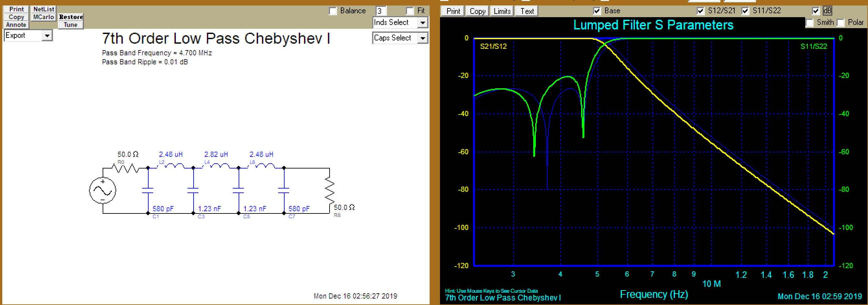

|  |  |
| --- | --- |
| C | Equiv |
| 580 pF | 180pF * 1 + 100 pF * 5 |
| 1270 pF | 330 pF * 3 + 180 pF * 1 + 100pF |
| L | Turns T106-2 |
| 2.48 uH | 15 |
| 2.82 uH | 16 |
|  |  |

# 40-30 Meters (7000-10150 kHz)

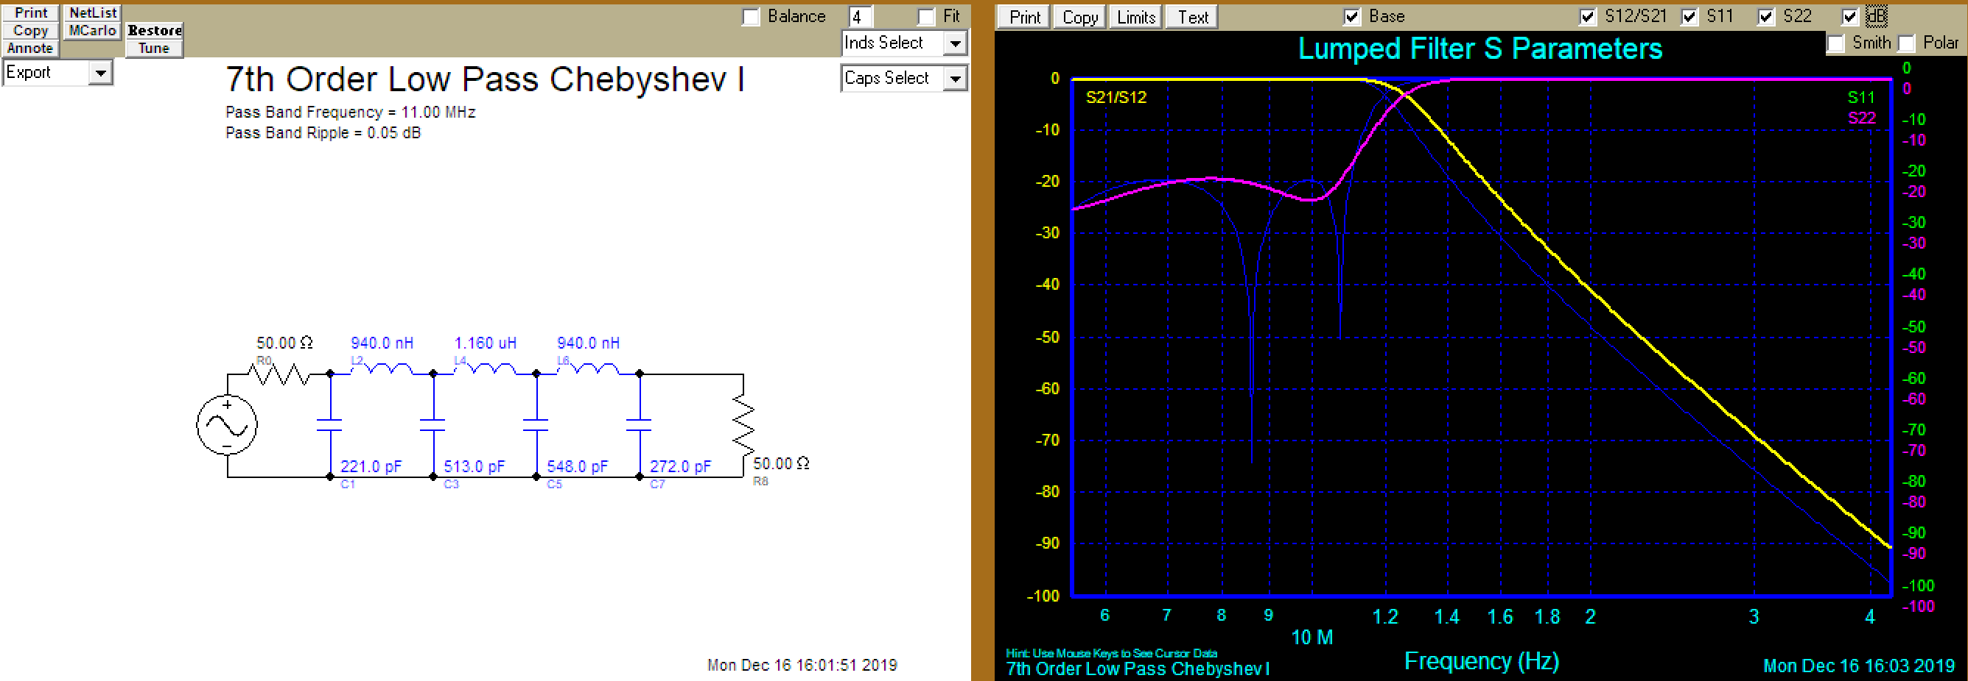

|  |  |
| --- | --- |
| C | Equiv |
| 221 pF | 47 pF * 4 + 33 pF |
| 513 pF | 180 pF * 1 + 100pF * 3 + 33 pF |
| 548 pF | 180 pF * 1 + 100pF * 3 + 68 pF |
| 272 pF | 68 pF * 4 |
| L | Turns @ T106-6 |
| 940 nH | 9 |
| 1.16 uH | 10 |
|  |  |

# 20-17 Meters (14000-18168 kHz)

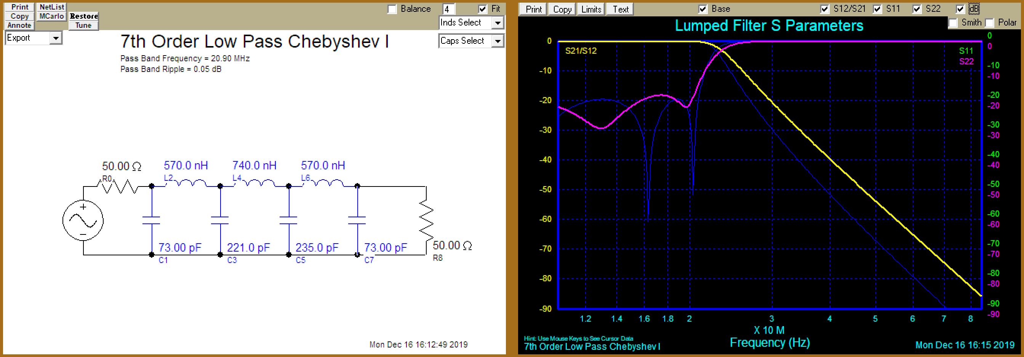

|  |  |
| --- | --- |
| C | Equiv |
| 73 pF | 10 pF * 4 + 33 pF |
| 221 pF | 47 pF * 4 + 33 pF |
| 235 pF | 47 pF * 5 |
| L | Turns @ T106-6 |
| 570 nH | 7 |
| 740 nH | 8 |
|  |  |

# 15-10 Meters (21000-29700 kHz)

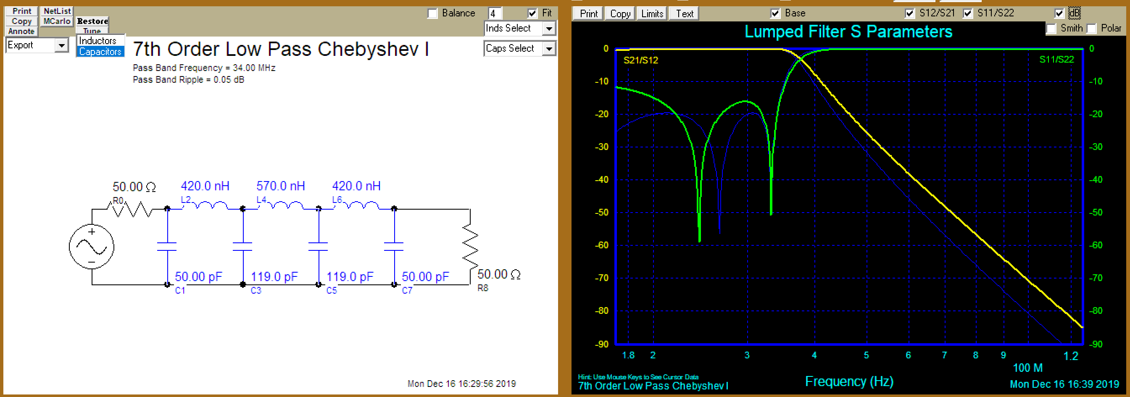

|  |  |
| --- | --- |
| C | Equiv |
| 50 pF | 10 pF *5 |
| 119 pF | 33 pF * 3 + 10 pF * 2 |
| L | Turns @ T106-6 |
| 420 nH | 6 |
| 570 nH | 7 |
|  |  |