160 Meters (1800-2000 kHz)
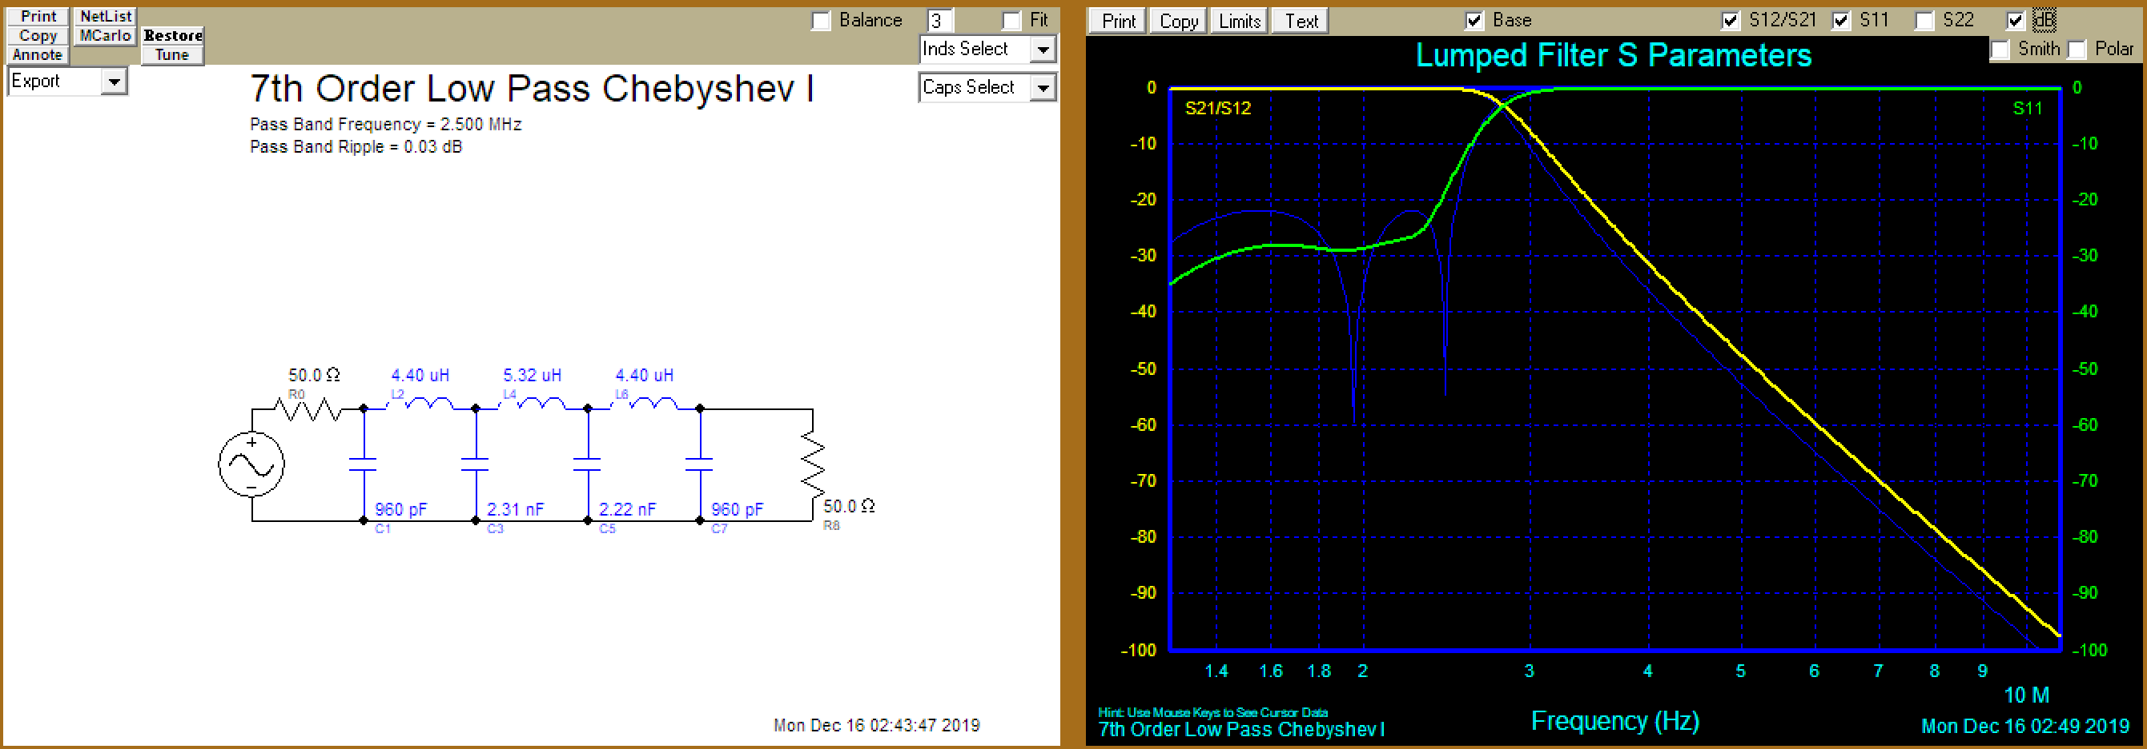
Cap | Equiv
960 pF | 330 pF * 2 + 100 pF * 3
2.31 nF | 330 pF * 7
2.31 nF | 330 pF * 7
Ind | Turns (T130-2)
4.4 uH | 20
5.32 uH | 22

80 Meters (3500-3900 kHz)
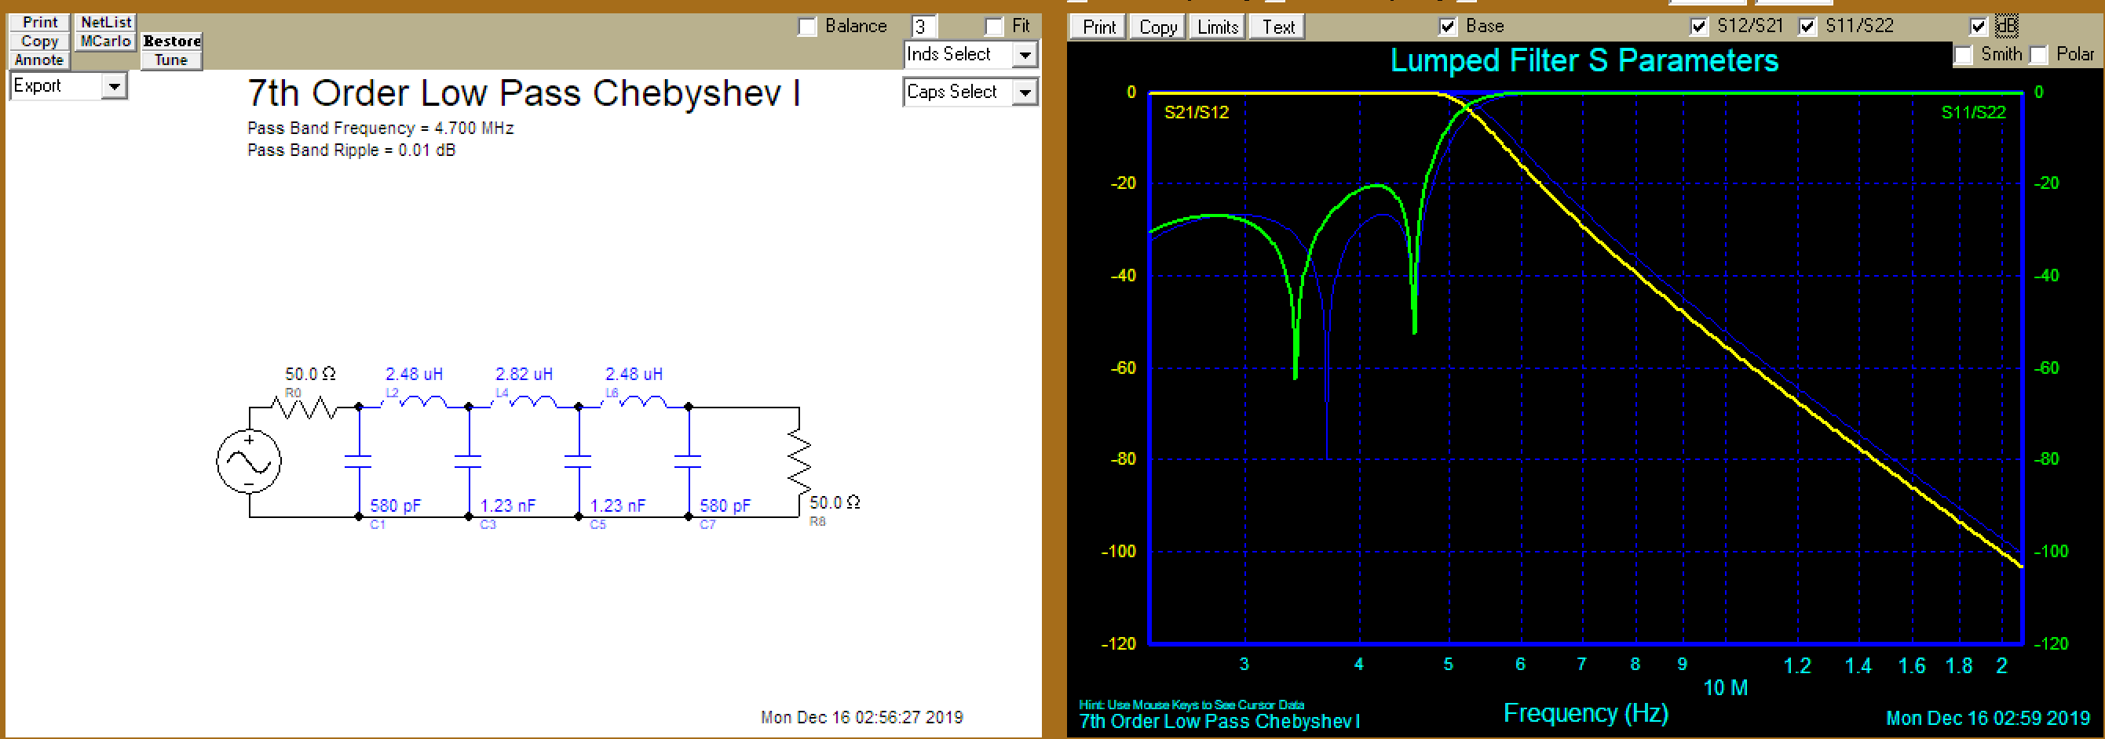
C | Equiv
580 pF | 180pF * 1 + 100 pF * 5
1270 pF | 330 pF * 3 + 180 pF * 1 + 100pF
L | Turns T106-2
2.48 uH | 15
2.82 uH | 16

40-30 Meters (7000-10150 kHz)
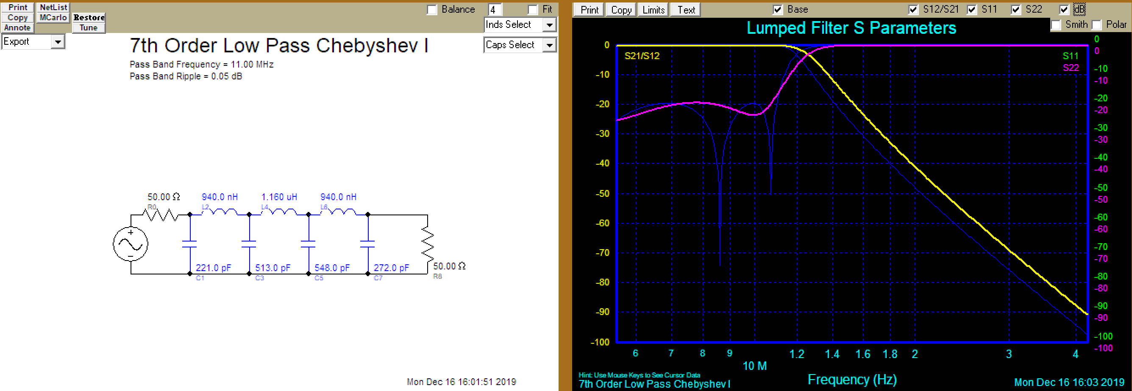
C | Equiv
221 pF | 47 pF * 4 + 33 pF
513 pF | 180 pF * 1 + 100pF * 3 + 33 pF
548 pF | 180 pF * 1 + 100pF * 3 + 68 pF
272 pF | 68 pF * 4
L | Turns @ T106-6
940 nH | 9
1.16 uH | 10

20-17 Meters (14000-18168 kHz)
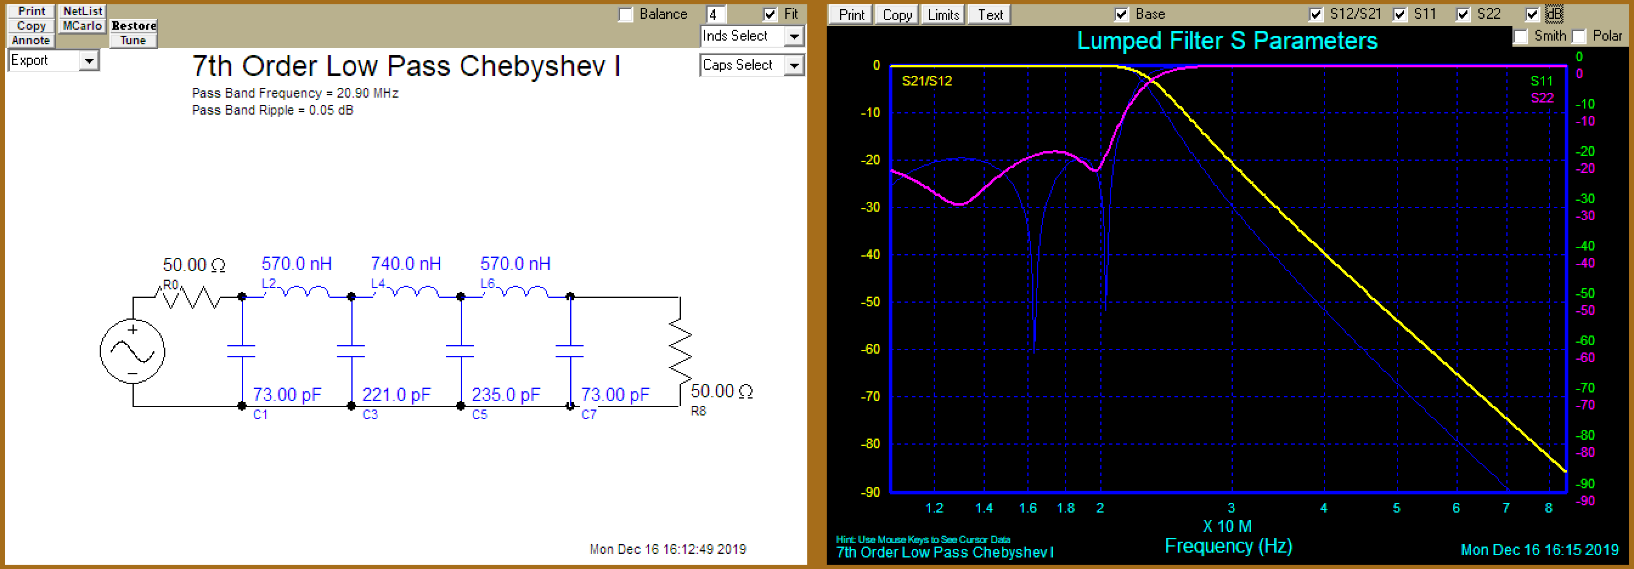
C | Equiv
73 pF | 10 pF * 4 + 33 pF
221 pF | 47 pF * 4 + 33 pF
235 pF | 47 pF * 5
L | Turns @ T106-6
570 nH | 7
740 nH | 8

15-10 Meters (21000-29700 kHz)
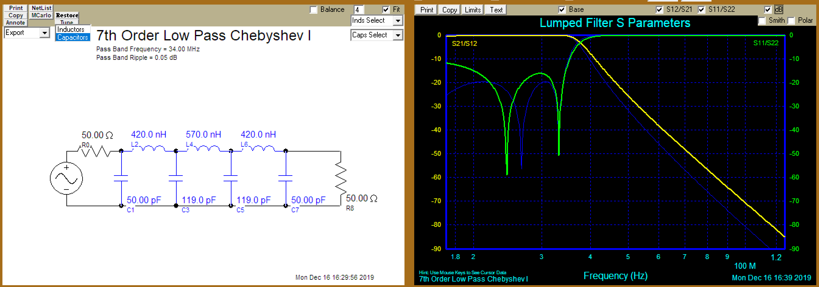
C | Equiv
50 pF | 10 pF *5
119 pF | 33 pF * 3 + 10 pF * 2
L | Turns @ T106-6
420 nH | 6
570 nH | 7

