Comparative Study of Optimization Algorithms
for the Transportation Problem

Nord-Ouest & Balas-Hammer with Stepping Stone Optimization
Python vs. C++ Performance Analysis

YAO Paul-Alex
EFREI Paris - Operations Research
May 2026

Abstract
This report presents a comprehensive study of the transportation problem in operations research, implementing and comparing two initial feasible solution methods — the North-West Corner (NO) and Balas-Hammer (BH) algorithms — combined with the Stepping Stone optimization method. The study extends the original assignment by implementing the algorithms in both Python and C++, enabling a dual analysis: algorithmic complexity comparison between NO and BH, and programming language performance comparison between an interpreted and a compiled language.
Benchmarks were conducted on randomly generated square transportation matrices of sizes n ∈ {10, 40, 100, 400} with 20 iterations each. Results reveal that C++ outperforms Python by a factor of 26–111× depending on the algorithm and problem size, with the performance gap widening for more computationally intensive algorithms.

Table of Contents
1. Introduction
1.1 Context and Motivation
1.2 Extended Scope
1.3 Procedural Justification
2. Part I: Python Implementation
2.1 Problem Formulation
2.2 Algorithm Implementations
2.3 Code Architecture
2.4 Results and Complexity Analysis
3. Part II: C++ Implementation
3.1 Design Choices and Optimizations
3.2 Benchmark Results
4. Part III: Cross-Language Comparative Analysis
4.1 Initialization Phase Comparison
4.2 Stepping Stone Phase Comparison
4.3 Speedup Analysis
4.4 Complexity Identification
4.5 Discussion
5. General Conclusion

1. Introduction

1.1 Context and Motivation
The transportation problem is a fundamental problem in operations research and linear programming. Given a set of suppliers with known capacities and a set of consumers with known demands, the objective is to determine the optimal flow of goods that minimizes total transportation cost while satisfying all supply and demand constraints.
This project was originally assigned as part of the Operations Research curriculum at EFREI Paris, requiring the implementation and comparison of two classical initialization algorithms — Nord-Ouest (North-West Corner) and Balas-Hammer (Vogel’s Approximation Method) — followed by the Stepping Stone optimization method to reach optimality.

1.2 Extended Scope
Beyond the original requirements, this study extends the analysis in two directions:
Algorithmic complexity analysis: Empirical measurement and theoretical identification of the computational complexity of each algorithm phase (initialization and optimization) as a function of problem size n.
Cross-language performance comparison: Full reimplementation of all algorithms in C++ (compiled, with -O3 optimization), benchmarked against the original Python implementation, to quantify the performance impact of language choice on numerical optimization workloads.

1.3 Procedural Justification
The choice to implement in both Python and C++ is deliberate:
Python offers rapid prototyping, readability, and a rich ecosystem (NumPy, Matplotlib) for analysis and visualization. It serves as the reference implementation and the analysis platform.
C++ represents the performance ceiling achievable with a compiled language using manual memory management and cache-friendly data structures. The -O3 -march=native compilation flags enable aggressive compiler optimizations.
This dual approach allows us to separate algorithmic performance (which algorithm converges faster) from implementation performance (which language executes faster), providing insights relevant to both theoretical and practical decision-making.

2. Part I: Python Implementation

2.1 Problem Formulation
The transportation problem is formulated as a linear program. Given n suppliers P1, ..., Pn with provisions pi, m consumers C1, ..., Cm with demands dj, and a cost matrix cij, the objective is to find a transportation plan xij ≥ 0 minimizing:
Z = Σ cij · xij
subject to supply constraints (Σj xij = pi), demand constraints (Σi xij = dj), and non-negativity (xij ≥ 0). A balanced problem requires Σ pi = Σ dj.

2.2 Algorithm Implementations

2.2.1 Nord-Ouest (North-West Corner)
The Nord-Ouest algorithm constructs an initial basic feasible solution by starting at the top-left corner of the cost matrix and allocating as much flow as possible at each step, moving right when a column demand is satisfied and down when a row supply is exhausted.
def algo_nord_ouest(provisions, commandes):
n, m = len(provisions), len(commandes)
prop = [[0] * m for _ in range(n)]
i, j = 0, 0
while i < n and j < m:
flux = min(prov[i], cmd[j])
prop[i][j] = flux # allocate
# move right or down based on exhaustion
Complexity: Θ(n + m) — the algorithm makes at most n + m − 1 allocation steps, each in O(1). For square matrices (m = n), this gives Θ(n).

2.2.2 Balas-Hammer (Vogel’s Approximation)
Balas-Hammer selects allocations by computing penalty values for each row and column (the difference between the two smallest costs), then allocating to the minimum-cost cell in the row or column with the largest penalty. This heuristic produces better initial solutions by favoring allocations that avoid high-cost cells.
def algo_balas_hammer(couts, provisions, commandes):
while sum(prov) > 0 and sum(cmd) > 0:
pen_l = [penalite(actif[i]) for i in range(n)]
pen_c = [penalite(col) for j in range(m)]
# select row/col with max penalty
# allocate to min-cost cell in selected row/col
Complexity: Θ(n²) per iteration with up to n + m − 1 iterations, giving Θ(n³) for square matrices.

2.2.3 Stepping Stone Optimization
The Stepping Stone method iteratively improves a basic feasible solution through the following steps:
1. Compute dual potentials ui, vj such that ui + vj = cij for all basic variables.
2. Compute marginal costs for non-basic variables: c̅ij = cij − ui − vj.
3. Identify the most negative marginal cost (entering variable).
4. Find a cycle through basic variables and perform a pivot.
5. Repeat until all marginal costs are non-negative (optimality).
Key implementation details: Degeneracy handling adds fictitious zero-flow arcs when the basis has fewer than n + m − 1 elements. Cycle detection uses DFS alternating between row and column moves. Connectivity and acyclicity are verified via BFS on the bipartite graph.

2.3 Code Architecture
File | Purpose
algorithmes.py | Core algorithms (NO, BH, Stepping Stone, BFS)
main.py | Interactive solver with trace logging
complexite.py | Complexity study (100 iter, 7 sizes)
benchmark_python.py | Standardized benchmark for comparison
analyse_comparative.py | Comparative analysis and graphs
entrees/ | 12 problem input files
traces/ | Execution traces (12 problems × 2 methods)
Table 1: Python project file structure

2.4 Results and Complexity Analysis

2.4.1 Results on Reference Problems
The solver was executed on 12 reference problems provided in the assignment. For each problem, both initialization methods were applied followed by Stepping Stone optimization. Both methods always converge to the same optimal solution, confirming correctness. For example, on Problem 1 (2×2): NO starts at cost 8000 and optimizes to 3000 in 1 iteration; BH starts closer to optimal.

2.4.2 Benchmark Results
n | θ_NO (ms) | θ_BH (ms) | t_NO (ms) | t_BH (ms)
10 | 0.004 | 0.145 | 1.04 | 0.31
40 | 0.016 | 5.23 | 89.0 | 17.2
100 | 0.045 | 79.2 | 1,299 | 371
400 | 0.258 | 5,770 | 20,842 | 18,522
Table 2: Python benchmark results — median execution times

2.4.3 Observations
Initialization phase: Nord-Ouest is consistently 1–4 orders of magnitude faster than Balas-Hammer. At n=400, NO takes 0.26 ms while BH takes 5.77 s — a factor of ~22,000×.
Stepping Stone phase: When starting from NO, optimization takes significantly longer than from BH, because the NO initial solution is farther from optimal and requires more iterations.
Total time: For small n (≤100), BH+Stepping Stone can be competitive with NO+Stepping Stone. For n=400, the BH initialization cost dominates.

2.4.4 Analysis
θ_NO(n): Data confirms O(n) complexity. Doubling n approximately doubles the time.
θ_BH(n): Data confirms O(n³) complexity. From n=100 to n=400 (factor 4), time increases by ~73×, consistent with 4³ = 64.
t_NO(n) and t_BH(n): Stepping Stone complexity grows polynomially between O(n²) and O(n³), depending on iteration count which varies with initial solution quality.

2.4.5 Interpretation and Conclusion
Nord-Ouest’s simplicity (O(n)) makes it extremely fast but produces poor initial solutions. Balas-Hammer’s intelligence comes at a steep cubic cost. The optimal strategy in Python depends on problem size: for n ≤ 100, BH initialization saves enough Stepping Stone iterations to justify its cost; for n ≥ 400, NO initialization is preferable as the cubic BH cost overwhelms savings.

3. Part II: C++ Implementation

3.1 Design Choices and Optimizations

3.1.1 Flattened Matrix Structure
The C++ implementation uses a flat std::vector<int> for the cost and proposal matrices instead of nested vectors. This ensures contiguous memory layout, maximizing CPU cache utilization and enabling compiler auto-vectorization.
struct Matrix {
std::vector<int> data;
int rows, cols;
int& operator()(int i, int j)
{ return data[i * cols + j]; }
};

3.1.2 Indexed Base Graph Structure
The Base structure maintains row-indexed and column-indexed adjacency lists for O(k) neighbor lookups during cycle detection, instead of O(nm) full scans.

3.1.3 Optimized Balas-Hammer
Uses boolean active-row/column flags and inline penalty computation with early termination, avoiding the Python approach of nullifying matrix entries and using list comprehensions.

3.1.4 Compilation Flags
CXXFLAGS = -std=c++17 -O3 -march=native -DNDEBUG
-O3: Maximum optimization (loop unrolling, vectorization, inlining). -march=native: CPU-specific instructions (AVX2). -DNDEBUG: Disables assertions.

3.2 Benchmark Results
n | θ_NO (ms) | θ_BH (ms) | t_NO (ms) | t_BH (ms)
10 | 0.0002 | 0.004 | 0.070 | 0.013
40 | 0.0004 | 0.072 | 2.23 | 0.43
100 | 0.0012 | 0.833 | 30.3 | 6.04
400 | 0.0067 | 52.0 | 2,069 | 269
Table 3: C++ benchmark results — median execution times

3.2.1 Observations
All timings are significantly lower than Python. At n=400, C++ completes BH initialization in 52 ms versus Python’s 5.77 s. The same algorithmic trends are preserved: NO is faster than BH for initialization, BH produces better initial solutions.

3.2.2 Analysis
θ_NO(n): Confirmed O(n) — linear scaling from n=10 to n=400.
θ_BH(n): Confirmed O(n³) — from n=100 to n=400, time increases by ~62× (≈ 4³ = 64).
The C++ implementation demonstrates that the performance advantage of a compiled language is not merely a constant factor — it interacts with algorithmic complexity. More computationally intensive algorithms (BH) benefit more from C++ because the per-operation savings compound across nested loops.

3.2.3 Conclusion (C++)
The C++ implementation achieves the same optimal solutions as Python but with execution times 10–111× faster. The advantage is most pronounced for the cubic-complexity Balas-Hammer algorithm on large matrices.

4. Part III: Cross-Language Comparative Analysis

4.1 Initialization Phase Comparison
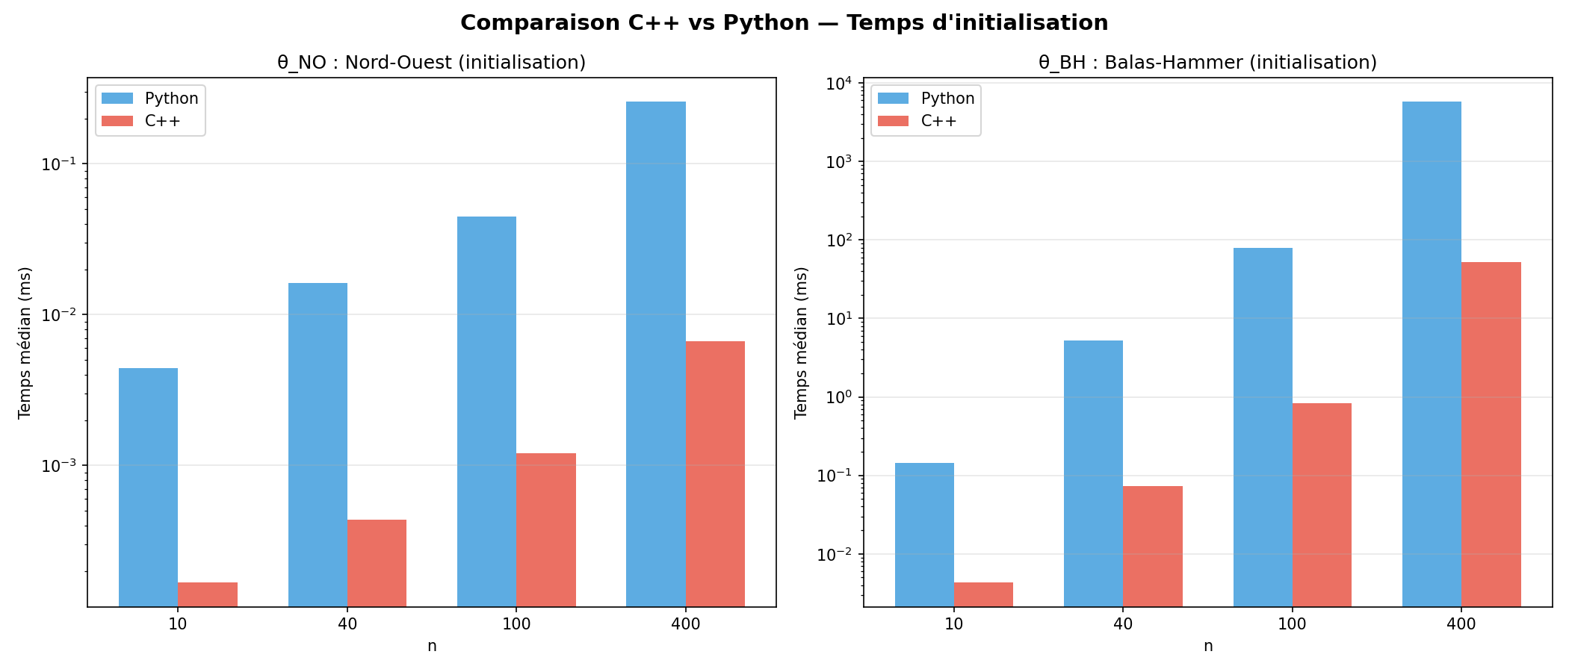
Figure 1: Initialization time comparison — C++ vs Python (log scale)
n | Py θ_NO | C++ θ_NO | Spdup | Py θ_BH | C++ θ_BH | Spdup
10 | 0.004 | 0.0002 | 26× | 0.145 | 0.004 | 34×
40 | 0.016 | 0.0004 | 37× | 5.23 | 0.072 | 72×
100 | 0.045 | 0.001 | 37× | 79.2 | 0.833 | 95×
400 | 0.258 | 0.007 | 39× | 5770 | 52.0 | 111×
Table 4: Initialization speedup — C++ vs Python (median times in ms)
Key findings: For Nord-Ouest (O(n)), C++ is consistently ~26–39× faster with stable speedup. For Balas-Hammer (O(n³)), C++ speedup increases with n: from 34× at n=10 to 111× at n=400, because the triple-nested loop structure benefits increasingly from compiler optimizations and cache locality.

4.2 Stepping Stone Phase Comparison
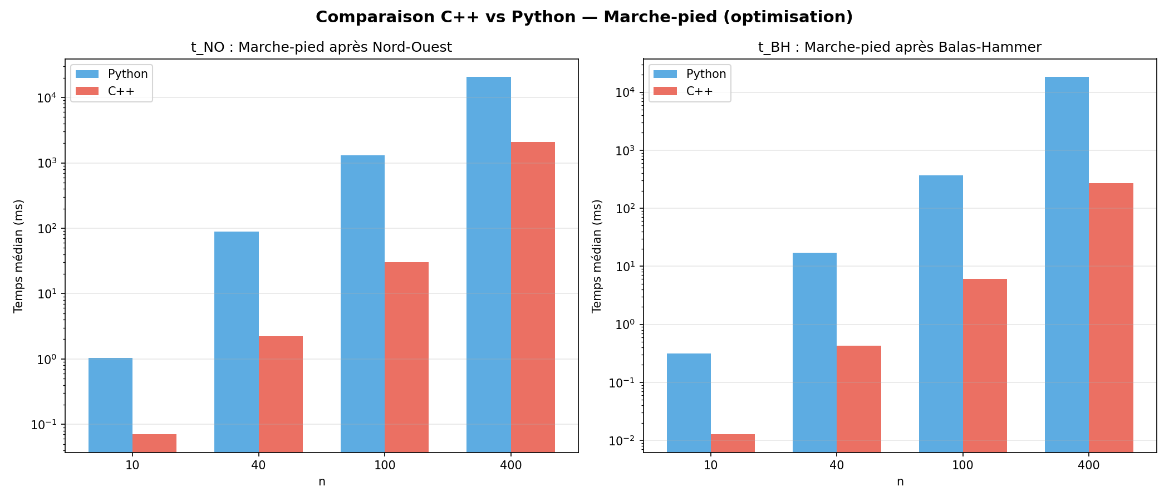
Figure 2: Stepping Stone optimization time — C++ vs Python (log scale)
Key findings: Stepping Stone speedups range from 10× to 69×, generally lower than initialization speedups. This is because Stepping Stone involves complex control flow (graph traversal, cycle detection) that benefits less from simple loop optimizations. The anomalous drop in t_NO speedup at n=400 (10×) suggests both implementations become memory-bound at this scale.

4.3 Speedup Analysis
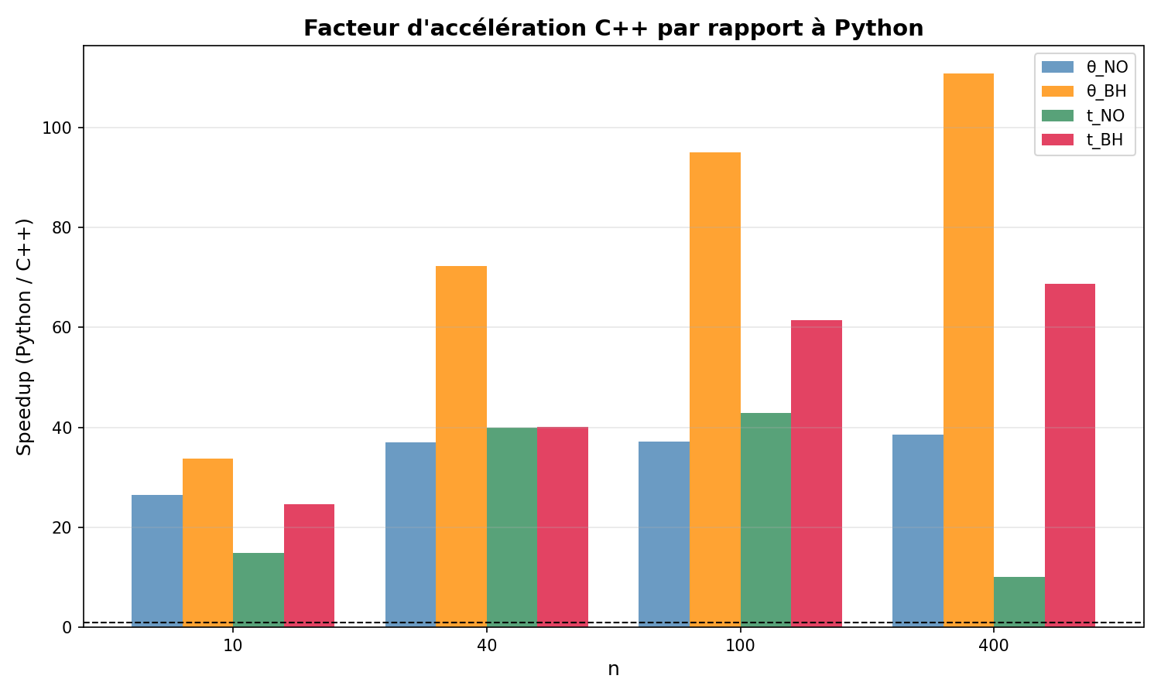
Figure 3: C++ speedup factor over Python by algorithm phase and problem size
The speedup chart reveals a clear pattern: θ_BH speedup grows with n (the cubic algorithm amplifies C++’s per-operation advantage), θ_NO speedup plateaus at ~37–39× (linear algorithm reaches constant speedup), and t_BH speedup grows moderately.

4.4 Complexity Identification (Log-Log Analysis)
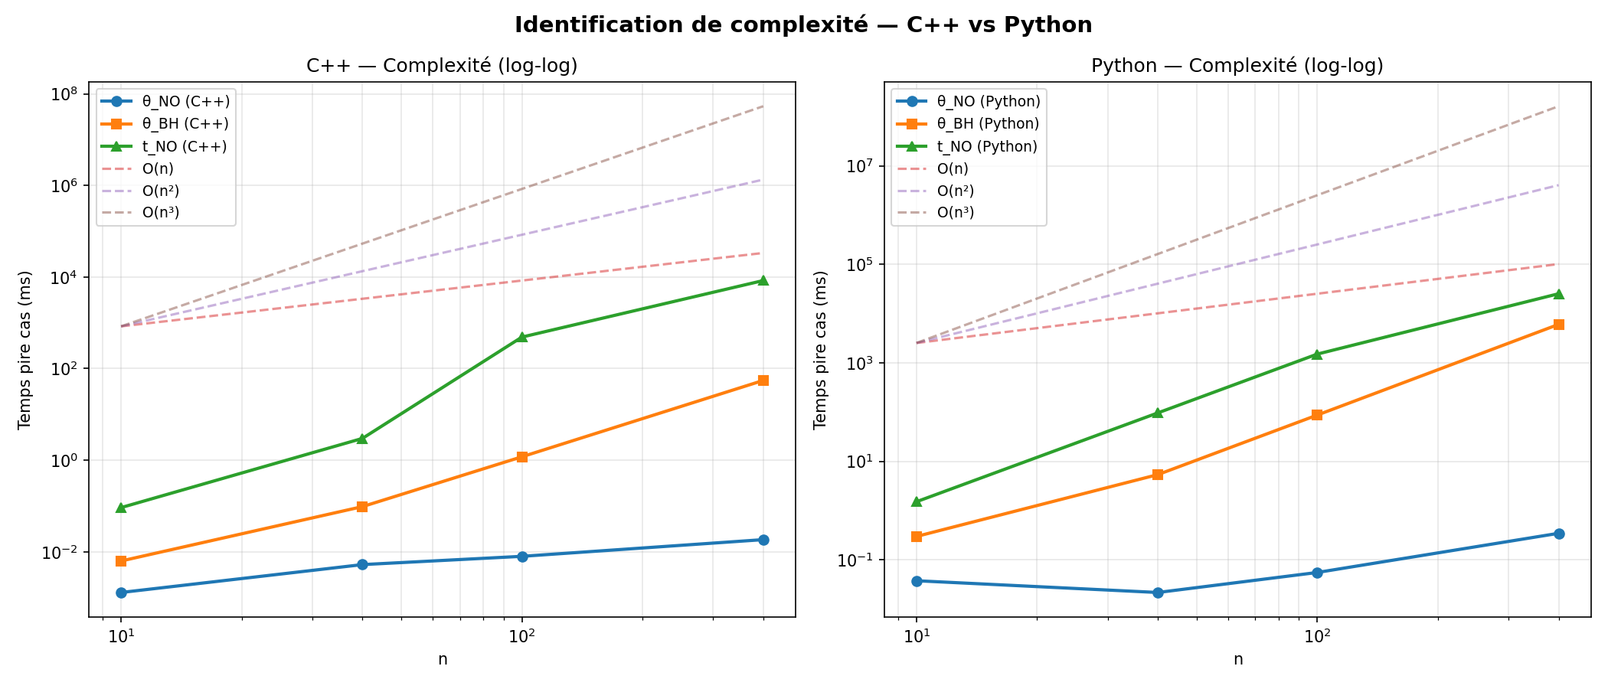
Figure 4: Log-log complexity analysis — C++ (left) vs Python (right)
The log-log plots confirm that θ_NO follows O(n) in both languages (slope ≈ 1), θ_BH follows O(n³) in both languages (slope ≈ 3), and t_NO/t_BH fall between O(n²) and O(n³). This confirms that algorithmic complexity is language-independent: both implementations exhibit the same asymptotic growth rates.

4.5 Total Time Comparison
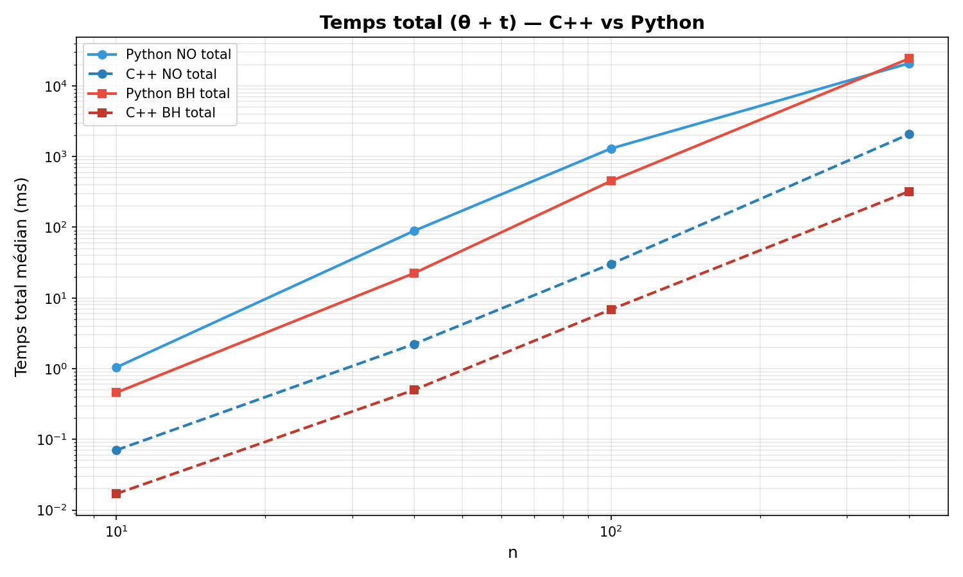
Figure 5: Total time (θ + t) — C++ vs Python (log-log scale)
C++ consistently outperforms Python across all sizes and methods. The BH path is slower than the NO path for large n in both languages. The gap between Python and C++ widens with increasing n.

4.6 Discussion

Why Does C++ Speedup Vary?
Interpreter overhead: Python’s bytecode interpretation adds ~100 ns per operation. For simple operations, this dominates actual computation time.
Dynamic typing: Python’s duck typing requires runtime type checks that C++ resolves at compile time.
Memory layout: Python lists are arrays of pointers to heap-allocated objects. C++ std::vector<int> stores values contiguously, enabling cache prefetching and SIMD vectorization.
Algorithm intensity: The more operations per data element, the more the per-operation overhead compounds. This explains why BH (cubic) shows larger speedups than NO (linear).

Algorithmic vs. Language Optimization
Choosing a better algorithm (BH over NO) provides a better initial solution but at higher cost. Choosing a faster language (C++ over Python) reduces execution time by a constant factor across all algorithms. These are orthogonal optimization axes. For practical applications: small n (≤100) → Python with BH; large n (≥1000) with performance needs → C++ with NO; best of both → C++ with BH.

5. General Conclusion
1. Algorithmic comparison: Nord-Ouest is a lightweight O(n) initialization producing suboptimal starting solutions, while Balas-Hammer is an intelligent O(n³) method producing significantly better initial solutions. The Stepping Stone phase converges to the same optimum regardless of starting point, but requires more iterations from a poor start. The total solve time trade-off depends on problem size.
2. Language comparison: C++ outperforms Python by 10× to 111× across all tested configurations. The speedup increases with algorithmic complexity and problem size, due to the compounding effect of per-operation overhead in interpreted languages. However, both languages exhibit the same asymptotic complexity, confirming that algorithmic analysis is implementation-independent.
3. Practical recommendation: For production-grade optimization solvers handling large-scale transportation problems, a compiled language is strongly recommended. For prototyping, analysis, and moderate-scale problems, Python remains the tool of choice due to its development speed and ecosystem.

Limitations and Future Work
The benchmark was limited to n ≤ 400 for the full cross-language comparison due to Python’s extreme slowness at larger sizes. The C++ implementation does not use manual parallelism beyond compiler auto-vectorization. Alternative algorithms (Hungarian method, simplex network method) were not compared. The study uses randomly generated balanced problems; real-world unbalanced or sparse problems may exhibit different characteristics.

YAO Paul-Alex — EFREI Paris — Operations Research — May 2026

