**MATLAB code for computing mixed urban land use degree with geo-big data**

We use the following equations to calculate the land use compatibility, poi compatible density and population mobility illustrated in Figure 1:

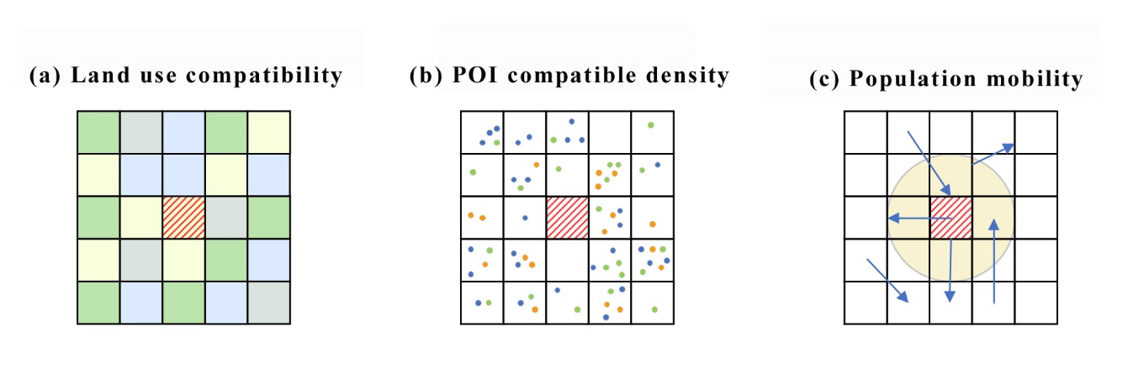

***Note:*** *Different colors in the 5*5 neighborhood in Figure 1(a) represent different land use types; different colored points in the neighborhood in Figure 1(b) represent different types of POIs; and Figure 1(c) represents the population flows interacting within and across the circular neighborhood of the core raster.*



*cmij* represents the compatibility of the grid cell in the *i*-*th* row and *j*-*th* column with other cells within a 5x5 neighborhood, shown in Figure. 1(a). *copij* (*g,* *h*) is the compatibility coefficient between the land use type of the grid cell in the *i*-th row and *j*-th column and the land use type of the grid cell in the *g*-*th* row and *h*-*th* column within the 5x5 neighborhood. These coefficients are derived from existing literature based on expert judgment. *dij* (*g, h*) represents the distance between the two grid cells. We assume there is a linear decay and that the greater the distance, the less the compatibility.



*cdij* represents the POI compatible density of the grid cell in the *i*-*th* row and *j*-*th* column within a 5x5 neighborhood in Figure. 1(b). *poic* (*m*, *n*) denotes the compatibility coefficient between POI type *m* and type *n*, while *q*(*m*) and *q*(*n*) represent the number of POIs of type *m* and type *n* within the 5x5 neighborhood, respectively.



*Pfij* represents the population mobility of the grid cell in *i*-*th* row and *j*-*th* column. *popij* (r<=2) denotes the population mobility within a 2000-meter neighborhood centered on the grid cell in the *i*-*th* row and *j*-*th* column. Conversely, *popij* (r>2) refers to the population mobility crossing the neighborhood.

The MATLAB code for computing the above equations in the attachments folders, respectively. Note: the third code run will last about 4 minutes.