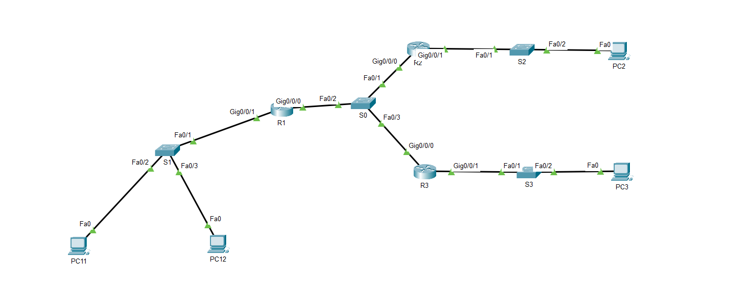

PC 11 ping PC 12:

PC 11 ping PC 2:

PC 11 ping PC 3:

Show ip route trên R1:

Show ip route trên R2:

Show ip route trên R3:

