BÁO CÁO THỰC HÀNH HỆ ĐIỀU HÀNH LAB5

Họ và tên: Nguyễn Đức Luân

MSSV: 22520825

BÀI 5.4.1.3:

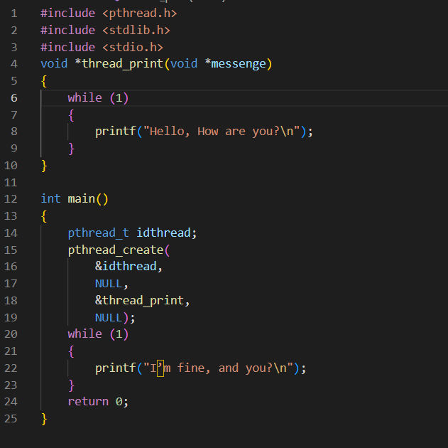

BÀI 5.4.1.4

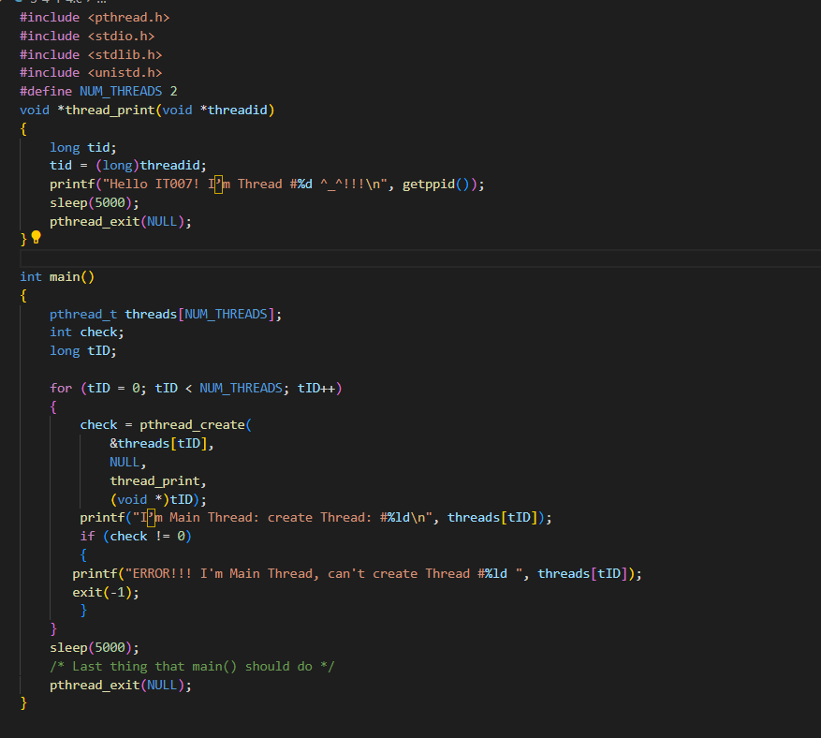

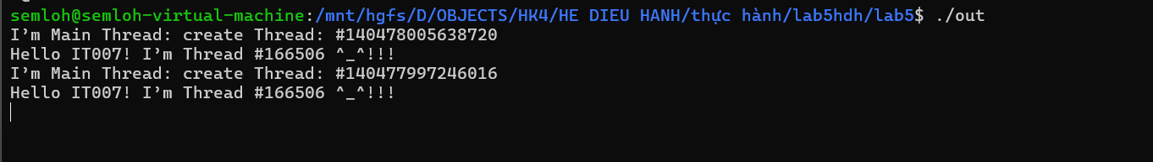

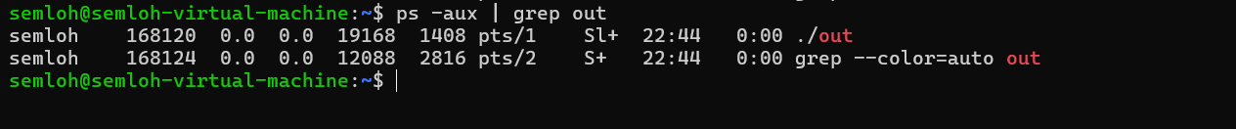

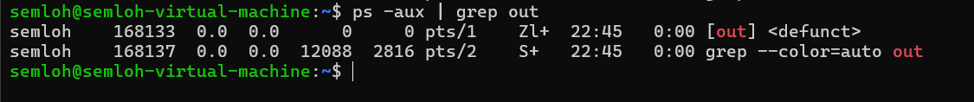

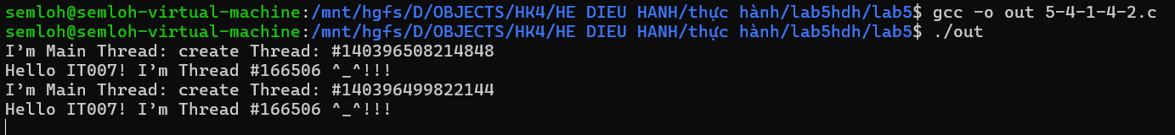

BÀI 5.4.1.5

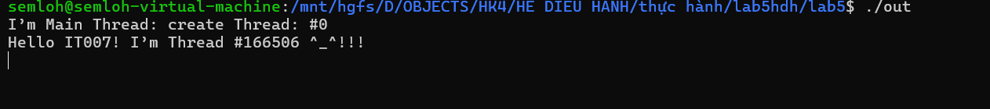

BÀI 5.4.1.6

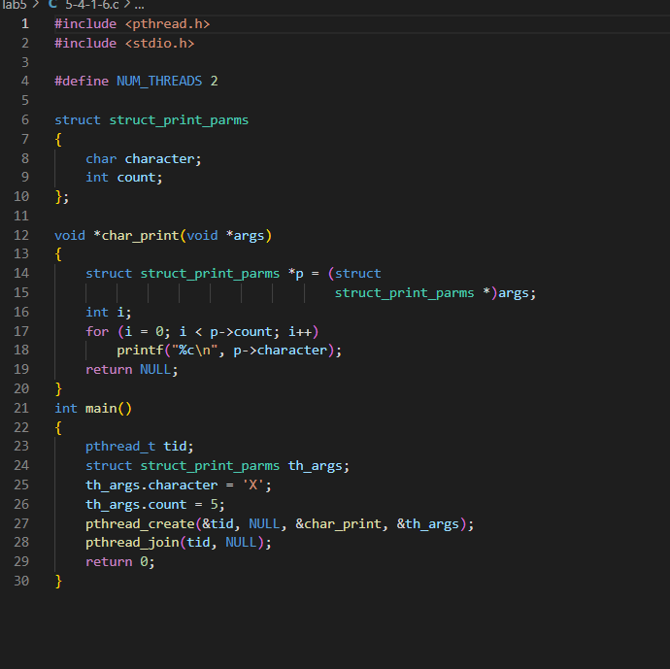

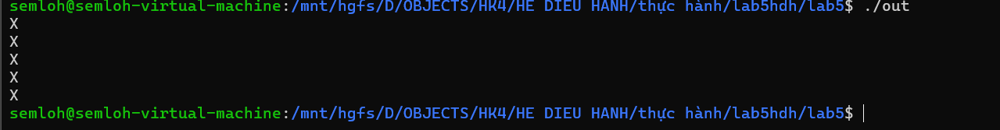

BÀI 5.4.2.1

BÀI 1:

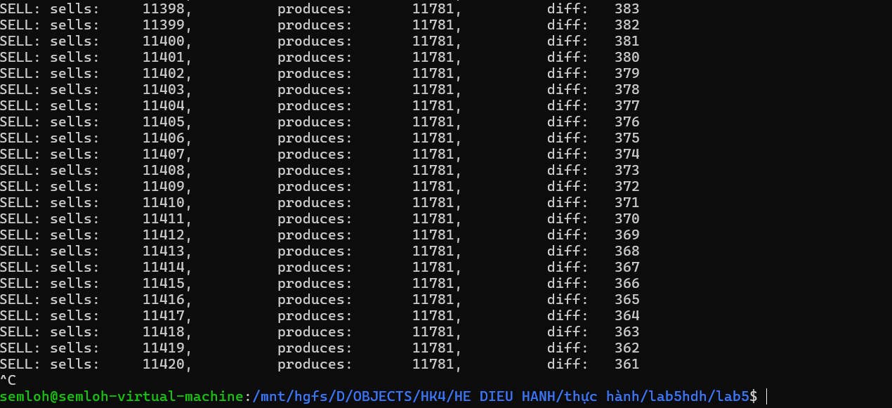

BÀI 2:

BÀI 3:

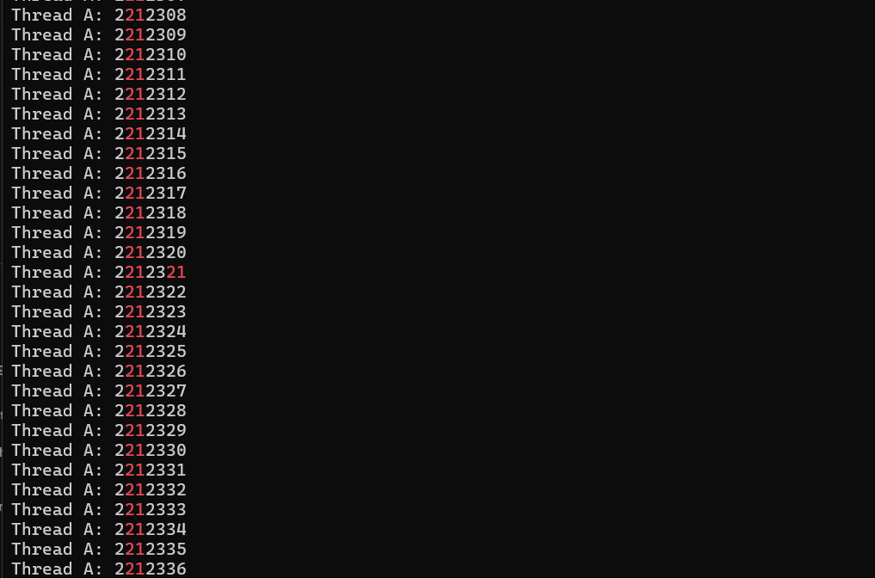

BÀI 4:

