**Project Name**: Emotion-Based Smart Home System

**Current Progress**: Today, we successfully set up the environment on the Jetson Orin Nano and configured the GPIO ports. For an initial test, we used a breadboard with an LED (since we haven't purchased a light strip yet) to demonstrate that the light turns on when a "neutral" expression is detected.

**Technical Breakthroughs**:

1. Successfully accessed the camera for real-time video streaming.
2. Implemented YOLO-based emotion detection in real-time to analyze facial expressions in the video feed.
3. Enabled LED control based on detected emotional states, achieving a basic emotional feedback mechanism.

**Code Implementation**: Our code employs a voting mechanism to aggregate emotions over a defined window. When "Happy" exceeds a set threshold, the GPIO interface controls the LED to turn on. Key modules include:

1.Real-time video processing and emotion detection.

2.Emotion voting mechanism based on a sliding window to ensure accurate feedback.

3.GPIO control for LED response, triggering based on the detection of specific emotions (e.g., " neutral ").

**Next Steps**: We plan to purchase a light strip to extend the system, enabling it to display different colors as feedback for various emotions, enhancing both interactivity and expressiveness.

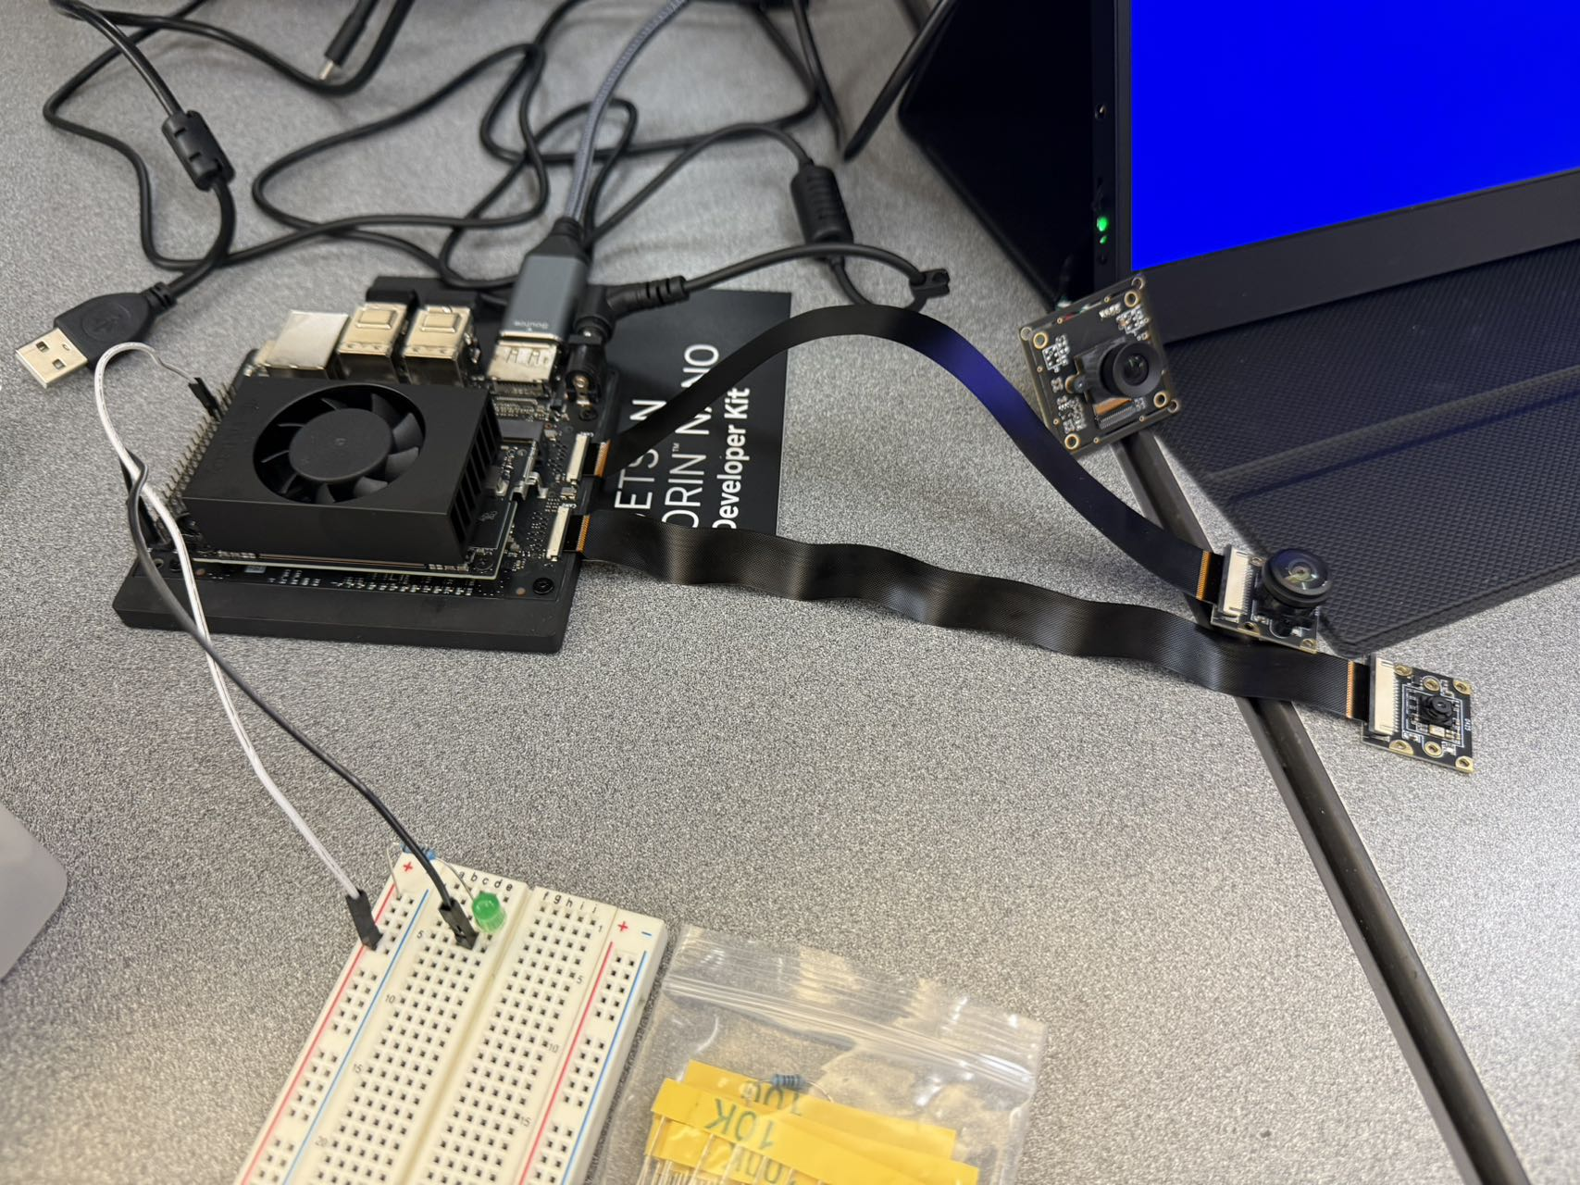 The image shows our Jetson Orin Nano board, LED, and the camera setup demonstrating real-time emotion feedback