**Project Participants:**

Luan Nguyen

**Title:**

Budget Tracking API

**Executive Summary:**

Budget tracking API intends to help users track their expenses and income to provide better visualization of their financial situations and aid users to make better financial decision.

**Initial Features:**

**Create a bulleted list of Initial Features**.This will be a list of features that meet the requirements of the final project.

* ERD:

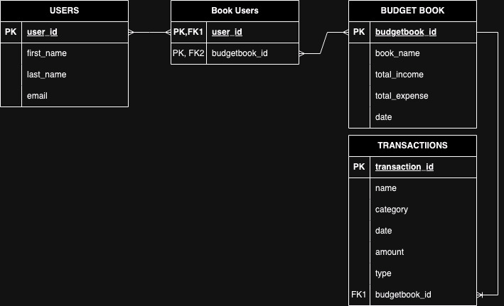

* Entity: User, Transaction, Budget Book.
* CRUD operations on users, transactions, and budget books.
* *Calculate total expenses for budget book.*
* *Get a list of transactions based on users.*
* *Add SwaggerUI for API testing and documentation.*

**Stretch Goals (to be completed if time allows, or after graduation):**

**Create a bulleted list of Stretch Goals**. These are Enhancements that you will add to your REST API after you get your initial features implemented. These should be features that may require more research in how to implement or features that would take longer than the allotted time frame.

* Integrations with another API to connect bank transactions and information. (Plaid API)
* Adding a front-end UI (React) for users to create visualizations chart, graphs etc.