PATRICK REVIEW EDITION
WatchDesk V2.2.1 - Guard check-in quick reference
Use this page to explain exactly what changes after an hourly check-in.
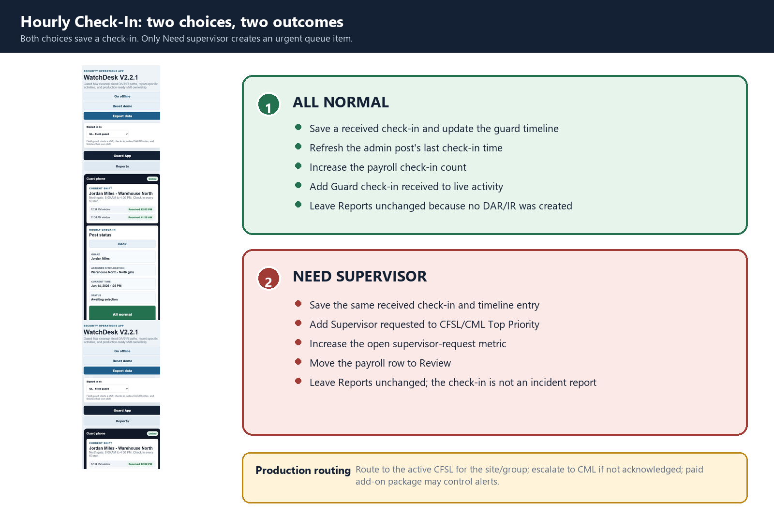
Page | All normal | Need supervisor
Guard App | Timeline + last check-in update | Timeline + Supervisor requested label
Admin | Post time/status + Activity | Same + Top Priority request and metric
Payroll | Received check-ins +1; wages unchanged | Same + row can move to Review
Reports | No change - not a DAR/IR | No change - not automatically an IR
Account / Setup | No change | No change
Payroll rule: Check-ins update contact counts and can affect Review status. Pay remains hours x that guard's rate, with overtime at 1.5x.

Reports rule: Reports changes only after Save note in a DAR or IR flow.

SUPERVISOR AND ADMIN RESPONSE
What happens next
Use this page after the guard enters data or a supervisor responds.
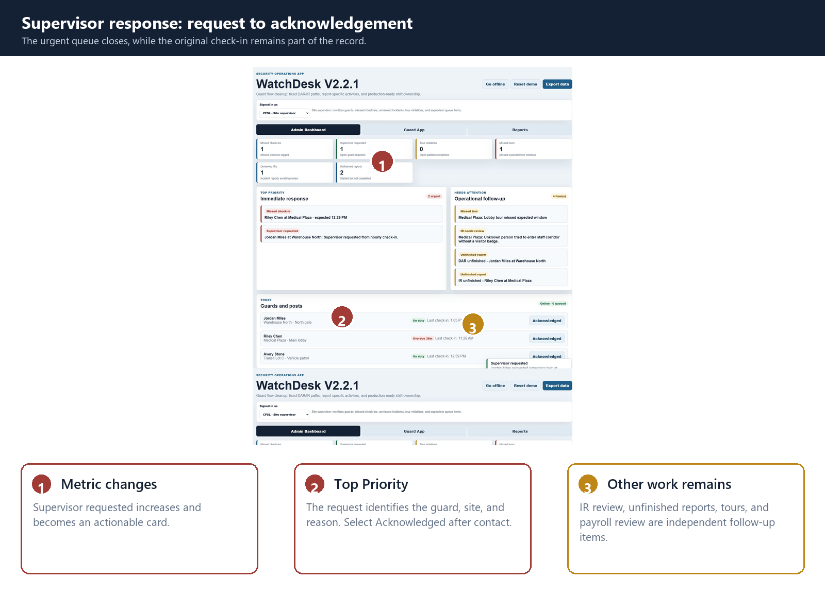
Supervisor/admin action | Result
Acknowledged | Closes request, lowers urgent count, logs activity; check-in remains.
Preview IR | Clears Unviewed only; report remains unfinished.
Finalize report | Locks record and lowers Unfinished reports.
Select payroll guard | Changes selected officer gross and detail to that guard's wage and hours.
Approve / Reject | Changes Payroll Summary and Detail; acknowledgement alone does not approve.
Reset demo | Restores original counters, queues, reports, and payroll.

Five-minute demo
Reset -> UL home -> All normal -> Payroll count -> Need supervisor -> CFSL Acknowledged -> UL Save IR -> Payroll rates -> Reports PDF
Best explanation: The guard saves once. Each role sees only the part of that action needed for operations, reporting, payroll, or account oversight.

