PATRICK REVIEW EDITION
WatchDesk V2.2.1
Reference Guide
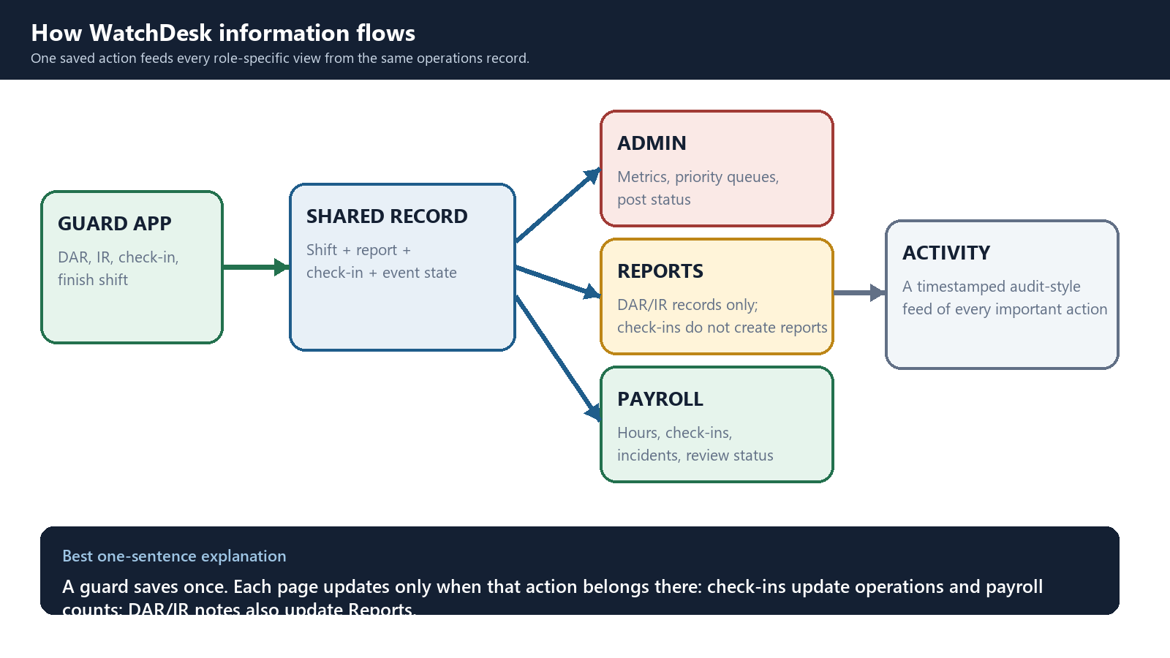
Guard action -> shared record -> role-specific operational updates
Live prototype: https://watchdesk-security-operations.vercel.app/
Prepared June 14, 2026

SECTION 01
Start here
What this prototype proves, who sees what, and the one limitation to say out loud.
Core idea: A guard action is entered once. WatchDesk then updates only the relevant operational views. Hourly check-ins update Guard, Admin, Activity, and Payroll counts; DAR/IR notes additionally update Reports.

Role hierarchy at a glance
Role | Profile | Main screens | Primary job
UL | Field guard | Guard App; own reports | Enter DAR/IR notes, hourly check-ins, finish shift.
CFSL | Site supervisor | Admin; Guard App; Reports | Respond to missed check-ins, supervisor requests, tours, and IR review.
CML | Operations manager | Admin; Payroll; Reports; Setup | Manage operations, payroll review, reports, and setup.
CAL | Client account lead | Admin; Payroll; Reports; Setup | Review 7-day account health and client-level activity.
ARUL | Account/billing user | Account; Setup | Review users, locations, bills, package, and account status.
SA | Super admin | All sections and controls | Full prototype access.

How to run the demo
- Open https://watchdesk-security-operations.vercel.app/.
- Select Reset demo before presenting.
- Choose UL - Field guard and perform an action.
- Switch roles in the same browser without resetting to show the downstream changes.
Current prototype limitation: The static prototype stores data in this browser's localStorage. It demonstrates the complete workflow in one browser, but a real guard phone will not yet update a separate admin computer. Production requires Supabase Auth, Postgres, row-level security, realtime notifications, and package permissions.

SECTION 02
The connected data model
Every page is a different view of the same shift, report, check-in, queue, payroll, and activity records.


What changes immediately
Guard action | System updates | Important rule
DAR saved | Active report + Reports + Unfinished + Activity | No mandatory DAR review.
IR saved | Unviewed IR + Needs Attention + Payroll Review + Activity | Viewing clears Unviewed; finalizing closes it.
All normal | Timeline + post time + payroll check-in count + Activity | Reports, Account, and Setup do not change.
Need supervisor | All normal updates + Top Priority + Payroll Review | Reports still does not change; acknowledgement closes only the request.
Finalize | Report locks + Unfinished falls + Continue returns to Start | Official record remains in Reports.
Finish shift | Admin post = Finished + Payroll recalculates + Activity | Review can remain when an exception is unresolved.

SECTION 03
UL Guard App home
The guard should understand the screen in seconds, without opening a full form first.
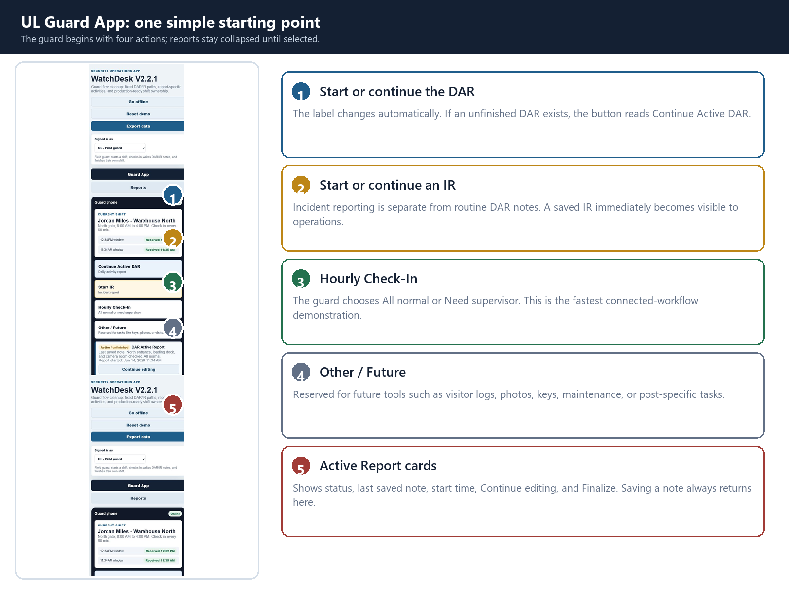
Report naming rule: If an unfinished report already exists for the shift, Start DAR/IR becomes Continue Active DAR/IR. Saving a note returns to this home. Finalizing returns the action to Start.

SECTION 04
Hourly Check-In
The same two-button screen supports routine confirmation and an urgent request.
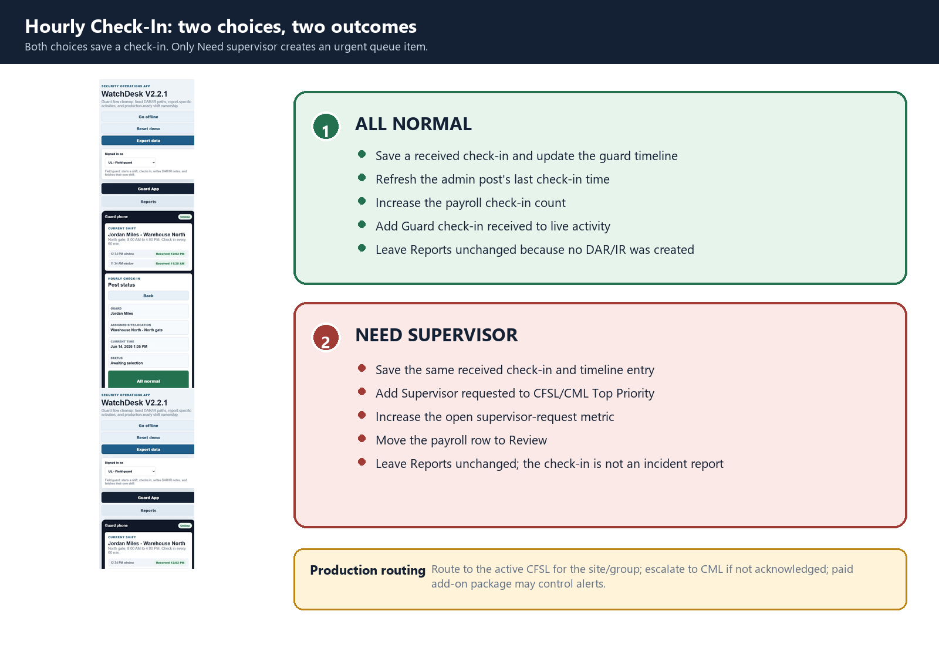

Guard steps
- Select Hourly Check-In.
- Confirm the guard name, assigned site/location, and current time.
- Select All normal or Need supervisor.
- The check-in saves and the guard returns to the four-button home.

SECTION 05
After a guard checks in: every page explained
This is the exact cross-page effect of All normal and Need supervisor.
Page / record | All normal | Need supervisor
Guard App | Adds a received check-in to the Guard Timeline, updates the last check-in time, and returns to the four-button home. | Adds the same timeline item, clearly labeled Supervisor requested.
Admin Dashboard | Refreshes the guard/post check-in status and adds Guard check-in received to Recent Activity. | Does the normal updates and adds Supervisor requested to Top Priority and the request metric.
CFSL/CML queues | No supervisor-request item is created. | Creates an open request for the active site/group. Future production routing assigns CFSL and can escalate to CML.
Payroll | Received Check-ins increases by one. Missed does not increase. Hours and gross pay still come from elapsed shift time and the guard's wage. | Received Check-ins increases by one and the row can move to Review. Gross pay still uses hours x that guard's rate.
Reports | No change. An hourly check-in is not a DAR or IR. | No change. Requesting a supervisor does not automatically create an incident report.
Account | No change to billing, package, activation, location, or account status. | No change.
Control Center / Setup | No change to users, sites, posts, shifts, tour patterns, assignments, holidays, or package settings. | No change.
Live Activity | Adds a timestamped Guard check-in received event. | Adds a timestamped Supervisor requested event.
Payroll rule: A check-in proves contact and updates operational counts. It does not pay a flat amount. Estimated pay remains regular hours x regular rate plus overtime hours x the guard's 1.5x overtime rate.

Reports rule: Reports changes only when the guard saves a DAR or IR note. This separation prevents a routine hourly check-in from becoming an official activity or incident report.

SECTION 06
Supervisor request and acknowledgement
Operations sees the request immediately and can close the queue without erasing the check-in.
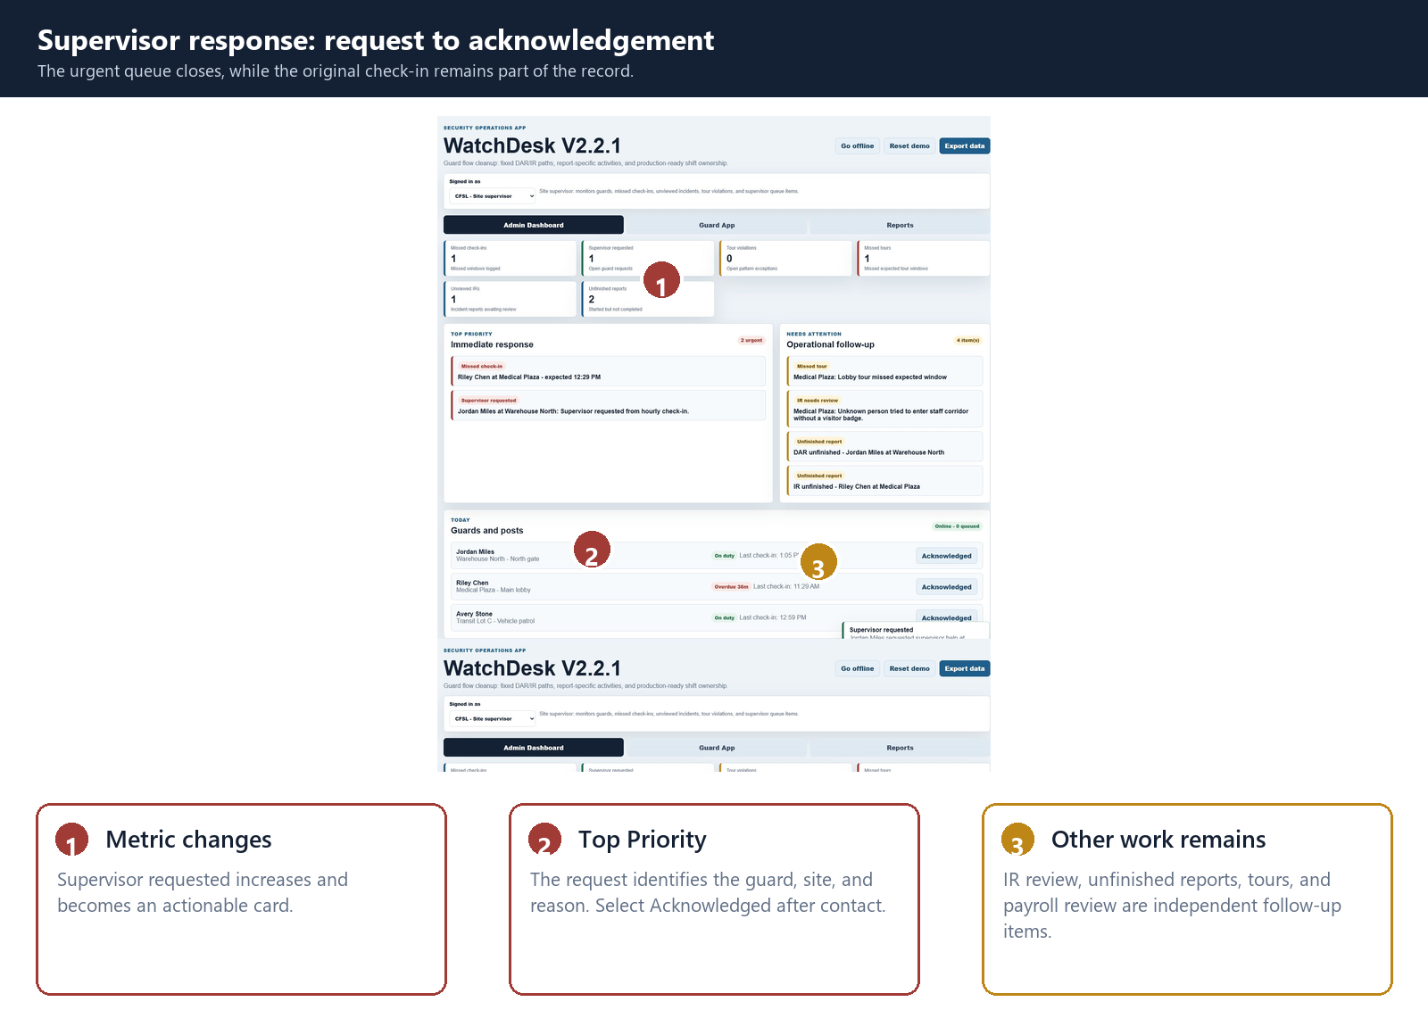

What Acknowledged changes
Area | Result
Supervisor queue | Open request closes.
Top Priority | Supervisor requested item disappears.
Metric | Open supervisor-request count decreases.
Live activity | Acknowledgement event is added.
Original check-in | Remains saved in the timeline and payroll count.
Payroll | Review may remain until payroll is separately approved or rejected.

SECTION 07
DAR and IR workflows
Both reports save to the same system, but incidents deliberately create more operational attention.
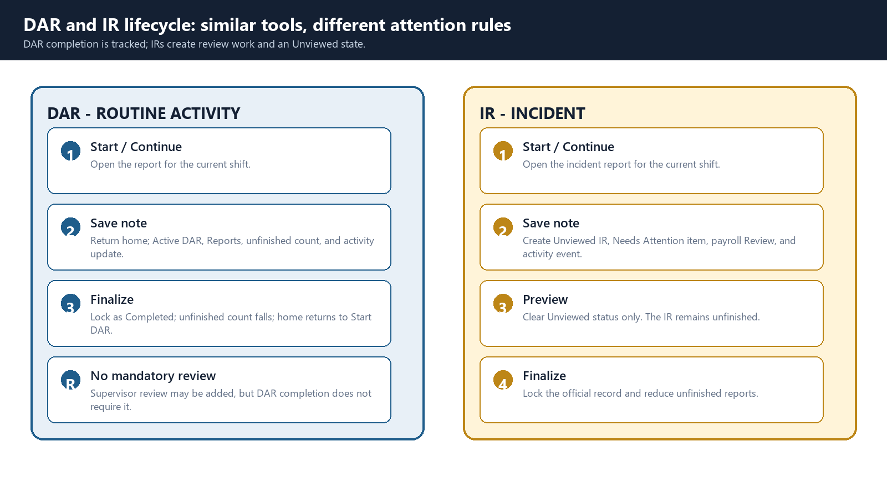
Remember: A saved note does not mean a report is finalized. Previewing an IR clears Unviewed, but does not complete it. DAR completion is tracked without mandatory supervisor review.

After Save note: exact downstream changes
Page | Visible result
Guard home | Returns to four actions; Active Report card shows the last saved note and start time.
Admin | Unfinished remains. A new IR also increases Unviewed IRs and adds IR needs review.
Reports | DAR/IR record and narrative update; state remains Unfinished until finalization.
Payroll | IR adds an incident and can move the officer row to Review. Routine DAR notes do not.
Activity | Adds a timestamped DAR note saved/updated or IR created event.

SECTION 08
Admin Dashboard
CFSL and CML work from two queues: urgent response first, operational follow-up second.
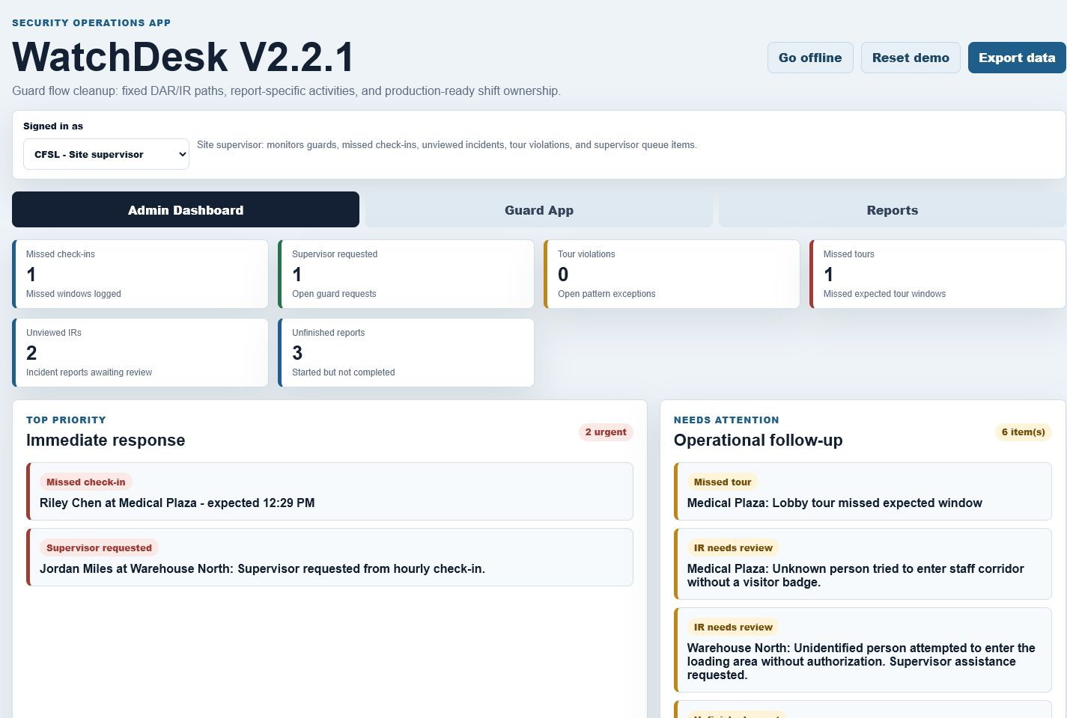

Queue dictionary
Section | Contains | Operator response
Top Priority | Missed check-ins; Supervisor requested | Contact the guard/site and acknowledge the request.
Needs Attention | Tour violations; missed tours; IRs needing review; unfinished reports | Review, correct, finalize, or follow up.
Actionable metrics | Small cards above the queues | Select a metric to preview or focus its related work.
Recent activity | Guard and supervisor events | Confirms what happened, when, and by whom.

SECTION 09
Payroll Summary and Detail
Every officer is calculated from that officer's rate, hours, and overtime.
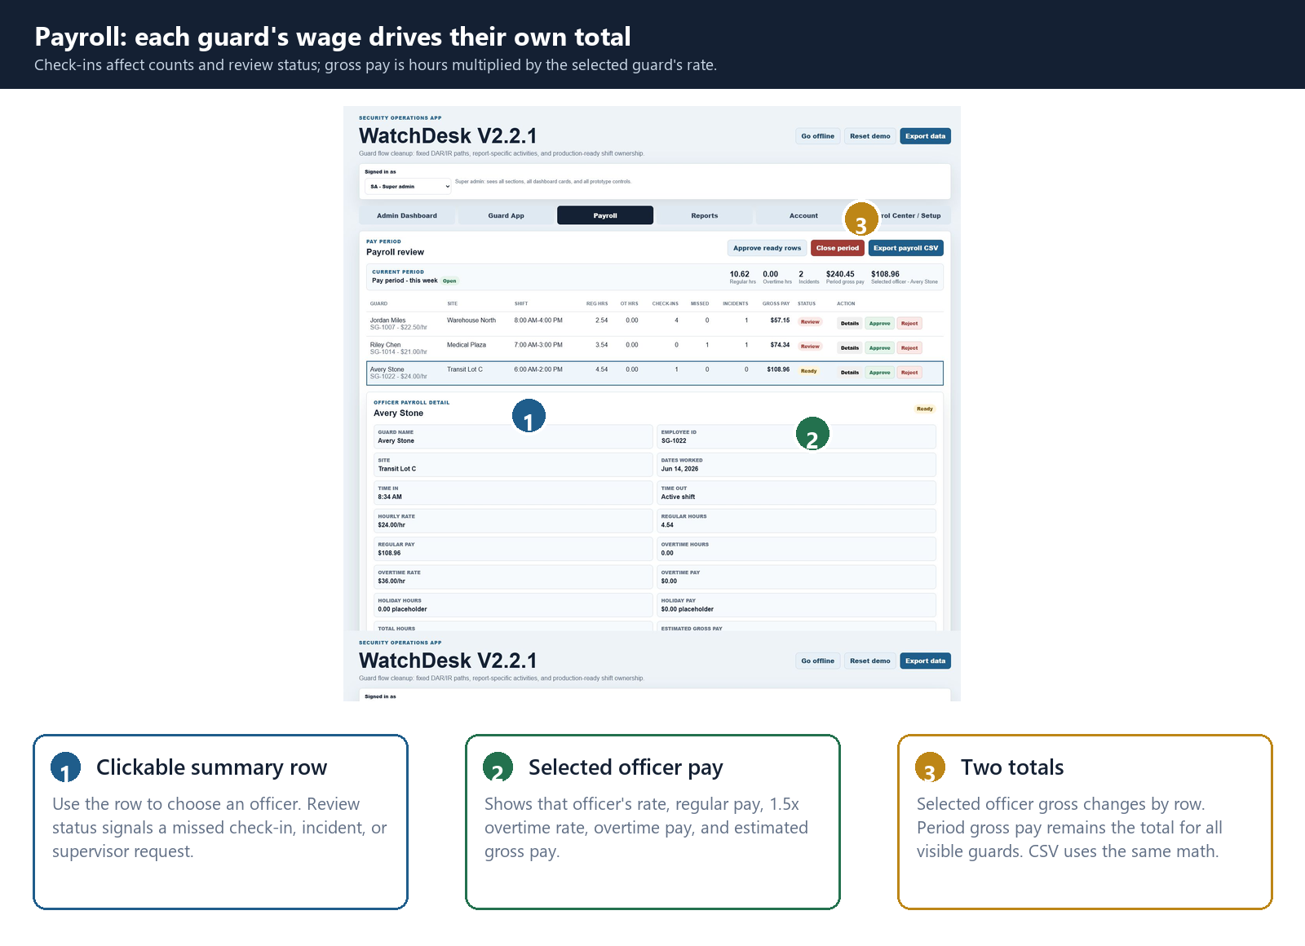

Payroll controls
- Select a guard row to update Selected officer gross and open that officer's rate, hours, regular pay, overtime rate, overtime pay, holiday placeholders, incidents, and approval.
- Regular pay = regular hours x the guard's hourly rate. Overtime pay = overtime hours x 1.5 x that guard's hourly rate.
- Period gross pay is the total of all visible officer rows, so it does not become a selected-officer total.
- Hourly check-ins increase the received count. Need supervisor, a missed check-in, or an IR can move the row to Review, but check-ins do not directly add wages.
- Approve or Reject updates both Payroll Summary and Payroll Detail.
- Close pay period locks every row; CSV exports the same rates and pay calculations shown on screen.

SECTION 10
Reports and PDF readiness
Reports is the official DAR/IR record view; hourly check-ins remain outside this list.
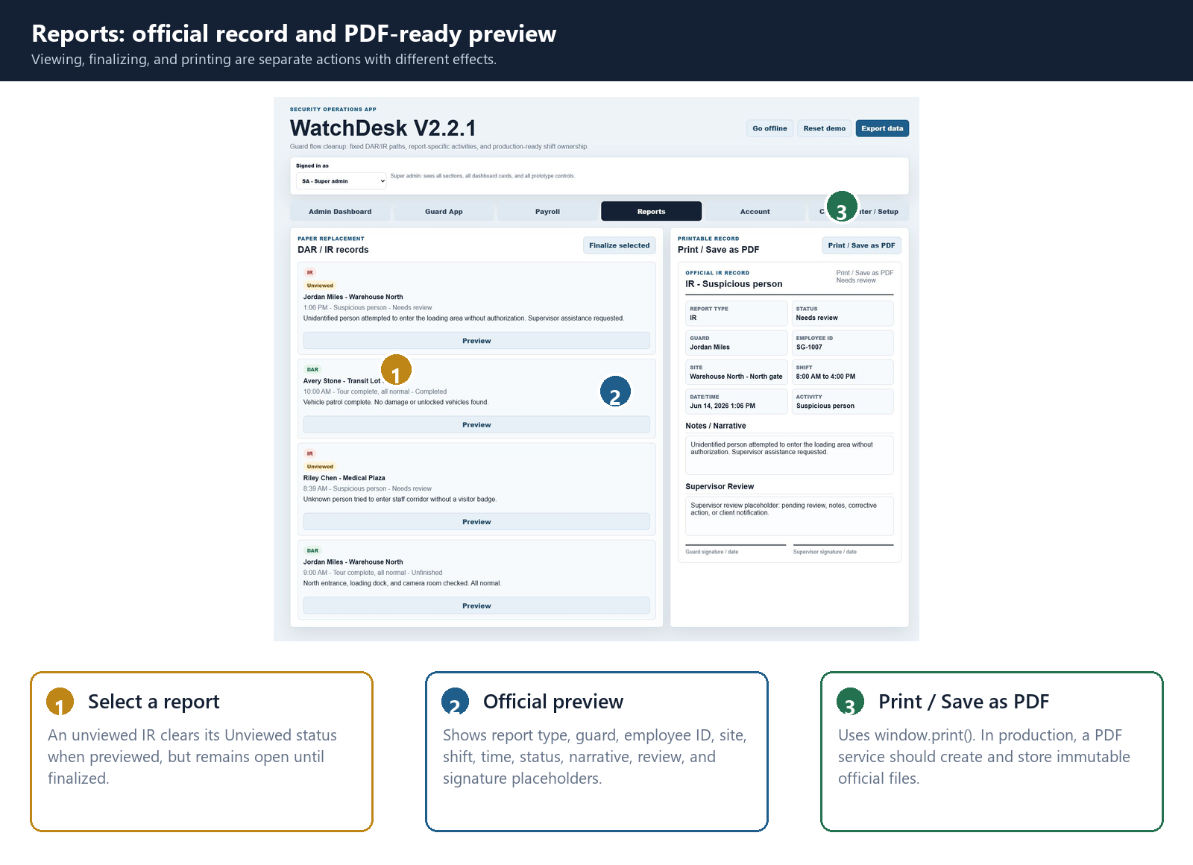

Print / Save as PDF
- Select the DAR or IR record.
- Review the official preview and status.
- Select Print / Save as PDF.
- Choose Save as PDF in the browser print dialog.

Report states
State | Meaning
Unviewed | An IR has not yet been opened by operations. Previewing clears only this status.
Unfinished | The report has saved data but has not been finalized.
Completed / Finalized | The report is complete, locked, and no longer appears as an active Continue report.

SECTION 11
Account, setup, and production growth
Higher roles can see account health and the modules needed to turn the prototype into a service.
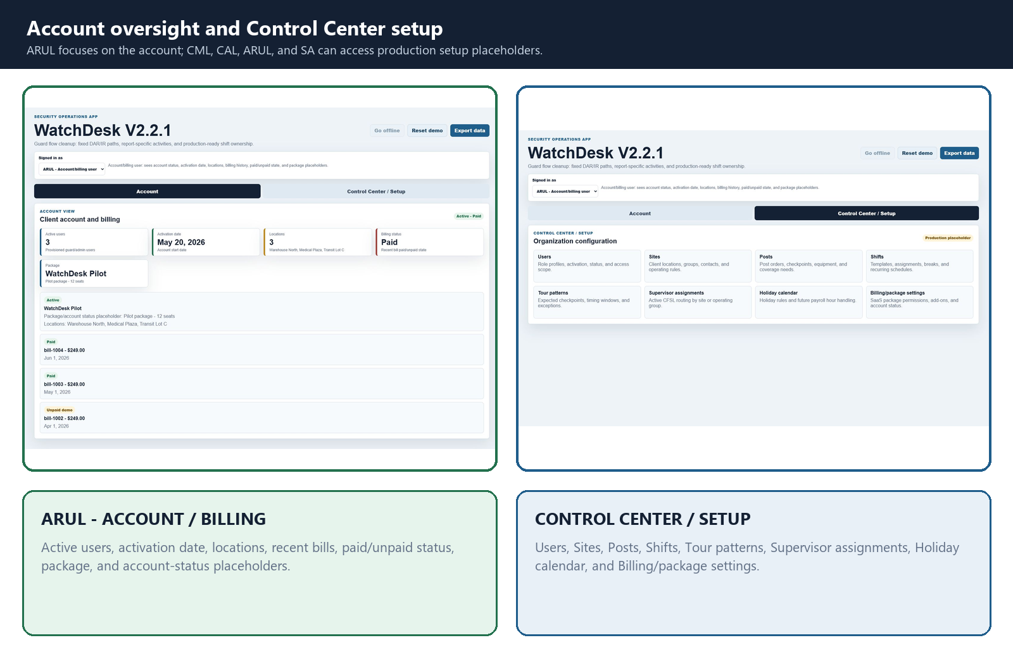
Production component | Purpose
Supabase Auth | Replace the role selector with real sign-in and role membership.
Postgres tables | Persist users, sites, shifts, reports, check-ins, queues, payroll, and events.
Row-level security | Limit records by role, account, site, and assignment.
Realtime notifications | Deliver CFSL alerts and CML escalation across devices.
SaaS permissions | Enable packages, limits, paid alerts, and billing controls.
PDF service | Generate immutable official DAR/IR files with audit history.

SECTION 12
Patrick-ready walkthrough
A short demonstration that proves the application is connected, role-aware, and ready for production planning.
Step | Show | What to do
1 | Reset | Select Reset demo; choose UL.
2 | Guard home | Point out the four actions and Active Report cards.
3 | DAR | Continue the active DAR, change the note, Save note, and show the updated home card.
4 | Request help | Hourly Check-In -> Need supervisor.
5 | Supervisor | Switch to CFSL; show the metric and Top Priority request; select Acknowledged.
6 | Incident | Switch to UL; create an IR with a short narrative.
7 | Operations | Switch to CFSL/CML; show Unviewed IRs, Unfinished reports, Needs Attention, and activity.
8 | Back office | Open Payroll Detail, Reports preview, and Print / Save as PDF.
9 | Future | Open Control Center and explain Supabase/Postgres multi-device synchronization.

Status rules that prevent confusion
- Unviewed is cleared by previewing an IR; unfinished is cleared only by finalizing.
- Acknowledged closes a supervisor request; it does not approve payroll.
- A DAR may be completed without mandatory supervisor review.
- Reset demo restores all starter reports, counters, queues, and payroll rows.
Close with this: The role and workflow model is already defined. The production step is replacing browser-only storage with authenticated, realtime database records so separate guard phones and admin computers stay synchronized.

