Car Price Estimate

Bradley Robinson, Luay Dajani

June 7, 2018

## Introduction

Car Estimate Predictions… 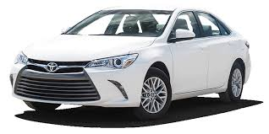

## Data Description

The data was downloaded from kaggle

## Explatory Data Analysis

As per the plots… Price is an interesting Explanatory Variable as below:

Assumptions: 1- Normality 2- Variance 3- Deviation

Data looks …

## Objetive 1: Regression

QOI: Car Pricing is heaviy impacted by …

### Regression Model Selections

### Model Comparisons

### Parameter Interpretation

### Conclusions

## Objective 2: Two-Way ANOVW or Time Series

QOI: Goal

### Main Analysis

### Conclusion

## Appendix

### References & Environment

### Code

# {r, code=readLines('Car_Price_Estimate-Data.R'), echo=TRUE} #

# {r, code=readLines('Car_Price_Estimate-Regression.R'), echo=TRUE} #

# {r, code=readLines('Car_Price_Estimate-Anova.R'), echo=TRUE} #