NETWORKING LAB REPORT

Wireshark Packet Analysis – Fragmentation & Protocols

Submitted By
Rabia Manzoor
Roll Number: bsdsf22a034
Department: Data Science

Part 1: Basic IPv4 (Traceroute & TTL)
Steps to Perform :
Start the wireshark..
Run the command
traceroute gaia.cs.umass.edu 56
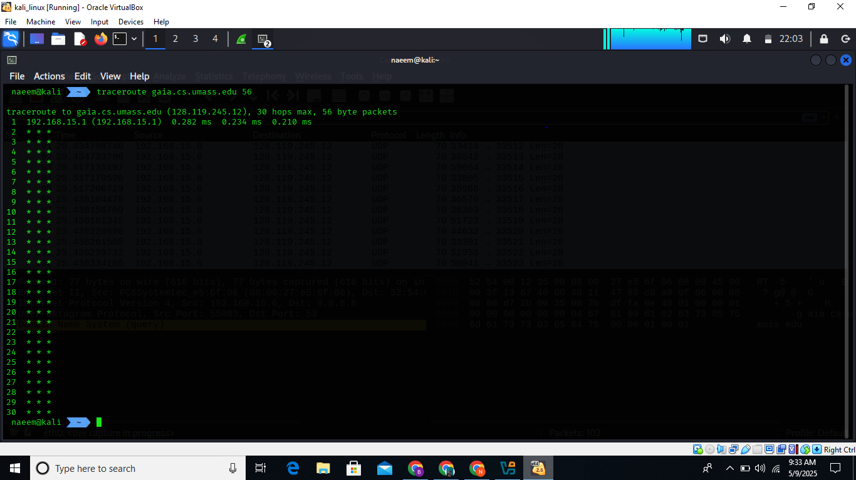
Start the wireshark
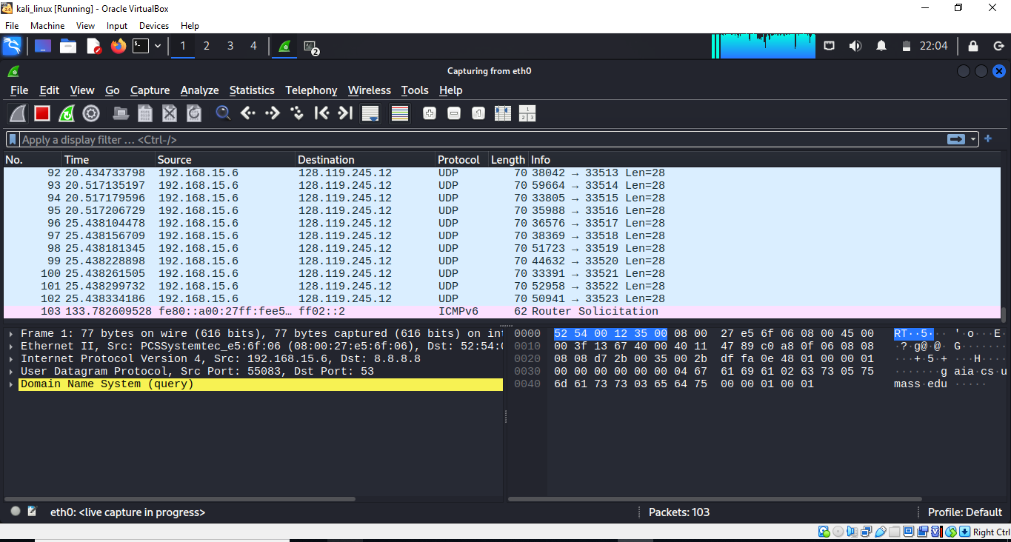
Then run this command
traceroute gaia.cs.umass.edu 3000
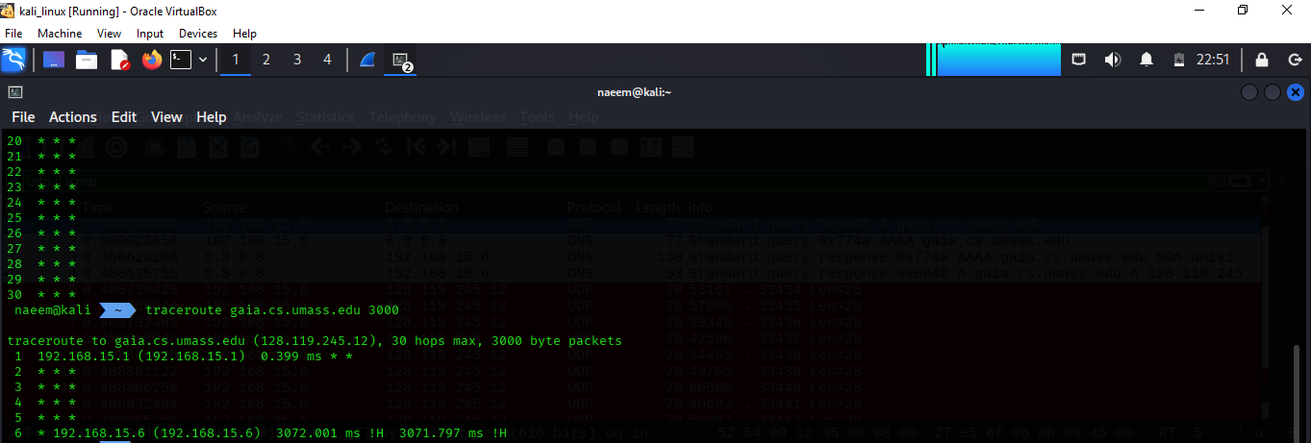
Then stop the wireshark
Used display filter for :
udp || icmp (for UDP and ICMP analysis)
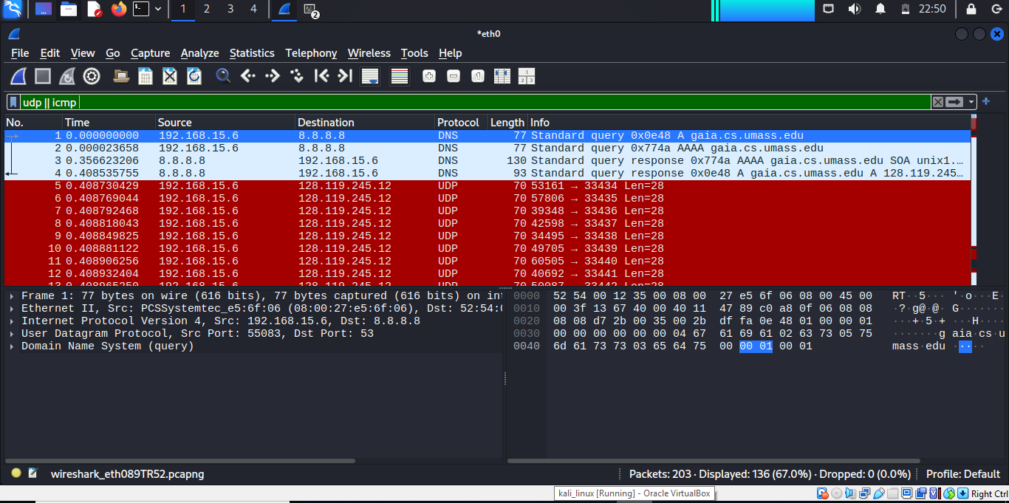ip.src== 192.168.15.6 and ip.dst==128.119.245.12 and udp and !icmp
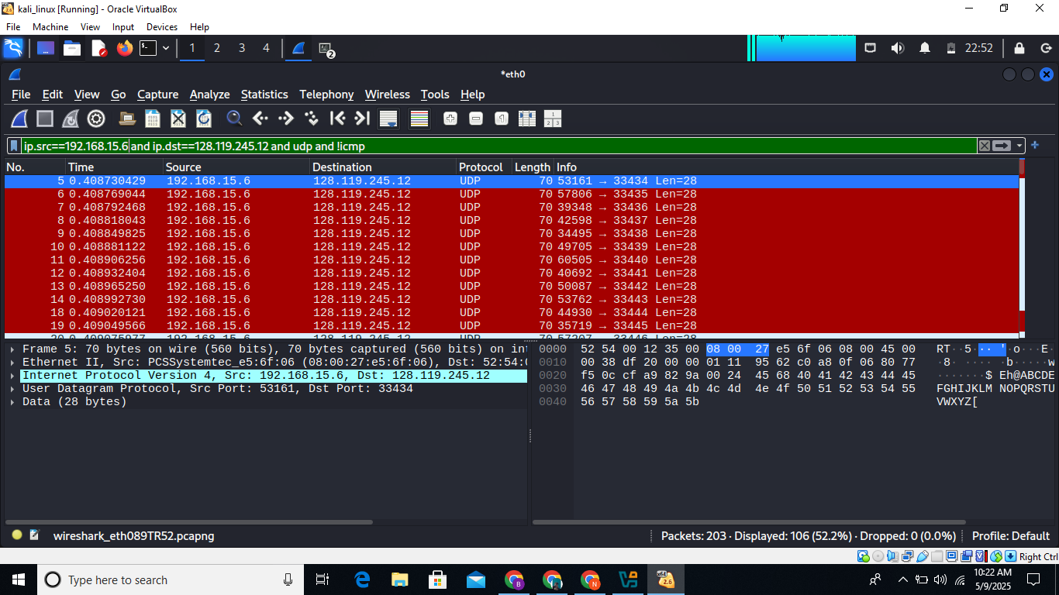
Then applied this filter
ip.dst==[your IP] and icmp
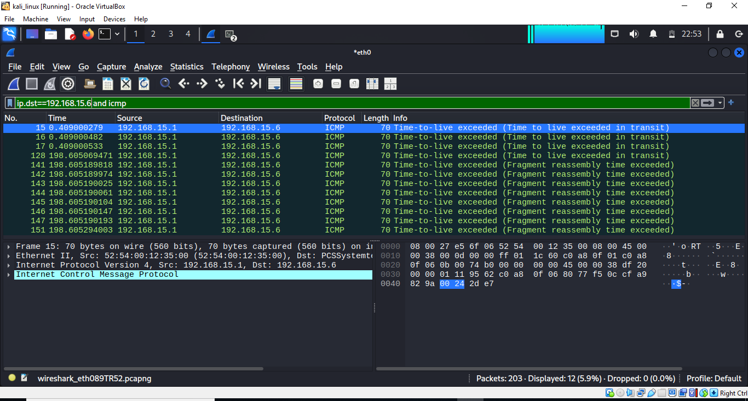

Answer The Given Questions :
Select first UDP packet to gaia.cs.umass.edu.
My Machine IP : 192.168.15.6
1.TTL value in IPv4 header?
101
2.Upper-layer protocol?
The packet should say: User Datagram Protocol (UDP)

3.Size of the IP header?

Look under IPv4 header, field: Header Length 20
4.Payload size?
Fomula: Payload = Total Length - Header Length

Total Length = 60 bytes
Header Length = 20 bytes
Payload = 60 - 20 = 40 bytes

5.Is it fragmented? How can you tell?

In IPv4 header → Flags field

If More fragments = 0 and Fragment offset = 0, then Not Fragmented
“No, it is not fragmented.”

6.Series of UDP packets to 128.119.245.12 — What IP fields change and why?

IP fields that change:

TTL: Increments with each packet (1, 2, 3, ...) to find the hop count.

Identification: Changes to identify different IP datagrams.

Checksum: Changes because header changes.

Reason: TTL increments per packet to trace the path (like in traceroute)
7.Which IP fields remain constant and why?

Constant fields:

Source IP: 192.168.15.6
Destination IP: 128.119.245.12
Protocol: UDP
Header Length: typically 20 bytes
Reason: You're sending the same request type to the same destination

8.Pattern in the Identification field?
Go through each UDP packet
1001, 1002, 1003, ...

11: Filter ICMP packets received (TTL exceeded)

Filter: icmp && icmp.type == 11
Use this to view TTL Exceeded responses.

12.What is the upper-layer protocol in them?

Even though it’s ICMP, check Original Datagram section
Should show UDP in the encapsulated original packet.

13.Are TTL values in ICMP packets similar?

ICMP reply TTL values depend on the router sending them (64, 128, or 255)
TTLs differ from sent packets, but Identification field remains.


Part 2: IP Fragmentation (Large Datagram Analysis)
Steps to Perform

Q1: Is the segment fragmented?
Answer:
Yes, a segment is fragmented if:

The More Fragments (MF) flag is set (MF = 1)

Or the Fragment Offset is greater than 0

Check:

IPv4 → Flags

IPv4 → Fragment Offset

Q2: What IP header fields show fragmentation?

Answer:

Flags field: shows More Fragments (MF) bit

Fragment Offset: shows position of fragment in original data

Identification: used to reassemble fragments of a datagram

Q3: How can you identify first vs. latter fragment?

Answer:

First fragment:

Fragment Offset = 0

MF = 1 (More Fragments flag set)

Latter fragments:

Fragment Offset > 0

Q4: Total size of first datagram (header + payload)?

Answer:
Check Total Length field in IPv4 header of the first fragment.

Formula:
Total Datagram Size = Total Length = IP Header + Payload

IP Header usually = 20 bytes

Payload = Total Length - Header Length

Q5: Second fragment — what shows it’s not the first?

Answer:

Fragment Offset > 0

MF = 1 (still more fragments after this one)

Same Identification as first

Part 3: IPv6
No fragmentation in IPv6 like IPv4.

Extension headers are used instead.


