Supplementary Figure S1
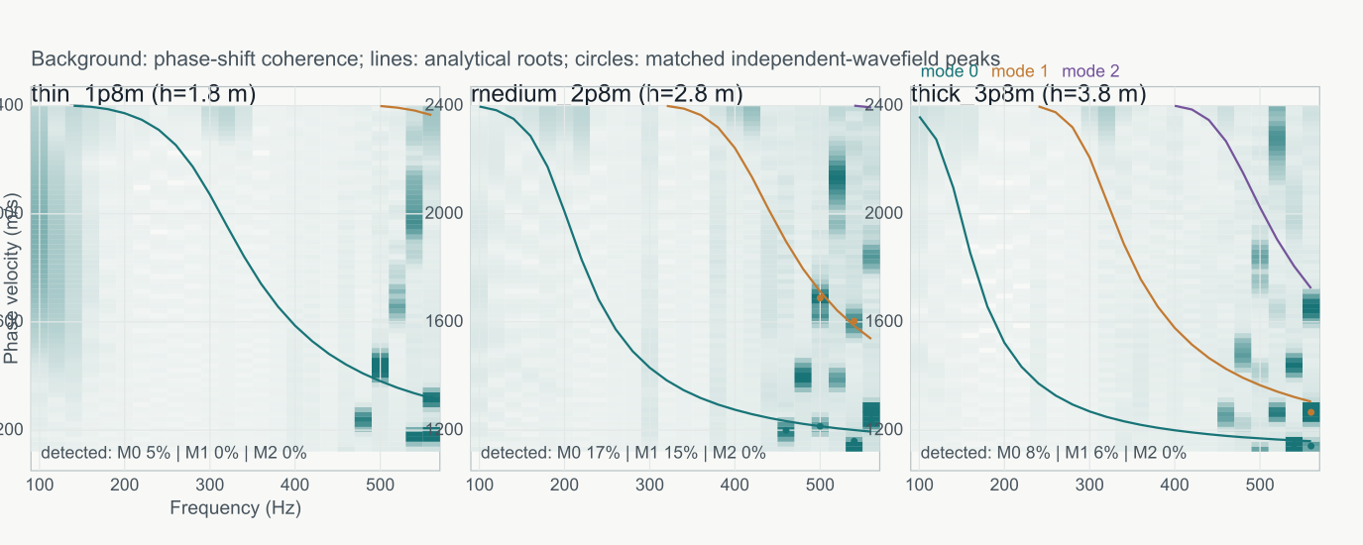
Raw normalized phase-shift coherence for the independent 2D SH finite-difference fields. Lines show analytical roots and circles show peaks that passed the aperture, coherence and contrast tests. Strong near-vertical or otherwise nonmodal coherence is retained in this diagnostic image but is not treated as a modal observation.

