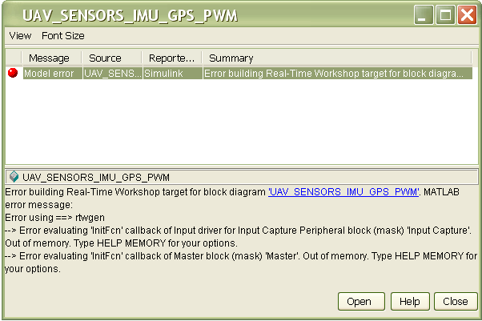

### Starting Real-Time Workshop build procedure for model: UAV_SENSORS_IMU_GPS_PWM
### Generating code into build directory: C:\Documents and Settings\Admin\My Documents\malife-SLUGS-3ec4910NEW\UAV_SENSORS_IMU_GPS_PWM_dspic\sources
Warning: The file containing block diagram 'sensorMCUSlugsMKII' is shadowed by a file of the same name higher on the
MATLAB path. This can cause unexpected behaviour. For more information see "Avoiding Problems with Shadowed Files"
in the Simulink documentation.
TTPNumber of I/O PINs used : 14
TPNumber of I/O PINs used : 14
TPTTPTPNumber of I/O PINs used : 14
TTPNumber of I/O PINs used : 14
TPNumber of I/O PINs used : 14
TPTTPTPTPT### Real-Time Workshop build procedure for model: 'UAV_SENSORS_IMU_GPS_PWM' aborted due to an error.

