DataverseNL workflow and tips - Data Stewards BehSci

V1.0 November, 2024

Willemijn Plomp  
  
In this document we show how we upload publication packages for the Behavioural Sciences (Psychology & Education and Child Studies). We hope this helps other institutions. If you have any questions you can always contact us at [datastewards_psy_ped@fsw.leidenuniv.nl](mailto:datastewards_psy_ped@fsw.leidenuniv.nl) . Please also know that Dataverse has many instructional documents and presentations that you can find here <https://dataverse.nl/dataverse/dans> .   
  
If you want to practice anything on DataverseNL you can use <https://demo.dataverse.nl/dataverse/Leiden> . Everything here is deleted after a year.

-------------------------------------------------------------

In this document:

* Preparation and contact with researchers
* Workflow
* Additional features on DataverseNL
* Risk assessment and checking the publication package

---------------------------------------------------------------

Preparation and contact with researchers

We have made an instructional document on how to make a publication package (See *Publication Package instructions* on this page [Open Science - Leiden University)](https://www.universiteitleiden.nl/en/social-behavioural-sciences/psychology/good-practises/open-science). This is based on the DSW “Guideline for the archiving of academic research for Faculties of Behavioural and Social Sciences in the Netherlands” (<https://doi.org/10.5281/zenodo.7583831>).

Based on these guidelines we have also made a template for a README (See *README template for Publication Packages* on this page [Open Science - Leiden University)](https://www.universiteitleiden.nl/en/social-behavioural-sciences/psychology/good-practises/open-science) and added an example of a good README. We recommend you make a README template with the metadata fields that your institute(s) need(s). We've noticed this has really helped. READMEs before the template were often very short or even missing.  
  
To encourage researchers to make a publication package, our Scientific Directors send regular emails as a reminder. We also host open office hours every week and we offer a monthly workshop. For the PowerPoint slides of the workshop, see *Workshop: Publication Packages - How and when to make them* on this page [Open Science - Leiden University](https://www.universiteitleiden.nl/en/social-behavioural-sciences/psychology/good-practises/open-science) . We’ve also made instructional posters with the training dates: <https://www.canva.com/design/DAGJUA823WU/hQHwUOAmN4hA9v2vaqqB7A/view>?   
  
We have made a Formdesk* questionnaire for researchers to fill in when they’ve created a publication package (see [DataVerseNL Publication Package Questionnaire for Psychology & Education and Child Studies (formdesk.com)](https://fd24.formdesk.com/universiteitleiden/DataVerseNL_Publication_Package_Questionnaire_for_Psychology_and_Education_and_Child_Studies_V2.0) ). This questionnaire asks:

-all the questions you need to get the metadata for DataverseNL (who wrote the paper, who is the point of contact, where can we find the related paper? etc.)

-the license that the researcher chooses (alternatively, we know our researchers aren't very familiar with CC licenses so we've added descriptions instead)

-which files the researcher wishes to be open, restricted/upon request and closed.

*For legal reasons, we were told in 2022 to not use Qualtrics. We could only use Qualtrics to collect research data. This may be different at other institutes.

Workflow

Check the files:

-Is anything missing? Is everything clearly structured?

-Is anything in the files too sensitive or too identifiable? (we use a low/medium/high risk analysis and depending on the risk, we do a more in-depth check of the files. See the section *Risk Analysis.* One of the most common problems we see is researchers including the participants' date-of-birth. We will ask researchers to change this variable into age or birth year before uploading the data.)

If necessary, create double-zipped folders or add numbers to create structure**

Go to dataverse.nl and login with your ULCN account.

Create a dataset. Add Data -> New Dataset (don't choose "create a dataverse" as this will give you a new folder)

Upload the files

Add restrictions to the files (open, restricted with access granted, restricted without access granted). In BehSci, the paper, materials, code and readme are usually open while the raw and processed data are usually restricted with access granted. (note: if you select multiple files and add a restriction, check if Dataverse applied it to all files!)

If one of more files are restricted, add the conditions for accessing the restricted data

Add metadata (Metadata -> Add + Edit Metadata). Copy this information from the Formdesk reply.

-include a data steward email address in the "point of contact" field

Add a license (Terms -> Edit Terms Requirements). Get this information from the Formdesk reply.

Publish (We use a four-eyes-principle to check that all restrictions are added correctly. The default setting on a file is Open, so any mistakes in the restrictions could lead to a data breach. If four-eyes is unfeasible, consider making the draft one day and uploading it the next.)

**DataverseNL does not have a folder structure (yet? there are some updates planned). If you have few files, I would just upload them separately. Make sure to number them (e.g., 1=files related to publication, 2 = files related to experiment procedure) so that related files stay together. If you are working with a larger amount of files, for instance if your Raw Data consists of separate files per participant, you may want to make a folder. You can do this by zipping the folder, and then zipping the folder above it as well. DataverseNL automatically unzips the first folder.   
We do not recommend adding the README to a folder. Adding it separately allows for researchers to preview it without downloading.

Additional features on DataverseNL

You can always make changes to the publication packages. This is done in a transparent way: any changes create a new version. If you make changes to the metadata you can decide whether this is a minor change (V1.1) or a major change (V2.0). Changes to the files are always a major change. All versions remain accessible. The DOI does not change and will always direct to the newest version.

If you need a version to go offline (e.g., data breach, wrong files), you can remove access to a version by Edit Dataset-> Deaccession Dataset. The files will still be in de Dataverse vault, but people (except DANS?) will not be able to access them.

It is possible to reserve a DOI before publishing the publication package. Make a draft and send the DOI to the researcher. This DOI will not be activated until the publication package is published, so it will show an error message until then. I like to send researchers a screenshot along with the reserved DOI, in case the journal needs any proof. 

if the journal needs any more proof, you can send a temporary link to the publication package by choosing Access Dataset -> Private URL. This link will not work anymore after the package has been published. Make it clear to the researcher that this link should not be included in a paper.

You can choose for this link to be anonymized. In that case, the authors and depositors will be redacted.

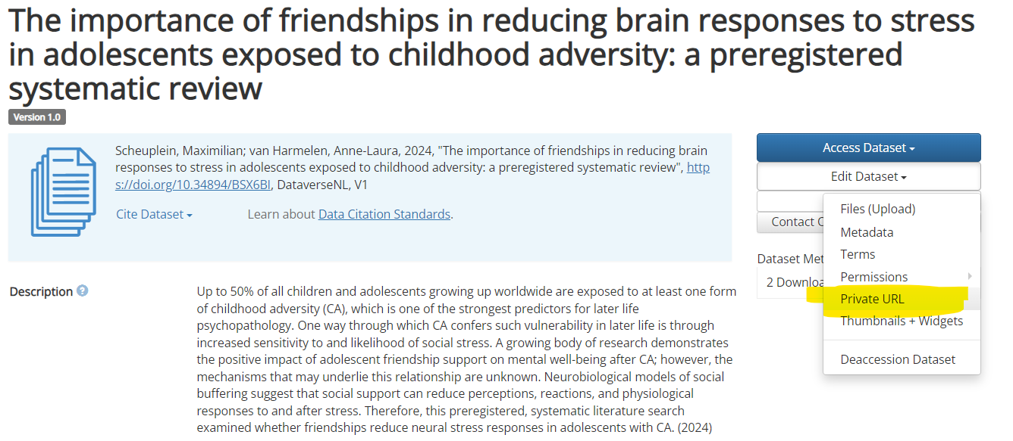

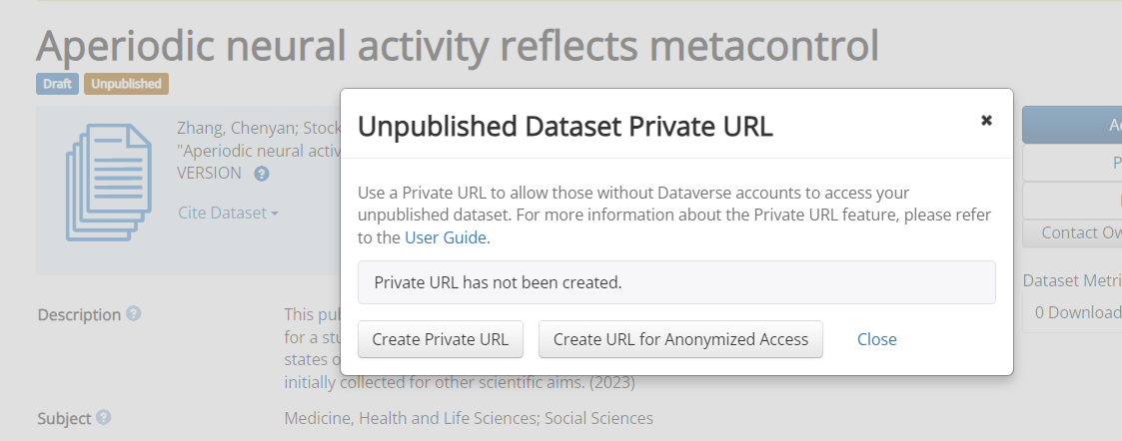

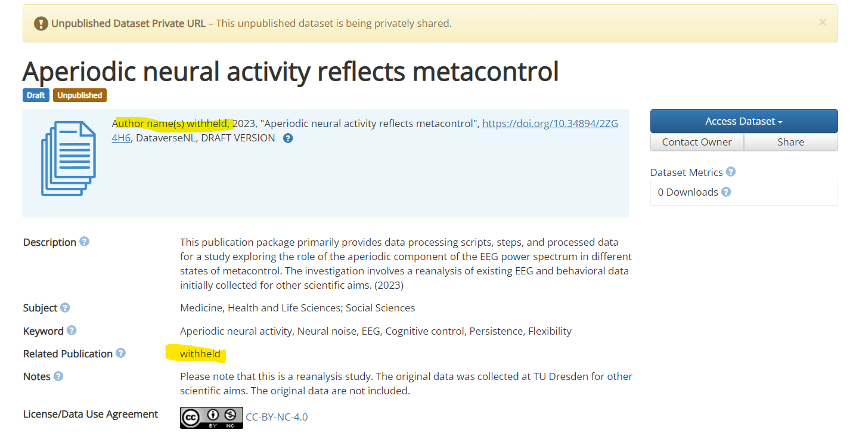

Risk assessment and checking the publication package  
  
1. **Abstract Review and risk assessment**

* The data stewards will review the abstract and the participant section of the methods of the published manuscript or article to determine the final risk classification (low, medium, high).
* Based on this information, the data stewards will determine the risk to be either low, medium or high. Publication packages that do not contain data, or contain only non-human data, simulated data, or data that are not covered by the GDPR, or only contain summaries of data, will be classified as low risk. Publication packages that contain conventional participant data will be classified as medium risk. Packages that contain data of participants in medical or vulnerable groups, or that contain special category data (e.g., diagnoses, religious or political affiliation, sexual orientation) will be classified as high risk.
* The risk assessment will take into account factors such as the nature of the sensitive information, the potential harm if the information was to be released, and the likelihood of re-identification by a third party. It will also look at the way the data was processed, and consequently how prone the package is to contain too much identifiable information due to human error.

|  |  |  |  |
| --- | --- | --- | --- |
| **Risk Assessment** | **Low** | **Medium** | **High** |
| **Read Abstract and Participant info** | No (human) data, simulated data, meta-analyses, data that are not covered by the GDPR | Participant data | Participant data, medical or vulnerable groups, special category data |
| **Read the Methods to determine how the data was collected** | **-** | **-** | Check if the data was collected and processed manually (prone to human error) or via script |

2. **Review and verification**

* Depending on the risk assessment, data stewards will perform a more or less involved review of the publication package (cf table below for more details).
* The data stewards will look for any indications of personally identifiable information, such as medical information, financial information, date of birth, used interventions/questionnaires, presence of audio/video material, sensitive populations, or other sensitive data. The method of data processing, particularly the collection and analyses (if it is automated via scripts or done manually).
* If any variables contain personally identifiable information, the data stewards will contact the responsible researcher to discuss which steps can be taken to remove or de-identify these variables before the package is archived.

|  |  |  |  |
| --- | --- | --- | --- |
| Review* | Low | Medium | High |
| Manuscript | Check if Open Access, if not ask researcher to send preprint/postprint | Idem | Idem |
| Readme | -Does it increase reusability, etc.?  -Use to get an overview of the structure of the package | Idem | Idem |
| Materials | Check if:  -IC is empty (not signed by participant)  -No personal phone numbers etc. in the instructions | Idem | Idem |
| Raw data | - | -Review main SPSS/Excel files  -Review 4 random raw data files per subset of data (e.g. data per session or output computer task; first 2 files, then 1 in the middle, then 1 at the end)  -If the publication package is too complex (many files, folders, files we can't open), contact researcher and ask them to explain the structure | -Review main SPSS/Excel files  -Review according to the medium category (if processed automatically with script), or 30% of raw data files per folder (if processed manually and more prone to human error)  -If the publication package is too complex (many files, folders, files we can't open), contact researcher and ask them to explain the structure |
| Computer code | - | - | - |
| Processed data | - | Review main SPSS/Excel file(s) -If the data consist of too many different files/folders or the structure is too complex, contact researcher and ask them to explain the structure | Review main SPSS/Excel file(s)  -If the data consist of too many different files/folders or the structure is too complex, contact researcher and ask them to explain the structure |
| DMP | -No personal phone number or personal email on first page  -Always restricted | Idem | idem |
| Ethics approval | -No personal phone numbers, signatures or personal email | Idem | Idem |
| Preregistration | -No personal phone numbers, signatures or personal email | Idem | Idem |

* This is a rule-of-thumb. The actual procedure will depend on the exact publication.  
Files that do not need to be reviewed for privacy reasons will be opened to check for file corruption, in case of many files some will be checked at random.

3. **Package publishing**

* Once the review and verification step has been performed in accordance with the risk level and necessary revisions - if any - were performed, the publication package is published on DataverseNL by the data stewards. The final publishing steps will be taken with the 4-eyes principle. The publishing process on DataverseNL is relatively error-prone so this is necessary to prevent data breaches.