
FareLens
Airline fare rules, explained.
Self-hosted API + admin UI that turns raw airline fare-rules text into traveller-friendly summaries and answers questions about them — using the LLM provider you choose.
Product & Technical Guide · Version 1.0.0
September 2026
Built by TravelSwitch for the travel-tech community · travelswitch.com
Open source under the MIT License

Contents
1. Introduction 3
1.1 Why FareLens 3
1.2 What you get 3
1.3 The admin interface at a glance 4
2. Quick start 5
2.1 Run it 5
2.2 Choose an LLM provider 5
2.3 Create an API key 5
2.4 Call the API 6
2.5 Try it in the Playground 6
2.6 Watch usage 8
3. API reference 9
3.1 Authentication and errors 9
3.2 POST /api/v1/fare-rules/summary 9
3.3 POST /api/v1/fare-rules/chat/stream 10
3.4 Other endpoints 10
3.5 POST /api/v1/amenities/summary 10
3.6 POST /api/v1/amenities/fare-names 12
3.7 Interactive documentation (Swagger UI) 13
4. Configuration 16
4.1 Environment variables 16
4.2 LLM providers 16
4.3 Using your own Postgres / Redis 17
4.4 Prompts 17
5. Architecture 19
5.1 Request flow 19
5.2 Code layout 19
5.3 Technology 19
6. Deployment 20
6.1 Production checklist 20
6.2 Reverse proxy 20
6.3 Scaling, persistence and upgrades 20
6.4 What FareLens stores 21
7. Contributing, credits and license 22

1. Introduction

1.1 Why FareLens
Airline fare rules are long, uppercase, telegraphic and full of ATPCO jargon (NON-REF, RFND, CHG PEN, NOSHOW…). Travellers just want to know: what does it cost me to cancel or change? FareLens answers that in plain language, in the traveller's own language, formatted for desktop or mobile — and caches the result so repeated fare rules cost zero tokens.
FareLens was built by TravelSwitch, where it powers fare-rule explanations in production booking flows, and is shared with the travel-tech community so any airline, OTA or travel-tech team can run it on their own stack.

The problem this solves for GDS / NDC integrators
If you consume airline content through a GDS (TravelSwitch runs on Amadeus), you will have hit this in NDC flows:
- Fare-family, price-class and fare-rule text is passed through exactly as the airline supplies it. The GDS does not generate a short version the way it does for EDIFACT.
- There is no parameter to control the length, and no standardisation across carriers.
- The text is often long and inconsistent, with detailed conditions or URLs embedded, which makes it unusable in a B2C booking flow.
- This is by design. When raised with the GDS, the position is that the behaviour is compliant with the NDC standard, so the integrator has to solve it.
FareLens is that solution. Feed it whatever the airline returned and get back a consistent, short, structured summary, plus a Q&A channel for the follow-up questions travellers actually ask.
It is content-source agnostic: Amadeus, Sabre, Travelport, direct-connect NDC or an airline API all produce the same clean output.

1.2 What you get
Capability | Description
Summary API | POST /api/v1/fare-rules/summary → Markdown "mini rules": a table on desktop, compact sections on mobile.
Chat API | POST /api/v1/fare-rules/chat/stream → Server-Sent Events Q&A over one or many itinerary segments; segment- and date-aware.
Amenities API | POST /api/v1/amenities/summary → raw fare-family benefit texts in; de-duplicated, classified, translated items out. POST /api/v1/amenities/fare-names → ECOLITE becomes "Economy Lite".
Bring your own model | OpenAI · Azure AI (Azure OpenAI) · Anthropic Claude · Google Gemini · Groq · AWS Bedrock. Pick one in the UI, test it, switch any time.
Multilingual | Arabic, Urdu, French, German, Hindi, Chinese and more — the response language is a request parameter.
Caching | Content-digest cache: Redis → Postgres → model. Identical rules never hit the LLM twice.
Admin UI | Provider setup, API keys, usage dashboard, datastore management, playground, account.
One command | docker compose up -d brings up the API, Postgres and Redis with zero configuration.

1.3 The admin interface at a glance
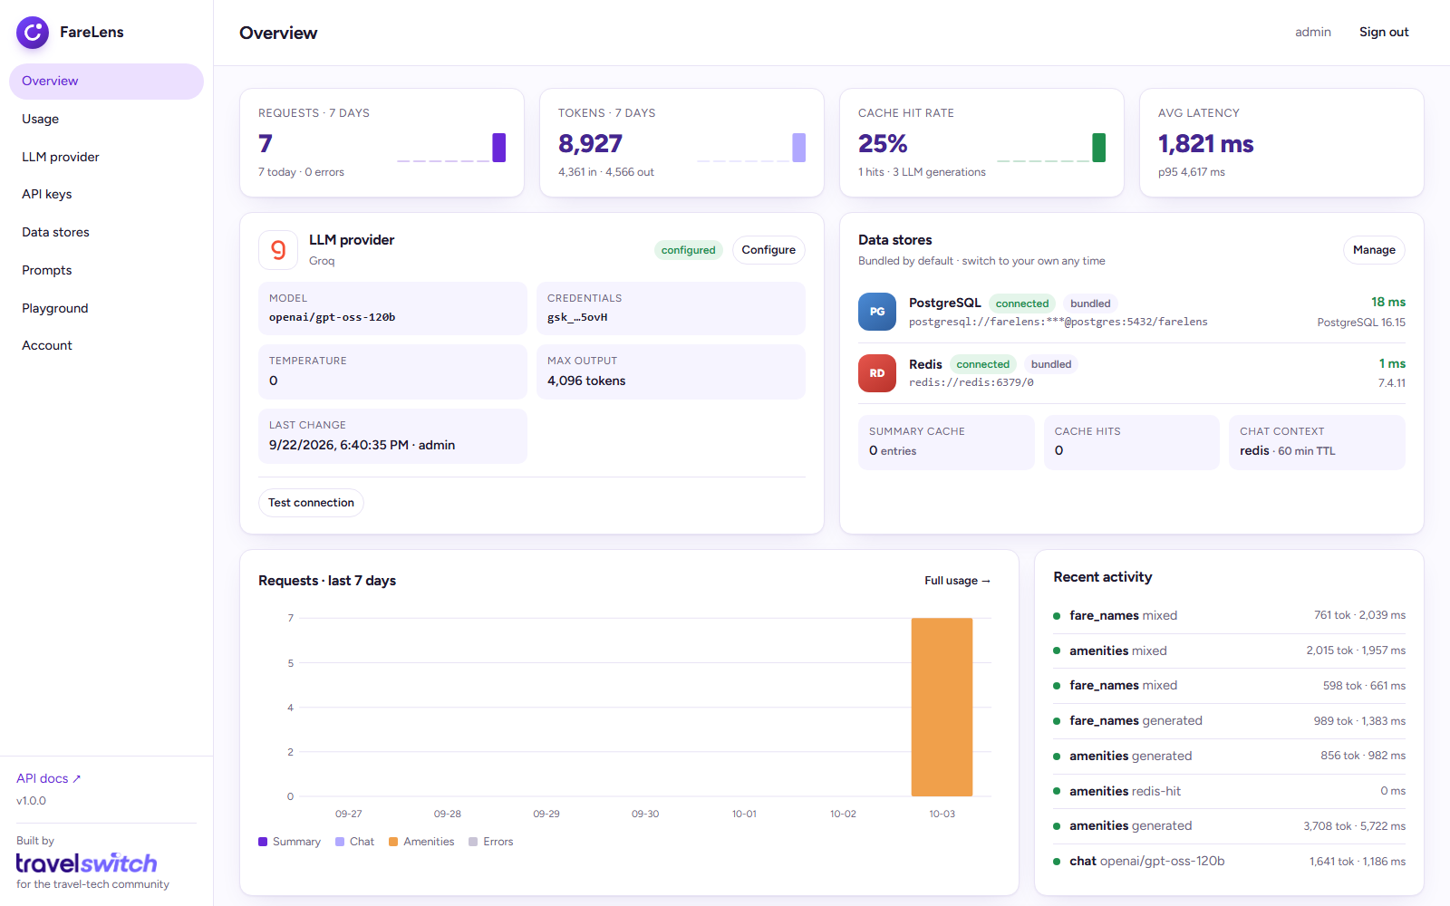
Figure 1 – Overview dashboard: usage tiles, provider status, live datastore checks, recent activity

2. Quick start
Requirements: Docker with Compose v2. Nothing else — no Python, no database to install.

2.1 Run it
git clone https://github.com/travelswitch/farelens.git
cd farelens
docker compose up -d

Open http://localhost:8000 and sign in with the default credentials admin / admin. The UI asks you to change the password on first login.

2.2 Choose an LLM provider
Pick a provider, paste your key, click Test connection, then Save & activate. Credentials are encrypted at rest. Any model id the provider accepts can be typed in; the suggested list is only a starting point.
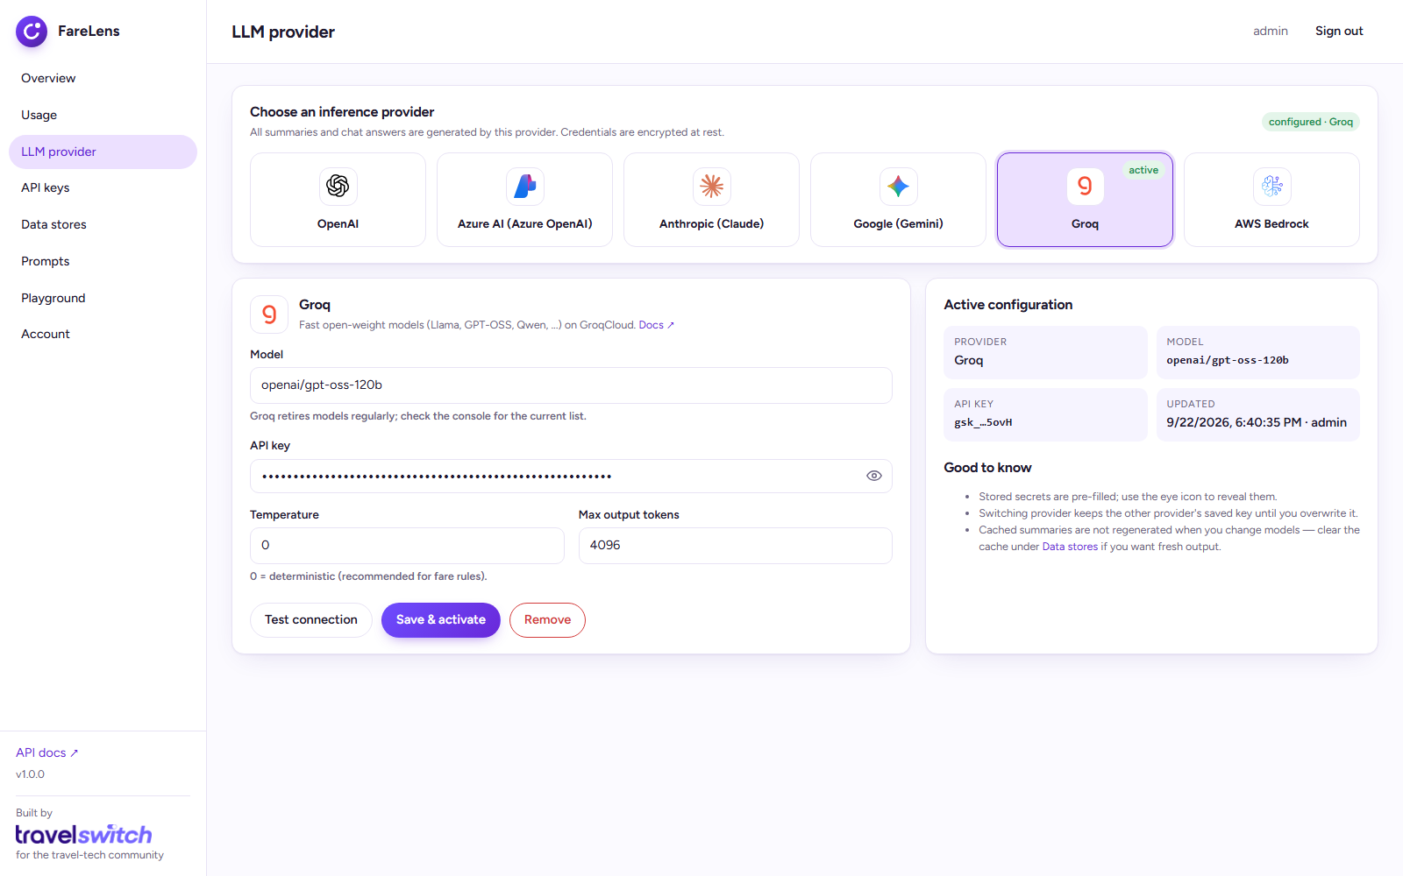
Figure 2 – Provider picker with connection test

2.3 Create an API key
API keys authenticate the public endpoints. The full key is shown once; only a hash is stored.
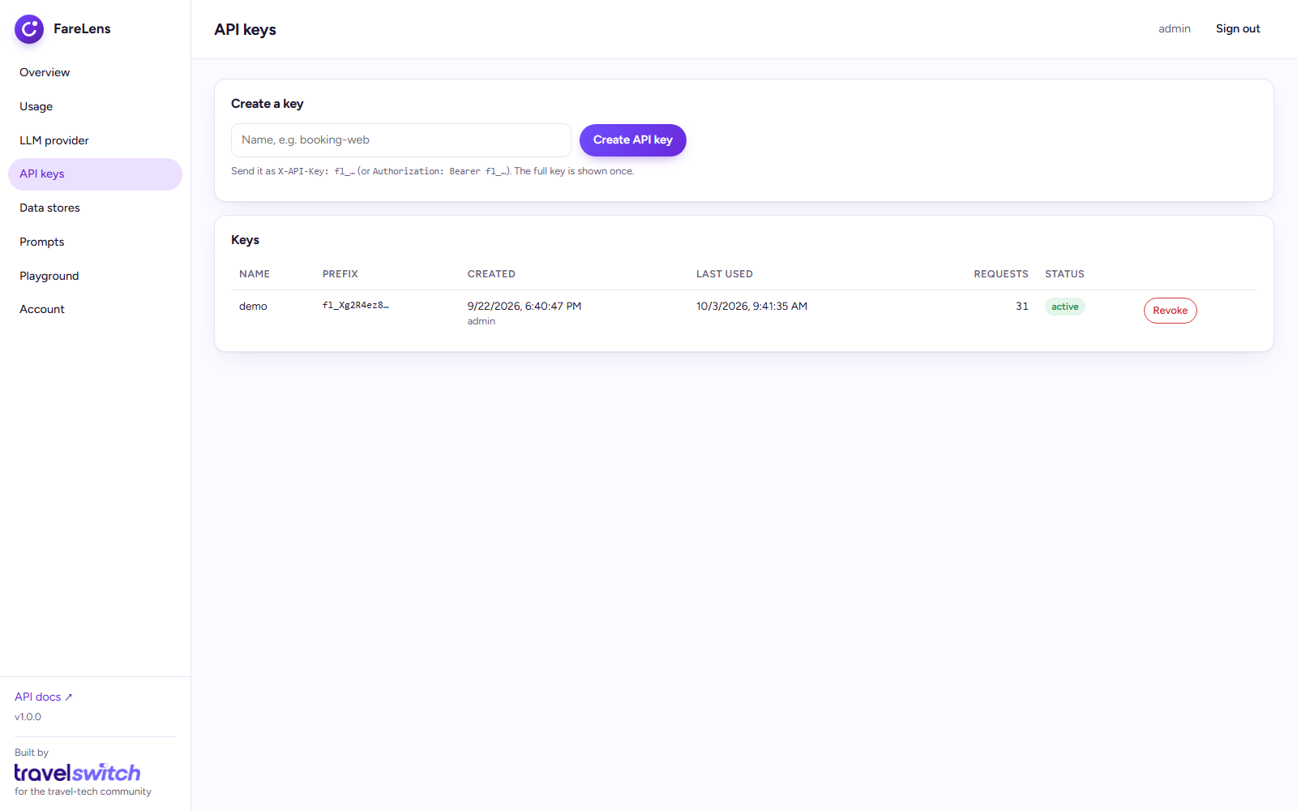
Figure 3 – API key management

2.4 Call the API
curl -X POST http://localhost:8000/api/v1/fare-rules/summary \
-H "X-API-Key: fl_..." \
-H "Content-Type: application/json" \
-d '{"fare_rules_text": "CANCELLATIONS BEFORE DEPARTURE CHARGE SAR 150 FOR CANCEL/REFUND ...", "lang": "en"}'

Interactive OpenAPI documentation is served at http://localhost:8000/docs (see Section 3.5).

2.5 Try it in the Playground
Both endpoints can be exercised from the UI without an API key (the admin session is used). Load a sample, choose a language and layout, and see the result rendered.
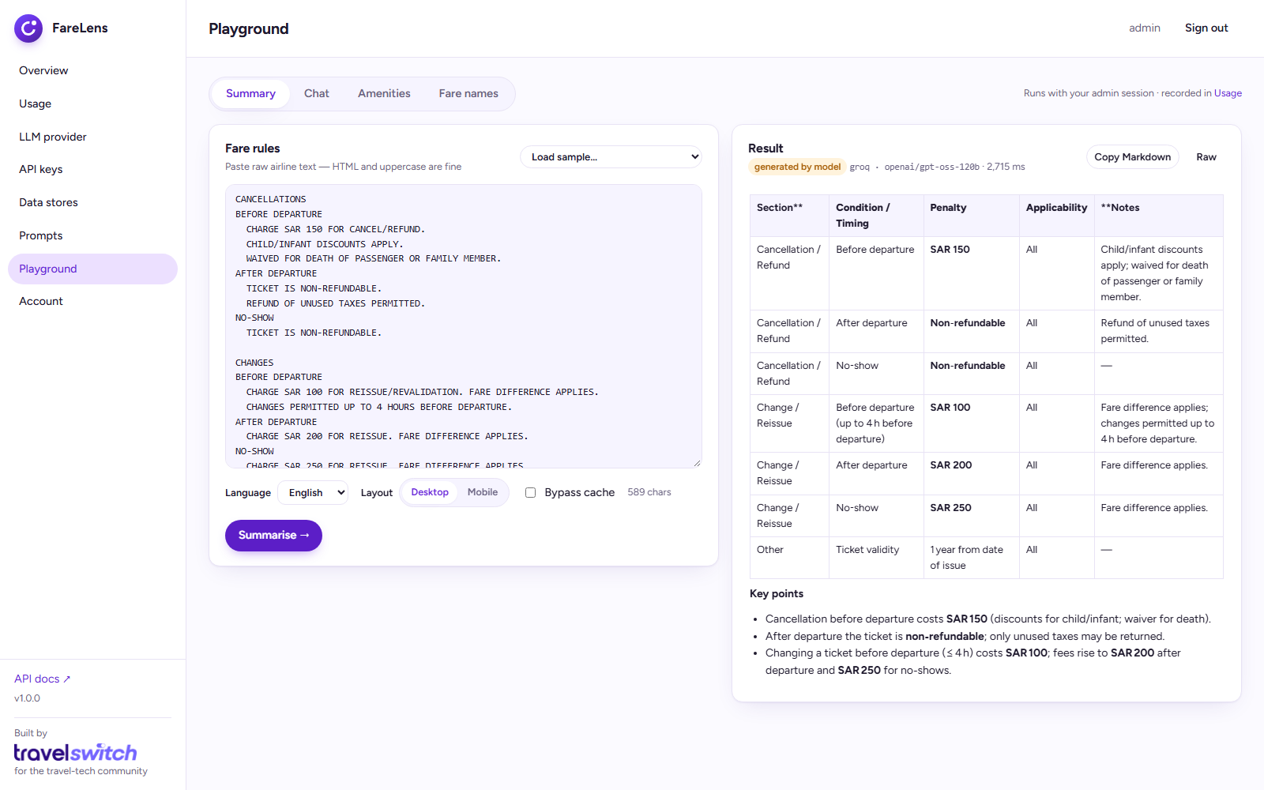
Figure 4 – Playground: fare-rules summary with cache badge, model and latency
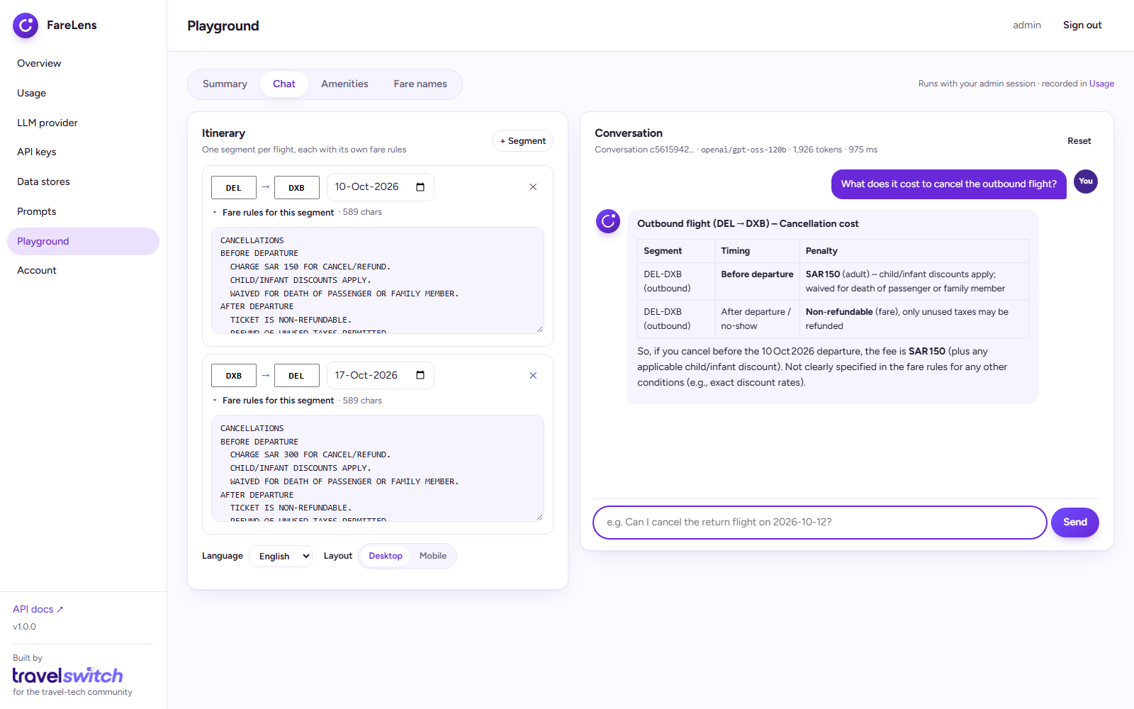
Figure 5 – Playground: multi-segment chat with streaming answers

2.6 Watch usage
Every request is recorded: tokens in/out, latency, cache status, language and API key. The Usage page aggregates per day, per feature, per model and per key.
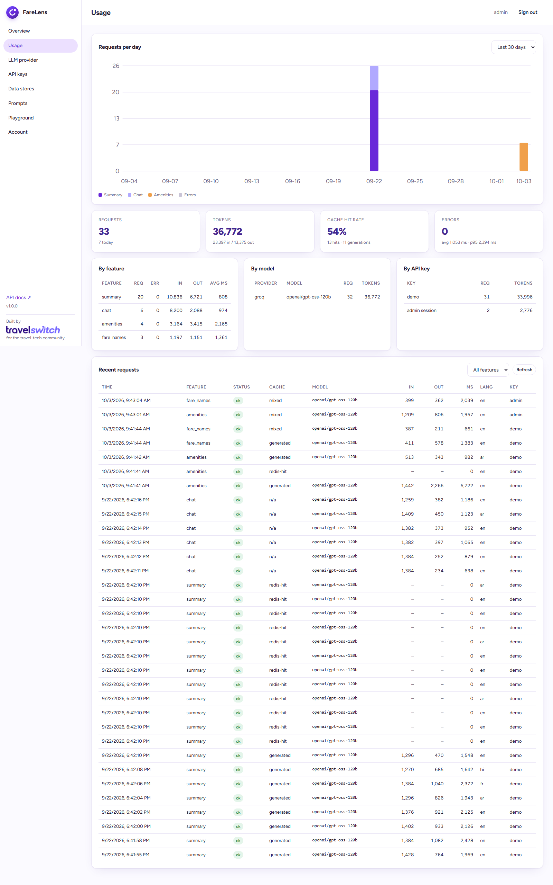
Figure 6 – Usage analytics

3. API reference

3.1 Authentication and errors
All public endpoints require an API key in the X-API-Key header (or Authorization: Bearer fl_…). Requests are rate-limited per key (default 120 per 60 s). Every response carries an X-Request-Id header; errors share one JSON envelope:
{"request_id": "…", "error": {"code": "LLM_NOT_CONFIGURED", "message": "…", "http_status": 503}}

HTTP | Code | Meaning
401 | UNAUTHORIZED / INVALID_API_KEY | Missing or revoked key.
413 | PAYLOAD_TOO_LARGE | Fare-rules text exceeds MAX_FARE_RULES_CHARS.
422 | VALIDATION_ERROR / CONVERSATION_EXPIRED / SEGMENTS_REQUIRED | Bad request shape, or the chat context is gone — resend segments.
429 | TOO_MANY_REQUESTS | Rate limit; see Retry-After.
502 / 503 / 504 | LLM_* | Upstream provider problem: auth, model not found, rate limited, timeout, or no provider configured.

3.2 POST /api/v1/fare-rules/summary
Field | Type | Notes
fare_rules_text | string | Raw fare rules; HTML is stripped. Required.
lang | string | Response language code, default en.
is_mobile_view | bool | Compact sections instead of tables.
bypass_cache | bool | Force regeneration.

Response:
{
"summary_markdown": "| Section | Condition / Timing | Penalty | Applicability | Notes |\n…",
"cache": "generated", // redis-hit | postgres-hit | generated (also in X-Cache header)
"provider": "groq",
"model": "openai/gpt-oss-120b",
"lang": "en",
"is_mobile_view": false,
"latency_ms": 1840
}

3.3 POST /api/v1/fare-rules/chat/stream
Start a conversation by sending the itinerary's segments. Follow-ups only need the convo_id, the new user_message and the client-side history. Segments are retained for CONVERSATION_TTL_SECONDS (default 1 hour).
{
"segments": [
{"source_airport": "DEL", "destination_airport": "DXB", "departure_date": "2026-11-06", "fare_rules_text": "…"},
{"source_airport": "DXB", "destination_airport": "DEL", "departure_date": "2026-11-12", "fare_rules_text": "…"}
],
"user_message": "Can I change the return flight?",
"history": [],
"lang": "en",
"is_mobile_view": false
}

The response is text/event-stream:
event: start data: {"convo_id": "…", "segments": [...]}
event: token data: {"content": "Yes — "}
event: token data: {"content": "changes on the return …"}
event: end data: {"convo_id": "…", "usage": {"prompt_tokens": 1450, "completion_tokens": 92}, "latency_ms": 2100}
event: error data: {"error": {"code": "…", "message": "…"}}

Follow-up message:
{"convo_id": "…", "user_message": "And if I no-show?", "history": [{"role": "user", "content": "…"}, {"role": "assistant", "content": "…"}]}

3.4 Other endpoints
Endpoint | Purpose
POST /api/v1/fare-rules/chat | Same request as the stream endpoint; single JSON response.
DELETE /api/v1/fare-rules/chat/{convo_id} | Forget a conversation's stored segments early.
GET /health | Liveness probe (reports Postgres/Redis connectivity).
GET /health/ready | Readiness probe (503 until Postgres is reachable; reports whether an LLM is configured).

3.5 POST /api/v1/amenities/summary
The other half of the fare-family payload is the benefit list: baggage, seat, lounge, meal, miles and so on. Airlines send it as repetitive, unstandardised text. This endpoint returns a short, de-duplicated, classified list in the traveller's language. The body can be an object or a bare JSON array of strings.
Field | Type | Notes
amenities | string[] | Raw benefit texts, one per line item (max 200).
lang | string | Output language code, default en.
summarize | bool | true (default): merge duplicates, classify, shorten. false: literal translation, one output per input.

{
"amenities": [
{"type": "CabinBaggage", "description": "1 cabin bag up to 7 kg", "details": "max 56x45x25 cm", "included": true, "is_chargeable": false, "ref_url": ""},
{"type": "Lounge", "description": "Lounge access not included", "details": "", "included": false, "is_chargeable": false, "ref_url": ""},
{"type": "Seat", "description": "Seat selection for a fee", "details": "", "included": false, "is_chargeable": true, "ref_url": "https://airline.example/seats"}
],
"cache": "mixed", "lang": "en", "summarize": true, "provider": "groq", "model": "openai/gpt-oss-120b", "latency_ms": 1420
}

- Types: Baggage, CabinBaggage, Seat, Meal, Lounge, Priority, Wifi, Entertainment, Miles, Upgrade, Refund, Change, GroundServices, Insurance, Warning, Other.
- included says whether the benefit is provided (true), explicitly not included (false) or unclear (null); is_chargeable flags paid add-ons; URLs are moved to ref_url.
- Caching is per item and language: a batch of 20 where 18 were seen before sends only 2 texts to the model (cache: redis-hit, postgres-hit, generated or mixed).
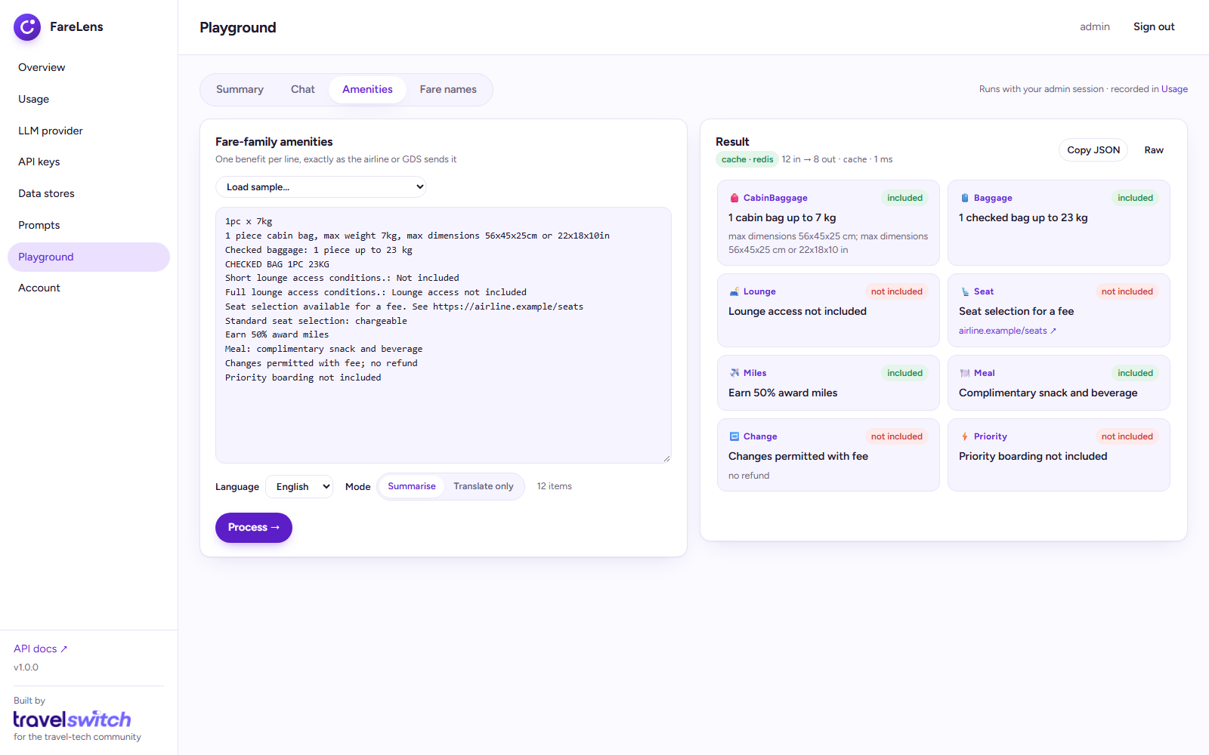
Figure 7 – Playground: amenities de-duplicated and classified

3.6 POST /api/v1/amenities/fare-names
Converts technical fare-family codes into short, friendly labels in the requested language. Results are cached per code and language.
{"names": ["ECOLITE", "BUSIFLEX", "PREMSAVR"], "lang": "en"}
→ {"names": {"ECOLITE": "Economy Lite", "BUSIFLEX": "Business Flex", "PREMSAVR": "Premium Economy Saver"}, "cache": "generated", ...}

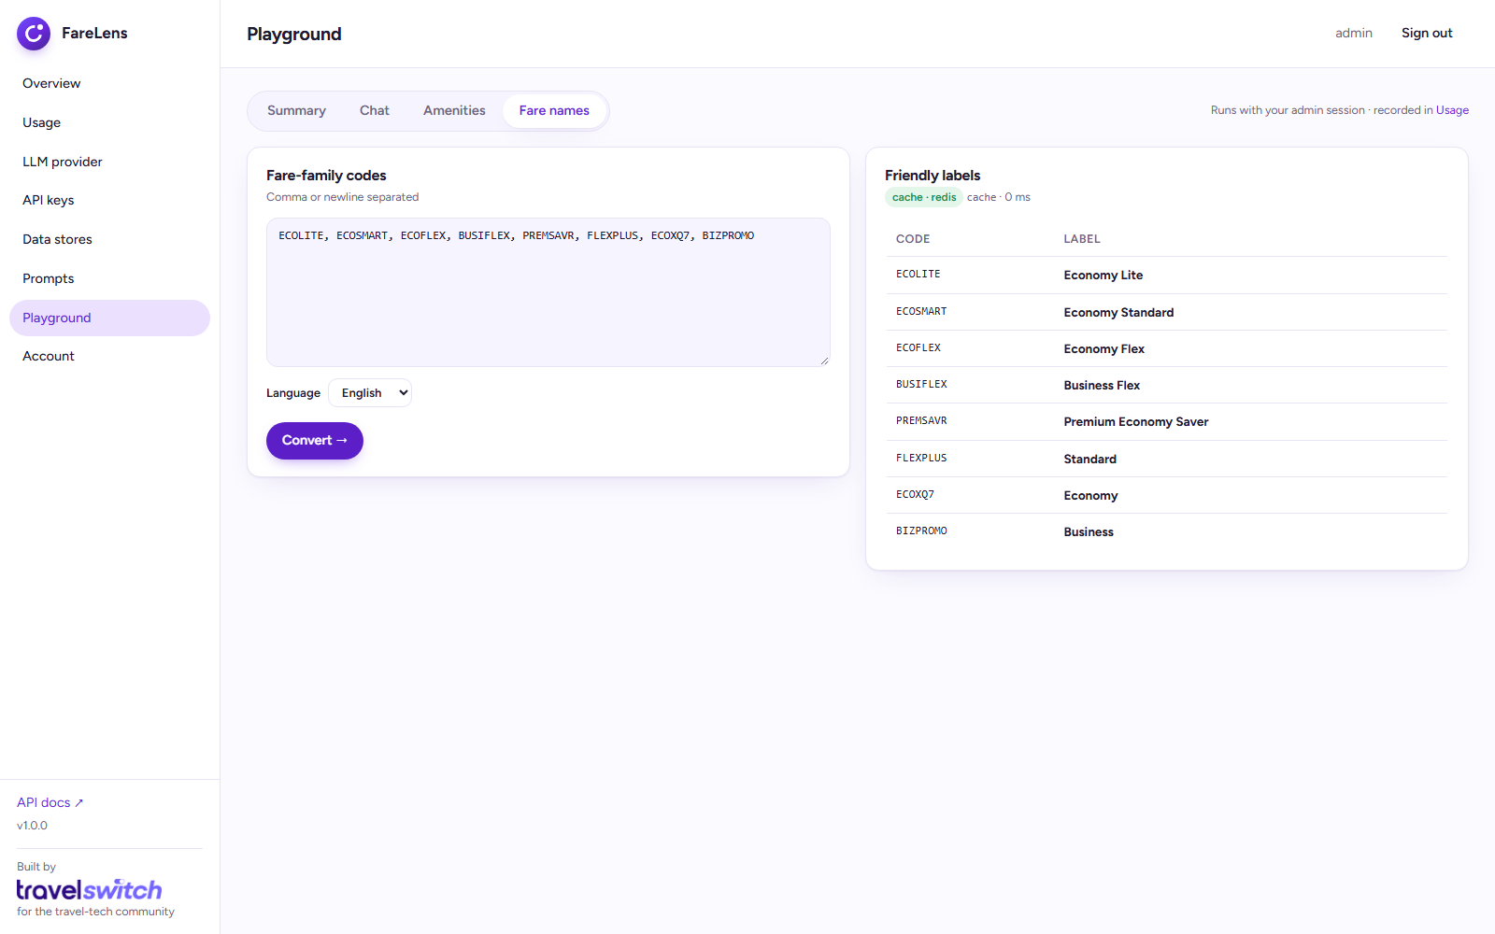
Figure 8 – Playground: fare-family codes to friendly labels

3.7 Interactive documentation (Swagger UI)
The OpenAPI 3.1 specification is served at /openapi.json and rendered at /docs (Swagger UI) and /redoc. Every request and response schema can be inspected and tried live.
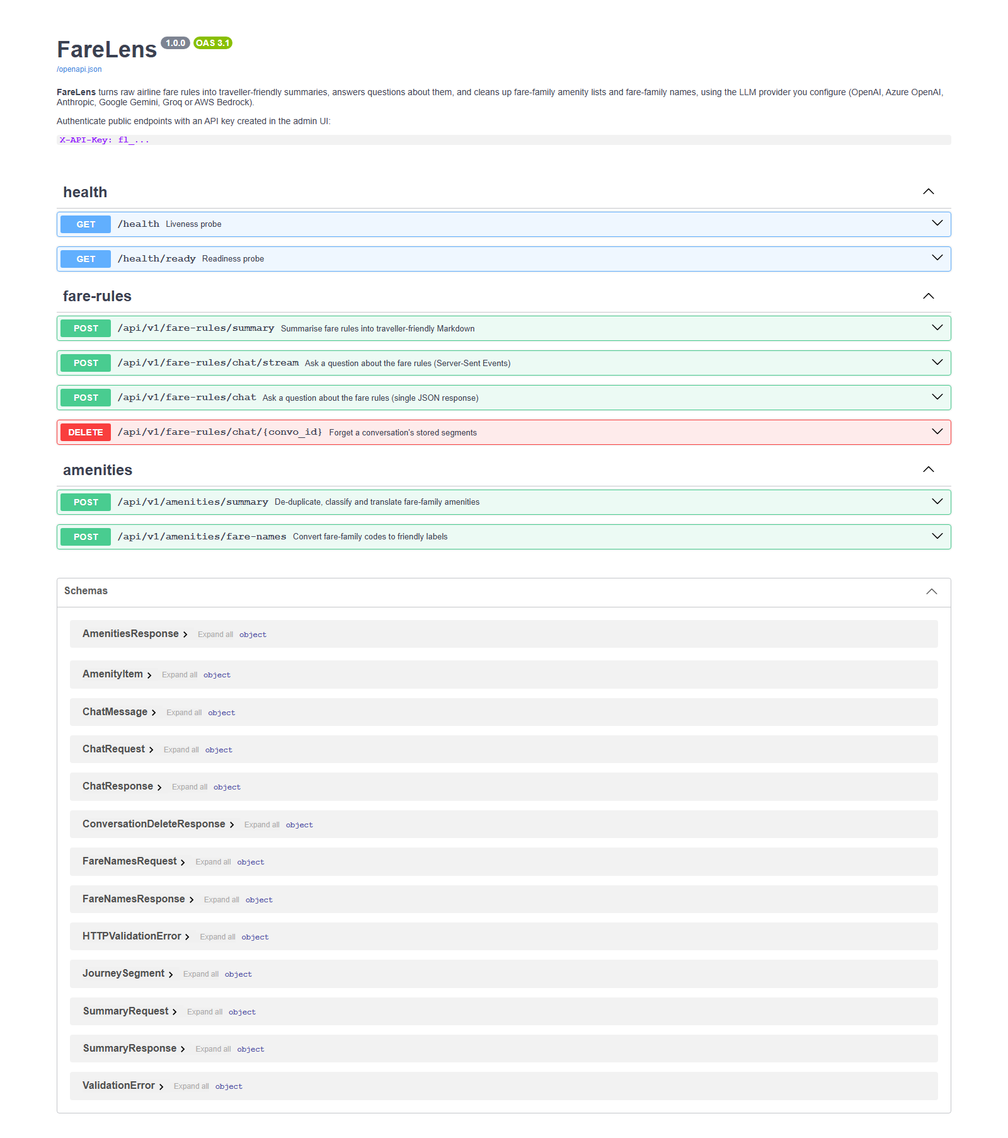
Figure 9 – Swagger UI at /docs
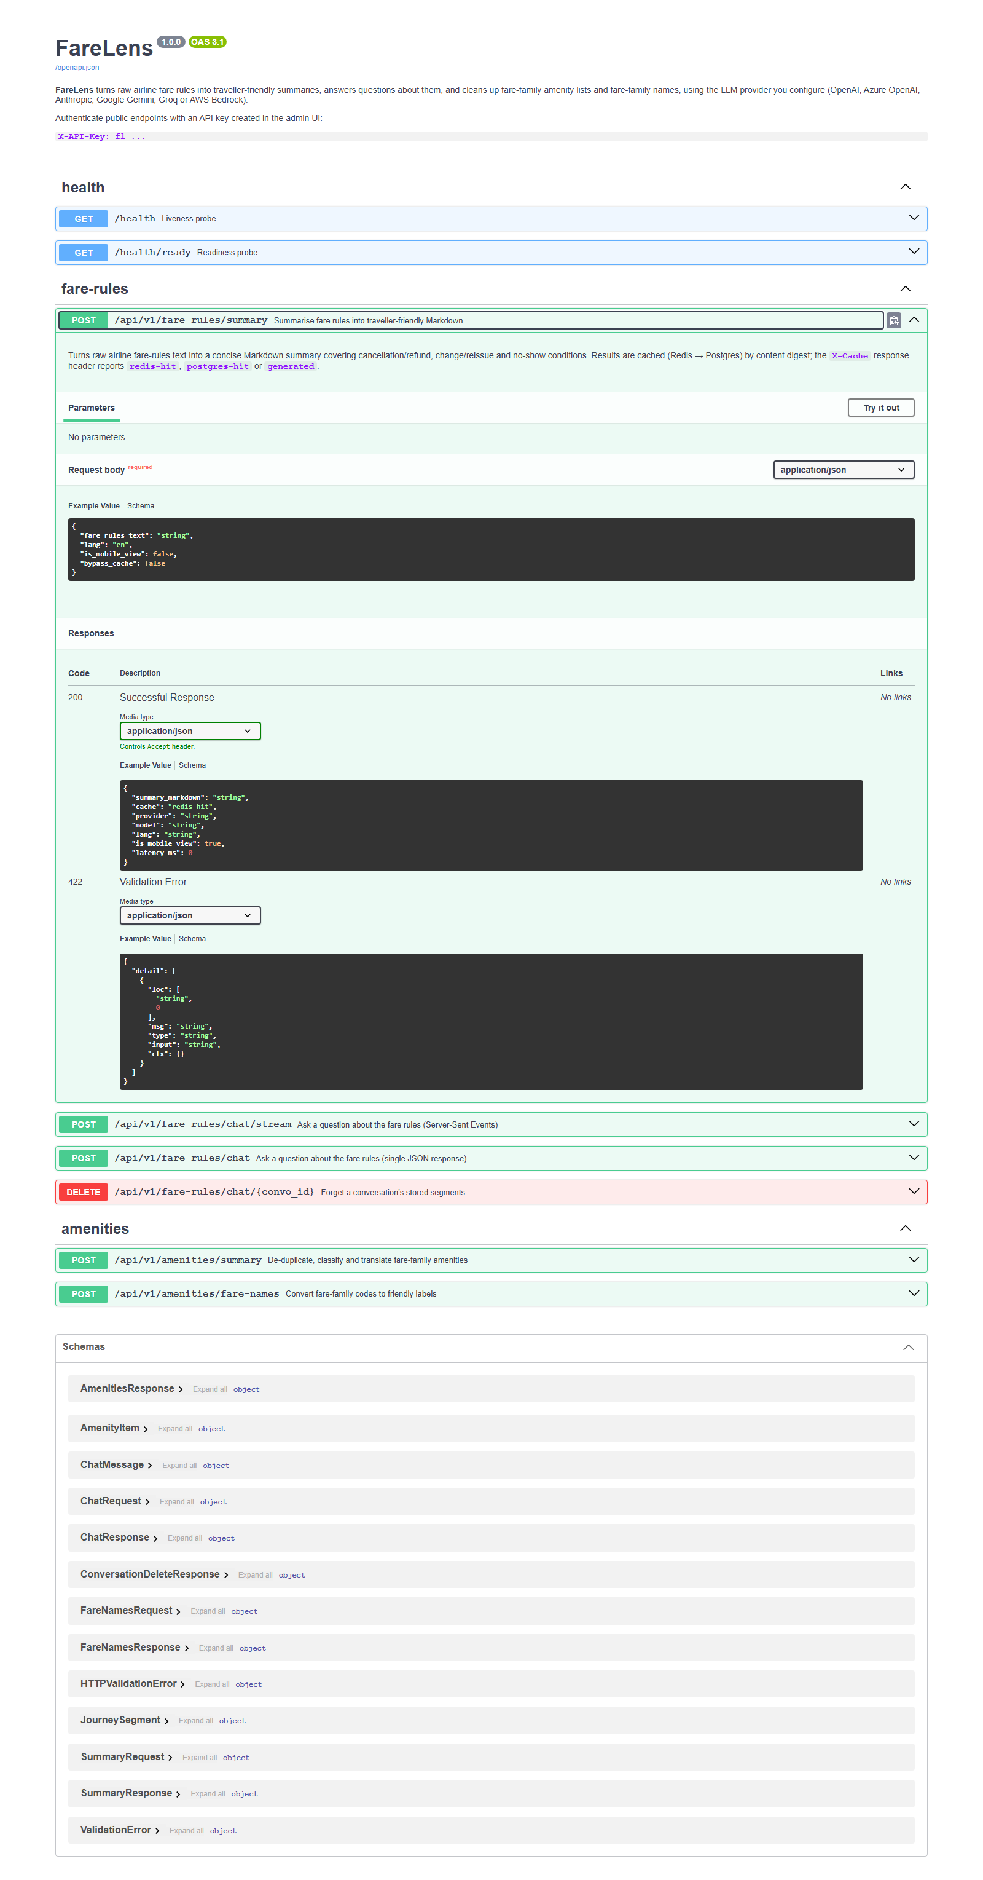
Figure 10 – Summary endpoint expanded: request schema and responses

4. Configuration
FareLens works with zero configuration. Copy .env.example to .env to change anything.

4.1 Environment variables
Variable | Default | Purpose
APP_SECRET_KEY | (generated) | Signs sessions and encrypts stored credentials. Set it in production. If empty, one is generated into APP_DATA_DIR/secret.key.
APP_DATA_DIR | /data (Docker) | Local state: generated secret, datastore overrides.
DATABASE_URL / REDIS_URL | bundled containers | Default datastores.
ADMIN_DEFAULT_USERNAME / ADMIN_DEFAULT_PASSWORD | admin / admin | Seeded once, on first start with an empty database.
MAX_FARE_RULES_CHARS | 60000 | Max fare-rules length per request / segment.
SUMMARY_CACHE_NAMESPACE | v1 | Bump to invalidate all cached summaries (e.g. after editing prompts).
SUMMARY_CACHE_TTL_SECONDS | 2592000 | Redis TTL for summaries; Postgres keeps them indefinitely.
CONVERSATION_TTL_SECONDS | 3600 | Retention of chat segments per convo_id.
RATE_LIMIT_REQUESTS / RATE_LIMIT_WINDOW_SECONDS | 120 / 60 | Sliding window per API key.
CORS_ALLOW_ORIGINS | * | Comma-separated origins for browser clients.
LLM_TIMEOUT_SECONDS | 90 | Upstream request timeout.

4.2 LLM providers
Provider | Credentials | Notes
OpenAI | API key, optional base URL | Base URL makes it work with any OpenAI-compatible gateway.
Azure AI (Azure OpenAI) | Endpoint, API key, API version | Model = your deployment name.
Anthropic (Claude) | API key | Sampling parameters are omitted (current Claude models reject them).
Google (Gemini) | API key | Google AI Studio keys.
Groq | API key | Fast open-weight models; Groq retires models regularly.
AWS Bedrock | Region, optional access key/secret | Empty keys → container IAM role. Uses the Converse API, so any Converse-capable model works.

Credentials are Fernet-encrypted with APP_SECRET_KEY. The public API never sees them; the admin UI shows them masked and can reveal them to a logged-in admin.

4.3 Using your own Postgres / Redis
The Data stores page lets you point FareLens at an existing Postgres and/or Redis with plain host / port / user / password fields (or a pasted connection string). It tests the connection, creates the schema, copies users, LLM configuration and API keys if the target is empty, and switches live — no restart. The choice is persisted, encrypted, in the data volume. Redis is optional: without it, summaries are cached in Postgres only and chat context lives in memory (single instance).
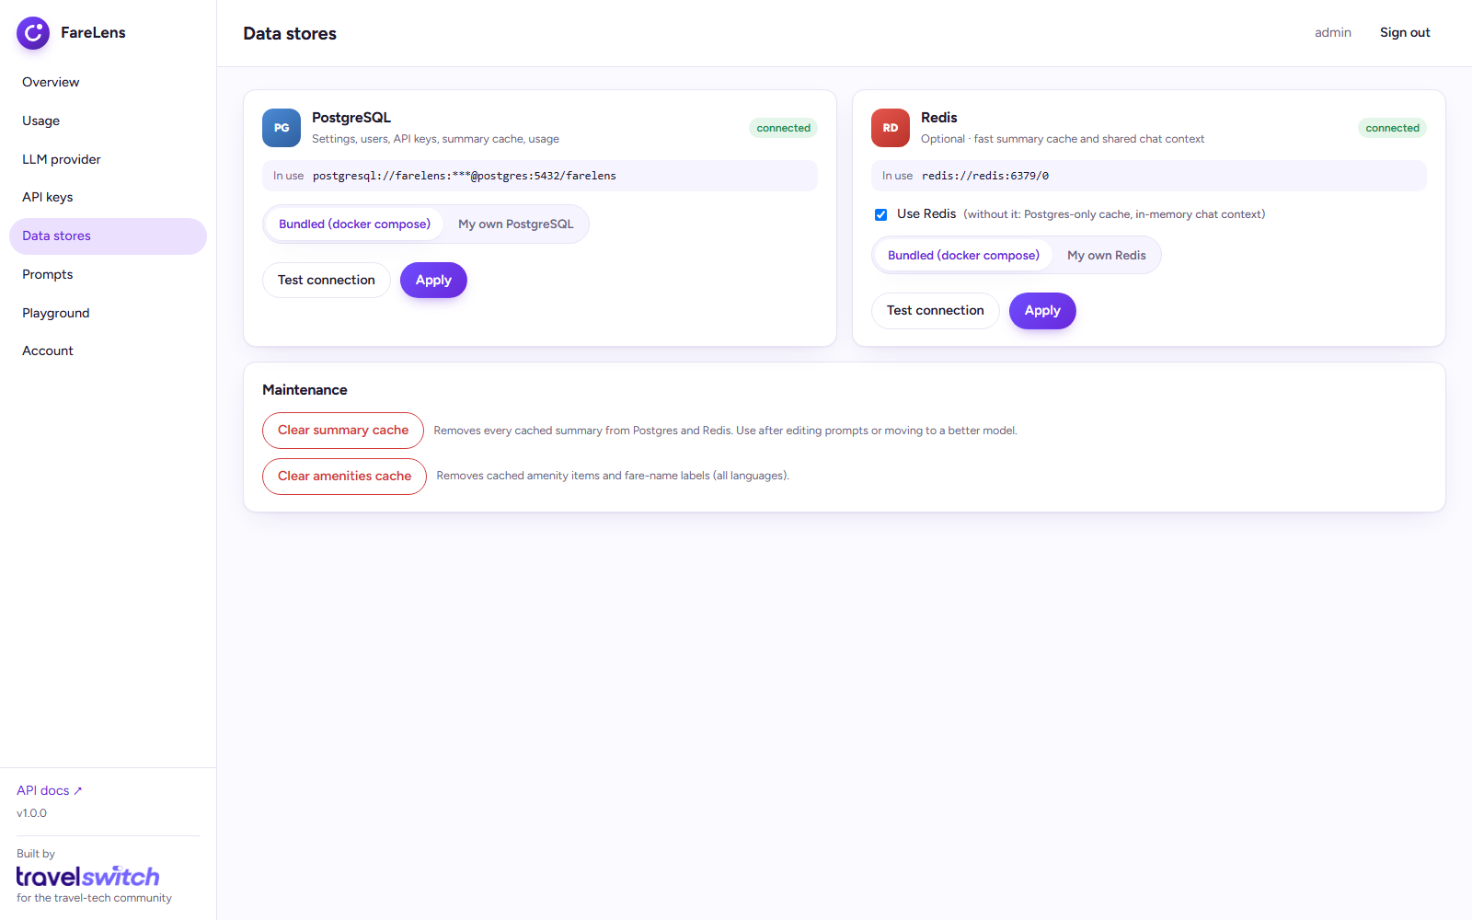
Figure 11 – Data stores: bundled or your own, with connection tests

4.4 Prompts
All prompts, including the amenities and fare-name ones, can be edited from the admin UI (Prompts page) or on disk. The UI validates required placeholders, previews the edited prompt against sample fare rules before saving, stores overrides in Postgres (so they apply to every instance and survive upgrades) and offers a one-click reset to the file default. Saving a summary prompt clears the summary cache so the change takes effect immediately.
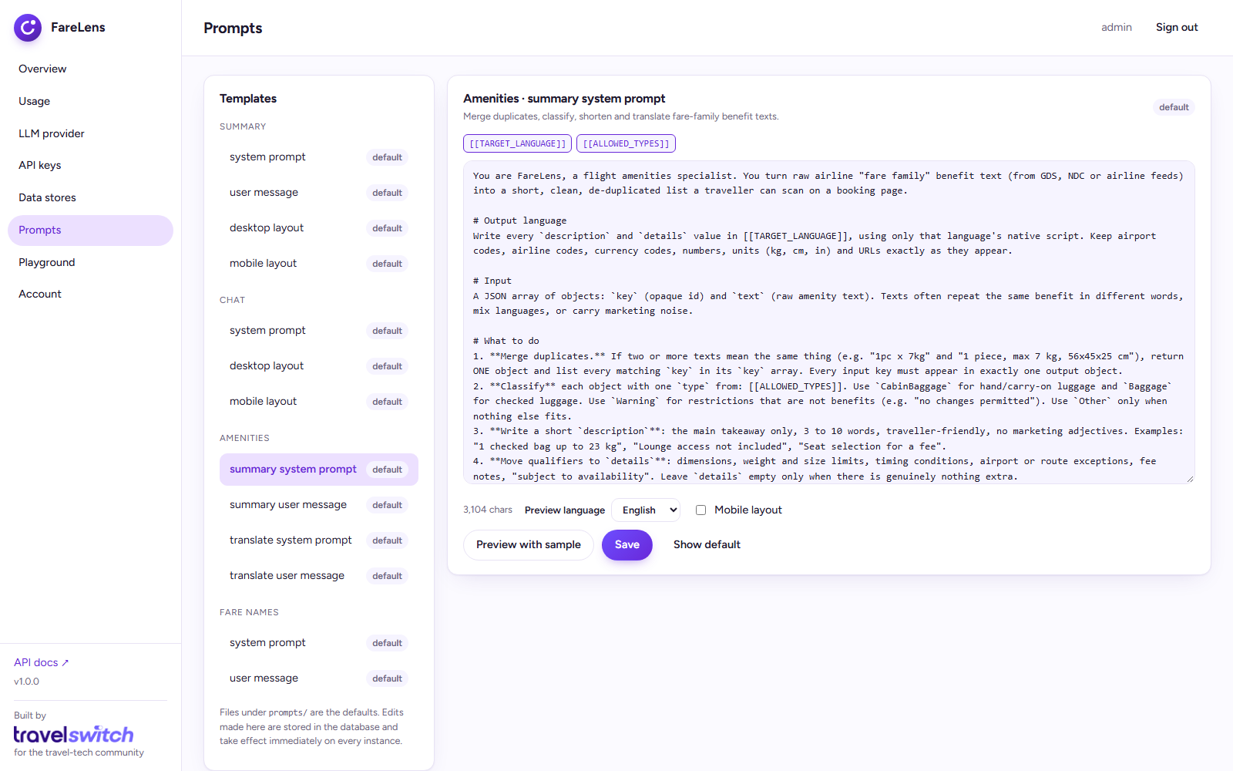
Figure 12 – Prompt editor with live preview
On disk, prompts live in prompts/fare_rules/*.md and are hot-reloaded on change. summary_system.md and chat_system.md carry the domain rules — ATPCO vocabulary, before/after-departure and no-show logic, a strict no-hallucination policy — while the *_layout_*.md files control desktop versus mobile formatting. After changing a prompt, bump SUMMARY_CACHE_NAMESPACE or clear the cache from the UI.

5. Architecture

5.1 Request flow
- The client calls the API with an X-API-Key; the key hash is verified (cached for 60 s) and the request is rate-limited.
- Fare-rules text is normalised (HTML stripped, whitespace and case canonicalised) and hashed with SHA-256 together with the language, layout and cache namespace.
- The digest is looked up in Redis, then Postgres. A hit returns immediately (X-Cache: redis-hit / postgres-hit).
- On a miss, the prompt is rendered from the templates and sent to the configured provider adapter.
- The result is stored in Postgres and Redis, a usage event is recorded (tokens, latency, cache status, key), and the response is returned.
Chat follows the same provider path but streams tokens over Server-Sent Events; segment context is stored per conversation in Redis (or memory) with a TTL.

5.2 Code layout
farelens/
api/ FastAPI routes (public v1 + admin), auth dependencies, middleware
services/ summary (cache → LLM), chat (SSE), usage, API keys, users, LLM config
llm/ provider registry + adapters (openai/azure/groq, anthropic, google, bedrock)
db/ asyncpg / redis managers, live datastore switching, SQL migrations
core/ settings, security (bcrypt · JWT · Fernet), error envelope
prompts/ editable prompt templates
migrations/ forward-only SQL applied at startup
ui/ admin SPA (vanilla JS, no build step)
docker-compose.yml · Dockerfile · tests/ · .github/workflows/ci.yml

5.3 Technology
Layer | Choice
Runtime | Python 3.12, FastAPI, Uvicorn (async end-to-end)
Datastores | PostgreSQL 16 (asyncpg), Redis 7 (optional)
LLM SDKs | openai (OpenAI, Azure, Groq), anthropic, google-genai, boto3 (Bedrock Converse)
Security | bcrypt passwords, HMAC-signed session cookies with CSRF guard, Fernet-encrypted secrets, SHA-256 API-key hashes
Packaging | Multi-stage Docker image, non-root user, healthchecks; GitHub Actions CI (ruff, pytest, image build)

6. Deployment

6.1 Production checklist
- Set APP_SECRET_KEY to a long random value and never change it afterwards (it encrypts stored credentials).
- Change the admin password (Account → Change password).
- Change the bundled Postgres password, or use your own Postgres.
- Serve over HTTPS behind a reverse proxy; the session cookie becomes Secure automatically.
- Restrict CORS_ALLOW_ORIGINS if browsers call the API directly.
- Keep Postgres and Redis on the private network — the compose file does not publish their ports.

6.2 Reverse proxy
FareLens listens on plain HTTP (port 8000) and honours X-Forwarded-* headers. Server-Sent Events require response buffering to be off on every proxy in the path.
# nginx
location / {
proxy_pass http://127.0.0.1:8000;
proxy_set_header Host $host;
proxy_set_header X-Forwarded-For $proxy_add_x_forwarded_for;
proxy_set_header X-Forwarded-Proto $scheme;
proxy_buffering off; # required for SSE
proxy_read_timeout 300s;
}

6.3 Scaling, persistence and upgrades
- Run several app replicas behind the proxy with Redis enabled; provider-config changes propagate within 30 s. Without Redis, keep a single replica.
- Back up the Postgres volume (pg_dump) and the /data volume (it holds the generated secret when APP_SECRET_KEY is not set).
- Upgrade with git pull && docker compose build app && docker compose up -d; schema migrations run automatically and are safe to run from multiple replicas.
- Usage rows are small but unbounded — prune usage_events periodically if traffic is heavy.

6.4 What FareLens stores
Data | Where | Protection
LLM API keys / cloud credentials | Postgres llm_config.secrets | Fernet-encrypted with APP_SECRET_KEY
External datastore DSNs | APP_DATA_DIR/datastores.json | Fernet-encrypted, file mode 600
Admin passwords | Postgres users | bcrypt (12 rounds)
API keys | Postgres api_keys | SHA-256 hash + display prefix
Fare-rules summaries | Redis + Postgres cache | Plain text (no PII expected)
Chat context (segments) | Redis (TTL) or memory | Plain text, expires
Usage events | Postgres | Metadata only — no request bodies

7. Contributing, credits and license
Issues and pull requests are welcome. Run ruff check farelens tests and pytest -q before opening a PR; see CONTRIBUTING.md for the full guide, including how to add a new LLM provider (a registry entry plus an adapter — the UI form is generated automatically).
Security issues should be reported privately as described in SECURITY.md.
Provider icons in the admin UI are from lobe-icons (MIT). Brand names and logos remain the property of their respective owners.
FareLens is released under the MIT License. © 2026 TravelSwitch.

Built by TravelSwitch for the travel-tech community · https://travelswitch.com

