LOAN AGREEMENT
concluded pursuant to Section 497 et seq. of Act No. 513/1991 Coll., the Commercial Code, as amended
(hereinafter the “Agreement”)
Informative English translation. Pursuant to Section 15.2 of the Agreement, the Slovak version is authoritative and prevails in the event of any discrepancy.
between the following parties:
LENDER (Investor):  GR Construction AB  legal form: Aktiebolag (Swedish limited company)  registered office: Gustav III:s boulevard 20, 169 73 Solna, Kingdom of Sweden  registration number (organisationsnummer): 556782-1334  represented by: Gatis Ritenieks, member of the board of directors  bank details: IBAN [__________], BIC [__________]  (hereinafter the “Lender”) | BORROWER (Company):  BauHausEurope s. r. o.  registered office: Konventná 9, 811 03 Bratislava, Slovak Republic  Company ID (IČO): 47 420 171, Tax ID (DIČ): 2023873533, VAT ID: SK2023873533  registered in the Commercial Register of the Municipal Court Bratislava III, Section: Sro, Insert No. 92393/B  represented by: Bc. Ľubomír Kruk, managing director  bank details (Borrower’s Account): IBAN SK43 1100 0000 0029 4304 1325, BIC (SWIFT) TATRSKBX, held with Tatra banka, a.s., Hodžovo námestie 3, 811 06 Bratislava 1, Slovak Republic  (hereinafter the “Borrower”)
(the Lender and the Borrower hereinafter jointly the “Parties” and each individually a “Party”)
Preamble
The Borrower is a business company operating in the field of construction and related services in Slovakia and abroad. The Lender wishes to provide the Borrower with long-term debt financing for the development of its business activities and investment activities under the terms set out in this Agreement. The Parties have agreed that this financing has the nature of a loan without any equity participation of the Lender in the Borrower and without any rights of the Lender to interfere in the management of the Borrower.
§ 1 Subject of the Agreement
1.1 The Lender undertakes to provide the Borrower with funds in the amount of [__________] EUR (in words: [__________] euro) (hereinafter the “Loan” or the “Principal”), and the Borrower undertakes to repay the funds provided and to pay interest thereon under the terms agreed in this Agreement.
1.2 The Loan is provided in euro (EUR). All payments under this Agreement shall be made in euro by cashless bank transfer.
1.3 The Loan is not secured by any security instrument. Neither the shareholders, the managing directors nor any other persons affiliated with the Borrower provide any guarantee, lien or other security for the Borrower’s obligations under this Agreement, and the Lender is not entitled to request any such security.
§ 2 Purpose of the Loan
2.1 The Loan is intended for the development of the Borrower’s business activities and for its investment activities in the Slovak Republic and abroad, in particular for:
a) financing of operating funds (working capital);
b) investments in machinery, equipment and technology;
c) acquisition, construction or reconstruction of real estate;
d) expansion into new markets and extension of activities;
e) personnel costs and team development;
f) other investment acquisitions, including the acquisition of shares in other companies and investments in subsidiaries and other entities within the Borrower’s group;
g) investments in innovation, development and digitalisation;
h) other purposes related to the business activities of the Borrower and its group.
2.2 The business plan and overview of the investment activities and acquisitions of the Borrower and its group form Annex No. 1 to this Agreement. Annex No. 1 is of an informative nature; any deviation from it or its update does not constitute a breach of this Agreement provided that the funds are used for any of the purposes under Section 2.1.
2.3 The specific use of the Loan funds within the purposes under Section 2.1 is decided exclusively by the Borrower. The Lender has no right to approve, condition or refuse individual uses of the funds.
§ 3 Provision of the Loan
3.1 The Lender shall provide the Loan by a single cashless transfer of the entire amount of the Principal to the Borrower’s Account specified in the heading of this Agreement within [__________] ([__________]) business days from the day on which the Borrower fulfils the conditions under § 6 of this Agreement, but no later than [__________].
3.2 The day of provision of the Loan is the day on which the entire amount of the Principal is credited to the Borrower’s Account (hereinafter the “Drawdown Date”). At the Lender’s request, the Borrower shall confirm the Drawdown Date in writing; such confirmation serves for record purposes only.
3.3 Each Party shall bear the costs associated with the transfer on its own side (“SHA” charges).
3.4 If the Lender fails to provide the Loan within the period under Section 3.1, the Borrower is entitled to withdraw from this Agreement. The Borrower is also entitled to withdraw from the Agreement without giving any reason at any time before the Drawdown Date.
§ 4 Interest
4.1 The Loan bears interest at a fixed interest rate of 7% p. a. (seven per cent per annum) on the Principal.
4.2 Interest is calculated as simple interest on the outstanding Principal from the Drawdown Date (inclusive) to the date of repayment of the Principal (exclusive). Interest is not capitalised, i.e. it is not added to the Principal and does not itself bear further interest, even in the event of an extension of maturity under § 5 Section 5.4. Interest is calculated on the basis of the actual number of days in the year and in the period (ACT/ACT, i.e. 365 days in a year and 366 days in a leap year).
4.3 Interest is not paid on an ongoing basis during the term of the Loan. All interest accrued from the Drawdown Date is payable in a single payment together with the Principal on the Maturity Date under § 5.
4.4 Illustrative example: with a Principal of EUR 100,000 and repayment exactly after 5 years, the interest amounts to 5 × EUR 7,000 = EUR 35,000 and the total amount payable on the Maturity Date is EUR 135,000; in the event of an extension of maturity by a further 3 years under Section 5.4, the interest amounts to 8 × EUR 7,000 = EUR 56,000 and the total amount payable is EUR 156,000.
4.5 Apart from the interest under this Article, the Borrower is not obliged to pay the Lender any fees, commissions, arrangement, administration or early repayment charges in respect of the Loan.
§ 5 Maturity, Early Repayment and Extension of Maturity
5.1 The Principal together with all accrued interest is payable in a single payment on the day which, by its designation, corresponds to the Drawdown Date and falls five (5) years after the Drawdown Date (hereinafter the “Maturity Date”). If such day is not a business day in the Slovak Republic, the Maturity Date shall be the next following business day, without any effect on the amount of interest.
5.2 The Borrower shall discharge its obligation by cashless transfer to the Lender’s account specified in the heading of the Agreement or to another account notified by the Lender to the Borrower in writing at least 30 days before the Maturity Date. The obligation is discharged on the day the amount is debited from the Borrower’s account.
5.3 The Borrower is entitled to repay the Principal or any part thereof, together with the interest accrued on the relevant part, at any time before the Maturity Date without any penalty, fee or compensation. The Borrower shall notify the Lender of the early repayment at least 10 days in advance; in the case of partial repayment, interest continues to accrue only on the remaining Principal. Section 503(3) of the Commercial Code applies with the proviso that the Lender is not entitled to interest for the period after early repayment.
5.4 Borrower’s right to extend maturity. The Borrower has the right to unilaterally extend the Maturity Date by a further three (3) years on the same terms, including the interest rate of 7% p. a. under § 4, by written notice delivered to the Lender no later than 30 days before the original Maturity Date. The Lender’s consent is not required. Upon delivery of the notice:
a) the Maturity Date is postponed to the day falling eight (8) years after the Drawdown Date (hereinafter also the “Extended Maturity Date”);
b) the maturity of the Principal and of all interest accrued from the Drawdown Date (including interest for the original five-year period) is postponed to the Extended Maturity Date, and the Principal together with all interest shall be paid in a single payment on the Extended Maturity Date;
c) interest for the original period is not capitalised and does not bear interest during the extended period either; interest continues to be calculated exclusively on the Principal in the manner set out in § 4.
5.5 All provisions of this Agreement, including § 10 and § 11, continue to apply in full after the extension of maturity until the Extended Maturity Date.
5.6 The Parties may also agree in writing on a further extension of maturity or on other repayment terms.
§ 6 Conditions Precedent to Disbursement of the Investment / Completion of the Transaction
6.1 The following conditions must be fulfilled before the investment is disbursed:
a) submission of a current extract from the Commercial Register of the Slovak Republic concerning the Borrower, not older than 30 days;
b) evidence of the authority of the person signing the Agreement on behalf of the Borrower to act for the Borrower (by an extract from the commercial register or, where applicable, a power of attorney);
c) submission of the Borrower’s current constitutional documents (memorandum of association / deed of foundation in full wording) and a description of its ownership structure, including its ultimate beneficial owners;
d) performance of KYC (know your customer) and AML (anti-money laundering) checks by the Lender to the extent notified by the Lender to the Borrower in writing upon signature of this Agreement, and the Borrower’s cooperation in such checks.
6.2 The Borrower shall provide the Lender with the documents under Section 6.1 without undue delay after signature of this Agreement. The Lender shall, without undue delay and no later than 10 business days after their delivery, confirm to the Borrower in writing that the conditions have been fulfilled, or specifically state which condition has not been fulfilled and for what reason. The conditions are also deemed fulfilled upon expiry of this period without a statement from the Lender.
6.3 Likewise, before the Drawdown Date, the Lender shall provide the Borrower with a current extract from the Swedish companies register (Bolagsverket), evidence of the authority of the person acting on behalf of the Lender, and a certificate of the Lender’s tax residence in the Kingdom of Sweden for the purposes of § 14.
§ 7 Representations and Warranties
7.1 The Borrower represents and warrants that:
a) it has been duly incorporated and exists in accordance with the laws of the Slovak Republic;
b) the person signing this Agreement is authorised to conclude it and the conclusion of the Agreement has been approved in accordance with the Borrower’s constitutional documents;
c) it shall provide the Lender with complete and true information that is material to its investment decision;
d) the investment funds will not be used to circumvent sanctions, anti-money laundering regulations or any other statutory provisions.
7.2 The Lender represents and warrants that:
a) it has been duly incorporated and exists in accordance with the laws of the Kingdom of Sweden and the person signing this Agreement is authorised to conclude it;
b) the Loan funds originate from legal sources, are its own funds, and no consent of any third party is required for their provision;
c) it is not a person subject to sanctions of the European Union, the United Nations or other international sanctions, and is not controlled by any such person;
d) the provision of the Loan is not conditional on any equity participation, management right, right to a share in the Borrower’s profit or any other performance beyond the scope of this Agreement.
§ 8 Borrower’s Obligations during the Term of the Loan
8.1 During the term of the Loan, the Borrower undertakes to:
a) use the Loan funds for the purposes under § 2;
b) provide the Lender once a year, by 31 July, with a copy of the Borrower’s ordinary financial statements for the preceding accounting period (or a reference to their publication in the Register of Financial Statements);
c) notify the Lender in writing within 30 days of any change of the Borrower’s business name, registered office or statutory body, and of the commencement of bankruptcy, restructuring or liquidation proceedings against the Borrower.
8.2 Beyond Section 8.1, the Lender has no right to request from the Borrower any other information, reports or consents, to participate in the meetings of the Borrower’s bodies, or to carry out inspections at the Borrower. A breach of the information duty under Section 8.1 does not entitle the Lender to accelerate the Loan, to terminate or to withdraw from the Agreement; the Lender is only entitled to subsequent performance of the obligation.
§ 9 Confidentiality
9.1 The Parties undertake to keep confidential all non-public economic, technical and legal information obtained in connection with this Agreement, including the contents of Annex No. 1.
9.2 This is without prejudice to statutory disclosure obligations and to the provision of information to attorneys, tax advisers, auditors, banks and financing providers who are bound by a duty of confidentiality of at least the same scope.
9.3 The duty of confidentiality applies for the term of this Agreement and for 5 years after repayment of the Loan.
§ 10 Exclusion of Termination, Withdrawal and Acceleration by the Lender
10.1 The Parties have expressly agreed that the Lender is not entitled to terminate this Agreement, to withdraw from it, or to demand repayment of the Principal or payment of interest, in whole or in part, before the Maturity Date (or the Extended Maturity Date, as applicable), for any reason whatsoever. The Principal and interest become due exclusively on the Maturity Date under § 5.
10.2 To the extent permitted by law, the Parties hereby exclude the application of Sections 505 and 506 of the Commercial Code, as well as any other provision that would give the Lender a right to withdraw from the Agreement or to accelerate the Loan. A deterioration of the Borrower’s financial situation, a change in its ownership structure, a change of its statutory body, a change of its business activities or a deviation from Annex No. 1 do not constitute grounds for acceleration of the Loan.
10.3 Section 10.1 shall not apply exclusively in the event that a court declares bankruptcy over the Borrower’s assets by a final decision, or dismisses a petition for bankruptcy by a final decision due to insufficiency of the Borrower’s assets, or the Borrower enters into liquidation; in such case the Lender’s receivable becomes due to the extent and in the manner provided by the applicable legislation.
10.4 The Lender is not entitled to unilaterally set off its receivable under this Agreement against any receivable of the Borrower before the Maturity Date.
§ 11 Prohibition of Assignment and Encumbrance of the Receivable
11.1 Without the prior written consent of the Borrower, the Lender is not entitled to assign this Agreement, the rights and obligations arising from it, or the receivable for repayment of the Principal or payment of interest, in whole or in part, to any third party. An assignment in breach of this prohibition is invalid (Section 525(2) of the Civil Code).
11.2 Without the prior written consent of the Borrower, the Lender is not entitled to pledge the receivable under this Agreement, to transfer it as security, to contribute it to a business company, or otherwise to encumber it or dispose of it in favour of a third party. The prohibition under this Article also applies to persons controlled by the Lender or controlling the Lender.
11.3 Without the prior written consent of the Lender, the Borrower is not entitled to transfer its obligations under this Agreement to a third party; this does not apply to universal succession in the event of a merger, amalgamation or division of the Borrower, provided that the legal successor assumes the obligations under this Agreement in full.
§ 12 Default Interest
12.1 If the Borrower is in default with the repayment of the Principal or payment of interest on the Maturity Date (or the Extended Maturity Date), it undertakes to pay the Lender default interest of 0.01% of the amount due for each day of default. The Parties have agreed on this rate of default interest within the meaning of Section 369(2) of the Commercial Code; default interest at the statutory rate shall not apply.
12.2 Default interest is the sole sanction for the Borrower’s default. The Lender is not entitled to any contractual penalty, to flat-rate compensation for the costs of enforcing the receivable beyond the statutory amount, or to compensation for damages exceeding the default interest.
12.3 If the Borrower is in default, the Borrower’s payments shall be applied first to the Principal, then to interest under § 4 and finally to default interest, unless the Borrower specifies otherwise when making the payment.
§ 13 Delivery and Communication
13.1 Documents under this Agreement shall be delivered to the addresses of the registered offices of the Parties specified in the heading or to the following e-mail addresses: Lender: [__________]; Borrower: info@bauhauseurope.de. The notice of early repayment (Section 5.3) and the notice of extension of maturity (Section 5.4) shall be delivered by registered mail or by e-mail with confirmation of receipt; they are deemed delivered on the day of receipt, otherwise on the third business day after dispatch.
13.2 The Parties undertake to notify each other of any change in their delivery details; until such notification, delivery shall be made to the last known details.
§ 14 Taxes
14.1 Each Party shall bear its own tax obligations arising from this Agreement. If the laws of the Slovak Republic require the Borrower to withhold or secure tax on the interest paid to the Lender, the Borrower shall withhold such tax and remit it to the competent tax authority and shall pay the Lender the interest reduced by the tax withheld; the amount so withheld is deemed to have been duly paid to the Lender. The Borrower is not obliged to pay the Lender any additional amount (“gross-up”) corresponding to the tax withheld.
14.2 The Lender shall provide the Borrower with a certificate of tax residence.
§ 15 Governing Law, Language and Dispute Resolution
15.1 This Agreement and all legal relations arising from it are governed by the laws of the Slovak Republic, in particular the Commercial Code.
15.2 The Agreement is executed in the Slovak language. If the Parties prepare a translation into English or Swedish, such translation is of an informative nature only and, in the event of any discrepancy, the Slovak version prevails.
15.3 The Parties shall resolve disputes arising from this Agreement primarily by negotiation. If a dispute is not resolved within 60 days, the court of the Slovak Republic having subject-matter and territorial jurisdiction according to the registered office of the Borrower shall have jurisdiction to decide it. In accordance with Article 25 of Regulation (EU) No 1215/2012 of the European Parliament and of the Council (Brussels Ia), the Parties have agreed on the exclusive jurisdiction of the courts of the Slovak Republic.
§ 16 Final Provisions
16.1 This Agreement becomes valid and effective on the day of its signature by both Parties.
16.2 This Agreement may be amended and supplemented only by written, numbered amendments signed by both Parties. This provision does not apply to unilateral acts of the Borrower expressly provided for in this Agreement (early repayment, extension of maturity).
16.3 If any provision of this Agreement becomes invalid or unenforceable, the validity of the remaining provisions shall not be affected. The Parties shall replace such provision with a valid provision that comes as close as possible to the purpose of the original provision; for the provisions of § 10 and § 11, this purpose is the protection of the Borrower against acceleration and against a change of the person of the Lender.
16.4 This Agreement constitutes the entire agreement of the Parties on its subject matter and supersedes all prior oral and written arrangements.
16.5 This Agreement is executed in two (2) counterparts, one for each Party. The Agreement may also be concluded electronically using qualified electronic signatures.
16.6 The following annexes form an integral part of this Agreement:
Annex No. 1 – Business plan and overview of the investment activities and acquisitions of the Borrower and its group
Annex No. 2 – Extract from the Commercial Register of the Slovak Republic concerning the Borrower
Annex No. 3 – Extract from the Bolagsverket register concerning the Lender and its certificate of tax residence
16.7 The Parties declare that they have read this Agreement, understood its contents, that it expresses their free and serious will, and that it was not concluded under duress or under conspicuously disadvantageous conditions, in witness whereof they sign it.

In Solna, on [__________]  ______________________________  GR Construction AB  Gatis Ritenieks, member of the board of directors  Lender | In Bratislava, on [__________]  ______________________________  BauHausEurope s. r. o.  Bc. Ľubomír Kruk, managing director  Borrower

ANNEX No. 1
to the Loan Agreement concluded between GR Construction AB (Lender) and BauHausEurope s. r. o. (Borrower)
BUSINESS PLAN
and overview of the investment activities and acquisitions of the Borrower and its group

BauHausEurope s. r. o.
Konventná 9, 811 03 Bratislava, Slovak Republic
Company ID: 47 420 171 | Tax ID: 2023873533 | VAT ID: SK2023873533
Commercial Register of the Municipal Court Bratislava III, Section Sro, Insert No. 92393/B
Group companies covered by the plan:
BauHausEurope s. r. o. · BHE Real Estate – Skyhill Residence s. r. o. · UBI-RENT, s. r. o.
Prepared by: Bc. Ľubomír Kruk, managing director
Bratislava, October 2026
CONFIDENTIAL – subject to the duty of confidentiality under § 9 of the Loan Agreement. Pursuant to Section 2.2 of the Agreement, this Annex is of an informative nature; any deviation from it or its update does not constitute a breach of the Agreement. Informative English translation; the Slovak version prevails.

Contents

The table of contents is updated when the document is opened in Word (File → Update fields / F9).

1. Executive Summary for the Investor
BauHausEurope s. r. o. (hereinafter the “Company”) is a Slovak construction and development company founded in 2013. The core of its business is the supply of construction works and qualified construction workers for building sites in Germany, and since 2022 the Company has been systematically building a second pillar – its own development projects and the construction of utility networks in Slovakia and Croatia. Together with the affiliated companies BHE Real Estate – Skyhill Residence s. r. o. and UBI-RENT, s. r. o., it forms a group under the common owner and managing director Bc. Ľubomír Kruk (hereinafter the “Group”).
The loan from GR Construction AB (5 years, fixed interest of 7% p. a., principal and interest payable in a single payment on the Maturity Date, unsecured and without equity participation) will allow the Group to bridge the preparatory phase of projects that are already secured in terms of ownership and permits, and to carry them out without the pressure of ongoing instalments. The sources for repayment of the loan including interest derive from the following projects:
Project / activity | Entity | Status (10/2026) | Volume
River Residence – Multifunctional residential buildings “Stará Pekáreň”, Levočská 11, Stará Ľubovňa (10,789 m² plot owned by the Company) | BauHausEurope | Valid zoning decision; architectural and urban study (Harajčík Architekti, 3/2025: 4 residential buildings, 240 apartments, multifunctional ground floor); building permit in preparation; study being adjusted from 12 to 8 storeys following the change of the zoning plan | budget EUR 24.0 m / sales EUR 46.0 m
Senec – Margovo: construction of utility networks for a new residential zone (38 ha, 835 apartments and houses) | BauHausEurope | Contract signing 11/2026 after issuance of the building permit for roads; subsequently participation in the tender for general contractor of the housing development | EUR 11.66 m excl. VAT
Croatia: construction of 27 apartments | BauHausEurope | Construction being launched | EUR 4.33 m excl. VAT
Sky Hill Residence, Tulská St., Banská Bystrica – 10,614 m² of land with a valid zoning decision for residential construction, unencumbered | BHE Real Estate – Skyhill Residence | Preparation of the building permit design | land value EUR 2.42 m
Vyšné Ružbachy – conversion of an unfinished building (1 basement + 6 above-ground floors, reinforced concrete frame) into 62 apartments, 5,981 m² of land, unencumbered | UBI-RENT | Layout study completed (59 units); municipality confirmed the possibility of change of use; construction to start after the investment | property value EUR 1.90 m
Innovation: IT systems, artificial intelligence, construction robotics | BauHausEurope | Roll-out of new IT systems already under way since 2026; AI and robotics 2027 – 2029 | approx. 20% of the loan

Key arguments for the investor:
- Stable operating base: the Company’s revenue ranged between EUR 7.1 m and EUR 11.3 m per year in 2021 – 2025, the Company has been continuously profitable at operating level, and its equity grew from EUR 0.16 m (2021) to EUR 0.84 m (2025).
- Asset base of the Group: three real estate holdings with independent expert appraisals at a total general value of EUR 6.17 m (Stará Ľubovňa EUR 1.85 m, Banská Bystrica EUR 2.42 m, Vyšné Ružbachy EUR 1.90 m), of which the land in Banská Bystrica and the building in Vyšné Ružbachy are unencumbered.
- A prepared project pipeline with a gross margin exceeding EUR 25 m within the loan maturity horizon, with the Stará Ľubovňa development project alone having a planned difference between sales price and budget of EUR 22 m.
- Contracted and ongoing orders with a total value of almost EUR 16 m excl. VAT (Senec – Margovo, Croatia) generate cash flow already in 2027 – 2028, long before the Maturity Date.
- Low bank indebtedness (current bank loans of EUR 0.18 m as at 31 December 2025) and the single bullet maturity after 5 years (with an option to extend by 3 years) give the Group sufficient time to complete and monetise the projects.

2. Profile of the Borrower – BauHausEurope s. r. o.

2.1 Basic Information
Item | Detail
Business name | BauHausEurope s. r. o.
Registered office | Konventná 9, 811 03 Bratislava, Slovak Republic
Company ID / Tax ID / VAT ID | 47 420 171 / 2023873533 / SK2023873533
Registration | Commercial Register of the Municipal Court Bratislava III, Section Sro, Insert No. 92393/B
Date of incorporation | 30 September 2013
Legal form | limited liability company (s. r. o.)
Statutory body | Bc. Ľubomír Kruk, managing director
Ownership structure | sole shareholder and ultimate beneficial owner: Ľubomír Kruk
Main activities | construction works and subcontracting (Werkvertrag) for building sites in Germany; provision and secondment of qualified construction workers; construction production in Slovakia and Croatia; development of residential projects; construction of utility networks
Main markets | Germany (construction subcontracting), Slovakia (development, utility networks), Croatia (residential construction)

2.2 History and Current Position
The Company was founded in 2013 as a supplier of construction works and workers for the German construction market. Over the years it has built a stable network of German general contractors for which it carries out shell construction, masonry, concrete, façade, drywall and finishing works under contracts for work. This model is the source of regular revenue and forms the “operating engine” of the Group: high demand for qualified labour in Germany, long-term relationships with customers, and its own team of experienced foremen and site managers.
Since 2022 the Company has been reinvesting the funds generated into real estate and development projects. In October 2022 it acquired the site of the former bakery on Levočská Street in Stará Ľubovňa (10,789 m²), which is now being prepared for residential construction, and through affiliated companies it acquired land in Banská Bystrica and an unfinished building in Vyšné Ružbachy. In 2025 and 2026 the Company expanded its construction production to include the construction of utility networks (Senec – Margovo) and a residential project in Croatia.

2.3 Financial Results 2021 – 2025
The following figures are taken from the Company’s ordinary financial statements published in the Register of Financial Statements of the Slovak Republic (in EUR).
Indicator (EUR) | 2021 | 2022 | 2023 | 2024 | 2025
Operating revenue | 7,126,603 | 8,743,155 | 8,662,883 | 11,307,204 | 9,346,482
of which revenue from services | 7,062,736 | 8,669,531 | 8,477,683 | 10,808,248 | 8,597,620
Operating result | 36,165 | 157,799 | 22,315 | 367,470 | 211,159
Depreciation | 45,788 | 223,022 | 476,907 | 434,074 | 428,561
EBITDA (operating result + depreciation) | 81,953 | 380,821 | 499,222 | 801,544 | 639,720
Profit after tax | 18,686 | 83,286 | -69,736 | 220,503 | 106,056
Total assets (net) | 1,351,175 | 2,974,620 | 2,709,699 | 3,386,125 | 3,490,376
of which property, plant and equipment | 287,167 | 1,783,967 | 1,672,519 | 1,865,839 | 1,537,681
Equity | 155,468 | 608,454 | 521,694 | 742,198 | 839,335
Total liabilities | 1,195,707 | 2,366,166 | 2,185,358 | 2,641,653 | 2,649,242
of which current bank loans | 7,008 | 91,392 | 109,919 | 117,901 | 175,227
Source: Register of Financial Statements of the Slovak Republic (registeruz.sk), financial statements for 2021 – 2025. The negative result in 2023 was caused by one-off increased depreciation and personnel costs during the ramp-up of new activities; at EBITDA level, 2023 was also profitable.
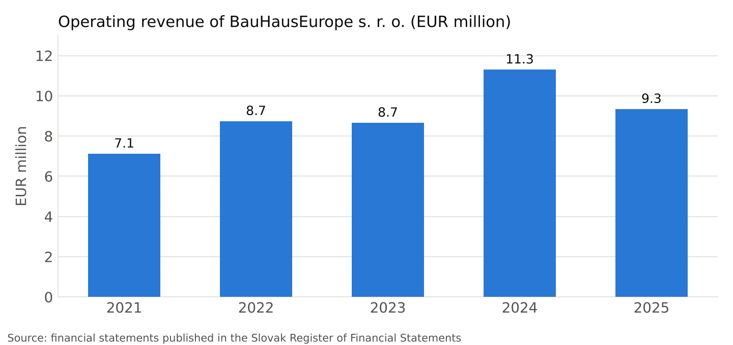
Chart 1 – Operating revenue 2021 – 2025
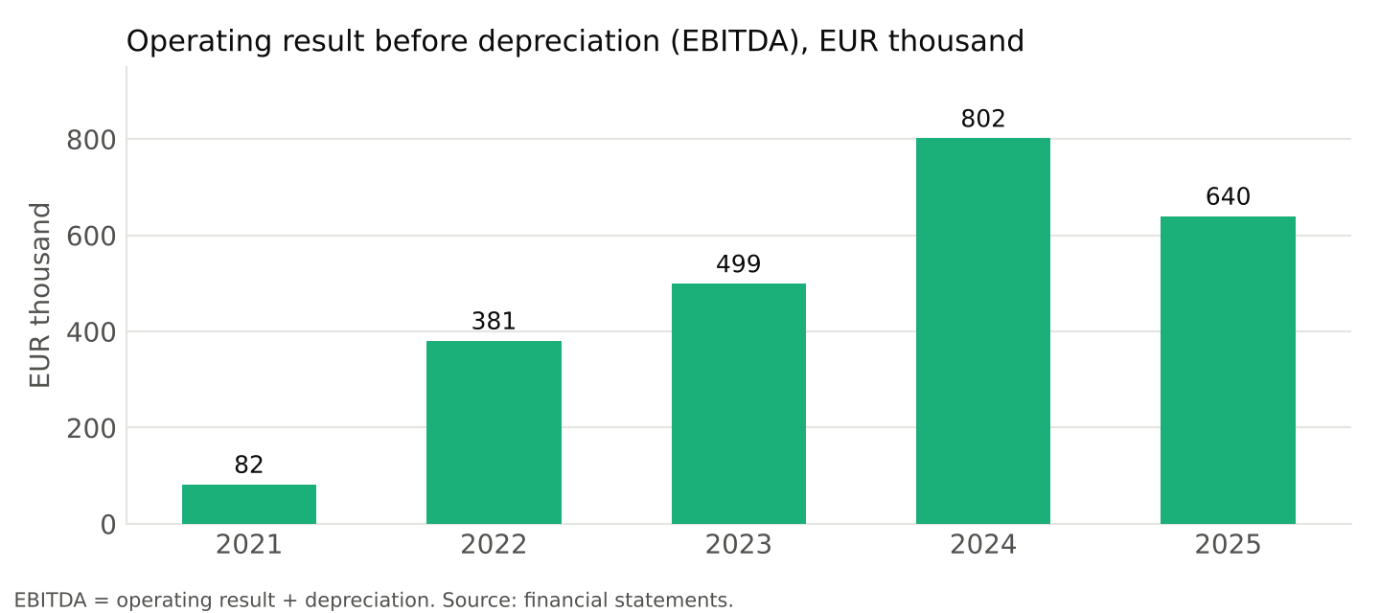
Chart 2 – EBITDA 2021 – 2025
The Company’s financial profile is characterised by: (i) a 5.4-fold growth of equity over five years without shareholder contributions, exclusively from retained earnings; (ii) stable operating profitability with an EBITDA margin of 5.8 – 7.1% over the last three years, which is above average in the construction subcontracting sector; (iii) minimal dependence on bank financing – current bank loans represent only 5% of the balance sheet total; (iv) assets in the form of real estate and construction equipment, which the Company depreciates on an ongoing basis and whose market value (see the expert appraisals in Section 4) significantly exceeds their book value.

3. Group Structure
The Group consists of three companies with the same owner and managing director. The Borrower under the Loan Agreement is exclusively BauHausEurope s. r. o.; the affiliated companies are the vehicles for specific real estate projects in which the Borrower may invest in accordance with § 2 Section 2.1(f) of the Agreement (investments in entities within the Borrower’s group).
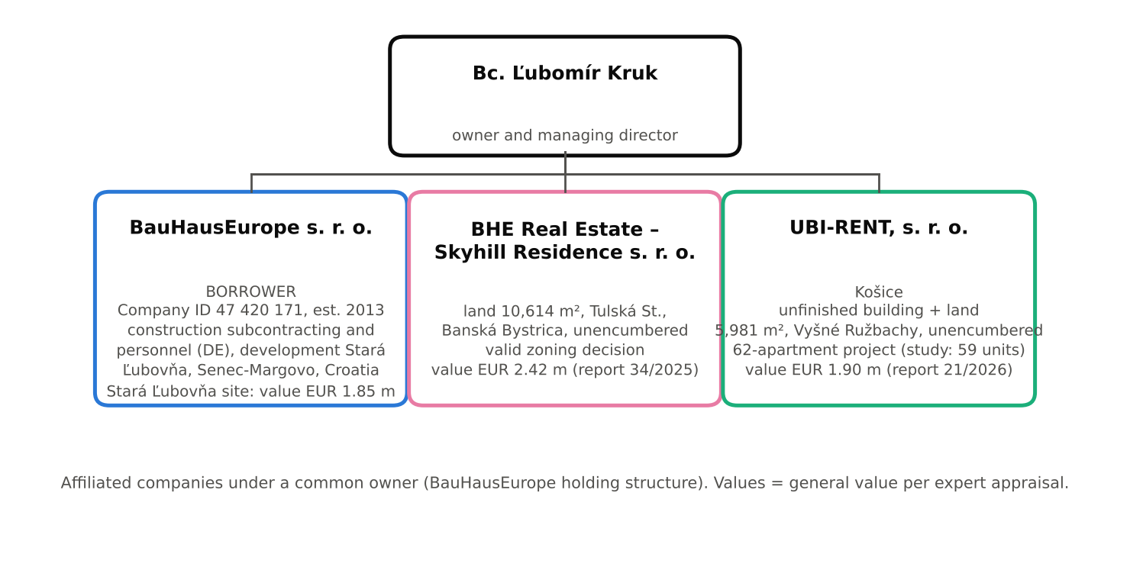
Figure 1 – Structure of the BauHausEurope Group
Company | Registered office | Role in the Group | Key assets
BauHausEurope s. r. o. (Borrower) | Konventná 9, Bratislava | operating and development company, contractor for Senec – Margovo and Croatia, owner of the Stará Ľubovňa site | site at Levočská 11, Stará Ľubovňa (10,789 m², 7 buildings), general value EUR 1,850,000
BHE Real Estate – Skyhill Residence s. r. o. | Levočská 363/29, 064 01 Stará Ľubovňa | project company for the Sky Hill Residence residential project in Banská Bystrica | land of 10,614 m², cadastral area Radvaň, Tulská St., Banská Bystrica, unencumbered, general value EUR 2,424,237.60
UBI-RENT, s. r. o. | Račí potok 47, 040 01 Košice | project company for the conversion of the building in Vyšné Ružbachy into apartments | unfinished recreational facility + land of 5,981 m², cadastral area Vyšné Ružbachy, unencumbered, general value EUR 1,900,000
General value = value determined by expert appraisal (Stará Ľubovňa: expert report No. 87/2024, Ing. Peter Repčák, 22 July 2024; Banská Bystrica: expert report No. 34/2025, Ing. Lucia Orosiová, 7 December 2025; Vyšné Ružbachy: expert report No. 21/2026, Ing. Slavko Sabol, 8 March 2026).

4. Overview of Projects and Investment Activities

4.1 River Residence – Multifunctional Residential Buildings “Stará Pekáreň”, Levočská 11, Stará Ľubovňa
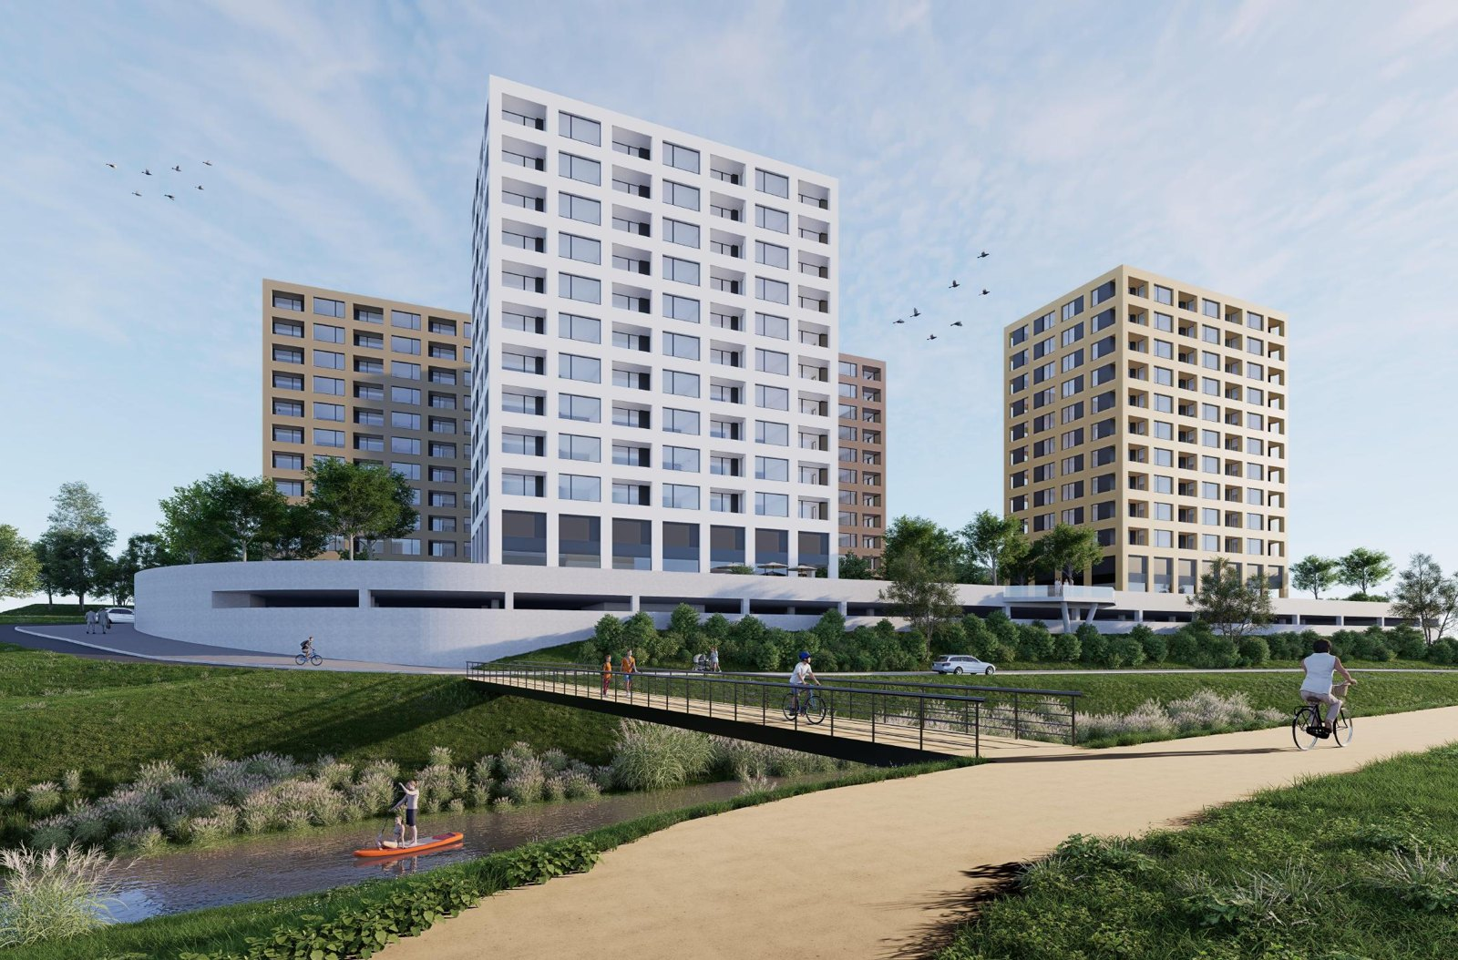
Figure 2 – River Residence Stará Ľubovňa: view from the Jakubianka river (visualisation, Harajčík Architekti, 3/2025)
Item | Detail
Project owner | BauHausEurope s. r. o. (owner of all plots, 1/1)
Land | plots KN-C No. 775/1 to 775/5, cadastral area Stará Ľubovňa, title deed No. 1382, total 10,789 m²; site of the former bakery between Levočská Street and the Jakubianka river in the built-up area of the town, close to the centre; acquired by purchase agreement (registration approved on 10 October 2022)
Existing buildings | three-storey administrative building, single-storey production hall, four-storey production and storage building, garages, boiler house, transformer station; own water, sewerage, gas and electricity connections; the site is currently partly leased
General value of the site | EUR 1,850,000 (expert report No. 87/2024, Ing. Peter Repčák, 22 July 2024), of which land EUR 628,675 (EUR 58.27/m²)
Architectural and urban study | “Multifunctional residential buildings Stará Pekáreň” (working name River Residence), HARAJČÍK ARCHITEKTI s. r. o., Trnava, Ing. arch. Juraj Harajčík, 03/2025
Concept | 4 residential buildings (A – D) on a shared two-level underground garage; multifunctional ground floor (supermarket – expected tenant Biedronka, kindergarten, restaurant and café, health centre, fitness and gyms), storage units for apartments on the 2nd floor, housing from the 3rd floor; each apartment with its own loggia; extensive green roofs, park, amphitheatre, playgrounds and sports areas by the river
Permitting status | valid zoning decision for residential construction; building permit documentation in preparation (engineering-geological and hydrogeological survey in progress); the town of Stará Ľubovňa is preparing a change of the zoning plan in the locality based on an urban study (SHARCH, Poprad) – the study is being adjusted accordingly from 12 to 8 above-ground storeys
Preliminary construction budget | EUR 24,000,000
Planned sales value | EUR 46,000,000 (apartments, multifunctional premises, parking spaces)
Planned gross difference (sales – budget) | EUR 22,000,000
Timeline | building permit 2027, construction 2027 – 2030 in phases (by individual buildings), apartment sales 2028 – 2031

Key figures according to the study of 03/2025 (12-storey variant):
Indicator | Value | Indicator | Value
Area of the site | 10,789 m² | Total floor area (1st – 12th floor) | 26,958 m² (FAR = 2.5)
Built-up area of buildings | 3,089 m² (BCR = 0.286) | Residential floor area (3rd – 12th floor) | 16,059.6 m²
Gross building volume | 152,676 m³ | Multifunctional / retail area (1st floor) | 2,153 m²
Greenery on the ground + green roofs | 4,229 m² + 2,836 m² (green ratio 0.42) | Underground garage (2 levels) | 19,074 m²
Building height above ground | 38.7 m | Parking spaces | 554 in garage + 23 at grade
Number of apartments | 240 | Number of storage units (2nd floor) | 240
Source: Accompanying report S.01 to the architectural and urban study, Harajčík Architekti, 29 March 2025. With the adjustment to 8 above-ground storeys, the number of apartments and the floor area will be reduced proportionately; the updated figures will form part of the building permit documentation.
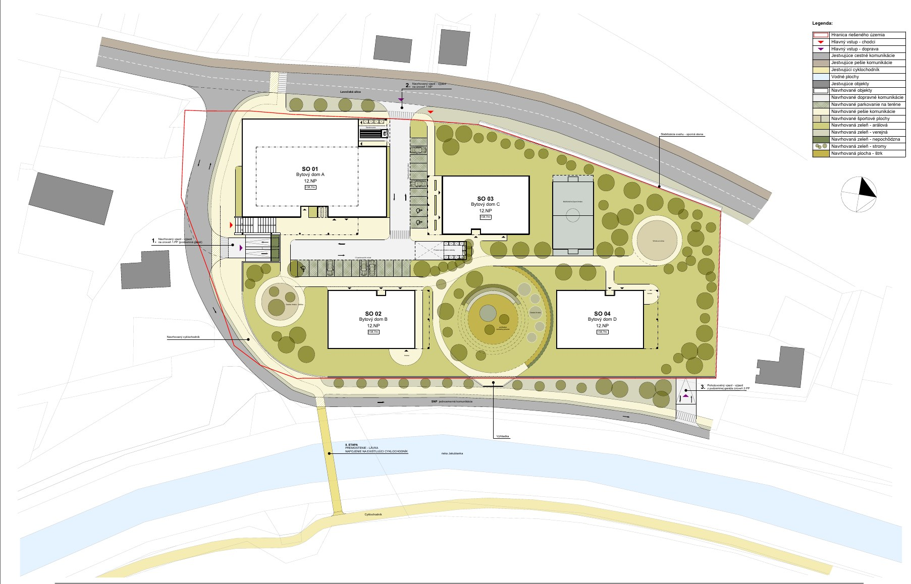
Figure 3 – Site plan of the design: 4 residential buildings, underground garage, park and amphitheatre by the river (drawing A.01)
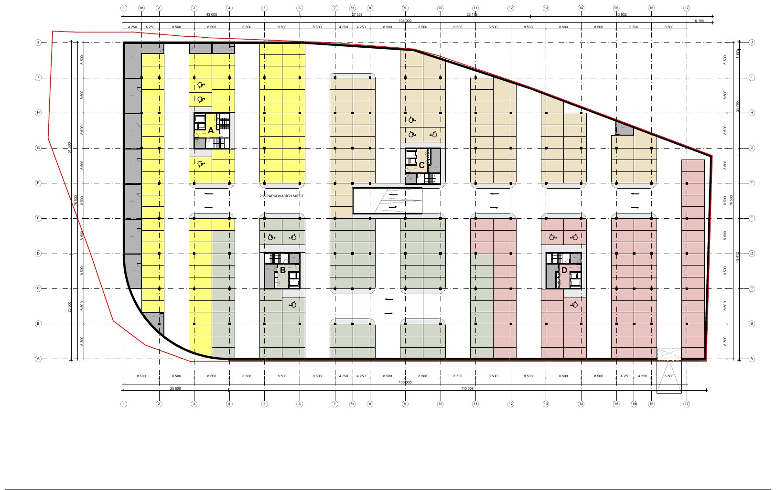
Figure 4 – Vertical sections and elevations, 12-storey variant (drawing A.06)
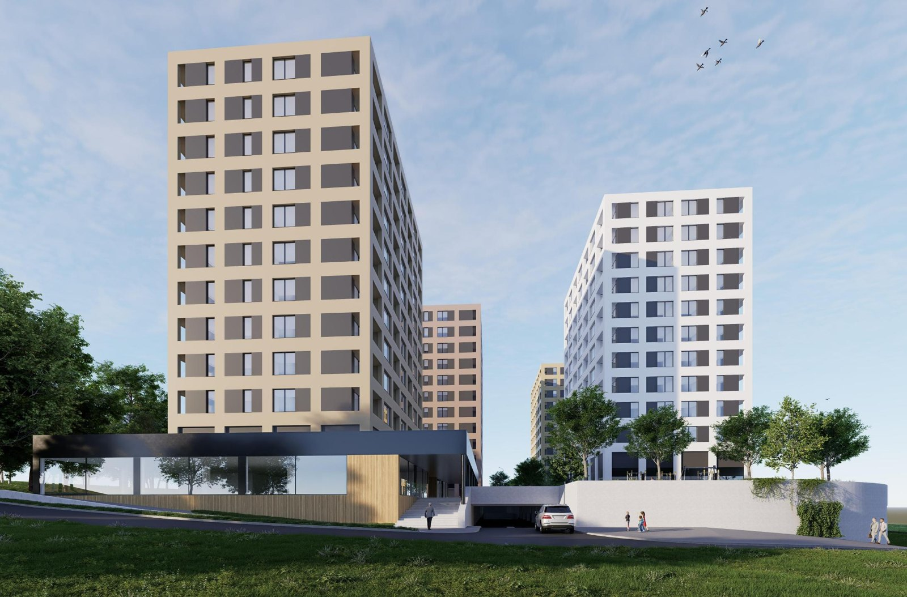 | 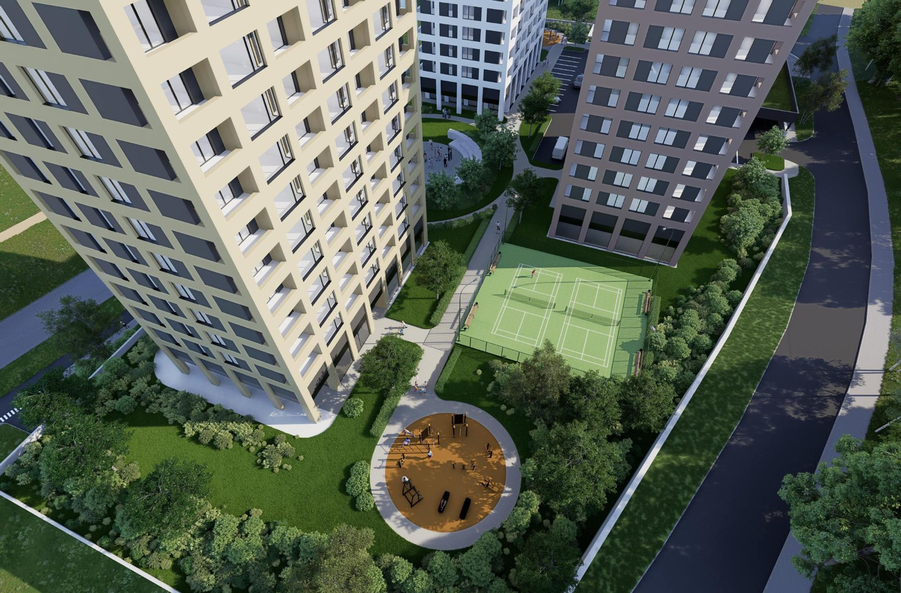
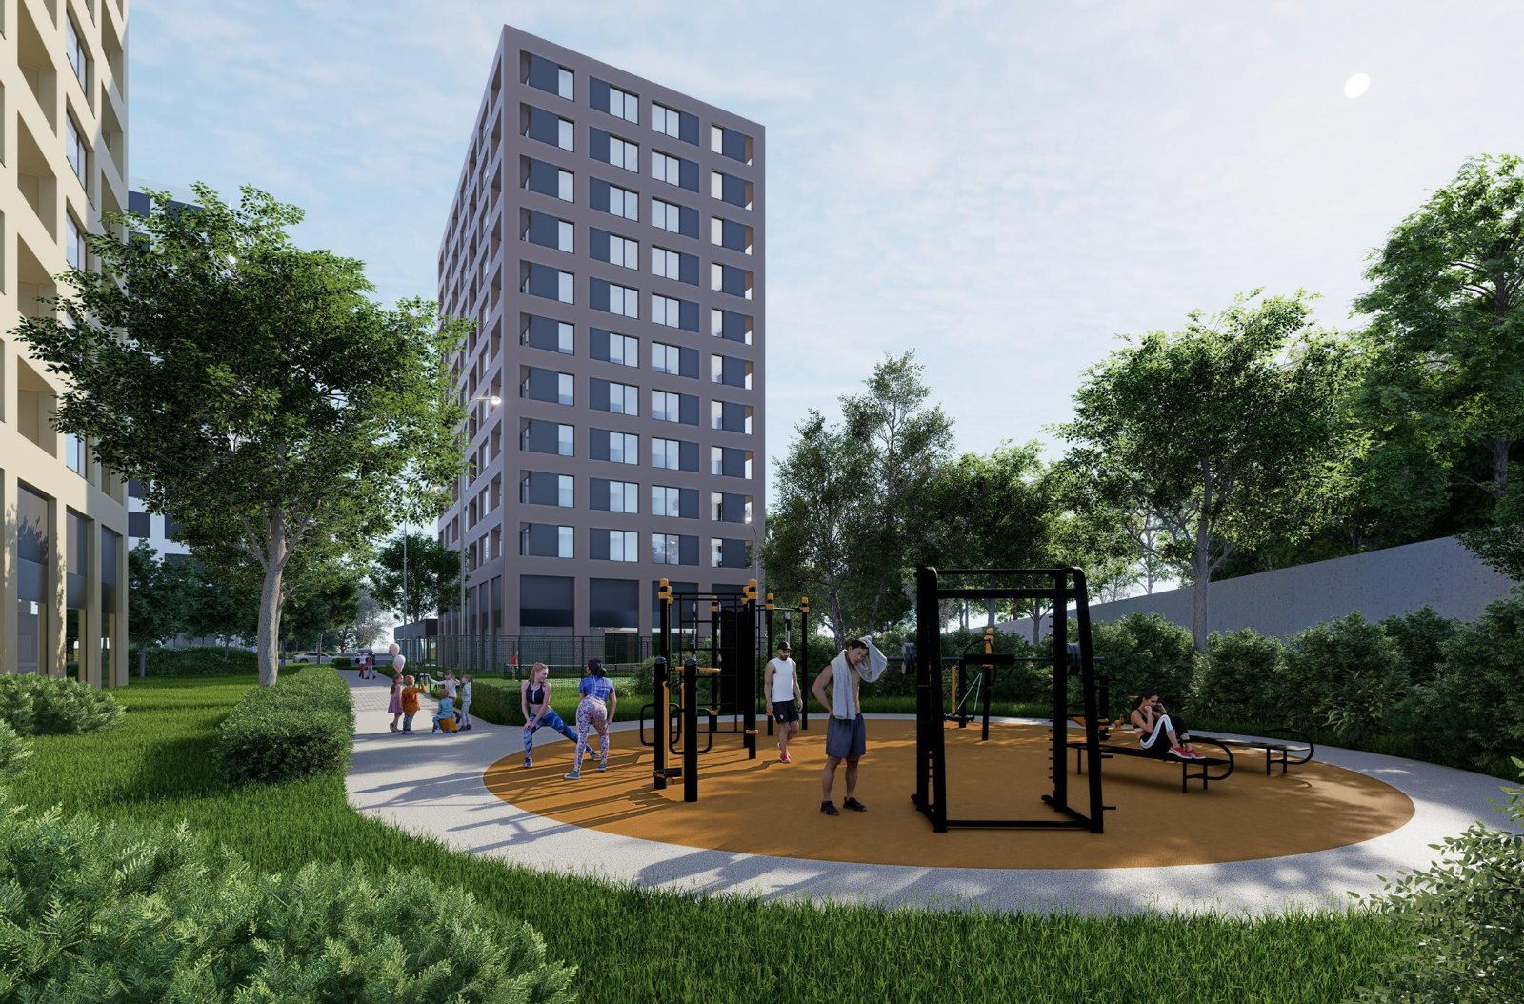 | 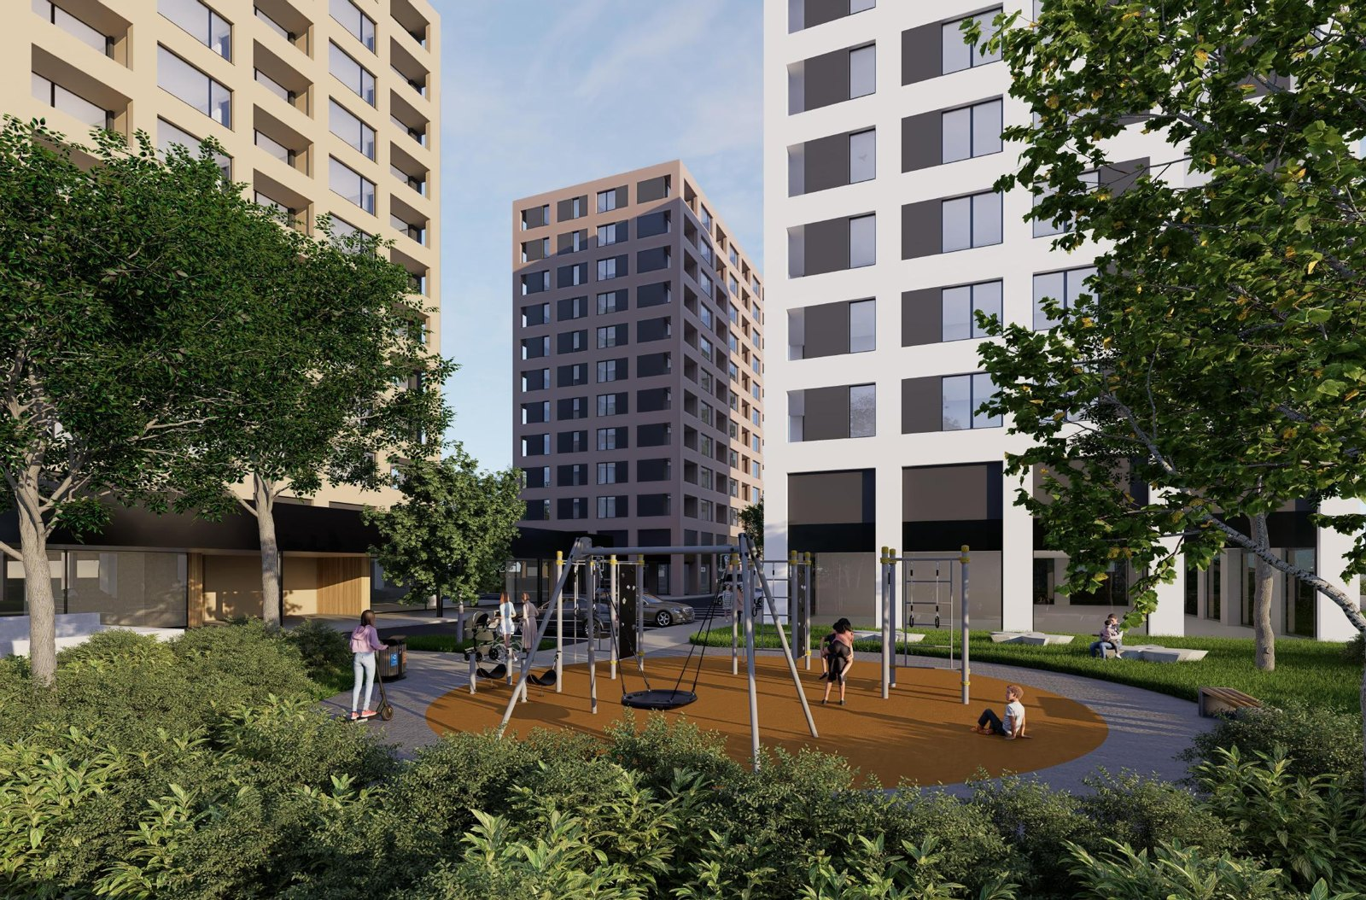
Figure 5 – Visualisations of the ground floor, courtyard and recreational areas (Harajčík Architekti)
This is the Group’s flagship project and the main source of loan repayment. Its advantage is that the land is already owned by the Company, has secured connection to all utility networks, and is located in the built-up area of a district town near the centre, in direct contact with the river and its embankment. The multifunctional ground floor with a supermarket, health centre and kindergarten increases the attractiveness of the housing as well as the value of the commercial premises, which can be leased on a long-term basis. Construction will be carried out using the Company’s own capacities (construction teams currently working in Germany) using a prefabricated wall system, which shortens construction time and reduces costs as well as the risk of subcontractor failures. The Company plans to divide construction into phases by individual buildings so that the sales of the first phase finance the subsequent phases; the loan funds will be used primarily for design preparation, the building permit, demolition works and the launch of the first phase.

4.2 Senec – Margovo: Construction of Utility Networks for a New Residential Zone
Item | Detail
Project | Senec Margovo (senecmargovo.sk) – a new residential district on 38 ha, approx. 2 km from the centre of Senec and 25 km from Bratislava, with fast access to the motorway
Scope of the zone | 835 apartments and family houses (detached houses, semi-detached houses, terraced houses, apartment buildings), kindergarten, primary school with 20 classrooms and a gym, retail zone with 2 multifunctional buildings, park with a lake of over 7,000 m², public transport stops and cycle paths
Company’s contract | construction of utility networks for the entire zone (roads, water mains, sewerage, gas, low-current networks)
Contract value | EUR 11,660,000 excl. VAT
Status | awaiting the building permit for roads; signing of the contract for work expected in 11/2026; execution 2027 – 2028
Further potential | after the launch of the networks, the Company will take part in the tender for the general contractor of the individual housing development in the zone – potential in the order of tens of millions of EUR beyond this plan (not included in the projections)

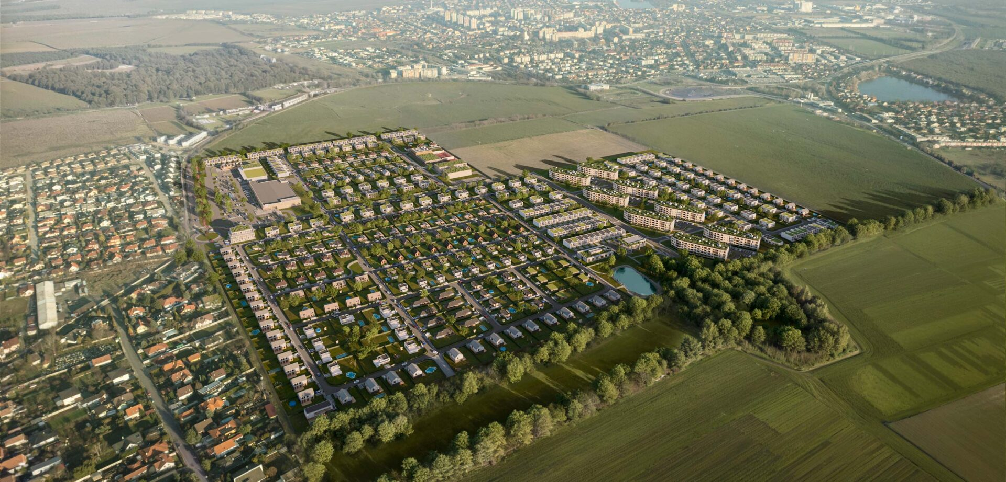
Figure 6 – Visualisation of the Senec – Margovo residential zone (source: senecmargovo.sk)
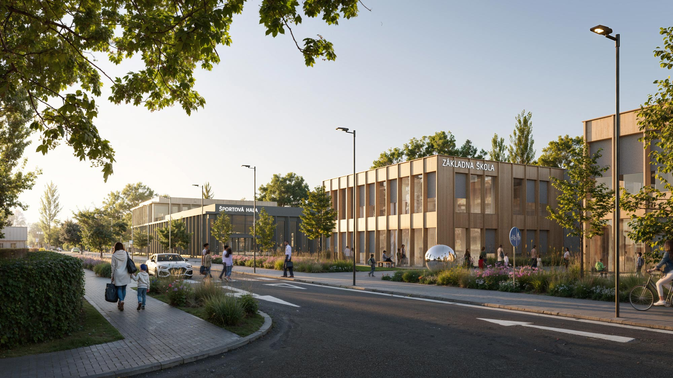 | 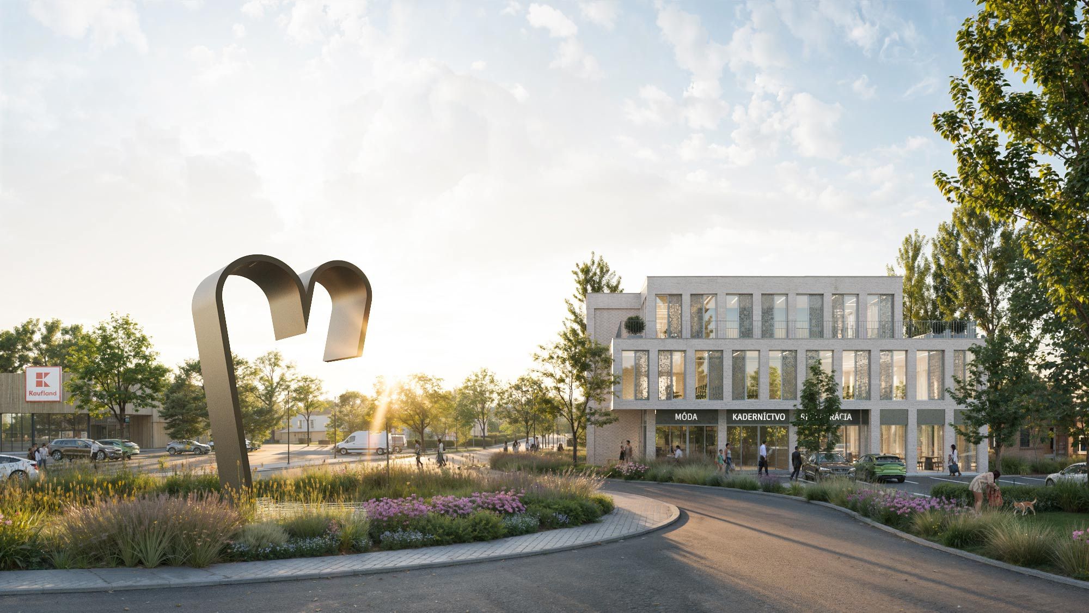
Figure 7 – Visualisations of the development in the Senec – Margovo zone (source: senecmargovo.sk)
The contract has a twofold significance for the Group: it generates an operating margin already in 2027 – 2028 (management estimate 10 – 12% of the contract value) and at the same time opens the way to obtaining the position of general contractor for the construction of the houses themselves, where the Company can fully utilise its construction capacities. The loan funds will serve to pre-finance works, guarantees, and the purchase of equipment and materials before the first invoicing.

4.3 Croatia: Construction of 27 Apartments
Item | Detail
Entity | BauHausEurope s. r. o.
Scope | construction of a residential building with 27 apartments
Project value | EUR 4,330,000 excl. VAT
Status | the Company is launching construction; execution 2027 – 2028
Significance | entry into the growing Croatian market for holiday properties using the Company’s own construction teams; reference project for further contracts in the region

4.4 Sky Hill Residence – Land on Tulská Street, Banská Bystrica (BHE Real Estate – Skyhill Residence s. r. o.)
Item | Detail
Owner | BHE Real Estate – Skyhill Residence s. r. o. (company affiliated with the Borrower), share 1/1
Land | plots No. 774/1 (3,668 m²), 2060/226 (2,294 m²), 2060/236 (302 m²), 788/1 (3,426 m²), 789/1 (924 m²); cadastral area Radvaň, municipality of Banská Bystrica, title deeds No. 3478, 3915, 3916, 4656; total 10,614 m²
Encumbrances | none (according to the title deed extracts as at 5 December 2025)
Zoning conditions | land designated by the zoning plan for the construction of apartment buildings (viewpoint part of the Fončorda housing estate); valid zoning decision for the construction of residential units; connection to all utility networks possible, public transport stop nearby
General value | EUR 2,424,237.60 (EUR 228.40/m²) – expert report No. 34/2025, Ing. Lucia Orosiová, 7 December 2025
Intention | Sky Hill Residence residential project – apartment buildings with a view of the city; 2027 – 2028 design preparation and building permit, followed by construction using own capacities or with a partner

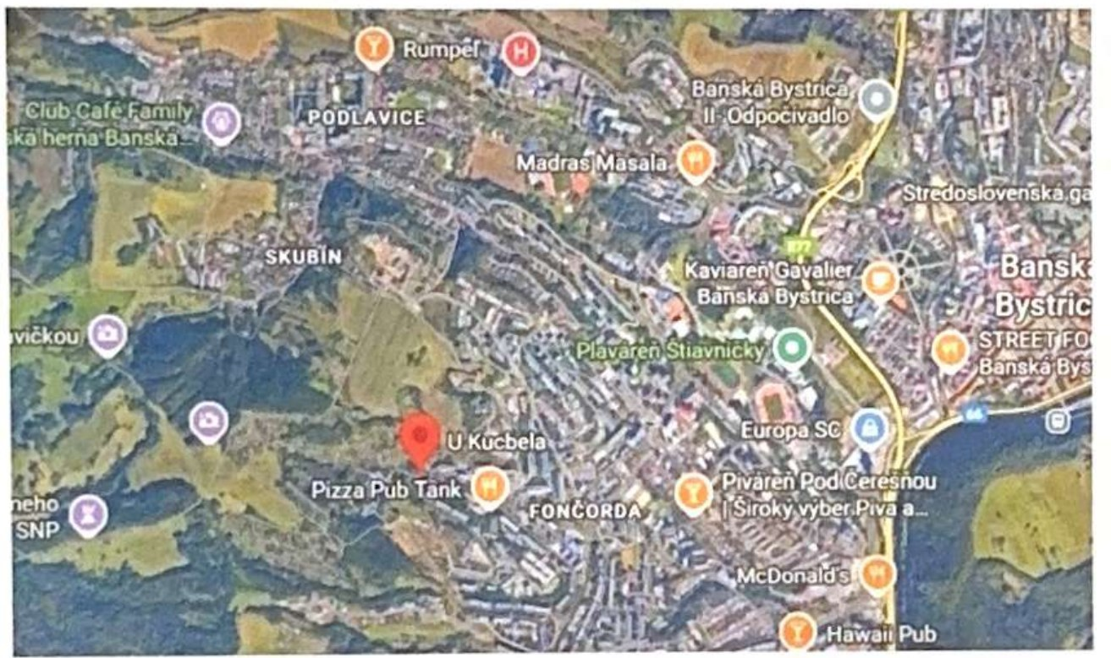
Figure 8 – Location of the Sky Hill Residence land in Banská Bystrica (source: expert report No. 34/2025)
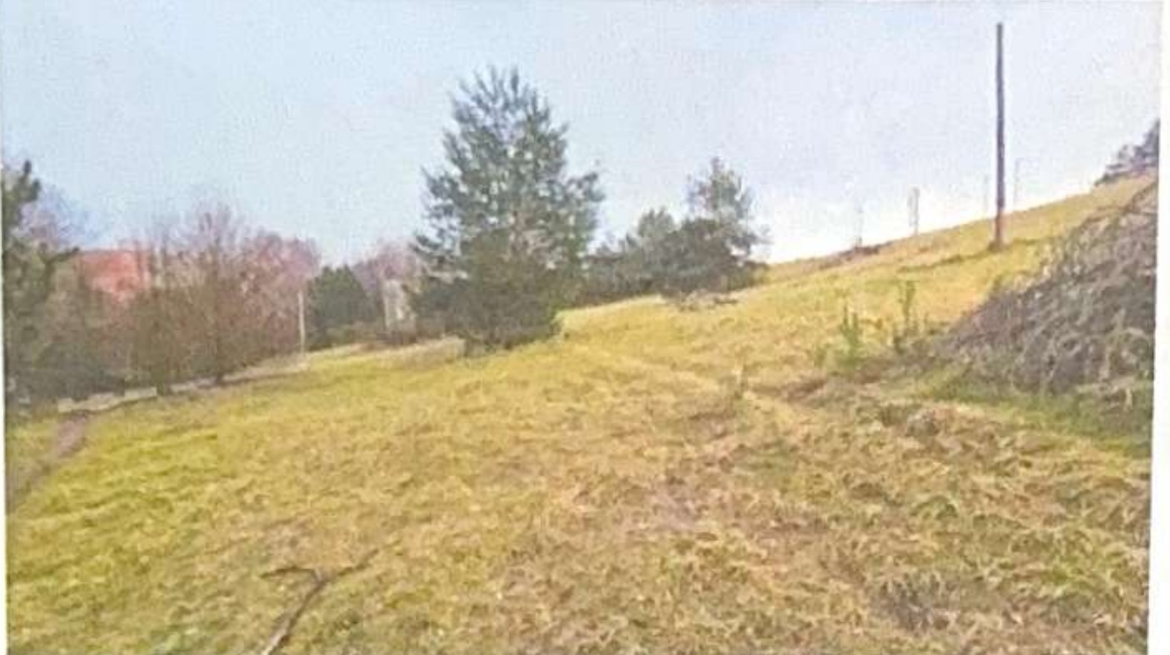 | 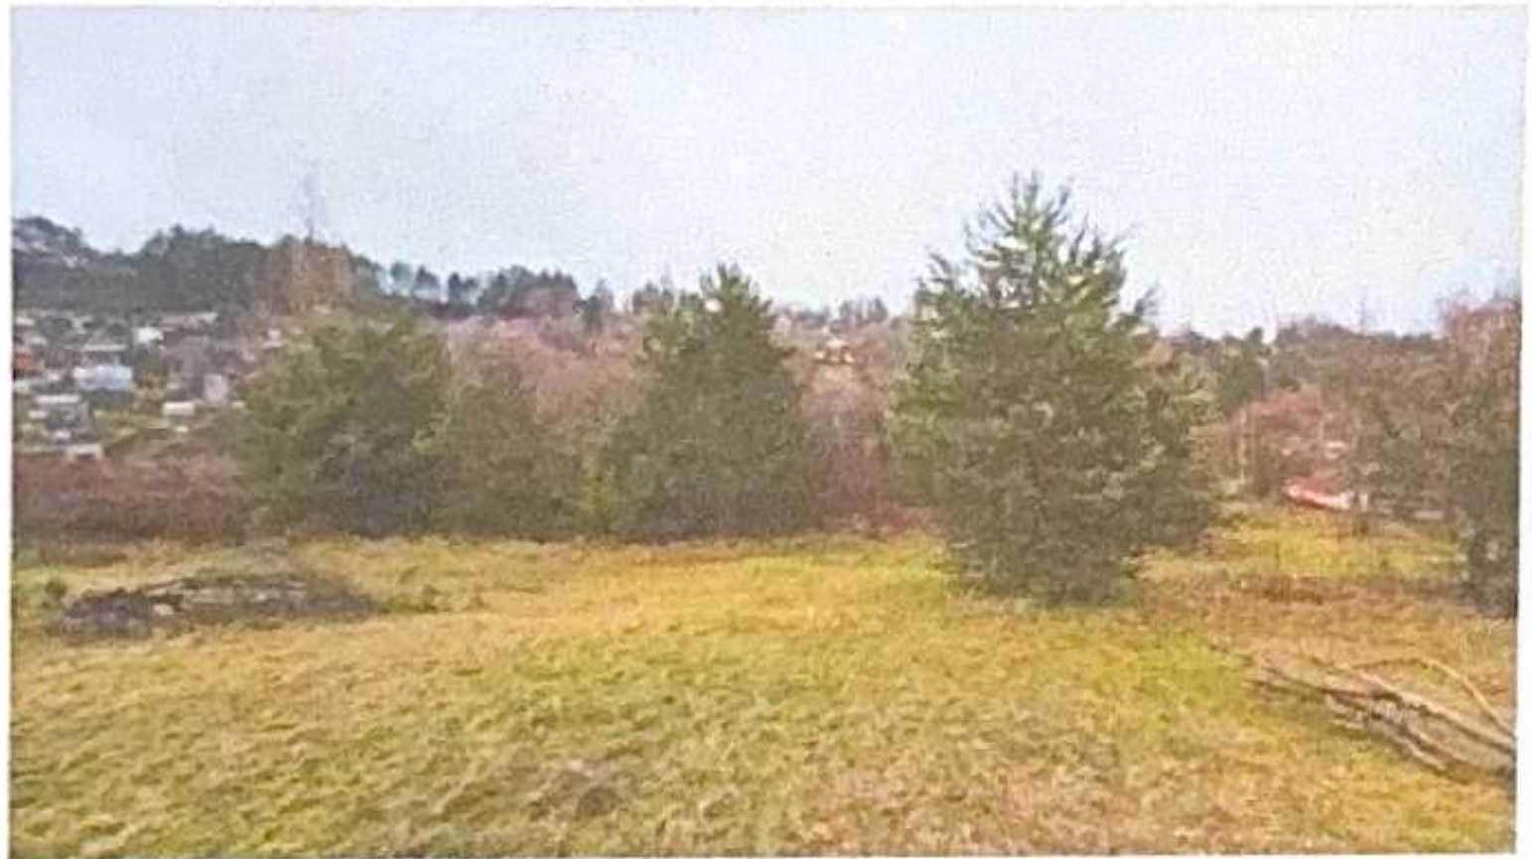
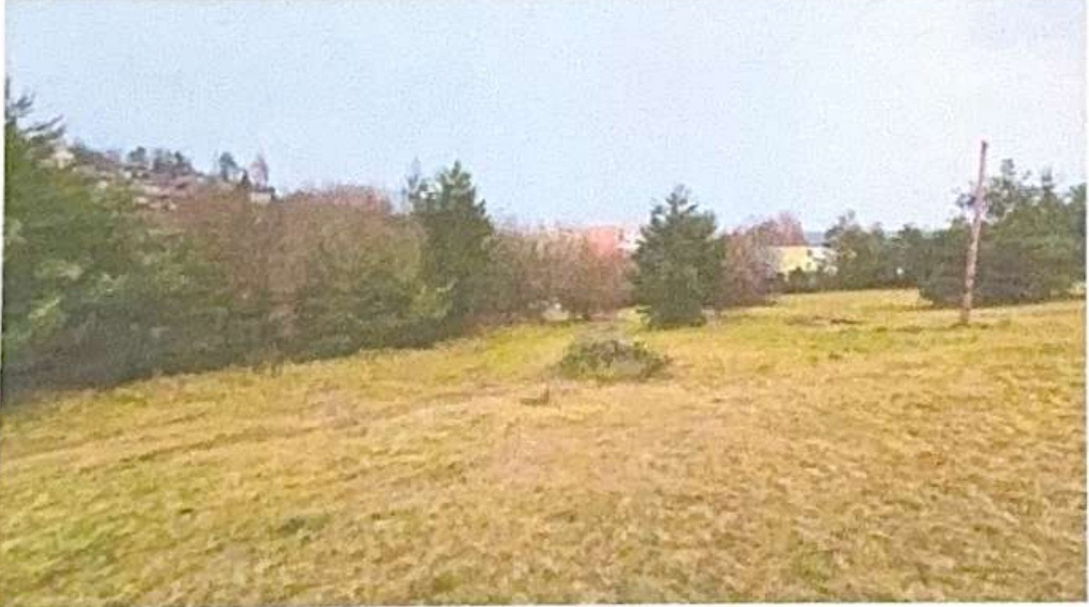 | 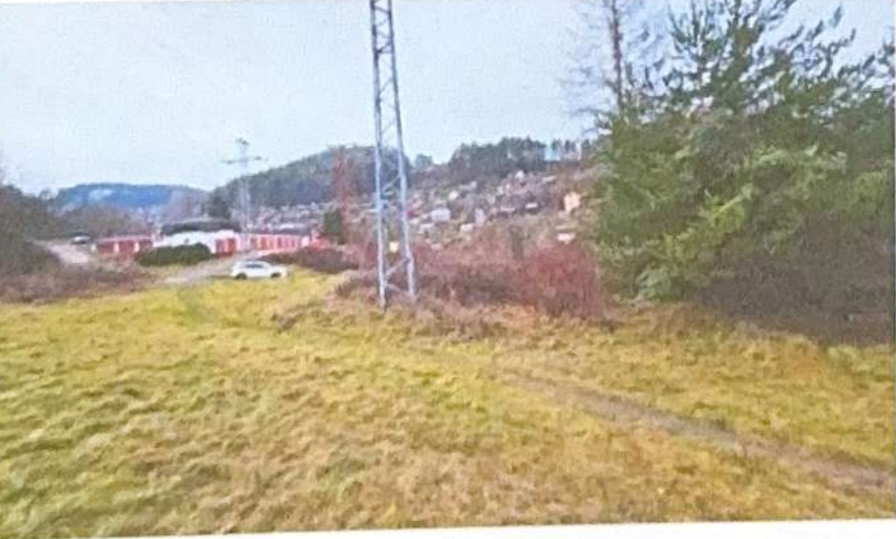
Figure 9 – Land on Tulská Street, Banská Bystrica (expert’s photo documentation, 7 December 2025)
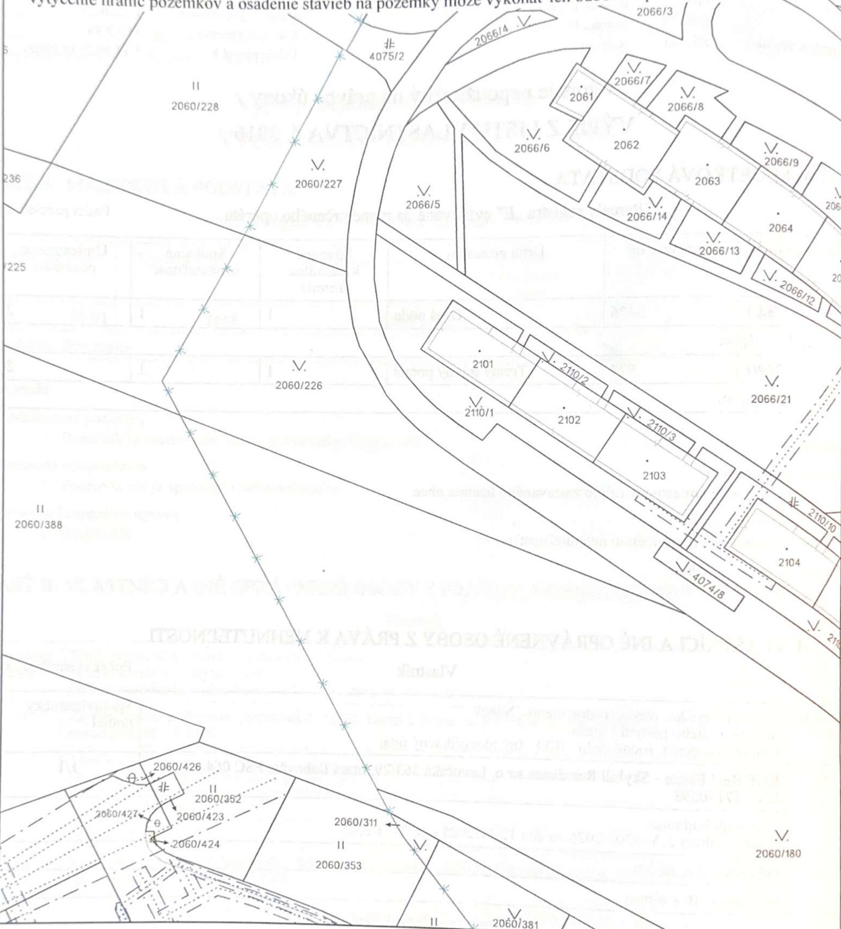
Figure 10 – Copy of the cadastral map, plot 2060/226 and surroundings (source: expert report No. 34/2025)

4.5 Vyšné Ružbachy – Conversion of an Unfinished Building into 62 Apartments (UBI-RENT, s. r. o.)
Item | Detail
Owner | UBI-RENT, s. r. o., Račí potok 47, 040 01 Košice (company affiliated with the Borrower); acquired by purchase agreements of 7 April 2025 and 5 June 2025
Property | unfinished recreational facility on plot CKN No. 2430/2 with accessories, and land plots CKN No. 2430/1 (4,218 m²) and 2430/2 (1,763 m²), total 5,981 m², cadastral area Vyšné Ružbachy, title deed No. 1274, district of Stará Ľubovňa
Encumbrances | none
Building characteristics | prefabricated reinforced concrete frame with aerated concrete envelope, 1 basement and 6 above-ground floors, two passenger lifts, own water, sewerage, gas and electricity connections; building enclosed, basic structural lifespan 80 – 100 years
General value | EUR 1,900,000 (buildings EUR 1,413,851.89, land EUR 485,956.25) – expert report No. 21/2026, Ing. Slavko Sabol, 8 March 2026
Preparation status | the municipality of Vyšné Ružbachy issued its statement on the change of use to residential premises on 17 February 2026; layout study of the conversion prepared (April 2026); after the investment, start of the building permit design and construction
Intention | conversion into an apartment building with approx. 62 residential units (according to the study 59 apartments on the basement to 5th floor, with a reserve on the 6th floor), intended for sale and partly for lease in the spa village of Vyšné Ružbachy

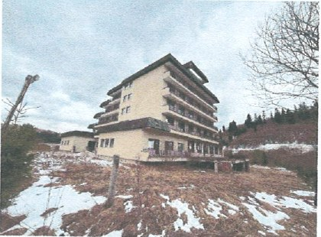 | 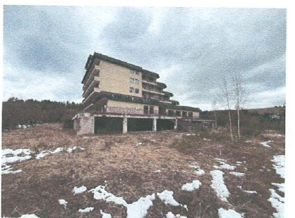
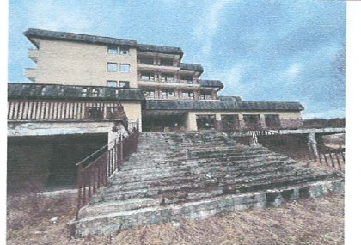 | 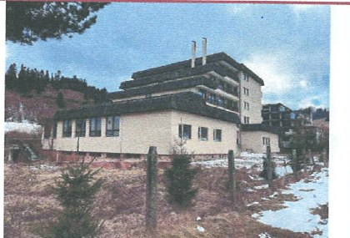
Figure 11 – Unfinished building in Vyšné Ružbachy (expert’s photo documentation, 2/2026)
The layout study of the conversion (April 2026) resolves the individual floors as follows:
Floor | No. of apartments | Mix | Apartment area (m²) | Non-residential areas (m²)
Basement | 16 | 1× 1-room, 8× 2-room, 6× 3-room, 1× 4-room | 978.85 | 606.76 (cellars 292.72; common 314.04)
1st floor | 13 | 2× 1-room, 9× 2-room, 1× 3-room, 1× 4-room | 757.33 | 232.97 (cellars 73.48; common 159.49)
2nd floor | 9 | 2× 1-room, 6× 2-room, 1× 3-room; balconies 64.53 | 482.30 | 77.67
3rd floor | 8 | 2× 1-room, 5× 2-room, 1× 3-room; balconies 64.53 | 421.04 | 77.67
4th floor | 7 | 2× 1-room, 4× 2-room, 1× 3-room; balconies 55.26 | 365.00 | 71.10
5th floor | 6 | 2× 1-room, 3× 2-room, 1× 3-room; balconies 45.98 | 307.34 | 64.53
Total | 59 |  | 3,311.86 | 1,130.70
Source: Floor plans and apartment schedule, conversion study (4/2026). The target of 62 apartments will be achieved by utilising the 6th floor and optimising the layouts in the building permit design.
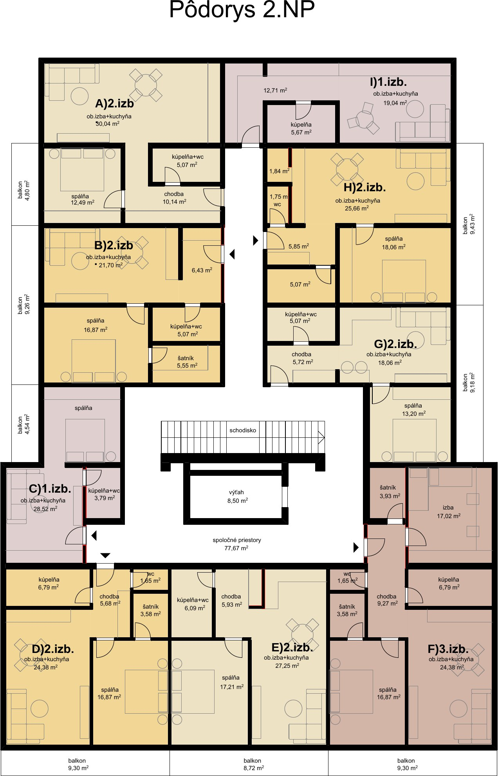 | 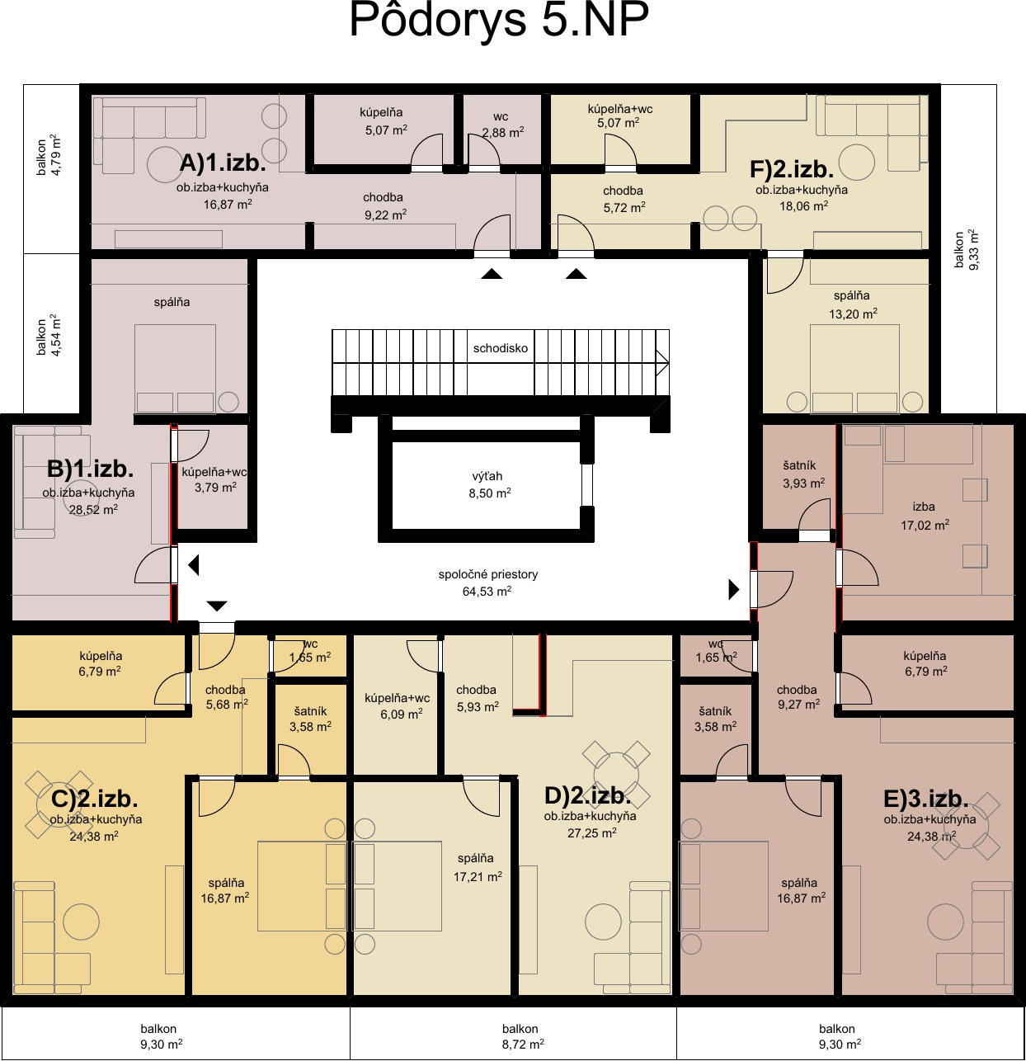
Figure 12 – Floor plans of the 2nd and 5th floors according to the layout study
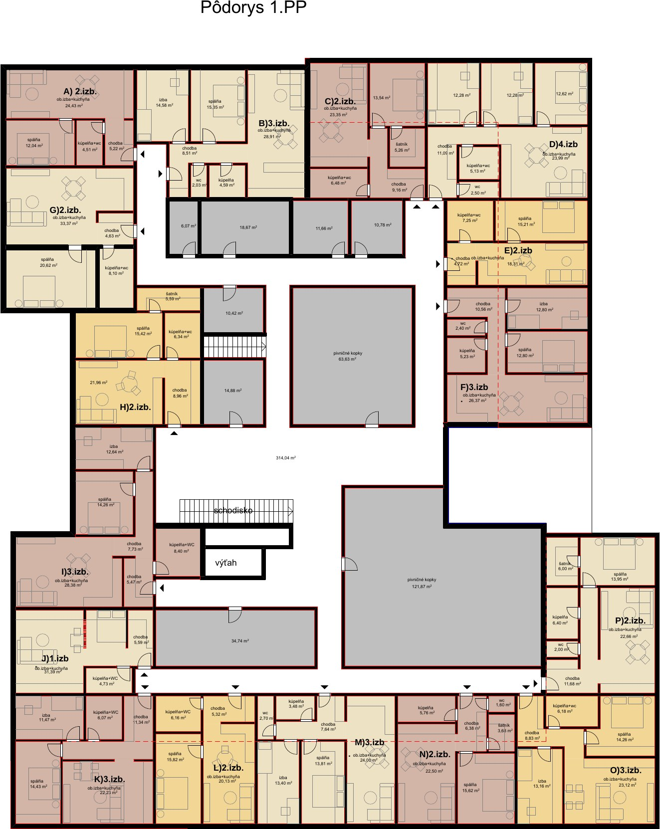
Figure 13 – Basement floor plan (16 apartments, cellars, common areas)
At a conservative average sales price of EUR 1,900 – 2,100/m² and a usable area of approx. 3,500 m² (after adding the 6th floor), the project has a sales potential of EUR 6.5 – 7.5 m against estimated conversion costs of EUR 4.0 – 4.5 m. The advantages are the completed load-bearing structure, existing utility connections and unencumbered ownership, which allow a quick start.

4.6 Innovation: IT Systems, Artificial Intelligence and Construction Robotics
The Company intends to invest approximately 20% of the loan funds in innovations that will speed up work, improve management and the economics of the company, and prepare it for rising labour costs in construction. The Company began modernising its internal IT systems in 2026 from its own resources; the loan funds will allow the programme to be completed and extended to artificial intelligence and robotics:
- Internal IT systems and digitalisation: roll-out under way since 2026 – a unified ERP and project system for managing contracts, attendance and the secondment of workers to Germany, electronic document and invoicing workflow, mobile applications for site managers (logs, reports, photo documentation), BIM and digital budgeting; completion and extension in 2027.
- Artificial intelligence: automated processing of bills of quantities and budgets, capacity planning and deployment of workers, review of contracts and German documentation, recruitment and administration of workers, real-time project cost analytics.
- Construction robotics: pilot deployment of robots for painting, laying tiles on large areas and installing drywall partitions, which are already offered by manufacturers from China; with rising labour costs in Germany and Slovakia, this is an opportunity to increase the productivity and margin of subcontracting. Evaluation and pilot planned for 2027 – 2028, deployment on own projects (Stará Ľubovňa, Vyšné Ružbachy) and subsequently for German customers.
Approximately 20% of the loan principal is allocated to IT systems and innovation (see Section 5), to be drawn in 2026 – 2029; investments will be assessed on the basis of their return and prioritised so as to directly reduce the costs of ongoing projects.

5. Planned Use of the Loan Funds
The use of funds corresponds to the purposes under § 2 Section 2.1 of the Agreement. The allocation is indicative; the specific use is decided by the Borrower (Section 2.3 of the Agreement). The percentages relate to the total amount of the principal.
Purpose (reference to § 2.1 of the Agreement) | Share | Specific use
Acquisition, construction and reconstruction of real estate (c), investments in the group (f) | 35% | design documentation and building permits (Stará Ľubovňa, Vyšné Ružbachy, Sky Hill), demolition and preparatory works, launch of the first construction phase in Stará Ľubovňa
Operating funds / working capital (a) | 25% | pre-financing of works and materials for the Senec – Margovo and Croatia contracts, guarantees and retentions, bridging the payment terms of German customers’ invoices
Machinery, equipment and technology (b) | 10% | construction machinery for utility network construction, formwork, scaffolding, vehicles; pilot robotic equipment
Innovation, development and digitalisation (g) | 20% | IT systems (ERP, project management, mobile applications, BIM) rolled out since 2026, AI tools, pilot deployment of construction robotics
Personnel costs and team development (e), expansion (d) | 5% | strengthening of the project and sales team for development and the Croatian market
Reserve for unforeseen expenses (h) | 5% | liquidity reserve of the Group

6. Financial Plan and Sources of Loan Repayment

6.1 Group Revenue Outlook 2026 – 2031
The outlook is based on the results achieved in 2021 – 2025, on contracted and ongoing orders, and on the planned development projects. It is a management estimate in EUR million (excl. VAT); projects that do not yet have a signed contract (general contractor for the Senec – Margovo housing development, Sky Hill Residence) are not included in the outlook and represent additional potential.
Segment (EUR million) | 2026 | 2027 | 2028 | 2029 | 2030 | 2031
Construction subcontracting and workers – Germany | 9.0 | 9.5 | 10.0 | 10.5 | 11.0 | 11.5
Senec – Margovo: utility networks | – | 5.0 | 6.7 | – | – | –
Croatia: 27 apartments | – | 2.0 | 2.3 | – | – | –
Stará Ľubovňa: apartment sales (EUR 46.0 m in total) | – | – | – | 12.0 | 18.0 | 16.0
Vyšné Ružbachy: sale / lease of apartments | – | – | – | 3.5 | 3.5 | –
Total Group revenue | 9.0 | 16.5 | 19.0 | 26.0 | 32.5 | 27.5

6.2 Sources for Repayment of Principal and Interest
The principal and interest are payable in a single payment five years after the Drawdown Date (assumption: drawdown at the end of 2026 / beginning of 2027, maturity at the end of 2031 / beginning of 2032). The main sources of repayment are listed in the order in which they arise:
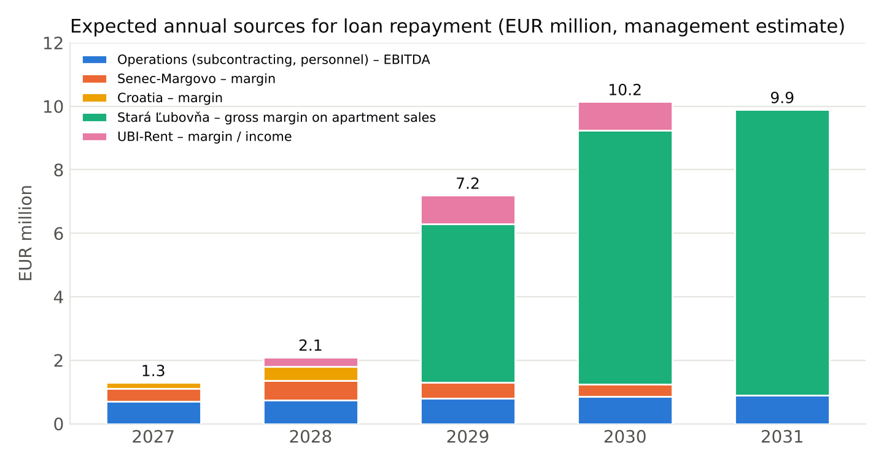
Chart 3 – Expected annual sources for loan repayment (management estimate)
Source | Period | Estimate (EUR m) | Assumption
EBITDA from operations (subcontracting and workers, Germany) | 2027 – 2031 | 4.0 | EBITDA margin of 7 – 8% on revenue of EUR 9.5 – 11.5 m per year (level of 2024 – 2025)
Margin on the Senec – Margovo contract (utility networks) | 2027 – 2030 | 1.9 | 10 – 12% of EUR 11.66 m including finishing works
Margin on the Croatia project | 2027 – 2028 | 0.65 | 15% of EUR 4.33 m
Gross margin on apartment sales in Stará Ľubovňa | 2029 – 2031 | 22.0 | sales EUR 46.0 m – budget EUR 24.0 m
Margin / income from the Vyšné Ružbachy project | 2028 – 2030 | 2.1 | sales potential EUR 6.5 – 7.5 m – costs EUR 4.0 – 4.5 m
Total sources within the maturity horizon | 2027 – 2031 | 30.65 | before income tax and before reinvestment

6.3 Loan Amount Scenarios and Coverage of the Obligation
Under § 4 of the Agreement, interest is simple (not capitalised), so the total amount repayable after 5 years is 135% of the principal and, if the 3-year extension option is used, 156% of the principal. The following table shows the obligation and its coverage for different principal amounts:
Principal (EUR) | Interest over 5 years (EUR) | Amount payable after 5 years (EUR) | Amount payable after 8 years (EUR) | Coverage by sources 2027 – 2031 (EUR 30.65 m) | Coverage by appraised real estate (EUR 6.17 m)
1,000,000 | 350,000 | 1,350,000 | 1,560,000 | 22.7× | 4.6×
2,000,000 | 700,000 | 2,700,000 | 3,120,000 | 11.4× | 2.3×
3,000,000 | 1,050,000 | 4,050,000 | 4,680,000 | 7.6× | 1.5×
5,000,000 | 1,750,000 | 6,750,000 | 7,800,000 | 4.5× | 0.9×
Coverage by real estate is stated for information only – under § 1 Section 1.3 of the Agreement the loan is unsecured. General values: Stará Ľubovňa EUR 1.85 m (site with a bank lien as at 7/2024), Banská Bystrica EUR 2.42 m (unencumbered), Vyšné Ružbachy EUR 1.90 m (unencumbered).
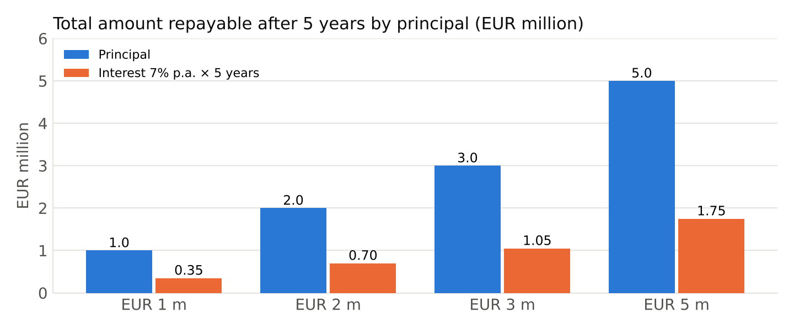
Chart 4 – Total amount repayable after 5 years by principal
Even in a conservative scenario in which the Stará Ľubovňa development project were delayed by two years and the Group had only the operating EBITDA, the margins on the Senec – Margovo and Croatia contracts and the income from Vyšné Ružbachy (approx. EUR 8.6 m in total) at its disposal, the loan obligation up to a principal of EUR 5 m remains fully covered. The option to extend maturity by 3 years (§ 5 Section 5.4) and the possibility of early repayment without penalty (§ 5 Section 5.3) give the Borrower the flexibility to adapt repayment to the actual progress of the projects.

7. Implementation Timeline
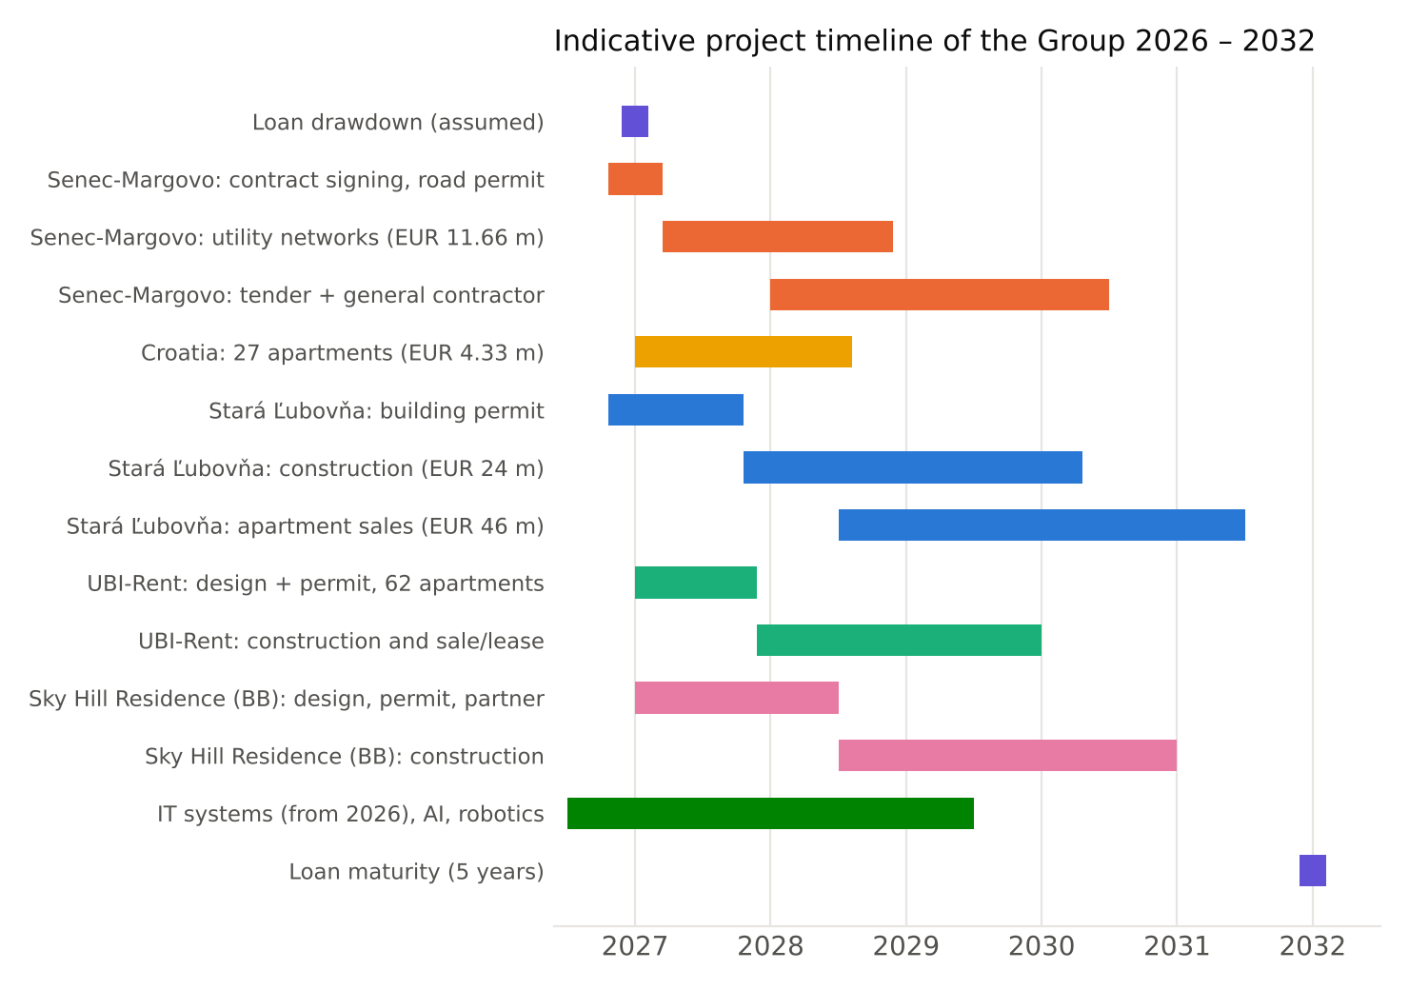
Chart 5 – Indicative project timeline of the Group 2026 – 2032
Period | Milestones
Q4 2026 | signing of the Loan Agreement and fulfilment of the conditions under § 6; signing of the Senec – Margovo contract for work (11/2026); building permit design for Stará Ľubovňa; ongoing roll-out of new IT systems
2027 | loan drawdown; start of construction of the Senec – Margovo utility networks and the Croatia project; building permit for Stará Ľubovňa; design and building permit for Vyšné Ružbachy; design preparation of Sky Hill Residence; completion of IT systems and introduction of AI tools
2028 | completion of the Senec – Margovo networks and the Croatian apartments; participation in the tender for general contractor of the housing development; construction of phase 1 in Stará Ľubovňa; conversion in Vyšné Ružbachy; construction robotics pilot
2029 | sales of phase 1 apartments in Stará Ľubovňa; completion and sale of the Vyšné Ružbachy apartments; building permit for Sky Hill Residence
2030 | construction and sale of further phases in Stará Ľubovňa; construction of Sky Hill Residence
2031 – 2032 | sale of the remaining apartments in Stará Ľubovňa; repayment of principal and interest on the Maturity Date (or earlier under Section 5.3)

8. Risks and Their Management
Risk | Mitigation
Delay of building permits (Stará Ľubovňa, Vyšné Ružbachy, Sky Hill) | the projects are at different stages and in different locations, which spreads the risk; zoning decisions are valid; in the event of delay, the maturity extension option (§ 5.4) will be used
Decline in demand or apartment prices | phased construction and pre-sales before the next phase; conservative sales prices in the plans; possibility of partial leasing (Vyšné Ružbachy)
Increase in construction costs | construction using own capacities, long-term relationships with material suppliers, reserves in budgets, robotisation of selected trades
Postponement of the Senec – Margovo contract signing | the contract is tied to the building permit for roads, which is in process; operations in Germany cover the Group’s fixed costs independently of this contract
Dependence on the German construction market | diversification into development and utility networks in Slovakia and into Croatia; several German customers
Liquidity and timing mismatch between income and expenditure | single bullet maturity without ongoing instalments; 5% reserve from the loan; possibility of early repayment in the event of earlier sales
Key person risk | strengthening of the project team from the loan funds; digitalisation of processes reduces dependence on individuals

9. Conclusion
The BauHausEurope Group is entering a period in which its long-built asset base (real estate appraised at EUR 6.17 m) and its operating experience from the German market will translate into its own development projects with a planned sales value of over EUR 50 m. The loan from GR Construction AB with a five-year bullet maturity precisely matches the investment cycle of these projects. The Borrower is convinced that the sources generated within the maturity horizon will exceed the loan obligation including interest several times over, and undertakes to provide the Lender with information to the extent set out in § 8 of the Agreement.
Pursuant to Section 2.2 of the Agreement, this business plan is of an informative nature. The estimates of revenue, margins and timelines are management estimates as at the date of preparation and will be updated on an ongoing basis.

List of Source Documents
- Expert report No. 87/2024 (Ing. Peter Repčák, 22 July 2024) – operating buildings with accessories and land, Levočská 11, Stará Ľubovňa
- Expert report No. 34/2025 (Ing. Lucia Orosiová, 7 December 2025) – land on Tulská Street, cadastral area Radvaň, Banská Bystrica, including extracts from title deeds No. 3478, 3915, 3916 and 4656 and a copy of the cadastral map
- Expert report No. 21/2026 (Ing. Slavko Sabol, 8 March 2026) – unfinished recreational facility and land, cadastral area Vyšné Ružbachy, including an extract from title deed No. 1274
- Architectural and urban study “Multifunctional residential buildings Stará Pekáreň” / River Residence Stará Ľubovňa (HARAJČÍK ARCHITEKTI s. r. o., 03/2025) including accompanying report S.01
- Floor plans and apartment schedule – layout study of the conversion of the Vyšné Ružbachy building (4/2026)
- Financial statements of BauHausEurope s. r. o. for 2021 – 2025 (Register of Financial Statements of the Slovak Republic)
- Information on the Senec – Margovo project (senecmargovo.sk)
In Bratislava, on ____________
______________________________
BauHausEurope s. r. o.
Bc. Ľubomír Kruk, managing director

