
LAND OFFER FOR A RETAIL PARK
Stará Pekáreň site, Levočská 11, Stará Ľubovňa (Slovakia)
Sale of a 10,789 m² plot at the main entrance to a district town – retail park with a grocery anchor, turnkey construction available
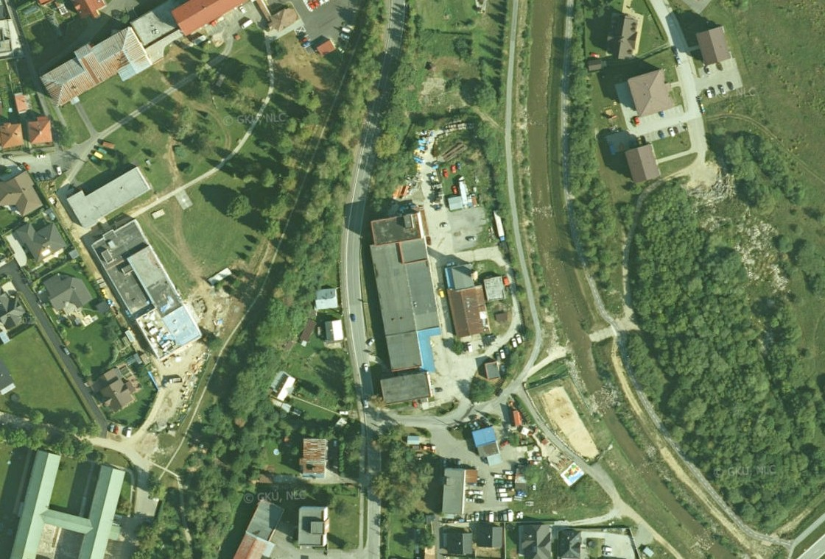
For:
retail park developers and investors, retail chains and agents

Offered by:
BauHausEurope s. r. o., Konventná 9, 811 03 Bratislava, Slovak Republic
Company ID 47 420 171 | Bc. Ľubomír Kruk, managing director | info@bauhauseurope.de | +421 904 027 703
Bratislava, 2 November 2026
Confidential – for the addressee only. This offer is non-binding and serves as a basis for negotiation.

1. Summary
BauHausEurope s. r. o. is the sole owner of the enclosed former bakery site on Levočská Street in Stará Ľubovňa with a total area of 10,789 m². The site lies at the main entrance to the town from Prešov and Poprad, by the Jakubianka river and opposite the district hospital, with full utility connections and its own transformer station. We offer it for sale as a location for a retail park with a grocery anchor (3,000 – 5,000 m² GLA, 150 – 200 parking spaces) in a district town of 15,800 inhabitants with a catchment of 53,000, which still lacks a modern retail park. The site was appraised in 2024 at EUR 1,850,000.
The offer has three parts: the sale of the site is the basis; construction and preparation are optional services ordered and paid for by the buyer as investor:
- A – Sale of the site: purchase of the plot with buildings (10,789 m²) into the buyer’s sole ownership; on request handed over after demolition as a prepared building plot.
- B – Turnkey construction: after the sale, BauHausEurope as general contractor, at the investor’s cost, carries out demolition with its own equipment (including a concrete crusher), earthworks, construction of the retail park, car park and utilities – under a construction contract with a fixed price and deadline.
- C – Permits and preparation: project management, selection of the architect, zoning and building permit procedures and communication with the town, where we have long-standing good relations including with the town leadership.

2. The Property
Item | Detail
Address | Levočská 345/11, 064 01 Stará Ľubovňa, Slovak Republic (GPS 49.295794, 20.690312)
Owner | BauHausEurope s. r. o., share 1/1 (title deed No. 1382, cadastral area Stará Ľubovňa), acquired by purchase in 2022
Plots | KN-C No. 775/1 (7,415 m²), 775/2 (2,608 m²), 775/3 (598 m²), 775/4 (111 m²), 775/5 (57 m²); total 10,789 m² per title deed No. 1382 (ZBGIS records plot 775/1 at 7,389 m²); type: built-up areas and courtyards
Existing buildings | three-storey administrative building (No. 345), single-storey production hall (built-up area 1,696 m²), four-storey production and storage building, garages, boiler house, oil facility, transformer station; approx. 3,190 m² built-up area in total; buildings from 1986 – 1992 intended for demolition or partial use
Utilities | own water connection, sanitary and storm sewer, gas connection, electricity connection and own transformer station; paved concrete areas, fenced site
Access | directly from Levočská Street (road III/3146 in town, connecting to national road I/68 Prešov – Stará Ľubovňa – Poland); existing entrance from the south; slightly sloping terrain, approx. 5.9 m height difference across the plot
Zoning | urban district V06; mixed-use area for residential buildings and civic amenities (town zoning information No. MsÚ-SL-151/195/2025 of 9 January 2026); max. 8 storeys, site coverage up to 50 %, greenery min. 20 % – see Section 4; also allows a combination of retail park + apartments on upper floors
Current use | storage and retail units under lease; the site can be handed over vacant
Legal status | no easements; the financing bank’s lien will be discharged from the purchase price on transfer
Available documents | expert appraisal No. 87/2024, title deed extract and cadastral map, geodetic survey, town zoning information No. MsÚ-SL-151/195/2025 (9 January 2026), engineering-geological and hydrogeological survey (completed, subsoil suitable for construction), design documentation of the existing buildings, building permit and occupancy permit

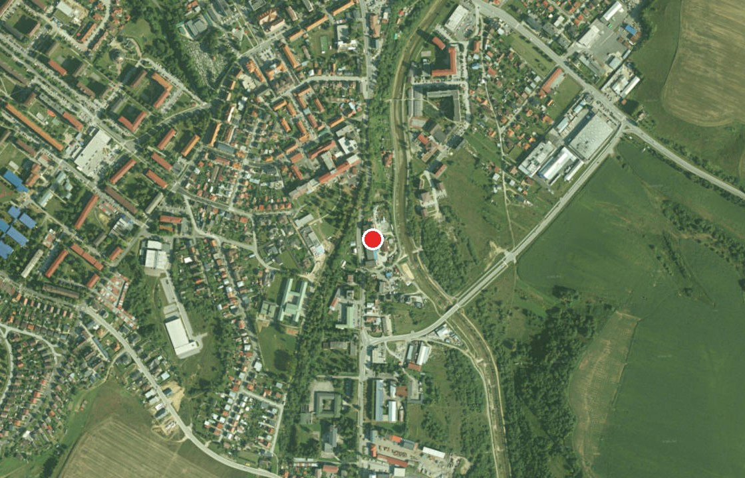
Figure 1 – Satellite image: location of the site (red dot) in the southern part of Stará Ľubovňa by Levočská Street (orthophoto GKÚ/NLC, Esri World Imagery)
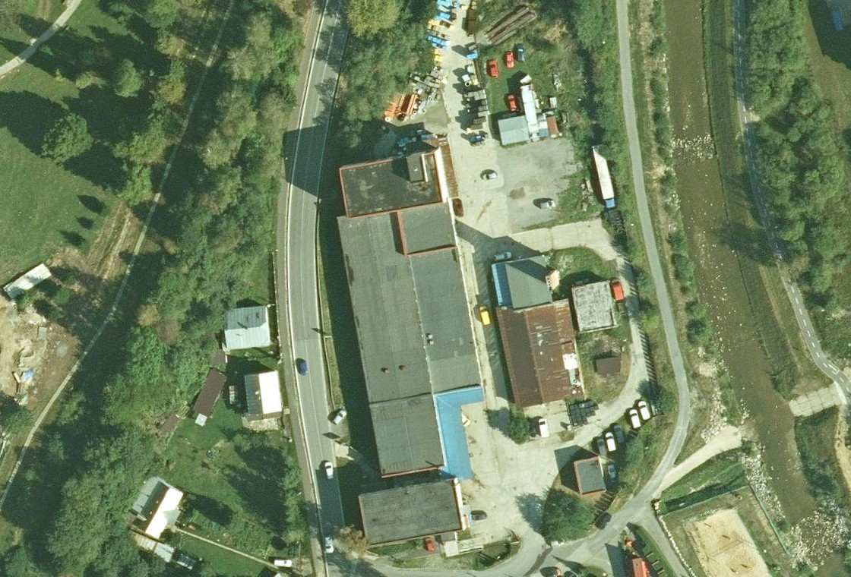
Figure 2 – Satellite image of the site: production hall, administrative building, storage buildings and paved areas between Levočská Street and the Jakubianka river
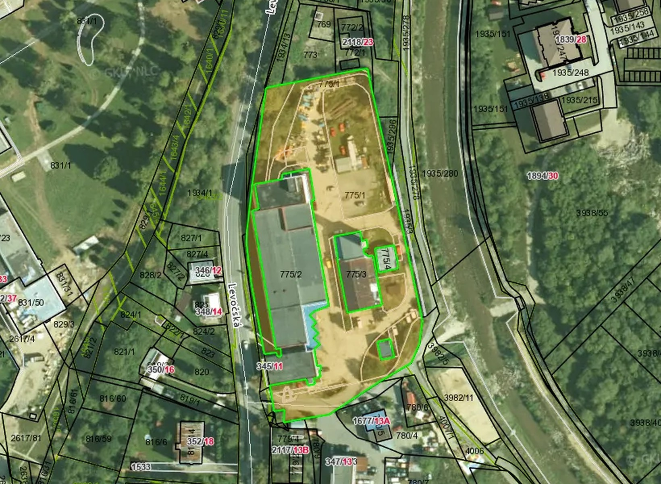
Figure 3 – Site boundary per the cadastral map: plots 775/1 (7,389 m² per ZBGIS), 775/2, 775/3, 775/4 and 775/5, owner BauHausEurope s. r. o., share 1/1 (ZBGIS, orthophoto GKÚ/NLC)
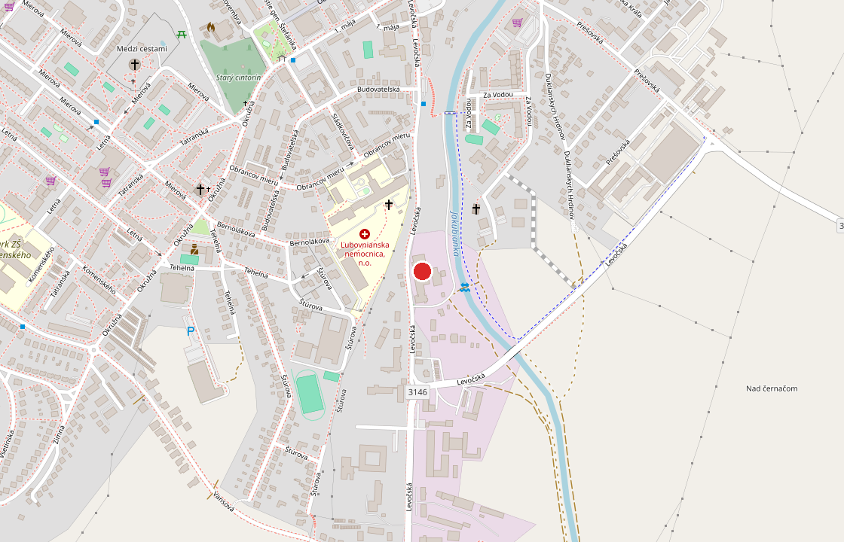
Figure 4 – Location of the site on the town map (OpenStreetMap)
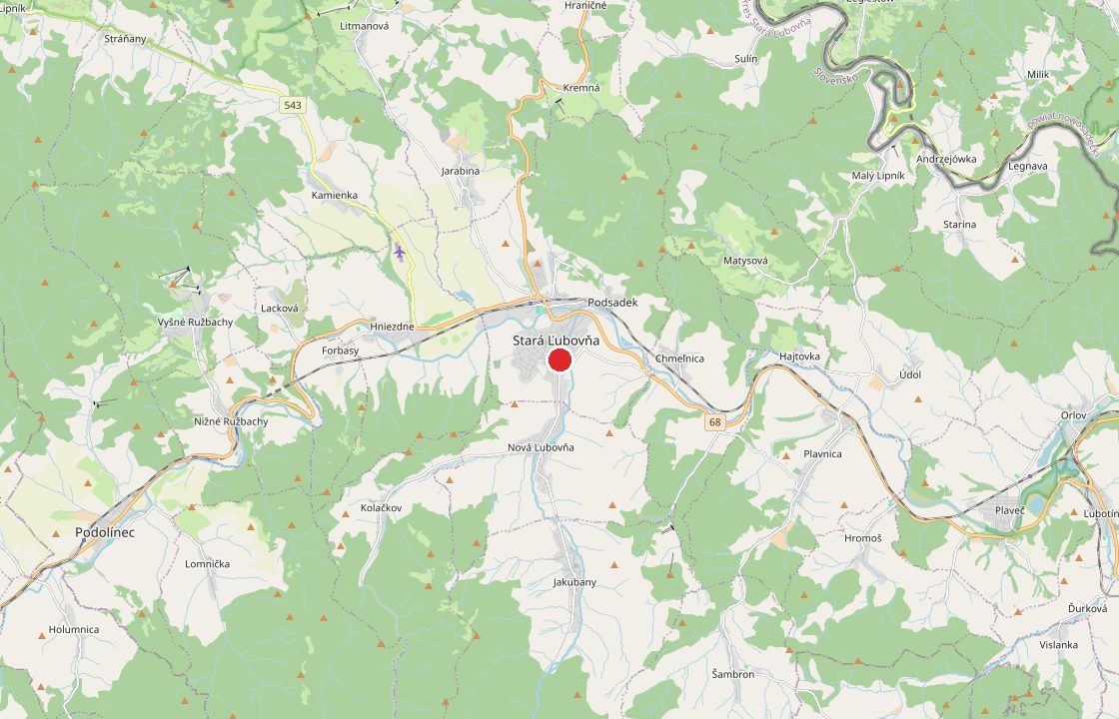
Figure 5 – Wider context: Stará Ľubovňa on road I/68 between Prešov and the Polish border (OpenStreetMap)

3. Data from the Expert Appraisal
The property was appraised by expert report No. 87/2024 (Ing. Peter Repčák, court expert in construction, real estate valuation, 22 July 2024). The report is based on an inspection and survey of 4 July 2024, the title deed extract No. 1382 and a copy of the cadastral map. The original bakery was built in 1953, the site was comprehensively rebuilt under a 1984 building permit (design by Potravinoprojekt Bratislava) and received its occupancy permit in 1992; the buildings have been in use since 1989.
Building | Gross volume (m³) | Built-up area (m²) | Storeys | Structure | General value (EUR)
Administrative building (three-storey part, No. 345) | 3,893.62 | 404.21 | 3 | prefabricated RC frame, aerated concrete panels, flat roof; ground floor refurbished, new PVC windows | 326,171.99
Production hall (single-storey part) | 13,050.14 | 1,696.14 | 1 | prefabricated RC frame, flat roof, internal utilities | 428,170.32
Production and storage building (four-storey part) | 5,655.36 | 327.50 | 4 | prefabricated RC frame, flat roof | 320,165.36
Garages | 3,511.66 | 445.31 | 2 | masonry / prefabricated | 28,860.05
Boiler house | 1,106.17 | 152.90 | 1 | masonry | 35,164.98
Oil facility | 529.86 | 109.02 | 1 | masonry | 19,377.16
Transformer station | 255.12 | 56.07 | 1 | masonry | 14,647.85
Fencing, connections (water, sanitary and storm sewer, gas, electricity), manholes, septic tank, paved concrete areas | – | – | – | external works | 52,832.89
Buildings and structures in total | 28,001.93 | 3,191.15 |  |  | 1,225,390.60
Plots No. 775/1 – 775/5 (10,789 m², location differentiation method, EUR 58.27/m²) | – | 10,789 | – | built-up areas and courtyards | 628,675.03
General value in total (rounded EUR 1,850,000) |  |  |  |  | 1,854,065.63
Source: expert report No. 87/2024, recapitulation of general value (combined method for buildings, location differentiation method for land, price level incl. VAT). Value in words: one million eight hundred and fifty thousand euro.
The full appraisal (39 pages, including a list of tenants and costs for 2023, the building permit and occupancy permit) will be provided at the site visit. An updated appraisal as at the transaction date can be prepared at the buyer’s request.

4. Zoning Information
The Stará Ľubovňa Town Office, Department of Construction, Spatial Development and Environment, issued for plots C KN No. 775/1, 775/2, 775/3, 775/4 and 775/5, cadastral area Stará Ľubovňa (title deed No. 1382) a zoning information – confirmation of the functional use of the land, No. MsÚ-SL-151/195/2025 of 9 January 2026 (handled by Ing. Anna Hrebíková, head of department). Under the town’s valid zoning documentation as amended by Changes and Amendments No. 1, 2, 3 and 4, the plots are located in urban district V06 and are designated as a mixed-use area for residential buildings and civic amenities within the scope of the proposal. Civic amenities, which the zoning plan explicitly includes shopping centres and retail parks in, are therefore a permitted use; the regulations also allow apartments above the retail ground floor. Binding regulations for the area:
Item | Detail
Functional use | mixed-use area for residential buildings and civic amenities; mixed-use areas are areas with at least two complementary functions
Height | max. 8 above-ground storeys including attic, no set-back storey permitted
Site coverage | buildings up to 50 % of the plot area (i.e. up to approx. 5,390 m² built-up area)
Parking | for non-residential premises per the relevant STN standard; for business activities on civic amenity areas, parking per STN 73 6110 always on the own plot; for apartments 2 spaces / 1 apartment
Greenery | greenery index min. 20 % of the plot area (green roofs and walls not counted)
Other requirements | covered and lockable waste storage as part of the project; road traffic noise assessment before construction; no unusual colours as dominant façade colours, uniform colour scheme for several buildings; technical connection to existing street networks
Zoning decision | a valid zoning decision for new development has been issued for the site

The town’s statement is informative and does not replace decisions and statements of the authorities in the permitting procedure. A full copy of the zoning information will be attached to the site visit documents. For a retail park of 3,000 – 5,000 m² with parking on the own plot, the site coverage (50 %) and greenery (20 %) regulations can be met.

5. Location and Market
Stará Ľubovňa is a district town of approx. 15,800 inhabitants with a district catchment of approx. 53,000. The international road I/68 Prešov – Stará Ľubovňa – Mníšek nad Popradom – Poland passes through the town; the border crossing with the bridge to Piwniczna-Zdrój is approx. 15 km away. The site lies on Levočská Street, the main entrance to the town from Prešov, Poprad and Levoča, next to the district hospital, residential districts and bus services, a few minutes’ walk from the centre.
The catchment area also includes the Vyšné Ružbachy spa, the recreational areas around Ľubovňa Castle and the Polish border municipalities (Piwniczna, Muszyna), from where customers regularly come to Slovakia to shop. Kaufland, Tesco and Lidl operate in the town, but a modern retail park with non-food discounters (Pepco, KiK, Action, Tedi, JYSK, dm, Sportisimo, furniture and DIY) is missing; the nearest retail parks are in Prešov and Poprad, 50 – 60 km away. The location is also suitable as an anchor for a new grocery chain entering the Slovak market (e.g. Biedronka).
Item | Detail
Inhabitants of town / district | approx. 15,800 / 53,000
Road | I/68 Prešov – Stará Ľubovňa – Poland; Levočská St. = main entrance to the town from the south
Distances | Prešov 65 km, Poprad 55 km, Piwniczna-Zdrój (PL) 15 km, Nowy Sącz (PL) 45 km, Košice 110 km
Neighbourhood | hospital, residential zones, mixed-use buildings, Jakubianka riverside
Plot area | 10,789 m² – suitable for a retail park of 3,000 – 5,000 m² GLA (grocery anchor 1,200 – 2,000 m² + 5 – 8 units of 300 – 800 m²) with 150 – 200 parking spaces and a service yard

6. Cooperation Options
Option | Scope | What BauHausEurope provides | What the buyer gains
A – Sale of the site | transfer of the 10,789 m² plots and buildings into the buyer’s ownership | handover vacant, discharge of the lien, cooperation with the cadastre; demolition before transfer on request | own plot on the main road, with utilities, unencumbered
B – Turnkey construction | option A + BauHausEurope as general contractor; the buyer is the investor and client, the works are paid under a construction contract (stage invoicing) | demolition with own equipment (crane, trucks, demolition machines, concrete crusher – recycled aggregate used for backfill on site), earthworks, shell of the hall, façade, roof, internal services, car park, connections, landscaping | one partner for land and construction, fixed price and deadline, savings on rubble haulage and transport; standard retail park halls (steel or RC frame, sandwich cladding) built by our own teams
C – Permits and preparation | service for the buyer before and during construction | preparation of the proposal for the town, selection of the architect, design, zoning and building permit procedures, project management; assistance in securing the anchor tenant and regional tenants | faster permits and a local partner who knows the town, authorities, tenants and suppliers

The purchase price of the site and the price of construction works will be negotiated after the site visit and clarification of the brief (size of the park, number of parking spaces, standard).

7. What Else We Can Provide
- Permits: preparation of the proposal for the town, zoning and building permit procedures including negotiations with the authorities concerned; we have long-standing correct relations with the town of Stará Ľubovňa and its leadership.
- Architect and designers: selection and coordination of the architect and designers, structural engineering, fire protection, traffic connection.
- Own equipment: mobile crane, trucks, demolition machines and a mobile crusher – demolition and bulk earthworks can start immediately after signing, without waiting for subcontractors.
- Construction capacity: own construction teams with many years of experience on sites for German general contractors (shell construction, concreting, masonry and prefabricated structures, façades, drywall, finishing works).
- Utilities and energy: existing water, sewer, gas and electricity connections and own transformer station shorten preparation; the engineering-geological and hydrogeological survey is complete with a satisfactory result – the subsoil is suitable for foundations without extraordinary measures.
- Local knowledge: construction base in the region, knowledge of local suppliers, authorities and the labour market.

8. Indicative Timeline
Period | Step
11 – 12/2026 | site visit, handover of documents (appraisal, survey, zoning information), first negotiation on price and scope
1/2027 | letter of intent, due diligence, agreement on the cooperation option (A / B / C)
Q1 2027 | purchase agreement and construction contract; start of demolition (2 – 3 months)
Q2 – Q4 2027 | design, zoning and building permit procedures in cooperation with the town
2028 | construction of the retail park, car park and utilities (8 – 10 months)
end of 2028 | occupancy permit and opening of the retail park

9. About BauHausEurope
BauHausEurope s. r. o. has operated since 2013 as a construction and development company. Its main business is the supply of construction works and qualified construction workers for general contractors in Germany; since 2022 the group has been developing its own development projects and utility network construction in Slovakia and Croatia.
Item | Detail
Revenue | 2023: EUR 8.7 m | 2024: EUR 11.3 m | 2025: EUR 9.3 m
Selected projects | utility networks for the Senec – Margovo residential zone (EUR 11.66 m excl. VAT, 38 ha, 835 apartments and houses); 27 apartments in Croatia; Sky Hill Residence Banská Bystrica; conversion of a building in Vyšné Ružbachy into 62 apartments
Group assets | real estate in Stará Ľubovňa, Banská Bystrica and Vyšné Ružbachy with a total value of EUR 6.17 m per expert appraisals
Equipment | mobile crane, trucks, demolition machines, mobile crusher, formwork and scaffolding
Managing director | Bc. Ľubomír Kruk, owner of the BauHausEurope group

Financial indicators of the company per the annual financial statements published in the Slovak Register of Financial Statements (in EUR):
Indicator (EUR) | 2021 | 2022 | 2023 | 2024 | 2025
Operating revenue (turnover) | 7,126,603 | 8,743,155 | 8,662,883 | 11,307,204 | 9,346,482
Operating result | 36,165 | 157,799 | 22,315 | 367,470 | 211,159
EBITDA (operating result + depreciation) | 81,953 | 380,821 | 499,222 | 801,544 | 639,720
Profit after tax | 18,686 | 83,286 | -69,736 | 220,503 | 106,056
Total assets (net) | 1,351,175 | 2,974,620 | 2,709,699 | 3,386,125 | 3,490,376
of which property, plant and equipment | 287,167 | 1,783,967 | 1,672,519 | 1,865,839 | 1,537,681
Equity | 155,468 | 608,454 | 521,694 | 742,198 | 839,335
Current bank loans | 7,008 | 91,392 | 109,919 | 117,901 | 175,227
Source: Slovak Register of Financial Statements (registeruz.sk), company ID 47 420 171; further company data: finstat.sk/47420171. The company has been continuously profitable at operating level since its foundation, equity has grown 5.4-fold in five years solely from retained earnings, and dependence on bank financing is minimal.
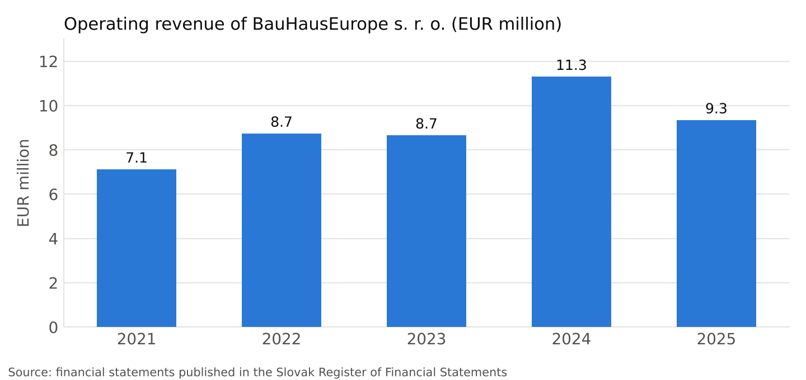
Chart – Revenue of BauHausEurope s. r. o. 2021 – 2025 (EUR million)

10. Next Steps and Contact
We propose a site visit combined with a meeting at the town office. For the meeting we will prepare the complete documents (title deed, appraisal, geodetic survey, zoning information, surveys) and, after receiving the buyer’s concept, an indicative construction budget and timeline. The offer is intended for direct negotiation; in case of brokerage, the commission is subject to agreement.
Item | Detail
Company | BauHausEurope s. r. o., Konventná 9, 811 03 Bratislava, Slovakia
Company ID / VAT ID | 47 420 171 / SK2023873533
Contact person | Bc. Ľubomír Kruk, managing director
E-mail | info@bauhauseurope.de
Phone | +421 904 027 703
Site | Levočská 345/11, 064 01 Stará Ľubovňa – https://maps.app.goo.gl/gTJZC8ehx5vQG2zS8
Bratislava, 2 November 2026
 | 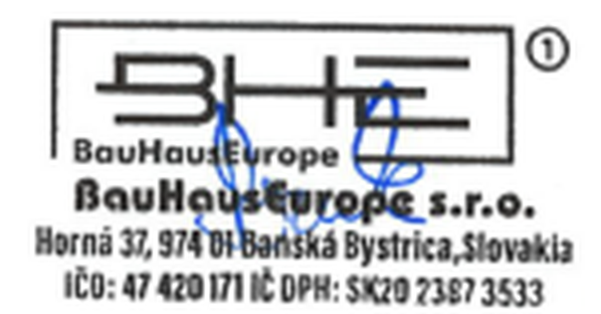
______________________________
BauHausEurope s. r. o.
Bc. Ľubomír Kruk, managing director

