"Reduced inflammation in challenge infection with Eimeria ferrisi?"
Abstract:
Eimeria is a genus of intracellular protozoan parasites, studied mostly for its economic impact on the livestock industry. Species of this genus are also prevalent in natural populations of wildlife with potentially high pathogenicity.
We investigate immunological underpinnings of resistance and susceptibility against natural and experimental Eimeria infections in wild, wild-derived and laboratory mice. The most studied species in mice is Eimeria falciformis, where immunity upon infection of intestinal epithelial cells is driven by IFN-ɣ attracted NK cells, CTLs, Th1 and Th17 cells. This applies to experimental infections with both E. falciformis and E. ferrisi. The species differ in the length of the patency period, intensity of immunological reaction by the host, and prevalence in wild populations.
In the wild, we found that immunity related gene expressions are downregulated in weakly infected mice. Meanwhile, highly infected individuals show gene expression on a level of non-infected mice. An experimental challenge infection of wild-derived and laboratory mice showed: a) enhanced (but not sterile) immunity against E. ferrisi challenge caused by the same primary infections, b) a reduction of Th1 response measured via both cell counts and cytokine expression during secondary infections. Infection intensities and immune reactions during experimental infections suggest that re-infections common in natural systems are associated with strictly controlled inflammatory immune response permitting parasite control, while preventing overt immunopathology in Eimeria infections. This might be an important mechanism underlying tolerance.

Lubomír Bednář,a,b Hongwei Zhang,e Alice Balard,a,b Víctor Hugo Jarquín-Díaz,a,b Svenja Ubl,a Anna Görlich,a Ľudovít Ďureje,c Iva Martincová,c Jaroslav Piálek,c Joëlle Goüy de Bellocq,c Stuart J. E. Baird,c Miloš Macholán,d Sebastian Rausche and Emanuel Heitlingera,b,*

aDepartment of Molecular Parasitology, Institute for Biology, Humboldt University Berlin (HU), Philippstr. 13, Haus 14, 10115, Berlin, Germany
bResearch Group Ecology and Evolution of Molecular Parasite-Host Interactions, Leibniz-Institute for Zoo and Wildlife Research (IZW), Im Forschungsverbund Berlin e.V. Alfred-Kowalke-Straße 17, 10315, Berlin, Germany
cResearch Facility Studenec, Institute of Vertebrate Biology, Czech Academy of Sciences, Květná 8, 603 65 Brno, Czech Republic
dLaboratory of Mammalian Evolutionary Genetics, Institute of Animal Physiology and Genetics, Czech Academy of Sciences, Veveri 97, 60200, Brno, Czech Republic
eDepartment of Veterinary Medicine, Institute of Immunology, Freie Universität Berlin (FU), Robert-von-Ostertag-Str. 7-13, Room 240, 14163 Berlin.
*Corresponding author. Department of Molecular Parasitology, Institute for Biology, Humboldt University Berlin (HU), Philippstr. 13, Haus 14, 10115, Berlin, Germany.
emanuelheitlinger@gmail.com

Introduction:
The Eimeria genus contains many species of economic relevance, mostly because of the impact the parasites can have on the cattle and poultry industry. In an exploratory laboratory setting, the animal models used most often are house mice (Mus musculus) of different strains (SWISS, NMRI, BALB/c, etc.), depending on the research focus. In said research, the most commonly used species of Eimeria is Eimeria falciformis, which has been extensively studied since it’s first categorization by Theodor Eimer. Unfortunately, other species infecting mice have not been as well investigated, making our understanding of this particular model limited and less applicable outside it’s niche. A more well understood shortcoming of using laboratory mice, is that the model does not represent what occurs in natural scenarios. In hand with this, using a parasite strain that has been passaged many times over, can lead to selection of traits beneficial for that particular scenario and a loss of the initial, wild-originating characteristics.

It has been established by a large number of previous studies that laboratory mice are in ideal tool for isolating and studying a variety of mechanisms, including immunity and infection. During recent years it has been extensively show that the observations made in laboratory animals differ widely from those made in wild living ones. This topic has become a focus for proof in many research studies, however very few focus on the difference under a specific and controlled infection scenario.

Here we introduce an immunological study of the host response to an understudies species of Eimeria, called Eimeria ferrisi. To circumvent the problematic of using laboratory mice, we infect inbred mice derived from wild mice captured in the European House Mouse Hybrid Zone (EHMHZ). As a comparison of model, we also include inbred SWISS mice and inbred wild-derived mice (parental strains isolated from the EHMHZ). In addition, the infecting Eimeria strain has been isolated from the same zone as the mouse strains. In combination with all the above mentioned factors, we aim to introduce as little variability as possible in a controlled model, which reflects naturally occurring infections better. Using a parasite strain and mouse lines isolated from the wild, we aim to provide a better model for infection scenario setting for unraveling the immunological processes that occur in natural populations. To our knowledge, this is the first study conducted focusing on untangling immunological responses in standard laboratory, wild derived and wild mice during an Eimeria infection.

people say that wild mice and lab are different. Ok so? But we want to see how different they are during infection. Our mice are lab, wild derived and wild. We re the only ones with an infection tahts prevalent in the wild and managable in the lab.
Methodology:
Design:
The animals used in this study underwent primary infection with E. falciformis and E. ferrisi, were allowed to recover for a period of one month and reinfected with E. ferrisi. Infections were carried out with 150 sporulated oocysts in 100µL 1X PBS by direct gavage to the stomach. Mice were sacrificed on the 8th day of infection (dpi8), therefore all qPCR, RT-qPCR, ELISA and cell counting results are from organs harvested at dpi 8. All assays were done on homogenized Caecum tissue, with the exception of cell counting, which was performed on mesenteric lymph nodes draining the Caecum.

An attempted E. falciformis infection was unsuccessful and treated as uninfected group, following a negative sequencing for E. falciformis COI (Cytochrome Oxidase subunit 1).

Animals:
The wild-derived mouse strains were obtained from a breeding facility in Studenec, Czech republic (Research Facility Studenec, Institute of Vertebrate Biology, Czech Academy of Sciences). The SWISS mice were obtained from on-site breeding facility in Berlin, Germany (Institut fur Biologie, Tierphysiologie, Humboldt-University Berlin). All mice were given an individual acclimatization period of 1 week on wood-chip bedding and environmental enrichment, with food and water ad libitum.
Wild mice were captured in the EHMHZ (capture permit No. 2347/35/2014) and dissected after 1 day. The capture protocol was described in a previous study (http://dx.doi.org/10.1101/636662). Fresh Caecums were collected in cryo tubes and flash frozen in liquid nitrogen. Mesenteric lymph nodes were processed on site by sieving and transported back to Berlin for fixation and cell counting.

Eimeria isolates:
Primary infections were done using the EHMHZ isolated E. falciformis and E. ferrisi, as described in the previous study (doi: http://dx.doi.org/10.1101/2020.01.24.918144). A challenge infection with E. falciformis was unsuccessful and treated as uninfected group, following a negative sequencing of COI (Cytochrome Oxidase subunit 1) and lack of oocyst shedding. The E. ferrisi challenge infection was successful.

DNA extraction:
DNA extraction was performed by flash freezing a whole mouse Caecum and crushing it with mortar and pestle. Powdered Caecum was split into 3 eppendorf tubes designated for DNA, RNA and protein use. Downstream DNA extraction was performed using the innuPREP DNA Mini Kit (Analytik Jena
AG, Jena, Germany) according to the manufacturer instructions. Quality and quantity of isolated DNA was measured using the NanoDrop 2000c spectrophotometer (Thermo Scientific, Waltham, USA). All DNA isolates were stored at -20 °C until processed.

Parasite load qPCR:
Primers targeting a short fragment of mitochondrial COI were used to amplify DNA from intracellular stages of Eimeria as described before (doi: http://dx.doi.org/10.1101/2020.01.24.918144)
Name | Sequence
Eim_COI_qX-F (Forward) | 5’-TGTCTATTCACTTGGGCTATTGT-3’
Eim_COI_qX-R (Reverse) | 5’- GGATCACCGTTAAATGAGGCA-3’
Ms_gDNA_CDC42_F (Forward) | 5’-CTCTCCTCCCCTCTGTCTTG-3’
Ms_gDNA_CDC42_R (Reverse) | 5’-TCCTTTTGGGTTGAGTTTCC-3’

Final reaction volume was 20 μL, which contained:
Name | Volume | Concentration
iTaqTM Universal SYBR® Green Supermix | 10 μL | 1X
Eim_COI_qX-F (Forward) | 0.8 μL | 100 nM
Eim_COI_qX-R (Reverse) | 0.8 μL | 100 nM
Molecular grade water | 7.4 μL | -
DNA template | 1 μL | 50 ng

1X iTaqTM Universal SYBR® Green Supermix (Bio-Rad Laboratories GmbH, München, Germany), each pimer and DNA template. qPCR was conducted in a Mastercycler® RealPlex 2 (Eppendorf, Hamburg, Germany) with the following cycling: 1 x 95 °C initial denaturation for 2 min, 95 °C x 40 cycles of denaturation for 15 s, 55 °C annealing for 15 s and 68 °C extension for 20 s. Melting curve analysis was conducted to control for primer dimers and non-specific amplification. The CDC42 gene from the nuclear genome of the house mouse was used as an internal control. Infection intensity was calculated as the ΔCt of Mouse – Eimeria.

RNA extraction and cDNA conversion:
RNA was extracted from homogenized mouse Caecum using the PureLink RNA Mini Kit (Invitrogen, Carlsbad, California, United States), following the manufacturer protocol. Quality and quantity of isolated DNA was measured using the NanoDrop 2000c spectrophotometer (Thermo Scientific, Waltham, USA). All extractions were carried out on ice and final RNA isolate was stored at -80 °C until converted to cDNA. cDNA conversion was done using the iScript cDNA synthesis kit (Bio-rad, Hercules, California, United States) following manufacturer instructions, using 1µg of RNA as template. Quality and quantity of isolated cDNA was measured using the NanoDrop 2000c spectrophotometer (Thermo Scientific, Waltham, USA). All cDNA was stored at -80 °C until used in the RT-qPCR.

Gene expression RT-qPCR:
Primers targeting a previously verified gene targets in mice were used to amplify mRNA from the host Caecum to determine the immunological reaction polarization at site of infection.
Name | Sequence
GAPDH_F (Forward)
GAPDH_R (Reverse)
β-actin_F (Forward)
β-actin_R (Reverse)
IRGA6_F (Forward)
IRGA6_R (Reverse)
GBP2_F (Forward) | 5’-CTGCACTATGTGACGGAGCTA-3’
GBP2_R (Reverse) | 5’-GAGTCCACACAAAGGTTGGAAA-3’
IL-12rb1_F (Forward) | 5’-ATGGCTGCTGCGTTGAGAA-3’
IL-12rb1_R (Reverse) | 5’-AGCACTCATAGTCTGTCTTGGA-3’
CXCR3_F (Forward) | 5’-CTG CTG CCC AGT GGG TTT-3’
CXCR3_R (Reverse) | 5’-GTT GAT GTT GAA CAG GGC ACC-3’
IL-6? | 5’-TAGTCCTTCCTACCCCAATTTCC-3’
IL-6
IFN-y?

20 µL reactions were set up for the RT-qPCR, containing:
Name | Volume | Concentration
iTaqTM Universal SYBR® Green Supermix | 10 μL | 1X
Forward primer | 1 μL | 100 nM
Reverse primer | 1 μL | 100 nM
Molecular grade water | 7 μL | -
cDNA template | 1 μL | 300 ng

RT-qPCR was conducted in a Mastercycler® RealPlex 2 (Eppendorf, Hamburg, Germany) with the following cycling: 1 x 95 °C initial denaturation for 2 min, 95 °C x 40 cycles of denaturation for 15 s, 55 °C annealing for 15 s and 68 °C extension for 20 s. Melting curve analysis was conducted to control for primer dimers and non-specific amplification. The averages of β-actin and GAPDH genes were used as an internal control. Gene expression per target was calculated as the ΔCt of Target – ((β-actin + GAPDH)/2). Individual internal controls with ΔCt of Target – β-actin and ΔCt of Target – GAPDH were verified to show little difference before applying the mean of both.

IFN-ɣ sandwich ELISA:
Sandwich ELISAs for IFN-ɣ protein abundance were performed using the IFN gamma Mouse Uncoated ELISA Kit (Invitrogen, Carlsbad, California, United States). The manufacturer protocol was followed and plate reads were done in the Synergy HTX Multi-Mode Reader (Biotek, Winooski, Vermont, United States) at 450 nm with a blank well subtraction and 10 second shaking steps between 3 reads of the same plate.

Cell sorting:
CD4+ and CD8+ T-cells were sorted from the mesenteric lymph node tissue cell suspensions in the FACS MACHINE OF DOOM . Two types of selection assays were performed, cytokine activated T-cells and marker expressing T-cells
Gating criteria for marker expressing T-cells have been set up as follows:
CD4+
RORgt+ in CD4+Foxp3- (Th17)
Ki-67+ in CD4+Foxp3-RORgt+ (dividing Th17)
Foxp3+ in CD4+ (Treg)
Ki-67+ in Foxp3+ (dividing Treg)
RORgt+ in Foxp3+ Treg (Treg17)
T-bet+ in CD4+Foxp3- (Th1)
Ki-67+ in CD4+Foxp3-T-bet+ (dividing Th1)
CD8+
T-bet+ in CD8+ (activated CD8+)
Ki-67+ in CD8+T-bet+ (dividing activated CD8+)

FSC-A_SSC-A_subset/single/live/CD4+/Foxp3-_Freq._of_Parent

Gating criteria for cytokine activated T-cells were selected for the following targets:
% IFN-g+ in CD4+
% IL-17A+ in CD4+
% IFN-g+ in CD8+

Statistical analysis:
Statistical analysis of data and graphical representation of results was done in RStudio using R 3.6.1.

Results:
Infections using E. falciformis in the murine system are well described throughout the literature. Immunological findings show that the most utilized responses are IFN-ɣ driven in both the innate and the adaptive immunity. In the innate response, the autonomous cell defenses such as IRGs, GBPs and the CXCR3-CXCL9 pathways are up-regulated in attempts to opsonize and digest the contents of the parasitophorous vacuole(10.1038/mi.2013.115). On the adaptive side, Th1 polarized CD4+ T-cells are recruited to the site of infection along with the CD8+ CTLs to facilitate direct cell lysis. Likewise, many studies show the discrepancies between clonal laboratory mice and wild mice. Here we show that 1) the immune cell populations support this observation during infection with E. ferrisis in wild-derived mice and something something something in wild mice. 2)Gene expression is negatively correlated with infection intensity in wild mice and the opposite is true for wild-derived mice.

Oocyst shedding:
We observed oocyst shedding throughout the infection to confirm the established shedding patter for E. ferrisi (Life Cycle of Eimeria ferrisi Levine 8c Ivens, 1965 in the Mouse, Mus musculus) and monitor the corresponding weight-loss.

Parasite load:

Gene expression:
RT-qPCR results from laboratory mice show an expected up-regulation of CXCR3, IL-12rb1 and IRGA6. These targets are specific for immune response to Eimeria infections and are likewise up-regulated in the E. ferrisi infected hosts.

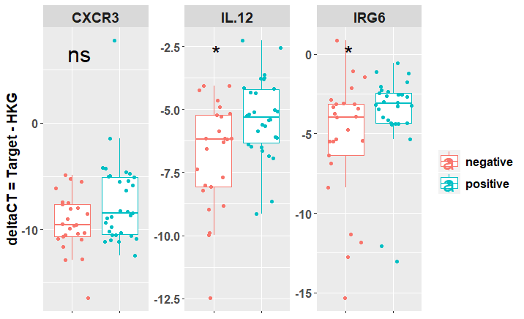

Wild
When compared to the results from laboratory animals, wild mice showed distinct down-regulation of selected genes under E. ferrisi infection.
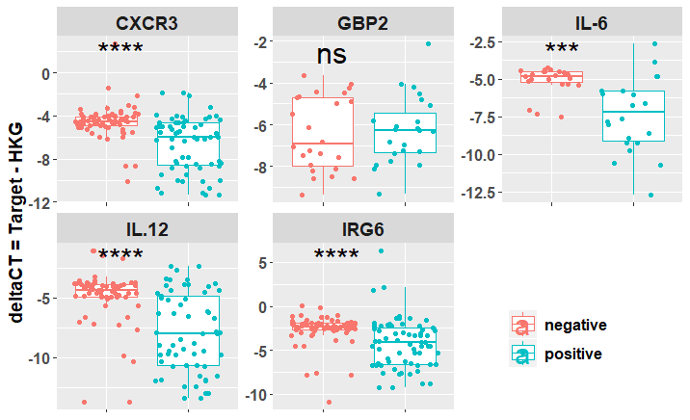

IFN-ɣ abundance:

Immune cell populations:
E. falciformis research shows that host immune response against the parasite is largely driven by
IFN-ɣ mediated pathways (10.1038/mi.2013.115). As such the an increase in CD4+ cell population is expected in Eimeria infections. Counter-intuitively, we observed a significant difference between the CD4+ populations of E. ferrisi positive and negative mice, where the negative mice exhibited higher percentage of the CD4+ populations.
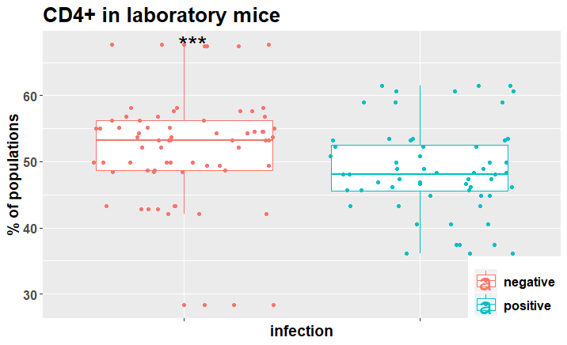

Expectedly for an IFN-ɣ driven immune response, the Th1 (T-bet+ in CD4+Foxp3-) polarization within the CD4+ population showed a marked increase in E. ferrisi positive mice.
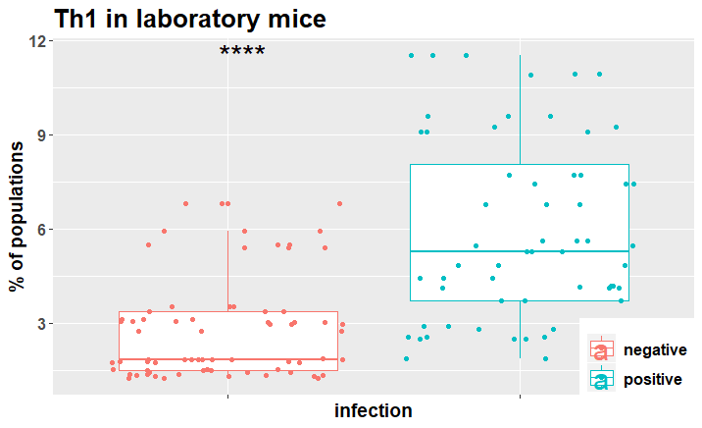

To further examine the direction of Th1 polarization during E. ferrisi infection, we investigated the Ki-67+ in CD4+Foxp3-T-bet+ polarized cells to see whether infected mice show a higher proportion of actively proliferating Th1 cells. Same as the increased Th1 populations, the actively proliferating Th1 populations were increased in E. ferrisi infected hosts.
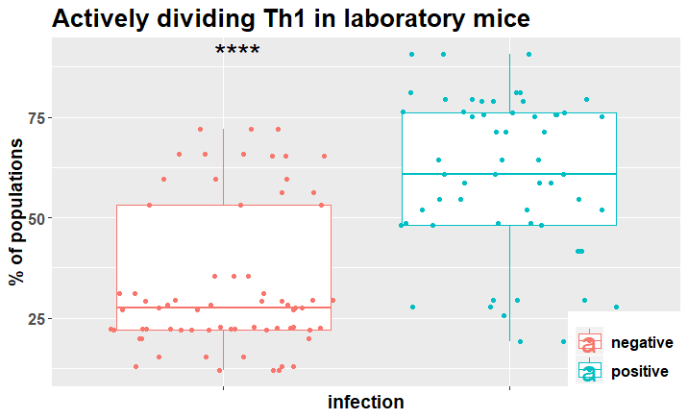
Discussion:

