ER-модель бд

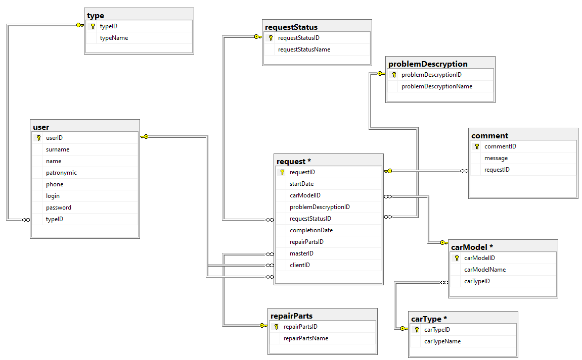

Словарь данных

|  |  |  |  |  |
| --- | --- | --- | --- | --- |
| **KEY** | **Имя поля** | **Тип данных / Размер** | **Необходимо?** | **Примечания** |
| PK | carTypeID | INTEGER | Y | Auto Increment |
|  | carTypeName | NVARCHAR (50) | Y |  |

|  |  |  |  |  |
| --- | --- | --- | --- | --- |
| **KEY** | **Имя поля** | **Тип данных / Размер** | **Необходимо?** | **Примечания** |
| PK | carModelID | INTEGER | Y | Auto Increment |
|  | carModelName | NVARCHAR (MAX) | Y |  |
| FK carType (carTypeID) | carTypeID | INTEGER | Y | On delete(update) cascade |

|  |  |  |  |  |
| --- | --- | --- | --- | --- |
| **KEY** | **Имя поля** | **Тип данных / Размер** | **Необходимо?** | **Примечания** |
| PK | commentID | INTEGER | Y | Auto Increment |
|  | message | NVARCHAR (50) | Y |  |
| FK request (requestID) | requestID | INTEGER | Y | On delete(update) cascade |

|  |  |  |  |  |
| --- | --- | --- | --- | --- |
| **KEY** | **Имя поля** | **Тип данных / Размер** | **Необходимо?** | **Примечания** |
| PK | problemDescryptionID | INTEGER | Y | Auto Increment |
|  | problemDescryptionName | NVARCHAR (50) | Y |  |

|  |  |  |  |  |
| --- | --- | --- | --- | --- |
| **KEY** | **Имя поля** | **Тип данных / Размер** | **Необходимо?** | **Примечания** |
| PK | repairPartsID | INTEGER | Y | Auto Increment |
|  | repairPartsName | NVARCHAR (50) | Y |  |

|  |  |  |  |  |
| --- | --- | --- | --- | --- |
| **KEY** | **Имя поля** | **Тип данных / Размер** | **Необходимо?** | **Примечания** |
| PK | requestStatusID | INTEGER | Y | Auto Increment |
|  | requestStatusName | NVARCHAR (50) | Y |  |

|  |  |  |  |  |
| --- | --- | --- | --- | --- |
| **KEY** | **Имя поля** | **Тип данных / Размер** | **Необходимо?** | **Примечания** |
| PK | typeID | INTEGER | Y | Auto Increment |
|  | typeName | NVARCHAR (50) | Y |  |

|  |  |  |  |  |
| --- | --- | --- | --- | --- |
| **KEY** | **Имя поля** | **Тип данных / Размер** | **Необходимо?** | **Примечания** |
| PK | requestID | INTEGER | Y | Auto Increment |
|  | startDate | Date | Y |  |
| FK carModel (carModelID) | carModelID | INTEGER | Y |  |
| FK problemDescryption (problemDescryptionID) | problemDescryptionID | INTEGER | Y |  |
| FK requestStatus (requestStatusID) | requestStatusID | INTEGER | Y |  |
|  | completionDate | Date | N |  |
| FK repairParts(repairPartsID) | repairPartsID | INTEGER | N |  |
| FK user (userID) | masterID | INTEGER | N |  |
| FK user (userID) | clientID | INTEGER | Y | On delete(update) cascade |

|  |  |  |  |  |
| --- | --- | --- | --- | --- |
| **KEY** | **Имя поля** | **Тип данных / Размер** | **Необходимо?** | **Примечания** |
| PK | userID | INTEGER | Y | Auto Increment |
|  | surname | NVARCHAR (50) | Y |  |
|  | name | NVARCHAR (50) | Y |  |
|  | patronymic | NVARCHAR (50) | Y |  |
|  | phone | char(11) | Y | like '8[0-9][0-9][0-9][0-9][0-9][0-9][0-9][0-9][0-9][0-9]' |
|  | login | NVARCHAR (50) | Y |  |
|  | password | NVARCHAR (50) | Y |  |
| FK type (typeID) | typeID | INTEGER | Y | On delete(update) cascade |

Скрипт бд

USE [master]

GO

/****** Object: Database [z111] Script Date: 30.10.2024 13:36:00 ******/

CREATE DATABASE [z111]

CONTAINMENT = NONE

ON PRIMARY

( NAME = N'z111', FILENAME = N'D:\MSSQL14.SQLSERVER\MSSQL\DATA\z111.mdf' , SIZE = 8192KB , MAXSIZE = UNLIMITED, FILEGROWTH = 10%)

LOG ON

( NAME = N'z111_log', FILENAME = N'D:\MSSQL14.SQLSERVER\MSSQL\DATA\z111_log.ldf' , SIZE = 1024KB , MAXSIZE = 2048GB , FILEGROWTH = 10%)

GO

ALTER DATABASE [z111] SET COMPATIBILITY_LEVEL = 140

GO

IF (1 = FULLTEXTSERVICEPROPERTY('IsFullTextInstalled'))

begin

EXEC [z111].[dbo].[sp_fulltext_database] @action = 'enable'

end

GO

ALTER DATABASE [z111] SET ANSI_NULL_DEFAULT OFF

GO

ALTER DATABASE [z111] SET ANSI_NULLS OFF

GO

ALTER DATABASE [z111] SET ANSI_PADDING OFF

GO

ALTER DATABASE [z111] SET ANSI_WARNINGS OFF

GO

ALTER DATABASE [z111] SET ARITHABORT OFF

GO

ALTER DATABASE [z111] SET AUTO_CLOSE OFF

GO

ALTER DATABASE [z111] SET AUTO_SHRINK OFF

GO

ALTER DATABASE [z111] SET AUTO_UPDATE_STATISTICS ON

GO

ALTER DATABASE [z111] SET CURSOR_CLOSE_ON_COMMIT OFF

GO

ALTER DATABASE [z111] SET CURSOR_DEFAULT GLOBAL

GO

ALTER DATABASE [z111] SET CONCAT_NULL_YIELDS_NULL OFF

GO

ALTER DATABASE [z111] SET NUMERIC_ROUNDABORT OFF

GO

ALTER DATABASE [z111] SET QUOTED_IDENTIFIER OFF

GO

ALTER DATABASE [z111] SET RECURSIVE_TRIGGERS OFF

GO

ALTER DATABASE [z111] SET DISABLE_BROKER

GO

ALTER DATABASE [z111] SET AUTO_UPDATE_STATISTICS_ASYNC OFF

GO

ALTER DATABASE [z111] SET DATE_CORRELATION_OPTIMIZATION OFF

GO

ALTER DATABASE [z111] SET TRUSTWORTHY OFF

GO

ALTER DATABASE [z111] SET ALLOW_SNAPSHOT_ISOLATION OFF

GO

ALTER DATABASE [z111] SET PARAMETERIZATION SIMPLE

GO

ALTER DATABASE [z111] SET READ_COMMITTED_SNAPSHOT OFF

GO

ALTER DATABASE [z111] SET HONOR_BROKER_PRIORITY OFF

GO

ALTER DATABASE [z111] SET RECOVERY SIMPLE

GO

ALTER DATABASE [z111] SET MULTI_USER

GO

ALTER DATABASE [z111] SET PAGE_VERIFY CHECKSUM

GO

ALTER DATABASE [z111] SET DB_CHAINING OFF

GO

ALTER DATABASE [z111] SET FILESTREAM( NON_TRANSACTED_ACCESS = OFF )

GO

ALTER DATABASE [z111] SET TARGET_RECOVERY_TIME = 0 SECONDS

GO

ALTER DATABASE [z111] SET DELAYED_DURABILITY = DISABLED

GO

ALTER DATABASE [z111] SET QUERY_STORE = OFF

GO

USE [z111]

GO

/****** Object: Table [dbo].[carModel] Script Date: 30.10.2024 13:36:00 ******/

SET ANSI_NULLS ON

GO

SET QUOTED_IDENTIFIER ON

GO

CREATE TABLE [dbo].[carModel](

[carModelID] [int] IDENTITY(1,1) NOT NULL,

[carModelName] [nvarchar](max) NOT NULL,

[carTypeID] [int] NOT NULL,

CONSTRAINT [PK_carModel] PRIMARY KEY CLUSTERED

(

[carModelID] ASC

)WITH (PAD_INDEX = OFF, STATISTICS_NORECOMPUTE = OFF, IGNORE_DUP_KEY = OFF, ALLOW_ROW_LOCKS = ON, ALLOW_PAGE_LOCKS = ON) ON [PRIMARY]

) ON [PRIMARY] TEXTIMAGE_ON [PRIMARY]

GO

/****** Object: Table [dbo].[carType] Script Date: 30.10.2024 13:36:00 ******/

SET ANSI_NULLS ON

GO

SET QUOTED_IDENTIFIER ON

GO

CREATE TABLE [dbo].[carType](

[carTypeID] [int] IDENTITY(1,1) NOT NULL,

[carTypeName] [nvarchar](50) NOT NULL,

CONSTRAINT [PK_carType] PRIMARY KEY CLUSTERED

(

[carTypeID] ASC

)WITH (PAD_INDEX = OFF, STATISTICS_NORECOMPUTE = OFF, IGNORE_DUP_KEY = OFF, ALLOW_ROW_LOCKS = ON, ALLOW_PAGE_LOCKS = ON) ON [PRIMARY]

) ON [PRIMARY]

GO

/****** Object: Table [dbo].[comment] Script Date: 30.10.2024 13:36:00 ******/

SET ANSI_NULLS ON

GO

SET QUOTED_IDENTIFIER ON

GO

CREATE TABLE [dbo].[comment](

[commentID] [int] IDENTITY(1,1) NOT NULL,

[message] [nvarchar](50) NOT NULL,

[requestID] [int] NOT NULL,

CONSTRAINT [PK_comment] PRIMARY KEY CLUSTERED

(

[commentID] ASC

)WITH (PAD_INDEX = OFF, STATISTICS_NORECOMPUTE = OFF, IGNORE_DUP_KEY = OFF, ALLOW_ROW_LOCKS = ON, ALLOW_PAGE_LOCKS = ON) ON [PRIMARY]

) ON [PRIMARY]

GO

/****** Object: Table [dbo].[problemDescryption] Script Date: 30.10.2024 13:36:00 ******/

SET ANSI_NULLS ON

GO

SET QUOTED_IDENTIFIER ON

GO

CREATE TABLE [dbo].[problemDescryption](

[problemDescryptionID] [int] IDENTITY(1,1) NOT NULL,

[problemDescryptionName] [nvarchar](50) NOT NULL,

CONSTRAINT [PK_problemDescryption] PRIMARY KEY CLUSTERED

(

[problemDescryptionID] ASC

)WITH (PAD_INDEX = OFF, STATISTICS_NORECOMPUTE = OFF, IGNORE_DUP_KEY = OFF, ALLOW_ROW_LOCKS = ON, ALLOW_PAGE_LOCKS = ON) ON [PRIMARY]

) ON [PRIMARY]

GO

/****** Object: Table [dbo].[repairParts] Script Date: 30.10.2024 13:36:00 ******/

SET ANSI_NULLS ON

GO

SET QUOTED_IDENTIFIER ON

GO

CREATE TABLE [dbo].[repairParts](

[repairPartsID] [int] IDENTITY(1,1) NOT NULL,

[repairPartsName] [nvarchar](50) NOT NULL,

CONSTRAINT [PK_repairParts] PRIMARY KEY CLUSTERED

(

[repairPartsID] ASC

)WITH (PAD_INDEX = OFF, STATISTICS_NORECOMPUTE = OFF, IGNORE_DUP_KEY = OFF, ALLOW_ROW_LOCKS = ON, ALLOW_PAGE_LOCKS = ON) ON [PRIMARY]

) ON [PRIMARY]

GO

/****** Object: Table [dbo].[request] Script Date: 30.10.2024 13:36:00 ******/

SET ANSI_NULLS ON

GO

SET QUOTED_IDENTIFIER ON

GO

CREATE TABLE [dbo].[request](

[requestID] [int] IDENTITY(1,1) NOT NULL,

[startDate] [date] NOT NULL,

[carModelID] [int] NOT NULL,

[problemDescryptionID] [int] NOT NULL,

[requestStatusID] [int] NOT NULL,

[completionDate] [date] NULL,

[repairPartsID] [int] NULL,

[masterID] [int] NULL,

[clientID] [int] NOT NULL,

CONSTRAINT [PK_request] PRIMARY KEY CLUSTERED

(

[requestID] ASC

)WITH (PAD_INDEX = OFF, STATISTICS_NORECOMPUTE = OFF, IGNORE_DUP_KEY = OFF, ALLOW_ROW_LOCKS = ON, ALLOW_PAGE_LOCKS = ON) ON [PRIMARY]

) ON [PRIMARY]

GO

/****** Object: Table [dbo].[requestStatus] Script Date: 30.10.2024 13:36:00 ******/

SET ANSI_NULLS ON

GO

SET QUOTED_IDENTIFIER ON

GO

CREATE TABLE [dbo].[requestStatus](

[requestStatusID] [int] IDENTITY(1,1) NOT NULL,

[requestStatusName] [nvarchar](50) NOT NULL,

CONSTRAINT [PK_requestStatus] PRIMARY KEY CLUSTERED

(

[requestStatusID] ASC

)WITH (PAD_INDEX = OFF, STATISTICS_NORECOMPUTE = OFF, IGNORE_DUP_KEY = OFF, ALLOW_ROW_LOCKS = ON, ALLOW_PAGE_LOCKS = ON) ON [PRIMARY]

) ON [PRIMARY]

GO

/****** Object: Table [dbo].[type] Script Date: 30.10.2024 13:36:00 ******/

SET ANSI_NULLS ON

GO

SET QUOTED_IDENTIFIER ON

GO

CREATE TABLE [dbo].[type](

[typeID] [int] IDENTITY(1,1) NOT NULL,

[typeName] [nvarchar](50) NOT NULL,

CONSTRAINT [PK_type] PRIMARY KEY CLUSTERED

(

[typeID] ASC

)WITH (PAD_INDEX = OFF, STATISTICS_NORECOMPUTE = OFF, IGNORE_DUP_KEY = OFF, ALLOW_ROW_LOCKS = ON, ALLOW_PAGE_LOCKS = ON) ON [PRIMARY]

) ON [PRIMARY]

GO

/****** Object: Table [dbo].[user] Script Date: 30.10.2024 13:36:00 ******/

SET ANSI_NULLS ON

GO

SET QUOTED_IDENTIFIER ON

GO

CREATE TABLE [dbo].[user](

[userID] [int] IDENTITY(1,1) NOT NULL,

[surname] [nvarchar](50) NOT NULL,

[name] [nvarchar](50) NOT NULL,

[patronymic] [nvarchar](50) NOT NULL,

[phone] [char](11) NOT NULL,

[login] [nvarchar](50) NOT NULL,

[password] [nvarchar](50) NOT NULL,

[typeID] [int] NOT NULL,

CONSTRAINT [PK_users] PRIMARY KEY CLUSTERED

(

[userID] ASC

)WITH (PAD_INDEX = OFF, STATISTICS_NORECOMPUTE = OFF, IGNORE_DUP_KEY = OFF, ALLOW_ROW_LOCKS = ON, ALLOW_PAGE_LOCKS = ON) ON [PRIMARY]

) ON [PRIMARY]

GO

ALTER TABLE [dbo].[carModel] WITH CHECK ADD CONSTRAINT [FK_carModel_carType] FOREIGN KEY([carTypeID])

REFERENCES [dbo].[carType] ([carTypeID])

ON UPDATE CASCADE

ON DELETE CASCADE

GO

ALTER TABLE [dbo].[carModel] CHECK CONSTRAINT [FK_carModel_carType]

GO

ALTER TABLE [dbo].[comment] WITH CHECK ADD CONSTRAINT [FK_comment_request] FOREIGN KEY([requestID])

REFERENCES [dbo].[request] ([requestID])

ON UPDATE CASCADE

ON DELETE CASCADE

GO

ALTER TABLE [dbo].[comment] CHECK CONSTRAINT [FK_comment_request]

GO

ALTER TABLE [dbo].[request] WITH CHECK ADD CONSTRAINT [FK_request_carModel] FOREIGN KEY([carModelID])

REFERENCES [dbo].[carModel] ([carModelID])

ON UPDATE CASCADE

ON DELETE CASCADE

GO

ALTER TABLE [dbo].[request] CHECK CONSTRAINT [FK_request_carModel]

GO

ALTER TABLE [dbo].[request] WITH CHECK ADD CONSTRAINT [FK_request_problemDescryption] FOREIGN KEY([problemDescryptionID])

REFERENCES [dbo].[problemDescryption] ([problemDescryptionID])

ON UPDATE CASCADE

ON DELETE CASCADE

GO

ALTER TABLE [dbo].[request] CHECK CONSTRAINT [FK_request_problemDescryption]

GO

ALTER TABLE [dbo].[request] WITH CHECK ADD CONSTRAINT [FK_request_repairParts] FOREIGN KEY([repairPartsID])

REFERENCES [dbo].[repairParts] ([repairPartsID])

ON UPDATE CASCADE

ON DELETE CASCADE

GO

ALTER TABLE [dbo].[request] CHECK CONSTRAINT [FK_request_repairParts]

GO

ALTER TABLE [dbo].[request] WITH CHECK ADD CONSTRAINT [FK_request_requestStatus] FOREIGN KEY([requestStatusID])

REFERENCES [dbo].[requestStatus] ([requestStatusID])

ON UPDATE CASCADE

ON DELETE CASCADE

GO

ALTER TABLE [dbo].[request] CHECK CONSTRAINT [FK_request_requestStatus]

GO

ALTER TABLE [dbo].[request] WITH CHECK ADD CONSTRAINT [FK_request_user] FOREIGN KEY([masterID])

REFERENCES [dbo].[user] ([userID])

ON UPDATE SET NULL

ON DELETE SET NULL

GO

ALTER TABLE [dbo].[request] CHECK CONSTRAINT [FK_request_user]

GO

ALTER TABLE [dbo].[request] WITH CHECK ADD CONSTRAINT [FK_request_user1] FOREIGN KEY([clientID])

REFERENCES [dbo].[user] ([userID])

GO

ALTER TABLE [dbo].[request] CHECK CONSTRAINT [FK_request_user1]

GO

ALTER TABLE [dbo].[user] WITH CHECK ADD CONSTRAINT [FK_user_type] FOREIGN KEY([typeID])

REFERENCES [dbo].[type] ([typeID])

ON UPDATE CASCADE

ON DELETE CASCADE

GO

ALTER TABLE [dbo].[user] CHECK CONSTRAINT [FK_user_type]

GO

ALTER TABLE [dbo].[user] WITH CHECK ADD CHECK (([phone] like '8[0-9][0-9][0-9][0-9][0-9][0-9][0-9][0-9][0-9][0-9]'))

GO

USE [master]

GO

ALTER DATABASE [z111] SET READ_WRITE

GO

Скриншоты резервного копирования

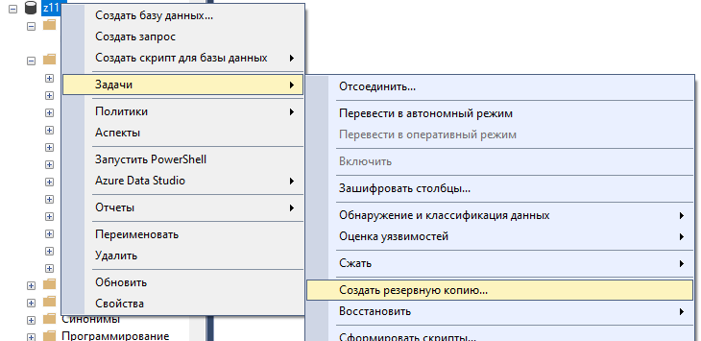

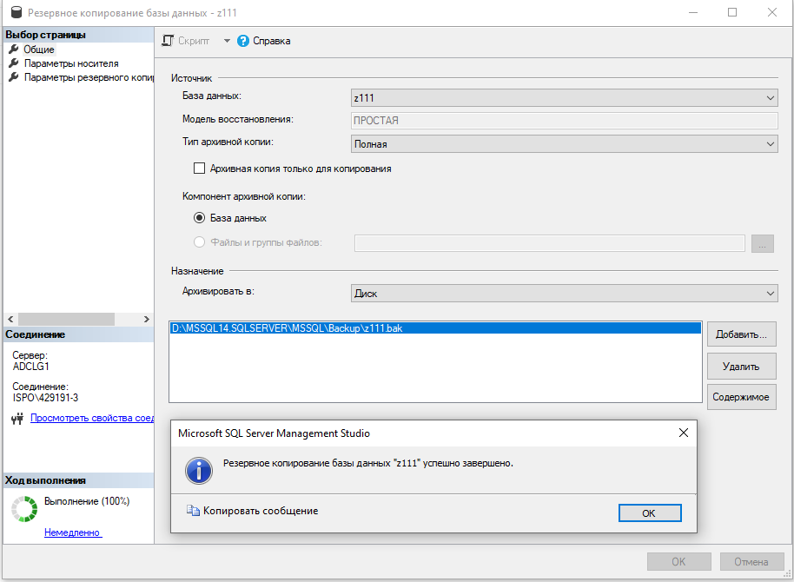

Скриншоты готовых таблиц с заполненными данными

